**Amfi Composites**

***Amfi Composites System***

***Version 1.0.0***

Confidentiality and Copyright

Proprietary, confidential data. All rights reserved.

Distribution and/or reproduction of these documents or any of their parts, their utilisation, or communication of their contents to third parties is not allowed unless formally conceded. Contravention will cause damages.

Copyright © 2019 by S4 Integration (Pty) Ltd.

S4 Integration (Pty) Ltd.

1 Leadwood Crescent

Fairview

Port Elizabeth

South Africa

6065

[www.s4.co.za](http://www.s4.co.za)

**Table of Contents**

Confidentiality and Copyright 2

1 Document Information 10

1.1 Change History 10

1.2 Review Record 10

1.3 Open Issues 10

2 Introduction 12

3 Setup 13

3.1 Prerequisites 13

3.1.1 A database management system such as SQL Server 13

3.1.2 An environment to host the services that is connected to Amfi Composites internal Network 13

3.1.3 An environment to host the web application that is connected to Amfi Composites internal network 13

3.2 Setting Up Environment 13

3.2.1 IIS 13

3.2.2 URL Rewrite 14

3.2.3 .Net Core hosting Bundle 15

3.2.4 SQL Server Express 15

SQL Server is needed to host the database used in the application. 15

3.2.5 Adding the Database 15

The database can be restored from a backup (.bak) file or from a script (.sql) file. Either of these will need to be generated from an existing instance of the AIS database. 15

4 Installation 20

4.1 Application overview 20

4.2 Hosting the website 20

5 Web Application 25

5.1 First time application start up 25

5.1.1 Login Details 25

5.1.2 Loading Screen 25

5.1.3 Login 26

5.2 Forgot Password 27

5.3 Reset Password 30

5.4 User Blocked 30

5.5 Web Application – Navigation 31

5.5.1 Login 31

5.5.2 Dashboard 31

5.5.3 Masterlist 31

5.5.3.1 Customers 31

5.5.3.2 Suppliers 31

5.5.3.3 Cost Managers 31

5.5.3.4 Cost Centers 32

5.5.3.5 Profit Centers 32

5.5.4 Stock Management 32

5.5.4.1 Stock 32

5.5.4.2 Profit Centers Stock 32

5.5.4.3 Stock Correction 32

5.5.5 Price Lookup 32

5.5.5.1 Current Prices 32

5.5.5.2 Price History 32

5.5.6 Products 33

5.5.7 Reports 33

5.5.7.1 Stock Report 33

5.5.8 User Management 33

5.5.8.1 Users 33

5.5.8.2 Allocation to Profit Centers 33

5.5.8.3 Role Template 33

5.5.8.4 Role Permissions 33

5.5.8.5 Assign Permissions 33

5.5.9 Settings 33

5.5.9.1 System Config 33

5.5.9.1.1 Supplier Category 34

5.5.9.1.2 Stock Category 34

5.5.9.1.3 Unit Of Measurement 34

5.5.9.1.4 Payment Methods 34

5.5.9.1.5 Employee Position 34

5.6 Web Application 34

5.6.1 Dashboard 34

5.6.1.1 Total Stock Items 35

5.6.1.2 Monthly Stock Value 35

5.6.1.3 Total Profit Centers 36

5.6.1.4 Last 5 Stock Items Added 36

5.6.1.5 Price Increase Reminders 36

5.6.1.6 Profit Centers Stock 37

5.6.1.7 Low Stock Notifications 37

5.6.1.8 Birthday Section 38

5.6.2 Masterlist 38

5.6.2.1 Customers 38

5.6.2.2 Suppliers 45

5.6.2.3 Cost Managers 53

5.6.2.4 Cost Centers 61

5.6.2.5 Profit Centers 70

5.6.3 Stock Management 79

5.6.3.1 Stock 79

5.6.3.1.1 Stock Categories Explained 80

5.6.3.1.2 Manage Stock 87

5.6.3.2 Profit Centers Stock 101

5.6.3.3 Stock Corrections 102

5.6.4 Price Lookup 104

5.6.4.1 Current Prices 104

5.6.4.1.1 Price Increase Reminder 111

5.6.4.1.2 Add Increase 115

5.6.4.2 Price History 117

5.6.5 Products 118

5.6.6 Reports 126

5.6.6.1 Stock Report 126

5.6.7 User Management 126

5.6.7.1 Users 126

5.6.7.1.1 Deactivated 131

5.6.7.1.2 Manage Password 133

5.6.7.1.3 Active 135

5.6.7.2 Allocation to Profit Centers 136

5.6.7.3 Role Template 138

5.6.7.4 Role Permissions 146

5.6.7.5 Assign Permissions 147

5.6.8 Settings 149

5.6.8.1 System Config 149

5.6.8.1.1 Supplier Category 150

5.6.8.1.2 Stock Category 158

5.6.8.1.3 Unit of Measurement 165

5.6.8.1.4 Payment Methods 173

5.6.8.1.5 Employee Position 180

5.6.9 Logout 188

**Table of Figures**

Figures 1: Windows Feature 23

Figures 2: IIS Manager With URL Rewrite Visible 24

Figures 3: Creating a database 25

Figures 4: Database Name 25

Figures 5: Restoring database 26

Figures 6: Restoring database 26

Figures 7: Restoring database 27

Figures 8: Restoring database 28

Figures 9: IIS Manager – Add website 29

Figures 10: IIS Manager – Add website 30

Figures 11: IIS Manager – Basic Settings 31

Figures 12: IIS Manager – Basic Settings 31

Figures 13: Database login context menu 32

Figures 14: Database login name 32

Figures 15: Database login permissions 33

Figures 16: Login Screen 34

Figures 17: Login Screen 35

Figures 18: Incorrect Login Details 36

Figures 19: Forgot Password 37

Figures 20: Forgot Password 38

Figures 21: Invalid Account Email 38

Figures 22: Forgot Password Email 39

Figures 23: Reset Password 40

Figures 24: Block User 41

Figures 25: Dashboard 45

Figures 26: Total Stock Items 45

Figures 27: Monthly Stock Value 46

Figures 28: Total Profit Centers 46

Figures 29: Last 5 Stock Items Added 46

Figures 30: Price Increase Reminder 47

Figures 31: Profit Centers Stock 47

Figures 32: Low Stock Notification 48

Figures 33: Birthdays 48

Figures 34: Customer View 49

Figures 35: Customer Add Button 49

Figures 36: Customer Add 50

Figures 37: Customer Added Successfully 51

Figures 38: Adding duplicate customers 51

Figures 39: Customer View 52

Figures 40: Customer Edit 53

Figures 41: Customer Edited Successfully 54

Figures 42: Customer View 55

Figures 43: Customer View 55

Figures 44: Customer Removed Successfully 56

Figures 45: Supplier View 57

Figures 46: Supplier Add Button 57

Figures 47: Supplier Add 58

Figures 48: Supplier Added Successfully 59

Figures 49: Adding duplicate suppliers 59

Figures 50: Supplier View 60

Figures 51: Supplier Edit 61

Figures 52: Supplier Edited Successfully 62

Figures 53: Supplier View 63

Figures 54: Supplier View 63

Figures 55: Error 64

Figures 56: Supplier Removed Successfully 65

Figures 57: Cost Manager View 66

Figures 58: Cost Manager Add Button 66

Figures 59: Cost Manager Add 67

Figures 60: Cost Manager Added Successfully 68

Figures 61: Adding duplicate Cost Manager 68

Figures 62: Cost Manager View 69

Figures 63: Cost Manager Edit 70

Figures 64: Cost Manager Edited Successfully 71

Figures 65: Cost Manager View 72

Figures 66: Cost Manager View 72

Figures 67: Error 73

Figures 68: Cost Manager Removed Successfully 74

Figures 69: Cost Centers View 75

Figures 70: Cost Centers Add Button 75

Figures 71: Cost Center Add 76

Figures 72: Adding Cost Center Names 77

Figures 73: Cost Center Added Successfully 78

Figures 74: Adding duplicate cost centers 78

Figures 75: Cost Center View 79

Figures 76: Cost Center Edit 80

Figures 77: Cost Center Edited Successfully 81

Figures 78: Cost Center View 82

Figures 79: Cost Center View 82

Figures 80: Error 83

Figures 81: Cost Center Removed Successfully 84

Figures 82: Profit Centers View 85

Figures 83: Profit Centers Add Button 85

Figures 84: Profit Center Add 86

Figures 85: Profit Center Color Picking 87

Figures 86: Profit Center Added Successfully 88

Figures 87: Adding duplicate profit centers 88

Figures 88: Profit Center View 89

Figures 89: Profit Center Edit 90

Figures 90: Profit Center Edited Successfully 91

Figures 91: Profit Center View 92

Figures 92: Profit Center View 92

Figures 93: Error 93

Figures 94: Profit Center Removed Successfully 94

Figures 95: Stock View 95

Figures 96: Stock View 96

Figures 97: Stock Add 97

Figures 98: Stock Added Successfully 98

Figures 99: Adding duplicate Stock Items 98

Figures 100: Stock View 99

Figures 101: Stock Edit 100

Figures 102: Stock Edited Successfully 101

Figures 103: Stock View 102

Figures 104: Remove Confirmation 102

Figures 105: Stock Removed Successfully 103

Figures 106: Manage Stock 104

Figures 107: Other Stock Categories 105

Figures 108: Price Lookup link 106

Figures 109: Current Price 107

Figures 110: Manage Stock 108

Figures 111: Adding Items 109

Figures 112: Adding Items Successfully 110

Figures 113: Remove quantity 111

Figures 114: Remove quantity filled in 112

Figures 115: Remove quantity successfully 112

Figures 116: Reset Stock 113

Figures 117: Reset Stock 114

Figures 118: Reset Stock Successfully 114

Figures 119: Recipe Stock Categories 115

Figures 120: Stock Recipe 116

Figures 121: Stock Recipe Items 117

Figures 122: Recipe Created 118

Figures 123: Profit Center Stock 119

Figures 124: Stock Correction 120

Figures 125: Stock Correction Edit 120

Figures 126: Price Lookup 121

Figures 127: Current Prices 122

Figures 128: Price Add Button 122

Figures 129: Price Add 123

Figures 130: Price Added Successfully 124

Figures 131: Current Price View 125

Figures 132: Price Edit 126

Figures 133: Price Edited Successfully 127

Figures 134: Current Price View 128

Figures 135: Current Price View 128

Figures 136: Price Removed Successfully 129

Figures 137: Increase View 130

Figures 138: Add Increase 131

Figures 139: Increase added successfully 131

Figures 140: Price Increase Reminder Update 132

Figures 141: Reminder Colors 133

Figures 142: Add Increase 134

Figures 143: Confirmation 134

Figures 145: Price Lookup View 135

Figures 146: Price History 136

Figures 147: Products View 137

Figures 148: Products View 137

Figures 149: Products View 138

Figures 150: Product Added Successfully 139

Figures 151: Products View 140

Figures 152: Product Edit 141

Figures 153: Role Edited Successfully 142

Figures 154: Product View 143

Figures 155: Product View 143

Figures 156: Product Removed Successfully 144

Figures 157: Sub Product Added 145

Figures 158: Stock Report 146

Figures 159: Users View 147

Figures 160: Users View 147

Figures 161: User View 148

Figures 162: User Added Successfully 149

Figures 167: User View 150

Figures 168: User Edit 151

Figures 169: User Edited Successfully 152

Figures 170: Deactivate User 153

Figures 171: confirmation box 154

Figures 172: Successfully Deactivate a user 155

Figures 173: Manage Password 156

Figures 178: Manage Password Popup 157

Figures 179: Activate User 158

Figures 180: Allocation to Profit Center 159

Figures 181: Allocation to Profit Center 160

Figures 182: Allocation to Profit Center 161

Figures 183: Roles Template View 162

Figures 184: Roles Add Button 162

Figures 185: Roles Add 163

Figures 186: Role Added Successfully 164

Figures 187: Adding duplicate Roles 164

Figures 188: Roles View 165

Figures 189: Roles Edit 166

Figures 190: Roles Edited Successfully 167

Figures 191: Role Template View 168

Figures 192: Role Template View 168

Figures 193: Role Template Removed Successfully 169

Figures 194: Role Permissions 170

Figures 195: Update Role Permissions 170

Figures 196: Assign Permissions 171

Figures 197: Assign Permissions 172

Figures 198: Rules 173

Figures 199: System Config 174

Figures 200: Supplier Category View 175

Figures 201: Supplier Category Add Button 175

Figures 202: Supplier Category Add 176

Figures 203: Supplier Category Added Successfully 177

Figures 204: Adding duplicate Supplier Categories 177

Figures 205: Supplier Category View 178

Figures 206: Supplier Category Edit 179

Figures 207: Supplier Category Edited Successfully 180

Figures 208: Supplier Category View 181

Figures 209: Supplier Category View 181

Figures 210: Supplier Category Removed Successfully 182

Figures 211: Stock Category View 183

Figures 212: Stock Category Add Button 183

Figures 213: Stock Category Add 184

Figures 214: Stock Category Added Successfully 185

Figures 215: Adding duplicate Stock Categories 185

Figures 216: Stock Category View 186

Figures 217: Stock Category Edit 187

Figures 218: Stock Category Edited Successfully 188

Figures 219: Stock Category View 189

Figures 220: Stock Category View 189

Figures 221: Stock Category Removed Successfully 190

Figures 222: UOM View 191

Figures 223: UOM Add Button 192

Figures 224: UOM Add 193

Figures 225: UOM Added Successfully 194

Figures 226: Adding duplicate UOM 194

Figures 227 UOM View 195

Figures 228: UOM Edit 196

Figures 229: UOM Edited Successfully 197

Figures 230: UOM View 198

Figures 231: UOM View 198

Figures 232: UOM Removed Successfully 199

Figures 233: Payment Method View 200

Figures 234: Payment Method Add Button 200

Figures 235: Payment Method Add 201

Figures 236: Payment Method Added Successfully 202

Figures 237: Adding duplicate Payment Method 202

Figures 238: Payment Method View 203

Figures 239: Payment Method Edit 204

Figures 240: Payment Method Edited Successfully 205

Figures 241: Payment Method View 206

Figures 242: Payment Method View 206

Figures 243: Payment Method Removed Successfully 207

Figures 244: Employee Position View 208

Figures 245: Employee Position Add Button 208

Figures 246: Employee Position Add 209

Figures 247: Employee Position Added Successfully 210

Figures 248: Adding duplicate Employee Position 210

Figures 249: Employee Position View 211

Figures 250: Employee Position Edit 212

Figures 251: Employee Position Edited Successfully 213

Figures 252: Employee Position View 214

Figures 253: Employee Position View 214

Figures 254: Employee Position Removed Successfully 215

Figures 255: Logout 216

# Document Information

## Change History

|  |  |  |  |
| --- | --- | --- | --- |
| **Date** | **Version** | **Changed Chapters** | **Author** |
| 15 November 2021 | 1.0.0 | Initial Document | Melody Kossmann |
| 3 December 2021 | 1.0.1 | Implemented Departments | Melody Kossmann |
|  |  |  |  |

## Review Record

|  |  |  |  |
| --- | --- | --- | --- |
| **Date** | **Reviewed Version** | **Comments** | **Reviewer** |
|  |  |  |  |
|  |  |  |  |
|  |  |  |  |

## Open Issues

|  |  |  |  |
| --- | --- | --- | --- |
| **Date** | **Description** | **Resolution** | **Responsible** |
|  |  |  |  |
|  |  |  |  |
|  |  |  |  |

# Introduction

This document will explain how to install and use ACS.

# Setup

## Prerequisites

### A database management system such as SQL Server

### An environment to host the services that are connected to Amfi Composites internal Network

### An environment to host the web application that is connected to Amfi Composites internal network

## Setting Up Environment

### IIS

IIS is used to host the web application.

**Step 1:** In the search bar on a Windows machine, type “features”

**Step 2:** Click on “Turn Windows features on or off.” This will display a window that has a list of Windows features.

**Step 3**: Scroll down until “Internet Information Services” is visible and click on the dropdown.

**Step 4:** Ensure that the following checkboxes are ticked, as shown in figure 1:

Internet Information Services → Web Management Tools → IIS Management Console

Internet Information Services → World Wide Web Services

**Image:**

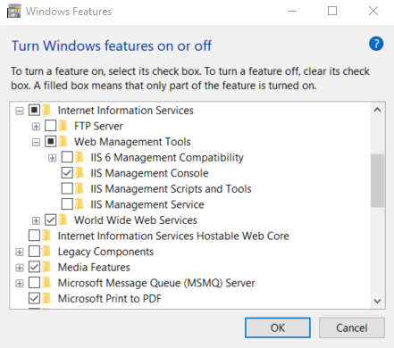

Figures 1: Windows Feature

**Step 5:** Click OK, this will install the necessary files and install IIS Manager.

### URL Rewrite

URL Rewrite is an extension for IIS that is needed for the Identity Server to function properly.

**Step 1:** Go to the IIS [website](https://www.iis.net/downloads/microsoft/url-rewrite) and click on “Install this extension.” This will download an exe file named something along the lines of “urlrewrite2.exe.”

**Step 2:** Run urlrewrite2.exe. This will bring up an installation wizard. Use the default settings and follow the wizard until the installation is completed. After installation, the Web Platform Installer will linger. This can be closed.

After installation, the URL Rewrite extension should be visible in the IIS Manager

**Image:**

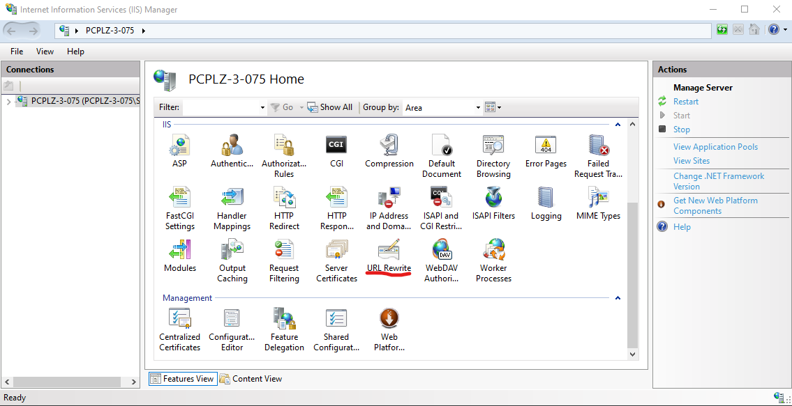

Figures 2: IIS Manager With URL Rewrite Visible

### .Net Core hosting Bundle

The .NET Hosting Bundle is required to host a .NET Core application on IIS.

**Step 1:** Download the [.NET Core Hosting Bundle installer](https://dotnet.microsoft.com/download/dotnet-core/thank-you/runtime-aspnetcore-3.1.8-windows-hosting-bundle-installer).

**Step 2:** Run the installer to install the hosting bundle.

### SQL Server Express

### SQL Server is needed to host the database used in the application.

**Step 1:** Download the installation tool from Microsoft’s [website](https://www.microsoft.com/en-us/Download/details.aspx?id=101064).

**Step 2:** Run the setup exe and choose “Basic Installation” for the database. The default settings can be used at every point in this installation process.

**Step 3:** Download [SQL Server Management Studio](https://docs.microsoft.com/en-us/sql/ssms/download-sql-server-management-studio-ssms?redirectedfrom=MSDN&view=sql-server-ver15)’s installer and run it. The installation wizard will guide you through the installation process.

### Adding the Database

### The database can be restored from a backup (.bak) file or a script (.sql) file. Either of these will need to be generated from an existing instance of the AIS database.

**Step 1:** Within SQL Server Management Studio(SMSS) connect to the server created in setup.

**Step 2:** Right-click on “Databases” and click on “New Database…”

**Image:**

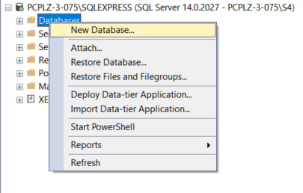

Figures 3: Creating a database

**Step 3:** Name the Database “**AIS**” and click “OK”

**Image:**

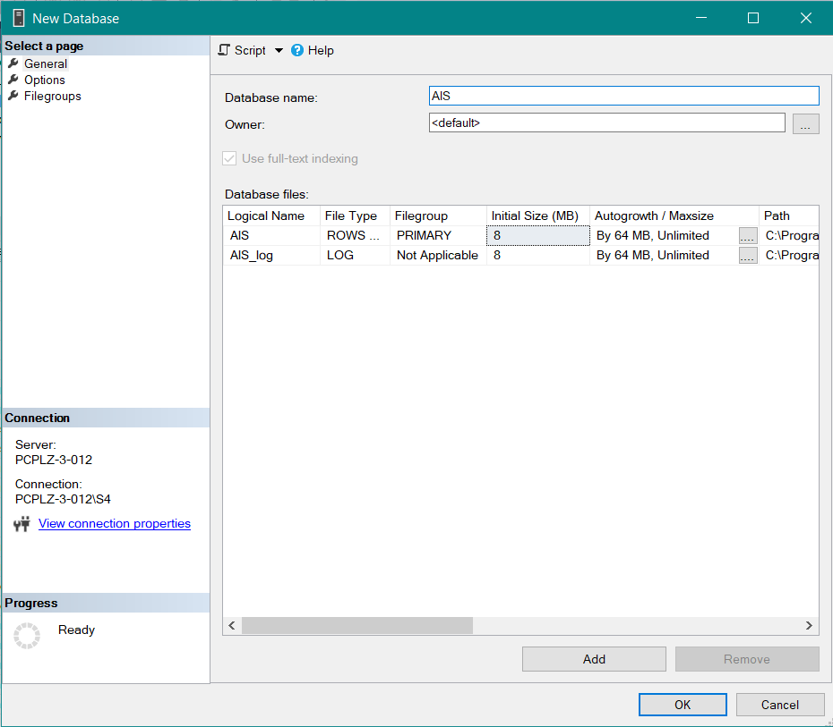

Figures 4: Database Name

**Step 6:** In the dialogue that follows, click on “Add”

**Image:**

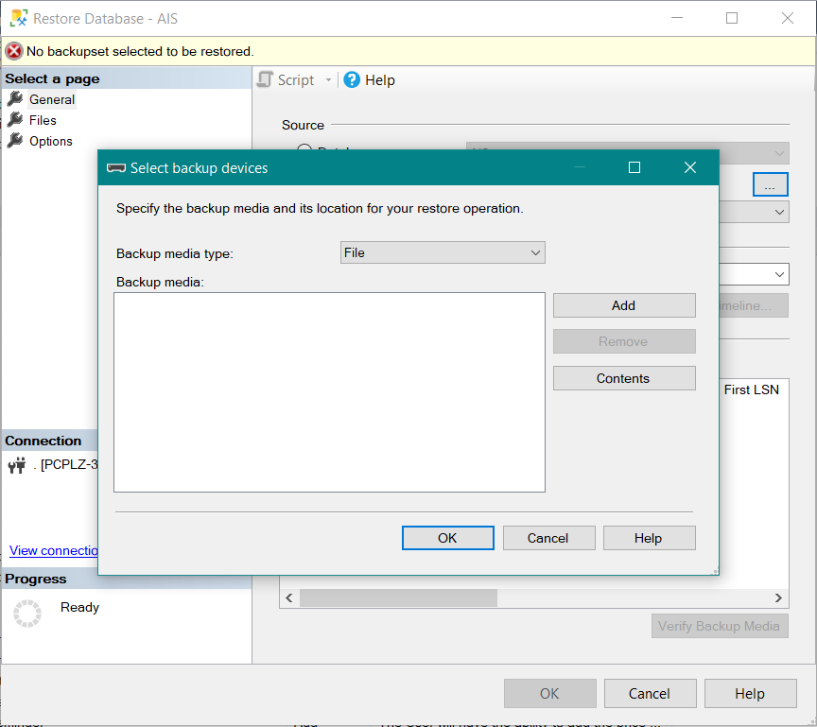

Figures 5: Restoring database

**Step 7:** In the dialogue that follows, navigates to the .bak file generated by SMSS and select it, then click “OK”.

**Image:**

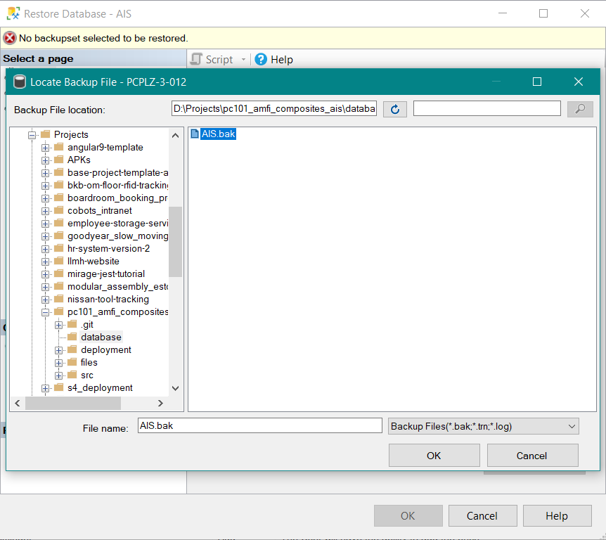

Figures 6: Restoring database

**Step 8:** Click “OK”

**Image:**

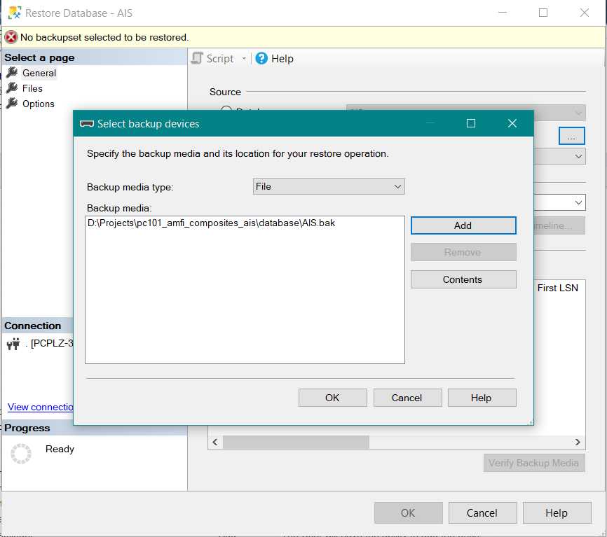

Figures 7: Restoring database

**Step 9:** Select “Options” in the top left and configure the form as follows:

**Image:**

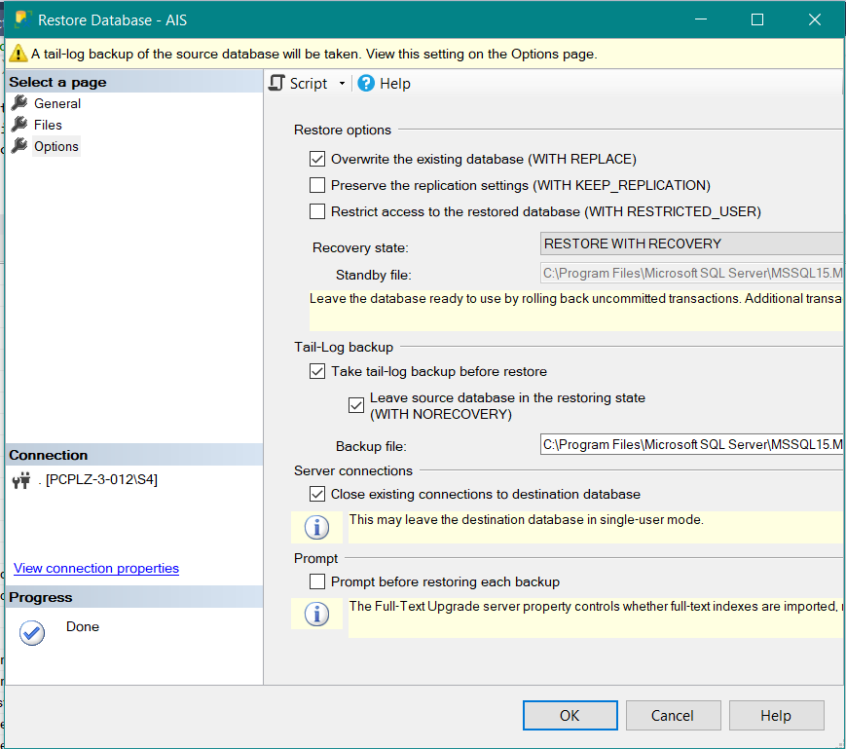

Figures 8: Restoring database

**Step 10:** Click on “OK”. This will generate the necessary tables and data for the system to function initially.

# Installation

## Application overview

The final product consists of:

1. *Web Application – Users will access the web application via chrome, edge, firefox, etc.*

## Hosting the website

**Step 1:** Launch IIS Manager

**Step 2:** In IIS Manager, right-click on “Sites” and click “Add Website”

**Image:**

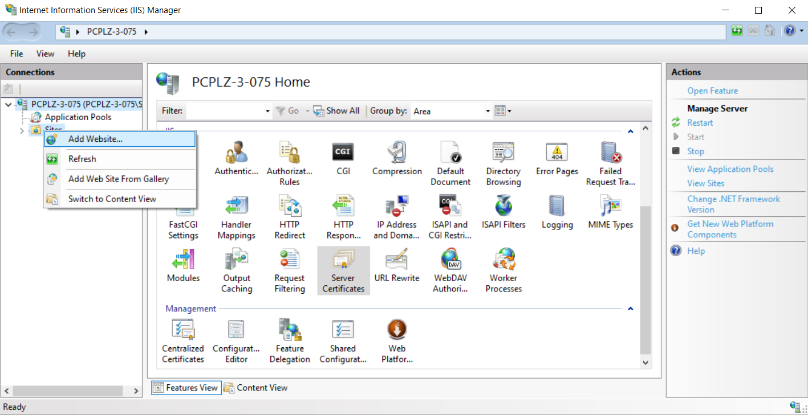

Figures 9: IIS Manager – Add website

**Step 3:** In the dialogue that follows, the website will need to be configured.

**Image:**

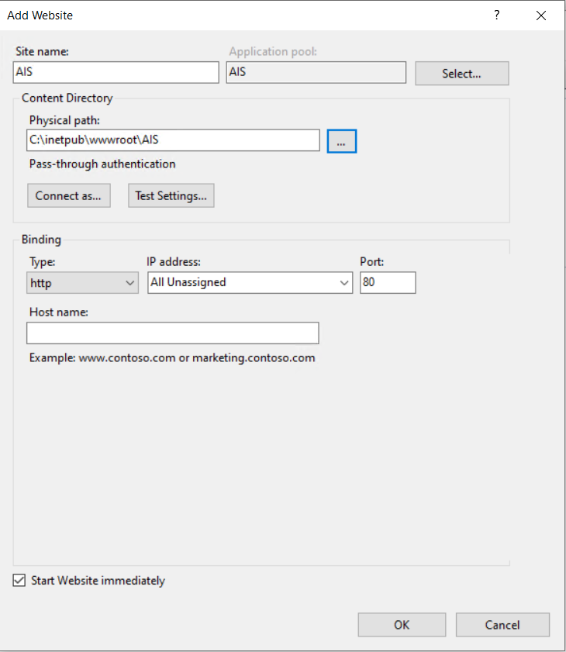

Figures 10: IIS Manager – Add website

**Site Name –** The site name does not have to be anything specific. This is the name that will be displayed in the IIS website list.

**Physical Path –** This is where the website’s files are located on the hard drive. Usually, the published website files go into the interpub/wwwroot directory generated by the IIS. This directory already has all the necessary permissions for IIS to access the correct files.

**Binding: Type –** The type under binding should be set to HTTPS.

**Binding: Port –** Any available port can be set.

**Step 4:** Click on “Application Pools”, right-click on the application pool for the Web application and click on Basic Settings

**Image:**

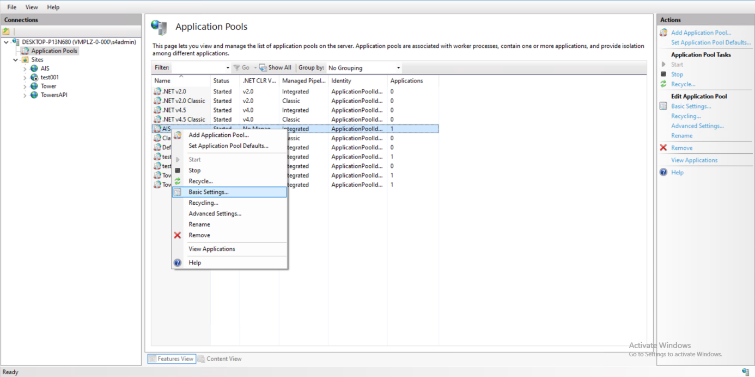

Figures 11: IIS Manager – Basic Settings

**Step 5:** In the dialogue that follows, click the .NET CLR version dropdown, select “No Managed Code” and click “OK”, then right-click on the Application pool and click “Recycle”

**Image:**

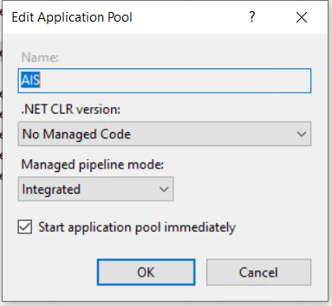

Figures 12: IIS Manager – Basic Settings

**Step 6:** Launch SQL Server Management Studio and connect to the server.

**Step 7:** Click on “Security” and then right-click on “Logins” and click on “New Login…”

**Image:**

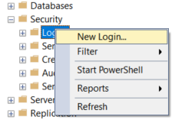

Figures 13: Database login context menu

**Step 8:** In the dialogue that follows, make the Login name “IIS APPPOOL\{name of app pool}”.

For example, here the name would need to be “IIS APPPOOL\GYSMW” because that is the name of the app pool created earlier. This is important because the app pool needs access to the database to store and retrieve data.

**Image:**

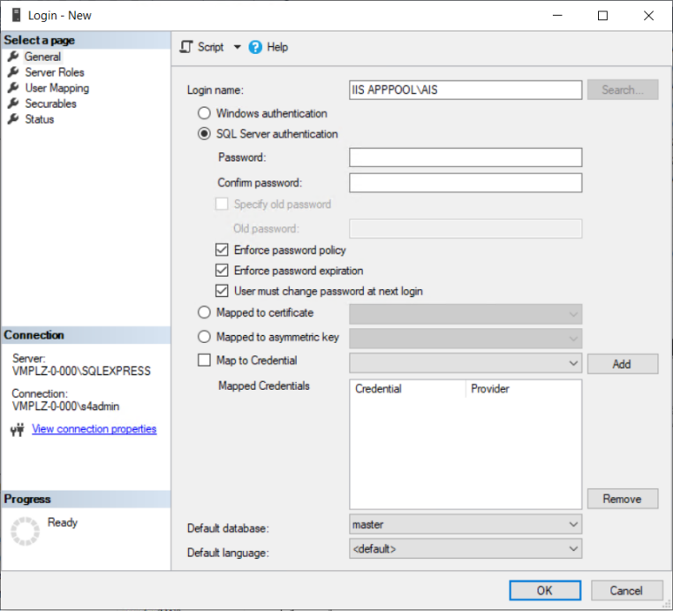

Figures 14: Database login name

**Step 9:** Under Server Roles, tick “sysadmin” then click “OK”.

**Image:**

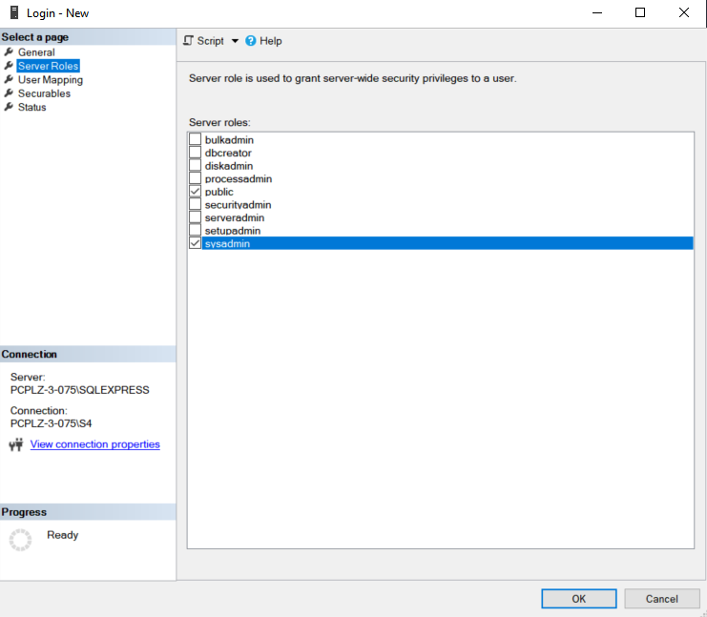

Figures 15: Database login permissions

# Web Application

## First-time application startup

### Login Details

The admin user will use the following details to create users for the system:

Username: Admin  
Password: superadmin

### Loading Screen

The first screen you will see is the login screen.

**Image:**

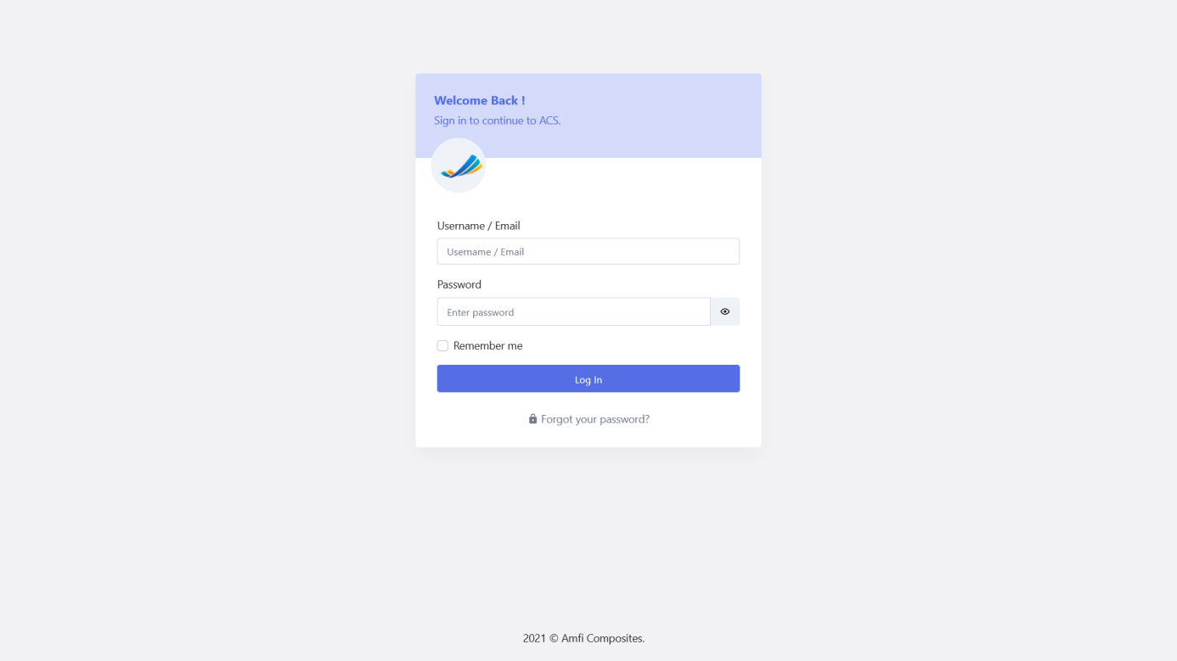

Figures 16: Login Screen

### Login

The login screen will prompt you for a username/email and password. Click on login to log in.

**Image:**

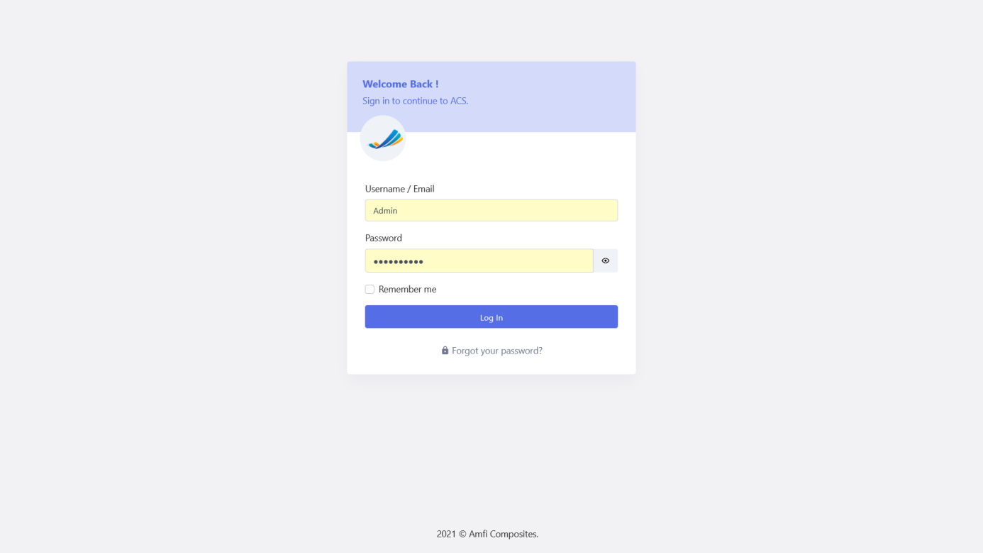

Figures 17: Login Screen

The user will have 3 attempts to log in, if the user fails to log in within the attempts remaining the user will be deactivated and should contact an admin user to activate them again and reset their password.

**Image:**

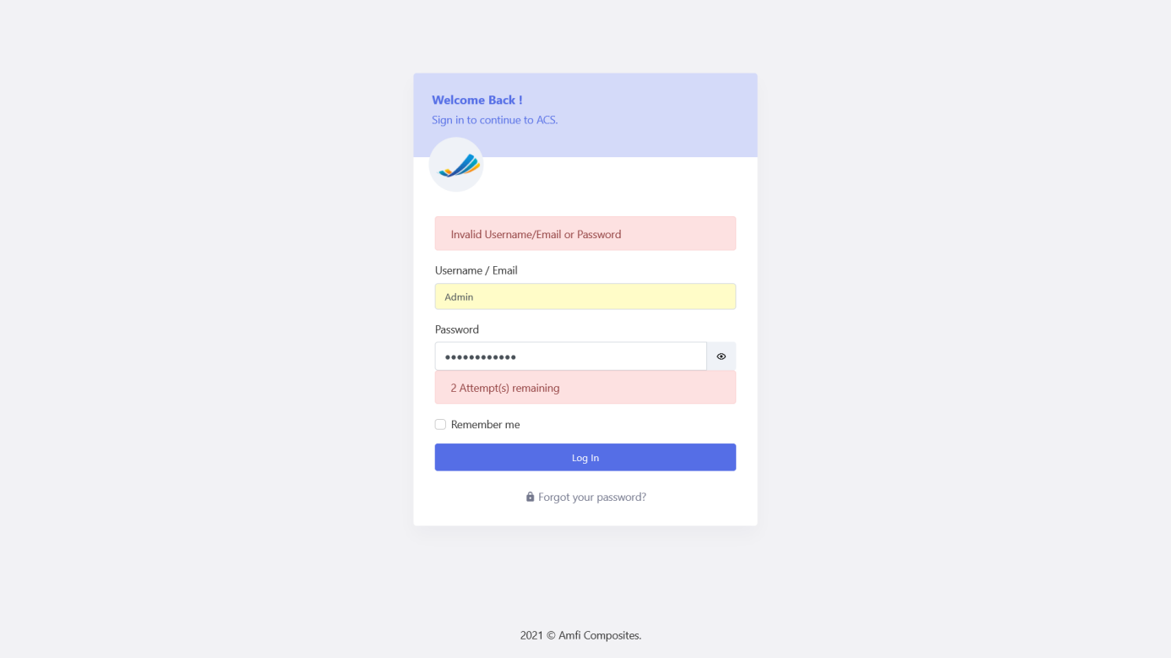

Figures 18: Incorrect Login Details

## Forgot Password

The user can navigate to the forgot password screen by clicking on the “Forgot Password“ link.

**Image:**

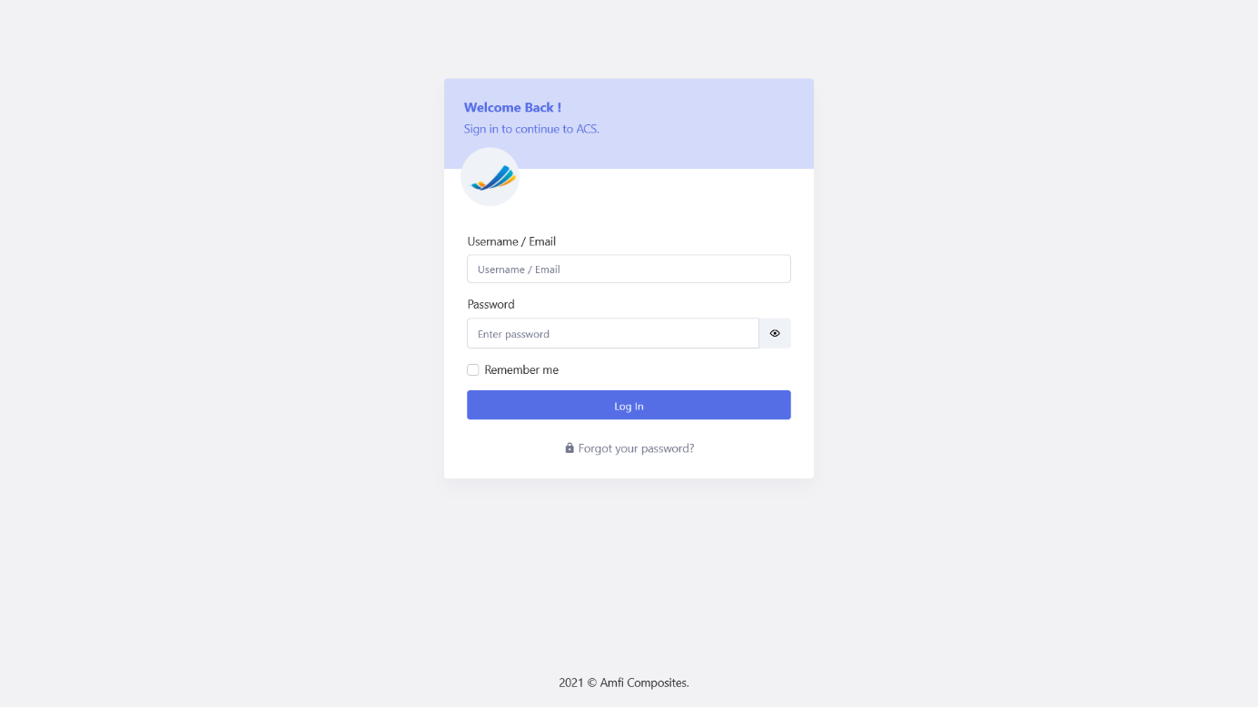

Figures 19: Forgot Password

The system will navigate the user to the Forgot Password page. The user can enter their email address and click submit.

**Image:**

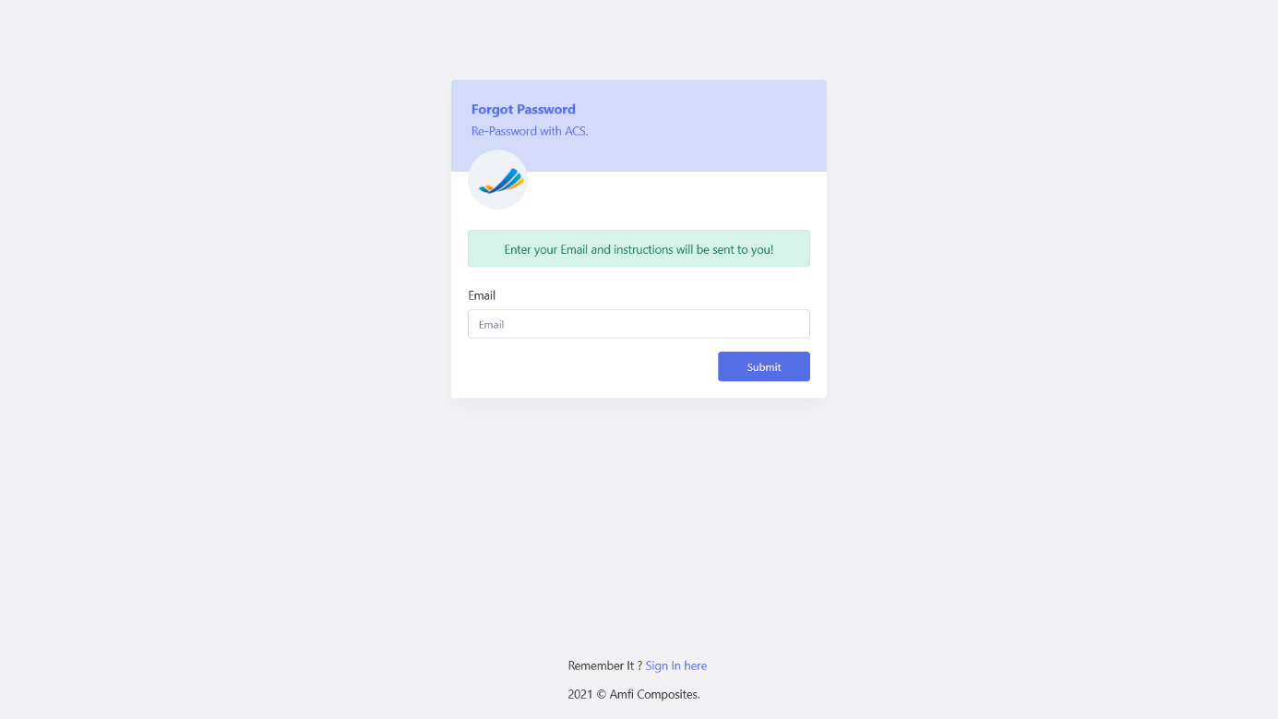

Figures 20: Forgot Password

The system will throw an error if the entered email address is not a valid user email address.

**Image:**

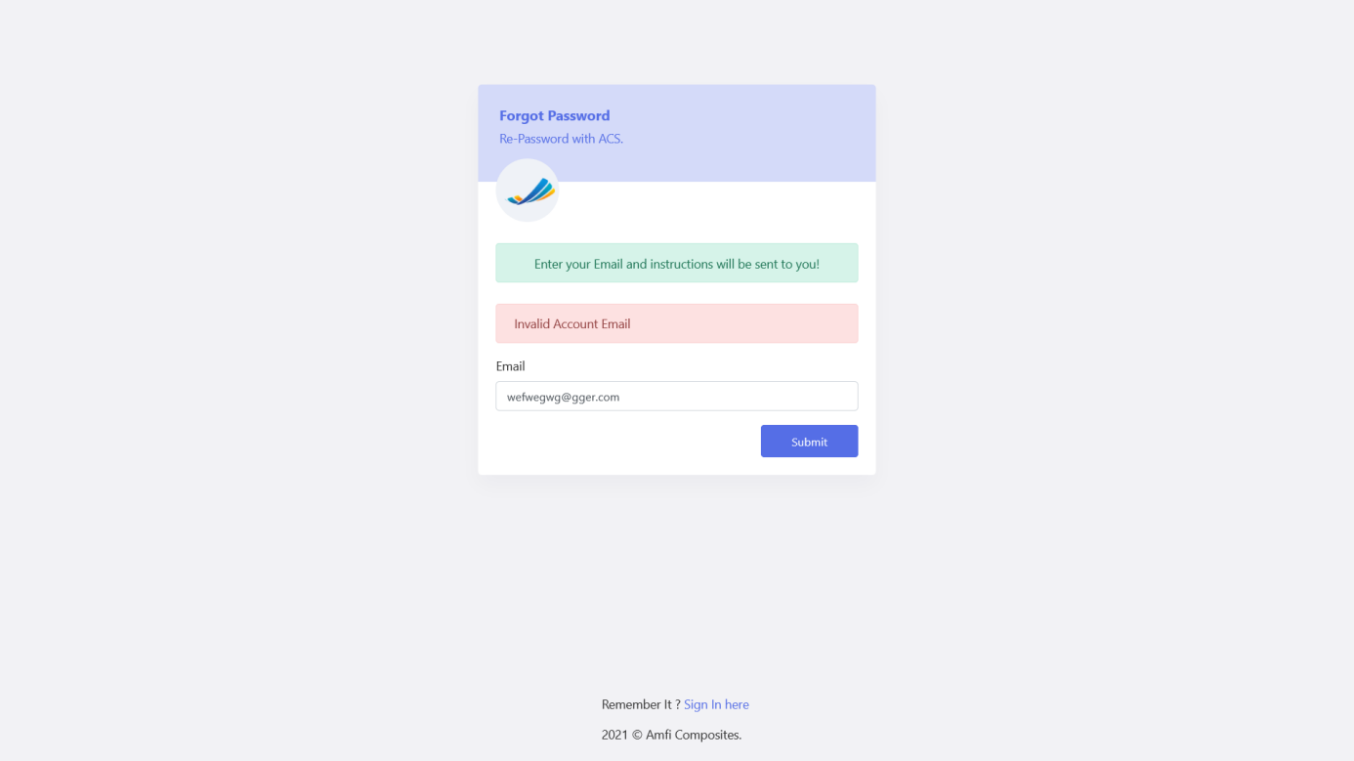

Figures 21: Invalid Account Email

The system will navigate to the login page if the email was valid and an email was sent to the entered address. The user will receive an email and can follow the instructions to set their password.

**Image:**

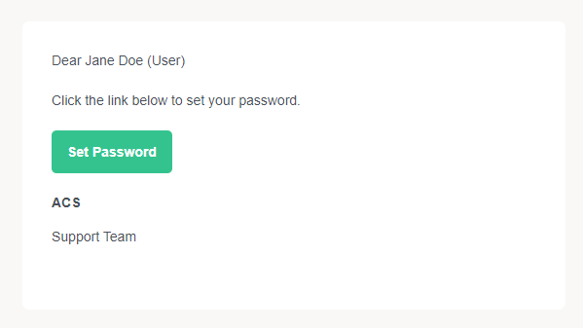

Figures 22: Forgot Password Email

## Reset Password

The user will then be navigated to a reset password screen. The user can enter their new password and click Reset.

**Image:**

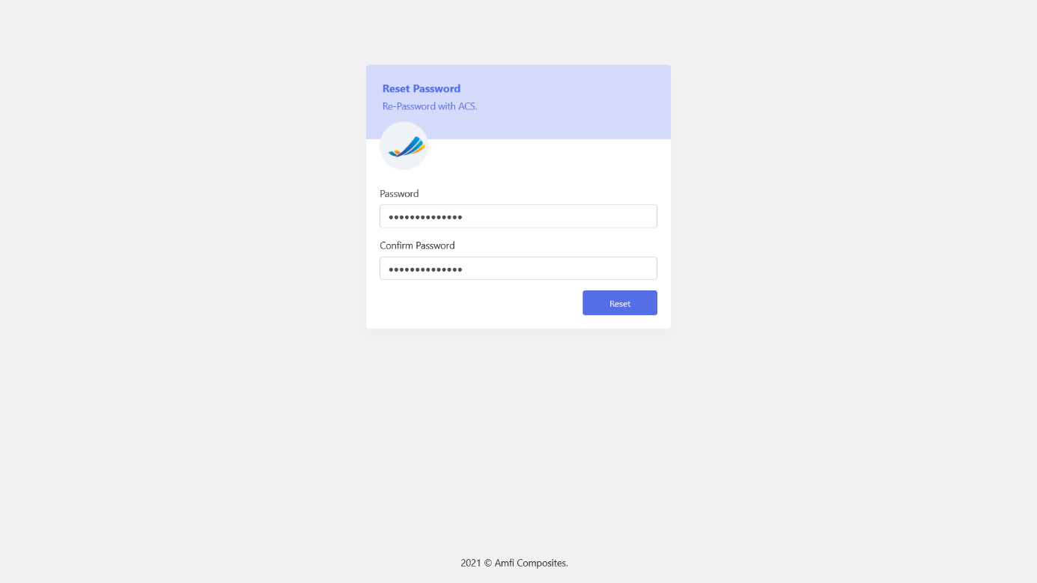

Figures 23: Reset Password

The user will then be navigated to the login screen and the user can log in with their username/email and new password.

## User Blocked

The system will block the user after 3 failed login attempts. The user will have to contact their Admin to manually change their password for them.

**Image:**

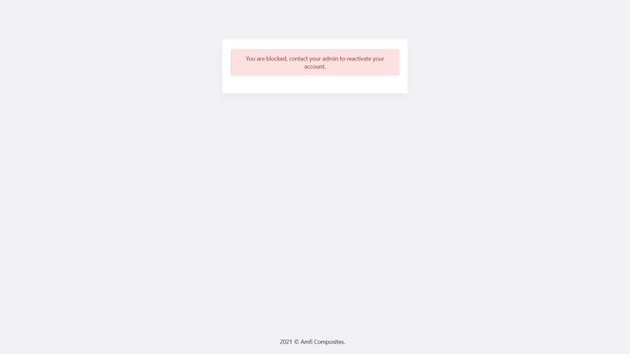

Figures 24: Block User

## Web Application – Navigation

### Login

Users have to log in to access the web application

### Dashboard

The dashboard will display a visual overview of stock items, profit centers, and reminders.

### Masterlist

#### Customers

The user will be able to add, edit and remove customers.

#### Suppliers

The user will be able to add, edit and remove suppliers.

#### Departments

The user will be able to add, edit and remove departments.

#### Department Managers

The user will be able to add, edit and remove department managers.

#### Profit Centers

The user will be able to add, edit and remove profit centers.

### Stock Management

The user will be able to access any stock-related pages under this menu item.

#### Stock

The user will be able to add, edit and remove stock items. The user will be able to manage stock items, add, remove and set stock quantities. The user will also be able to create stock recipes under a certain stock category named “Recipes“

#### Profit Centers Stock

The user will be able to view all the Profit Centers and the stock allocated to each profit center. Each profit center will have the total stock items listed under it and the total stock price for each profit center.

#### Warehouse Stock

The user will be able to view all the Warehouses and the stock allocated to each warehouse. Each warehouse will have the total stock items listed under it and the total stock price for each warehouse. The user will also be able to edit a record and add, edit the warehouse field.

#### Grouping Stock

The user will be able to view all the stock groups and the stock allocated to each stock group. Each stock group will have the total stock items listed under it, the quantity stock and the total stock price for each stock group.

#### Stock Correction

The user will be able to bypass any logs to correct the stock. This feature will only be allowed for the highest level of ADMIN seeing that it’s linked directly to edit records in the Database. The user will only be allowed to edit stock items and the field they are allowed to edit is the following:

* Quantity
* Price
* Profit Center

### Price Lookup

#### Current Prices

The user will be able to add prices for each stock item. The user will also be able to add Price Increase Reminders to the stock items.

#### Price History

The user will be able to view the prices of stock items changed over 5 years.

### Products

The user will be able to add, edit and remove products. Each product should have stock items assigned to them, these items are used to make/assemble the product. Each stock item assigned to the product can be added, edited, and removed.

### Reports

The user will be able to view any report-related pages under this menu item.

#### Stock Report

The user will be able to view the stock report, stock quantities added and removed.

### User Management

The user will be able to view any user and permission-related pages under this menu item.

#### Users

The admin user will be able to add, edit, deactivate, activate users, and do a manual password change.

#### Allocation to Profit Centers

The user will be able to see a list of active users and allocate a percentage of a user to a profit center. The user should be allocated to profit centers and have a total percentage of 100%.

#### Role Template

The user will be able to add, edit and remove roles.

#### Role Permissions

The user will be able to create role blueprints.

#### Assign Permissions

The user will be able to assign a role blueprint to a user.

### Settings

The user will find any system settings under this menu item.

#### System Config

The user will be able to add data to use within the system, this data will auto-populate some dropdowns used within the system.

##### Supplier Category

The user will be able to add, edit and remove items.

##### Stock Category

The user will be able to add, edit and remove items.

##### Unit Of Measurement

The user will be able to add, edit and remove items.

##### Payment Methods

The user will be able to add, edit and remove items.

##### Employee Position

The user will be able to add, edit and remove items.

## Web Application

### Dashboard

The Dashboard will be used for an overview of stock and other reminders.

**Image:**

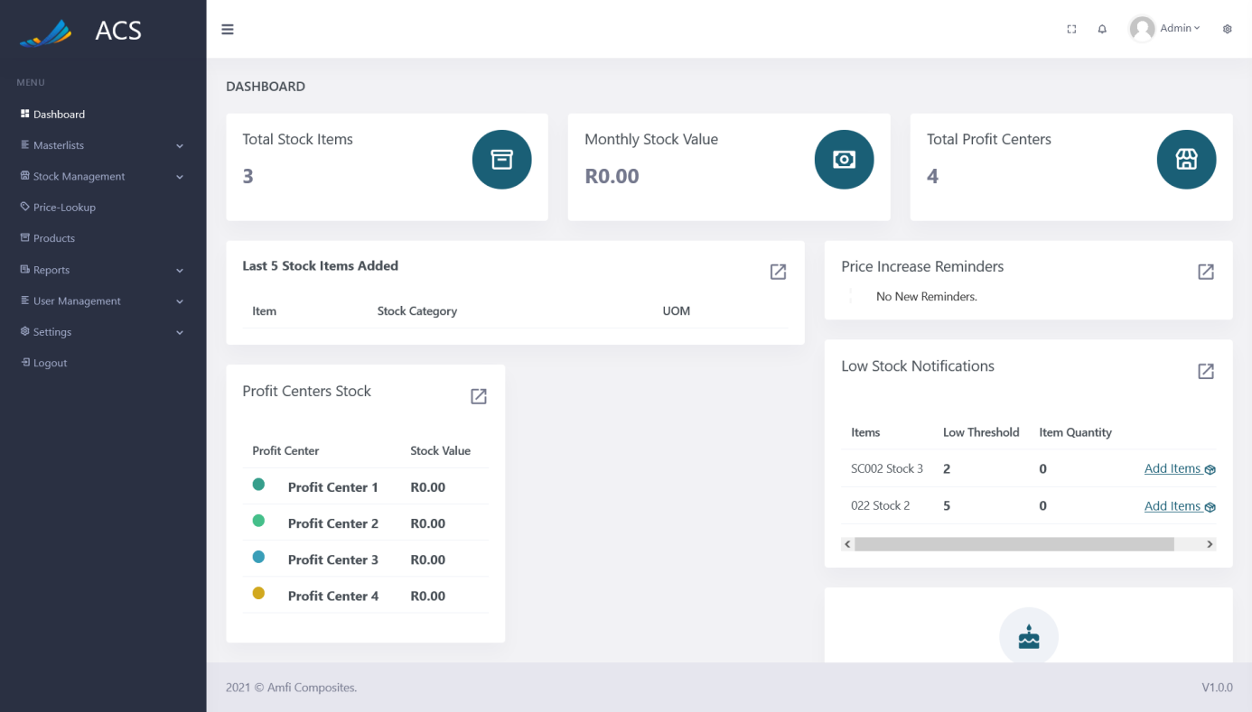

Figures 25: Dashboard

#### Total Stock Items

The user will be able to see the total stock items in the system.

**Image:**

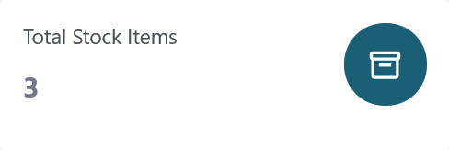

Figures 26: Total Stock Items

#### Monthly Stock Value

The user will be able to see the total monthly stock value of all the stock items in the system.

**Image:**



Figures 27: Monthly Stock Value

#### Total Profit Centers

The user will be able to see the total profit centers in the system.

**Image:**



Figures 28: Total Profit Centers

#### Last 5 Stock Items Added

The user will be able to see the last 5 stock quantities added.

**Image:**

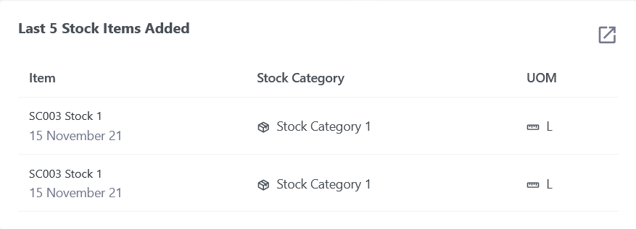

Figures 29: Last 5 Stock Items Added

#### Price Increase Reminders

The user will be able to see Price Increase Reminders, when a stock item's price is increasing on a specific date, the user can add a price increase reminder and the dashboard will show a quick preview of price increase reminders.

**Image:**

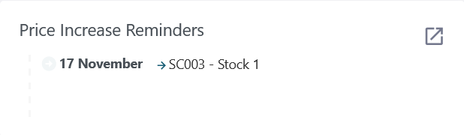

Figures 30: Price Increase Reminder

#### Profit Centers Stock

The user will be able to view the stock value for each Profit Center in the system.

**Image:**

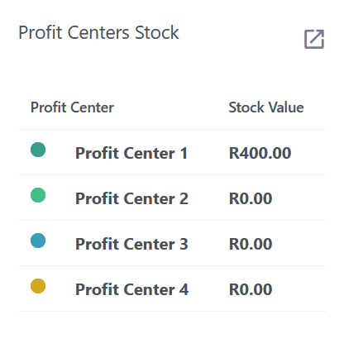

Figures 31: Profit Centers Stock

#### Low Stock Notifications

The user will be able to view low stock items, when adding a stock item the user will enter a low threshold, the threshold will be a minimum quantity of the item before the low stock notification should appear. The user will be able to add items by clicking on the “Add Items“ link in the Low Stock Notification section.

**Image:**

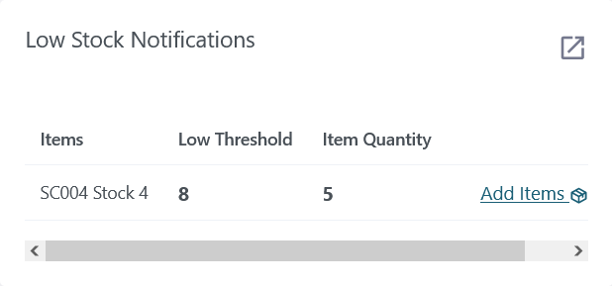

Figures 32: Low Stock Notification

#### Birthday Section

The user will be able to view all the birthdays for that current month.

**Image:**



Figures 33: Birthdays

### Masterlist

#### Customers

The user will be able to view, add, edit and remove customers. The user can capture customer information, multiple contact details, physical address, and delivery address(not required).

**Image:**

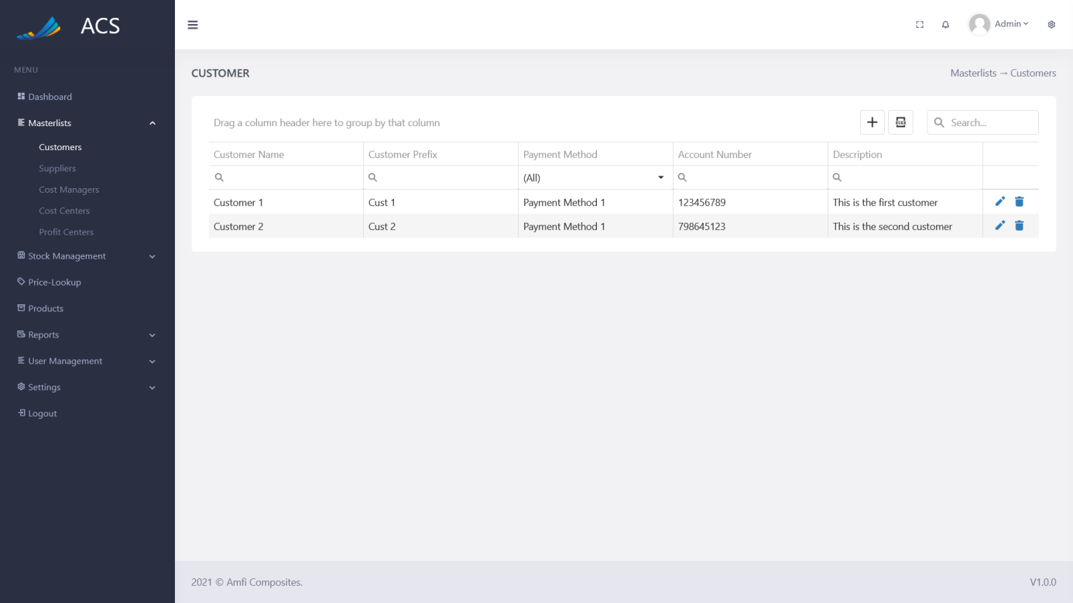

Figures 34: Customer View

The user will be able to add a new customer by pressing the plus icon button below.

**Image:**

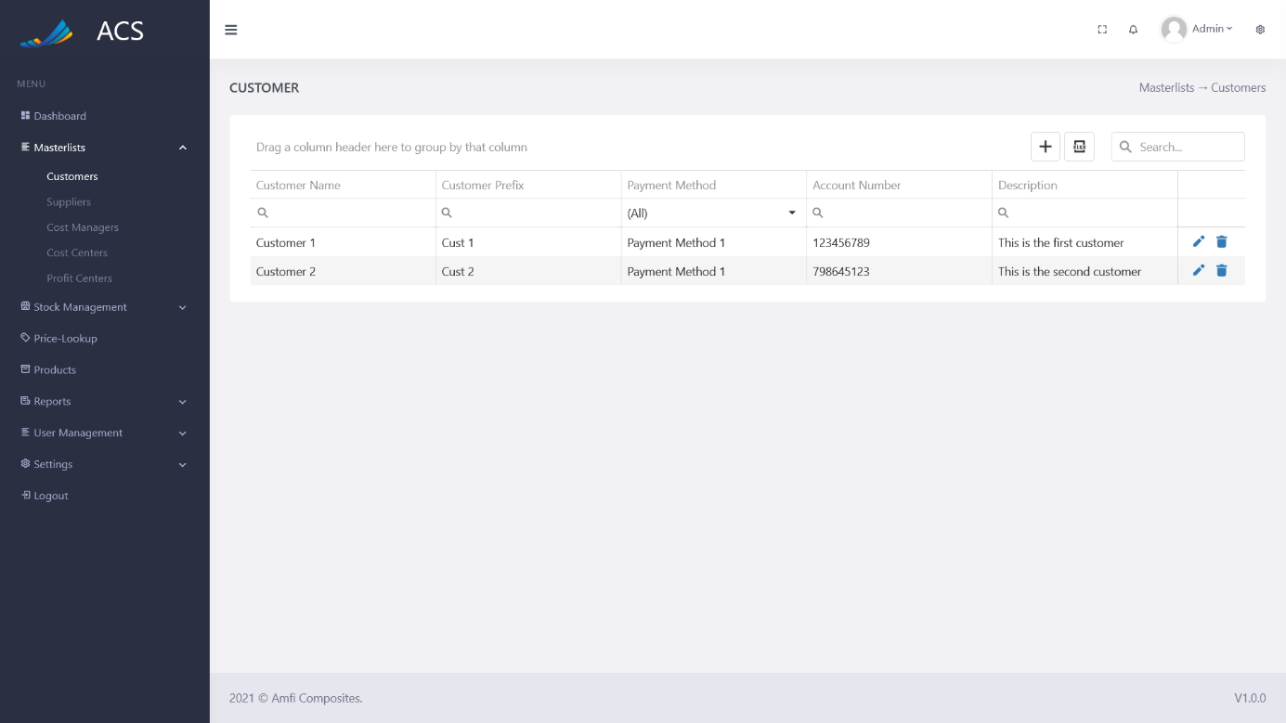

Figures 35: Customer Add Button

A Customer Information popup will appear, the user can fill in all the required fields (marked with a red *) and press the save button.

**Image:**

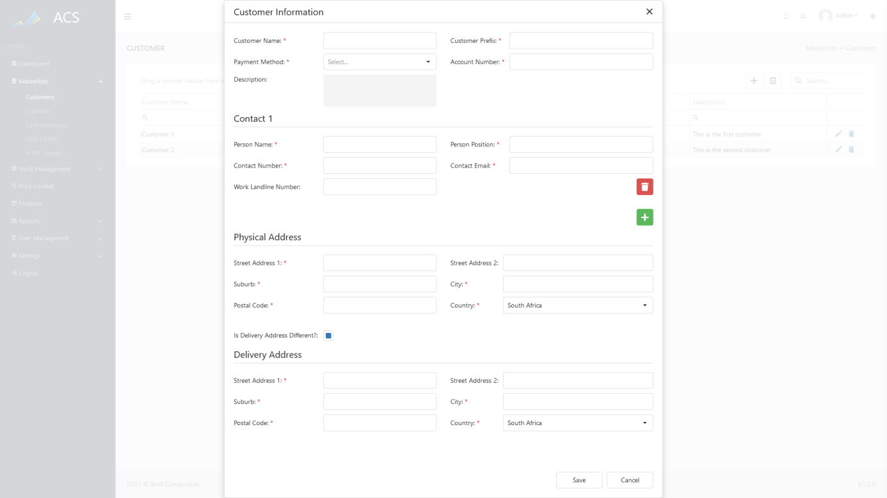

Figures 36: Customer Add

A success message will appear at the bottom of the screen if a customer was added successfully.

**Image:**

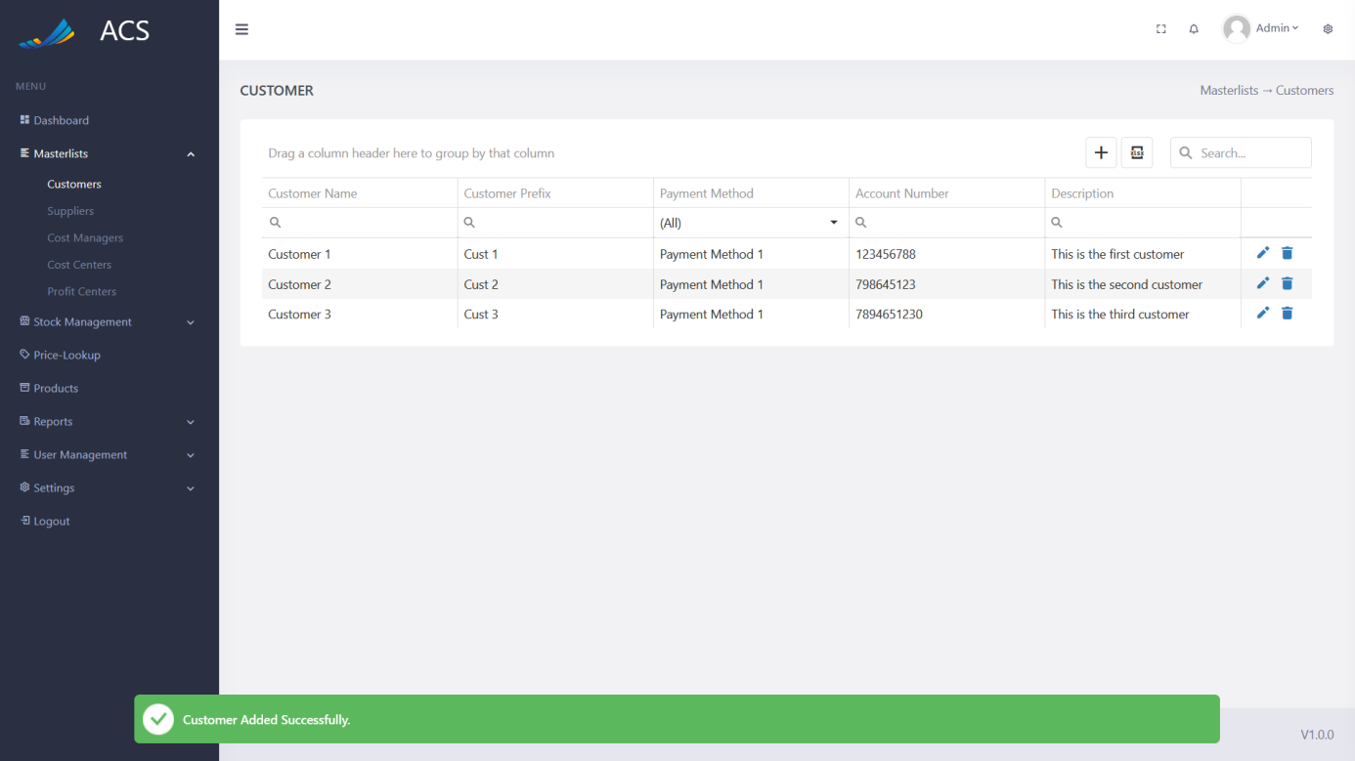

Figures 37: Customer Added Successfully

If duplicate customers are added the system will block the request and send back an error message to the user to state the customer already exists.

**Image:**

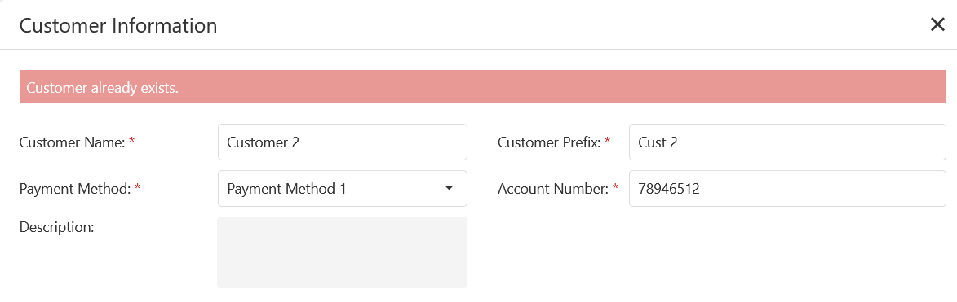

Figures 38: Adding duplicate customers

The user will be able to edit a customer by pressing the pencil icon button on the record they wish to edit, see below.

**Image:**



Figures 39: Customer View

The Customer Information popup will appear with pre-populated data of the customer, the user can fill in/change all the required fields (marked with a red *) and press the save button.

**Image:**

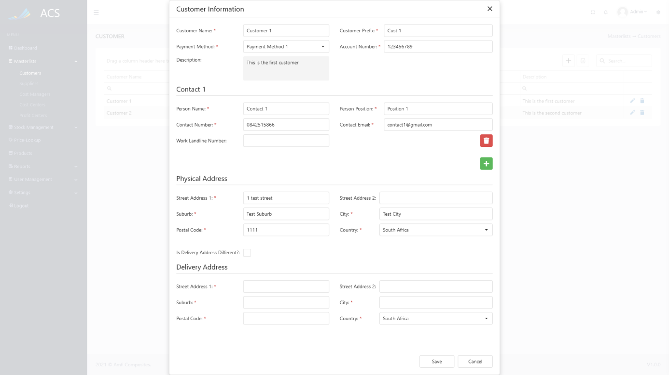

Figures 40: Customer Edit

A success message will appear at the bottom of the screen if a customer was updated successfully.

**Image:**

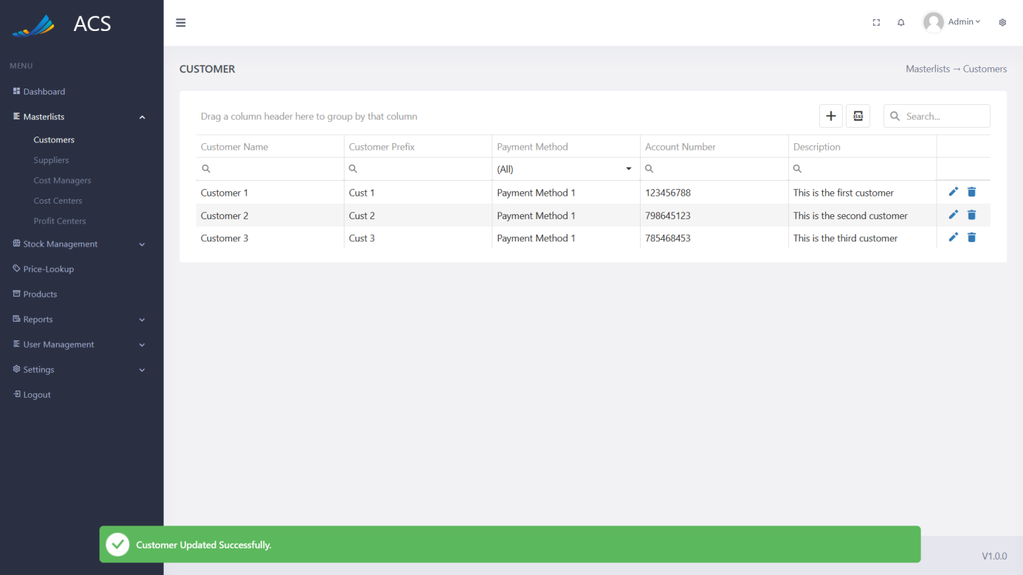

Figures 41: Customer Edited Successfully

The user will be able to remove a customer by pressing the trash icon button on the record they wish to remove, see below.

**Image:**



Figures 42: Customer View

A confirmation popup will appear, press yes to continue OR no to cancel.

**Image:**

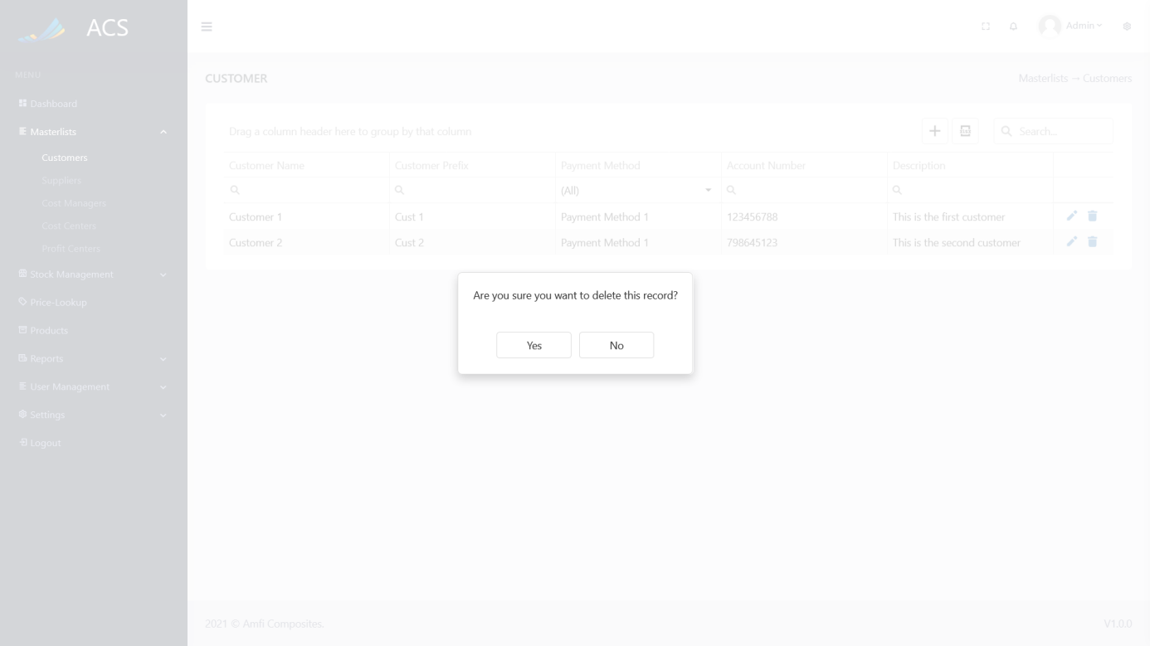

Figures 43: Customer View

**Image:**

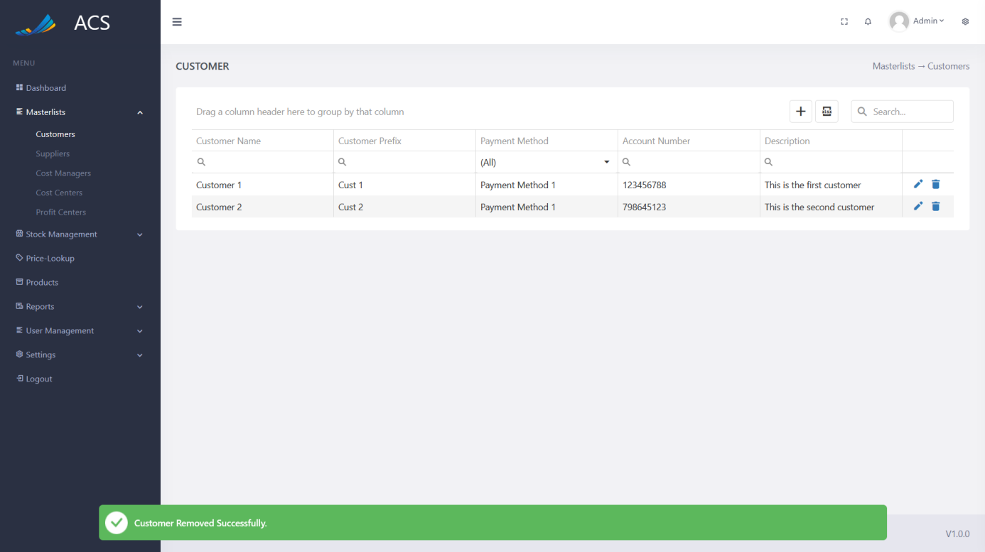

Figures 44: Customer Removed Successfully

#### Suppliers

The user will be able to view, add, edit and remove suppliers. The user can capture supplier information, multiple contact details, physical address.

**Image:**

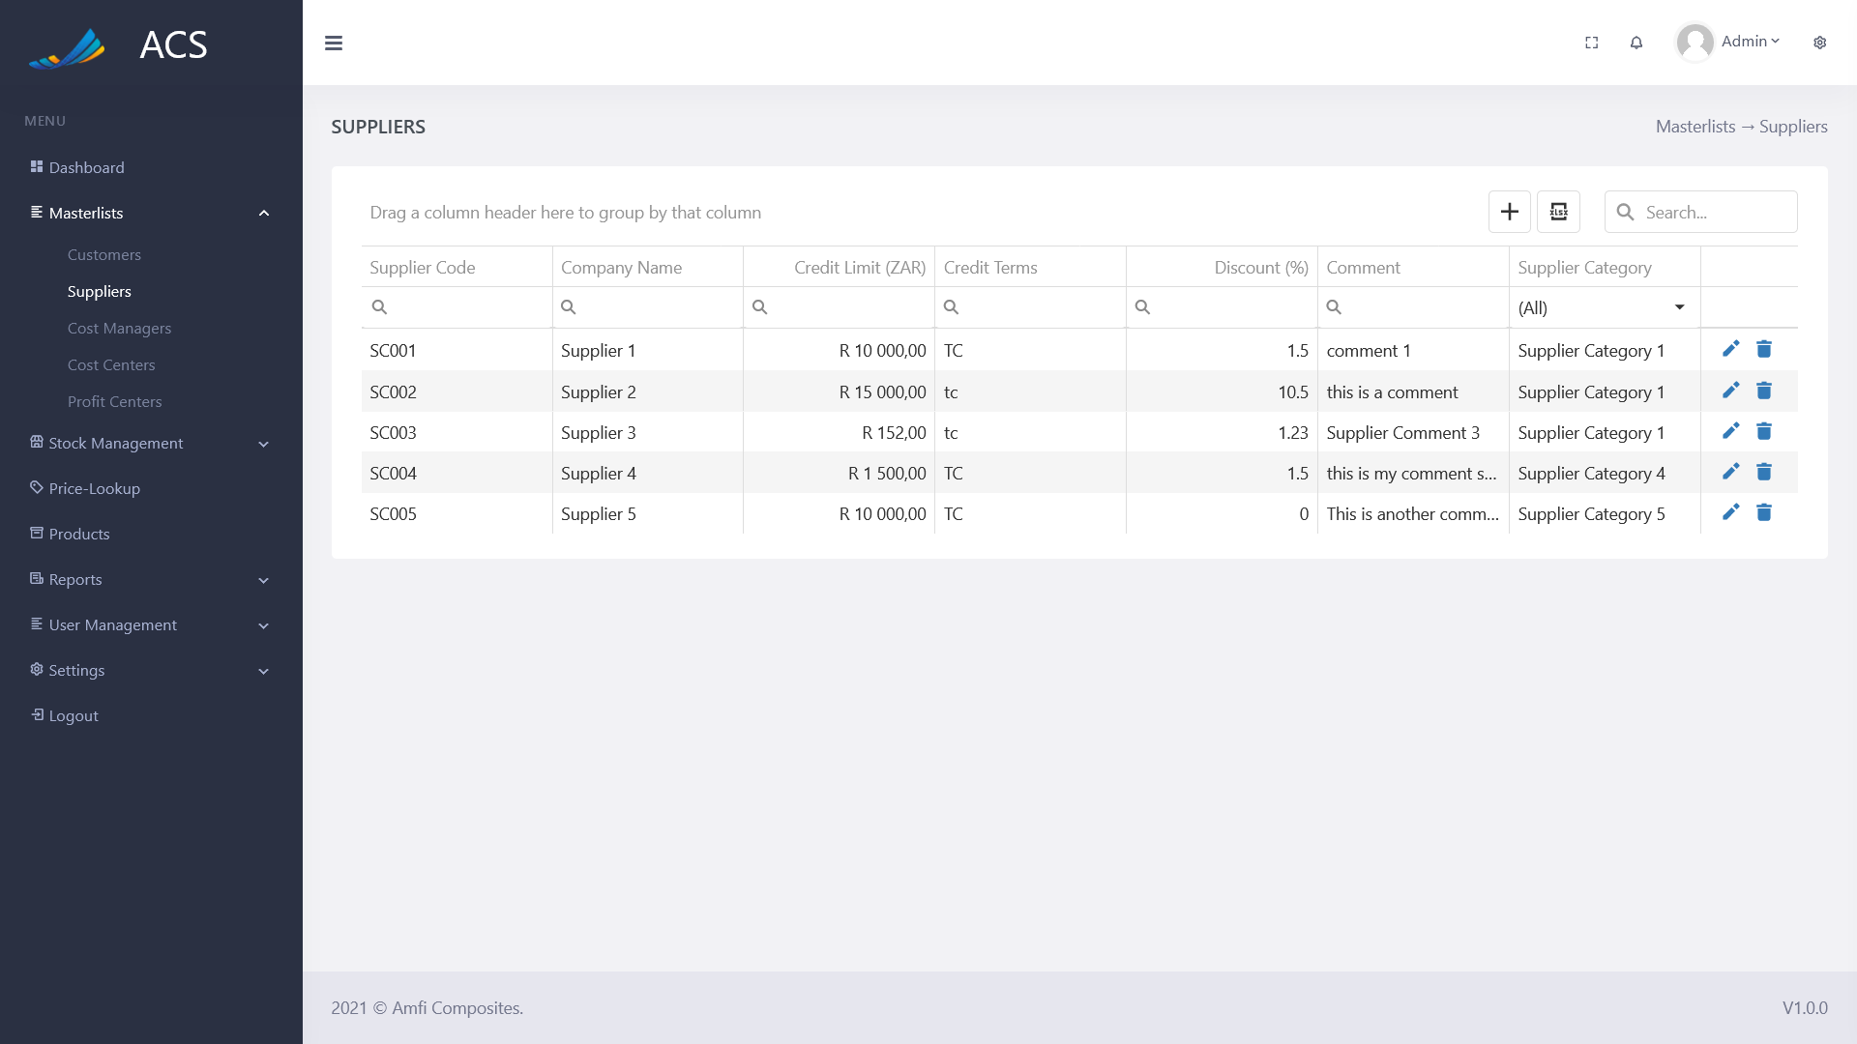

Figures 45: Supplier View

The user will be able to add a new supplier by pressing the plus icon button below.

**Image:**

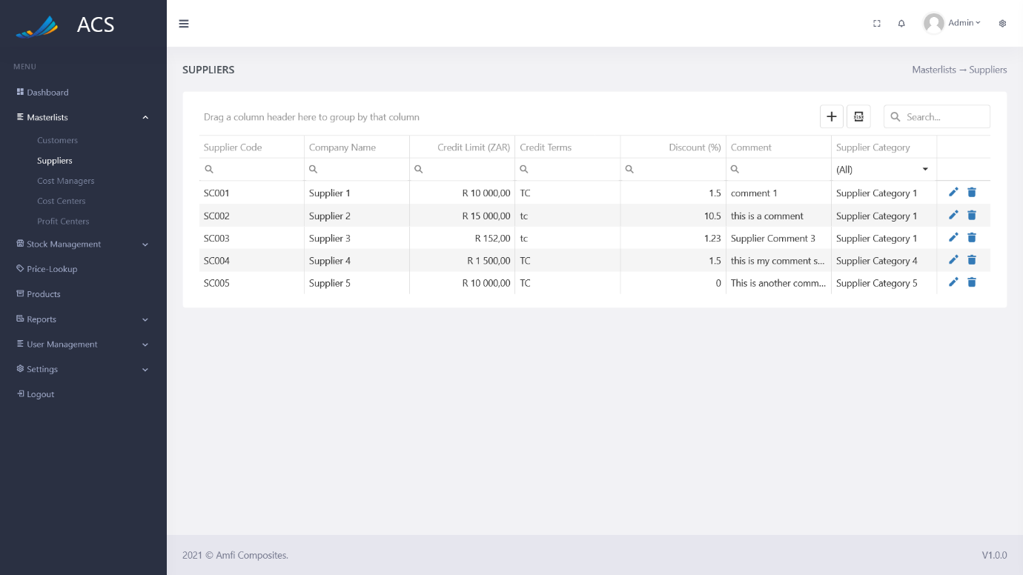

Figures 46: Supplier Add Button

A Supplier Information popup will appear, the user can fill in all the required fields (marked with a red *) and press the save button.

**Image:**

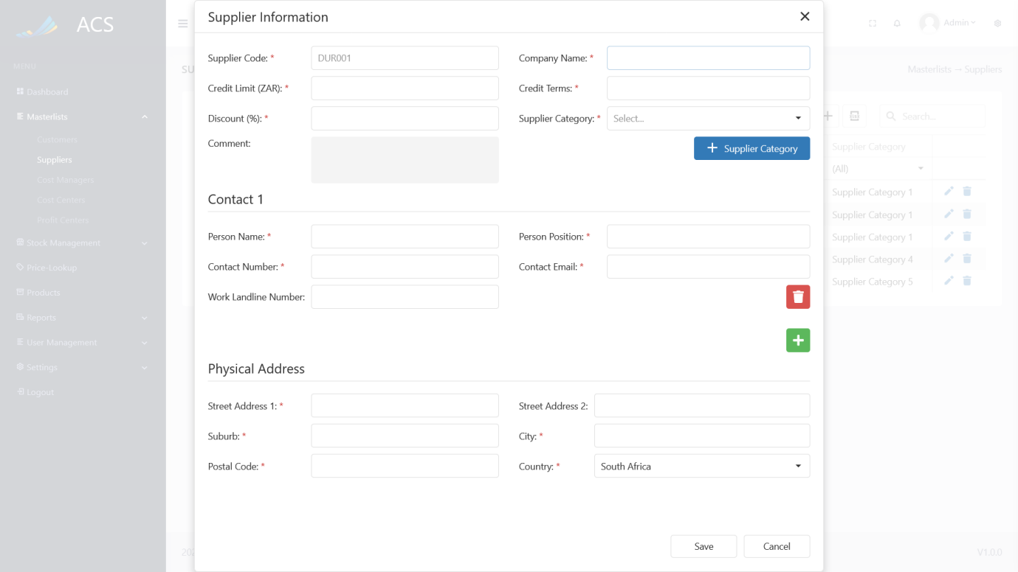

Figures 47: Supplier Add

A success message will appear at the bottom of the screen if a supplier was added successfully.

**Image:**

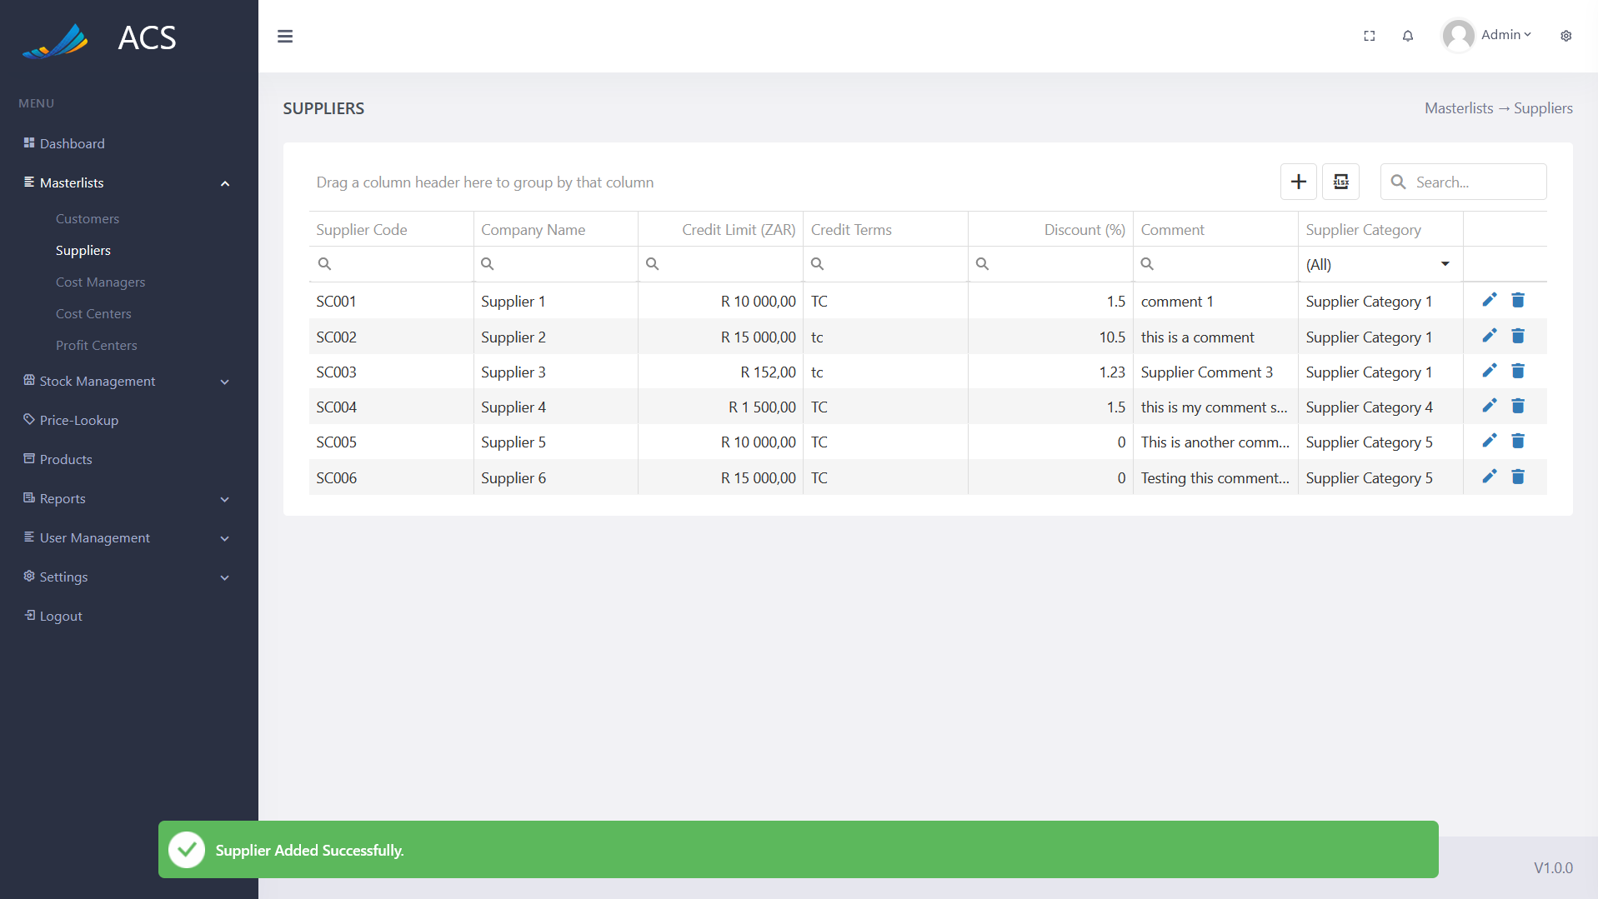

Figures 48: Supplier Added Successfully

If duplicate suppliers are added the system will block the request and send back an error message to the user to state the supplier already exists.

**Image:**

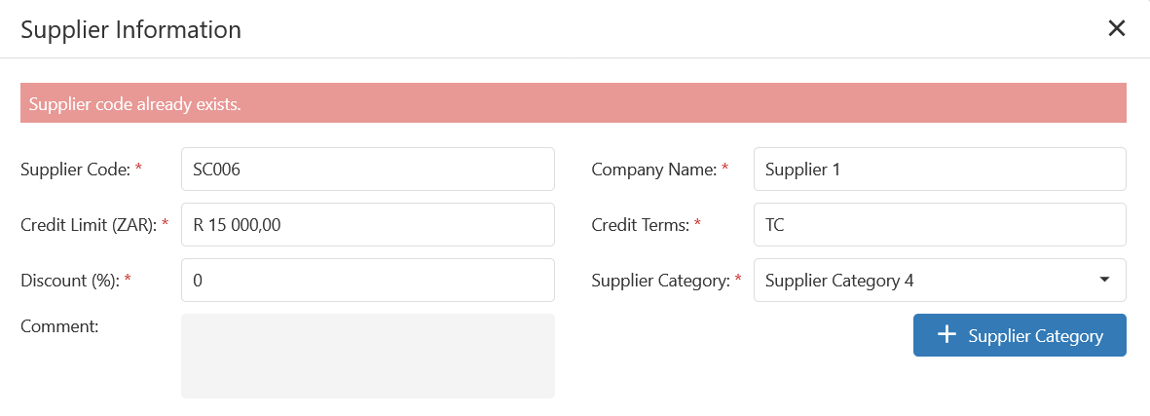

Figures 49: Adding duplicate suppliers

The user will be able to edit a supplier by pressing the pencil icon button on the record they wish to edit, see below.

**Image:**



Figures 50: Supplier View

The Supplier Information popup will appear with pre-populated data of the supplier, the user can fill in/change all the required fields (marked with a red *) and press the save button.

**Image:**

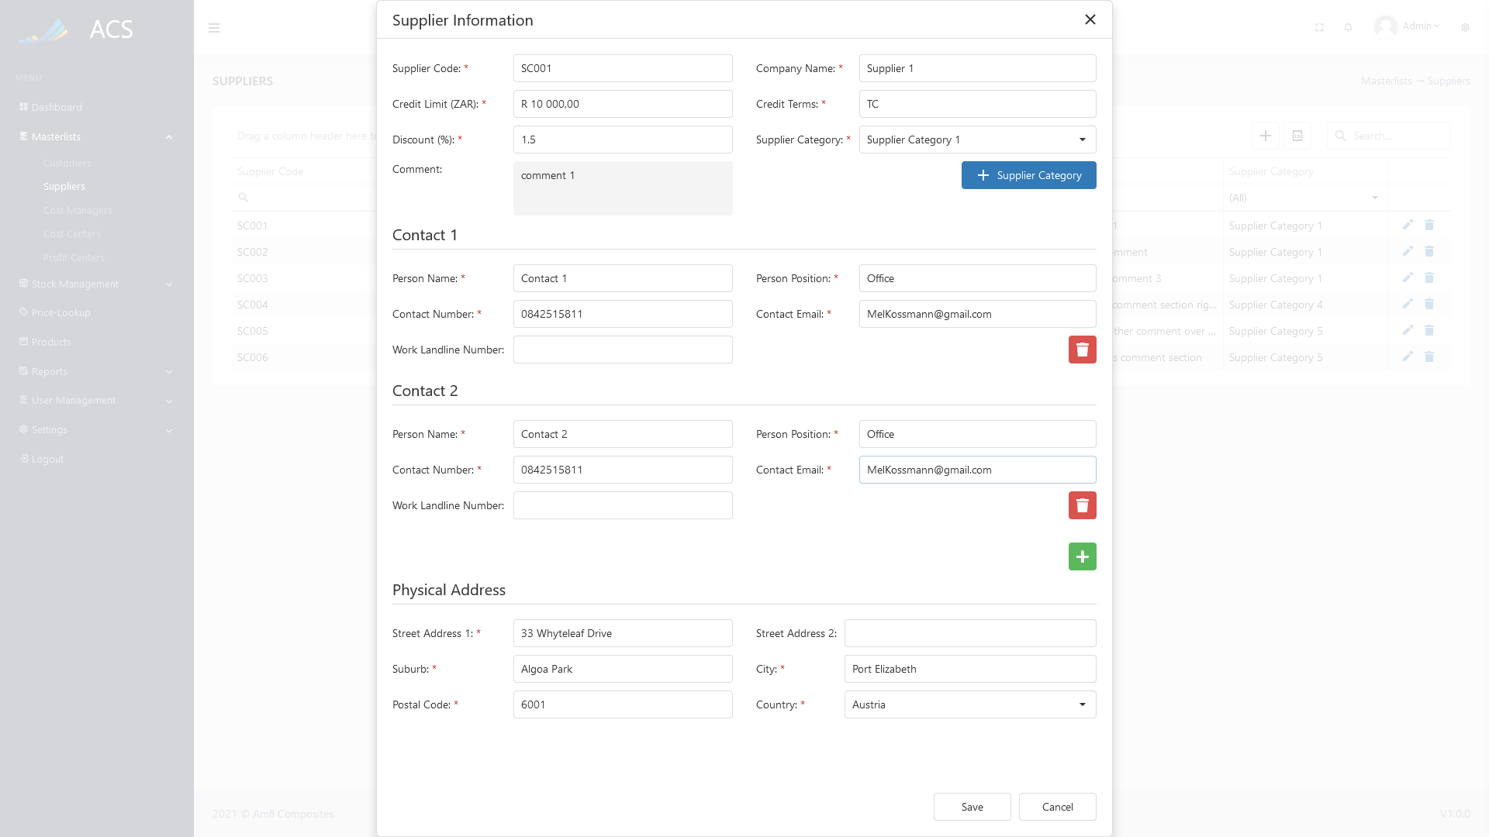

Figures 51: Supplier Edit

A success message will appear at the bottom of the screen if a supplier was updated successfully.

**Image:**

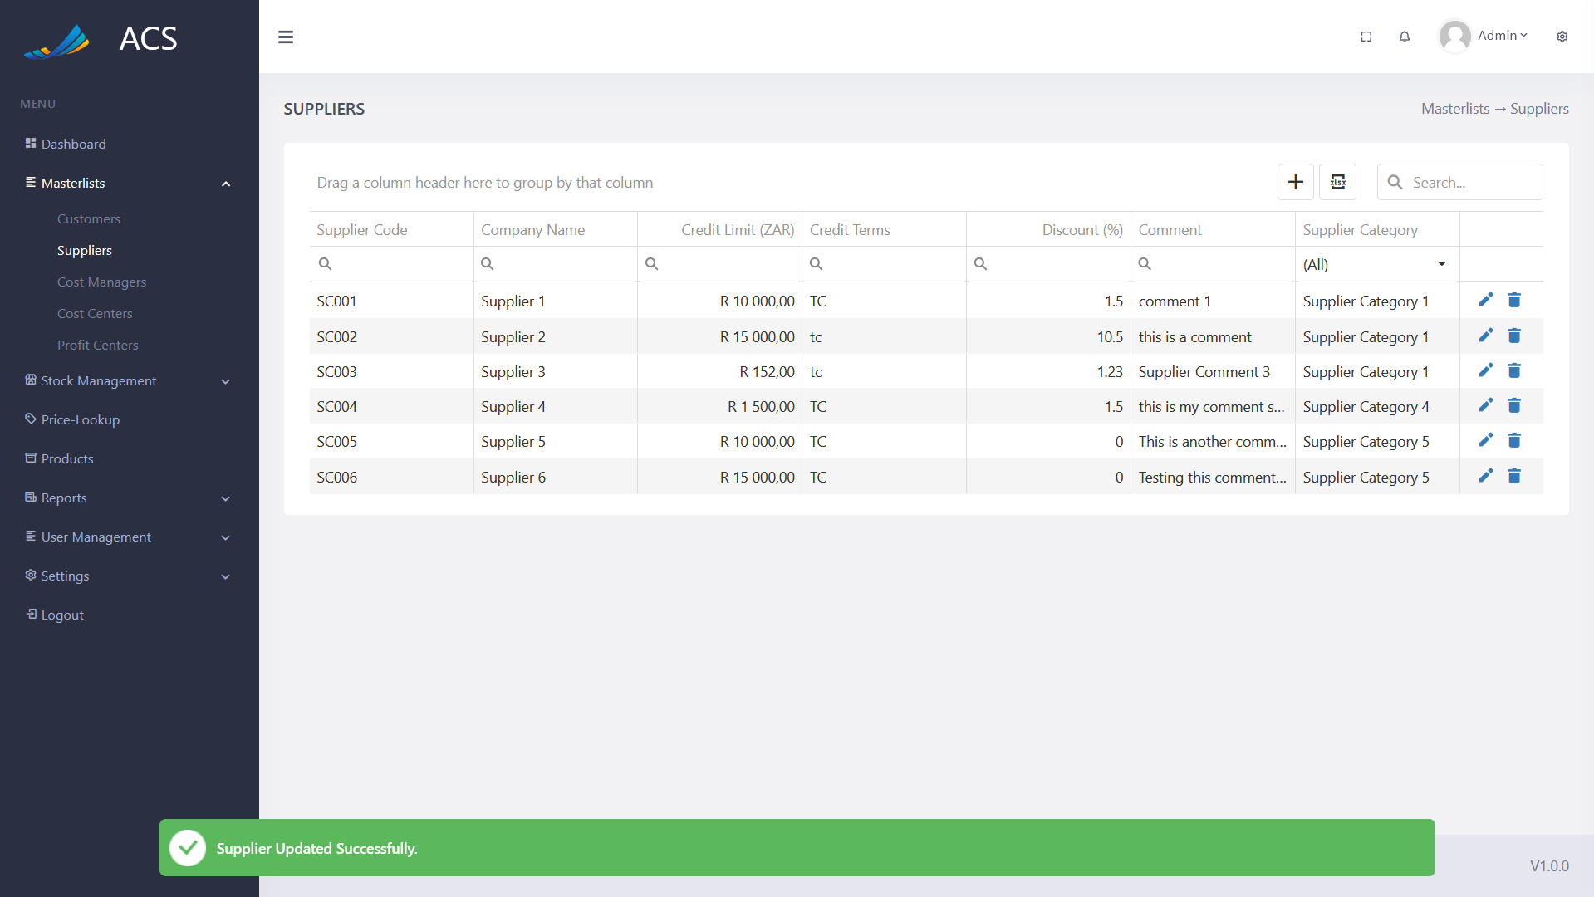

Figures 52: Supplier Edited Successfully

The user will be able to remove a supplier by pressing the trash icon button on the record they wish to remove, see below.

**Image:**



Figures 53: Supplier View

A confirmation popup will appear, press yes to continue OR no to cancel.

**Image:**

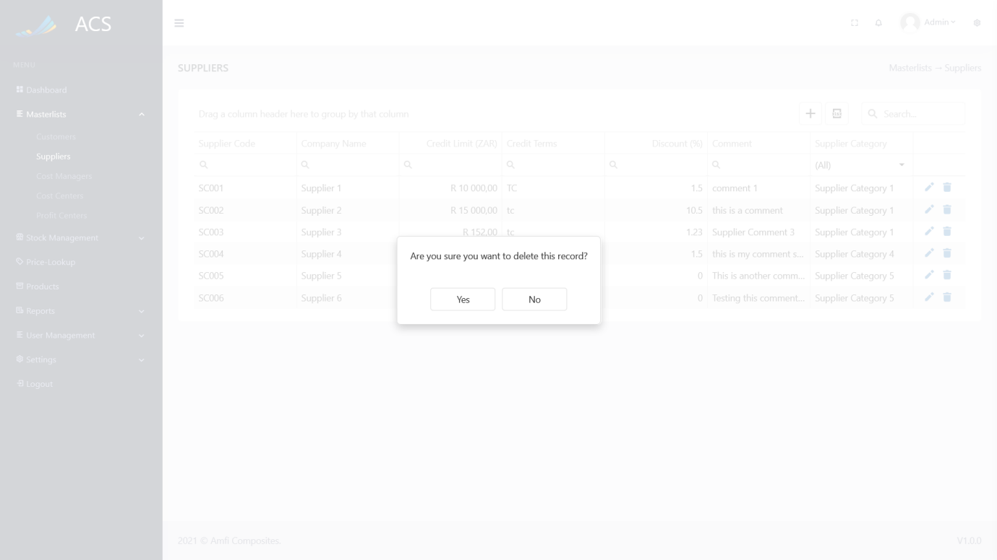

Figures 54: Supplier View

The system will display an error message if the user tries to delete a supplier that is linked to a Price in the Price Lookup.

**Image:**

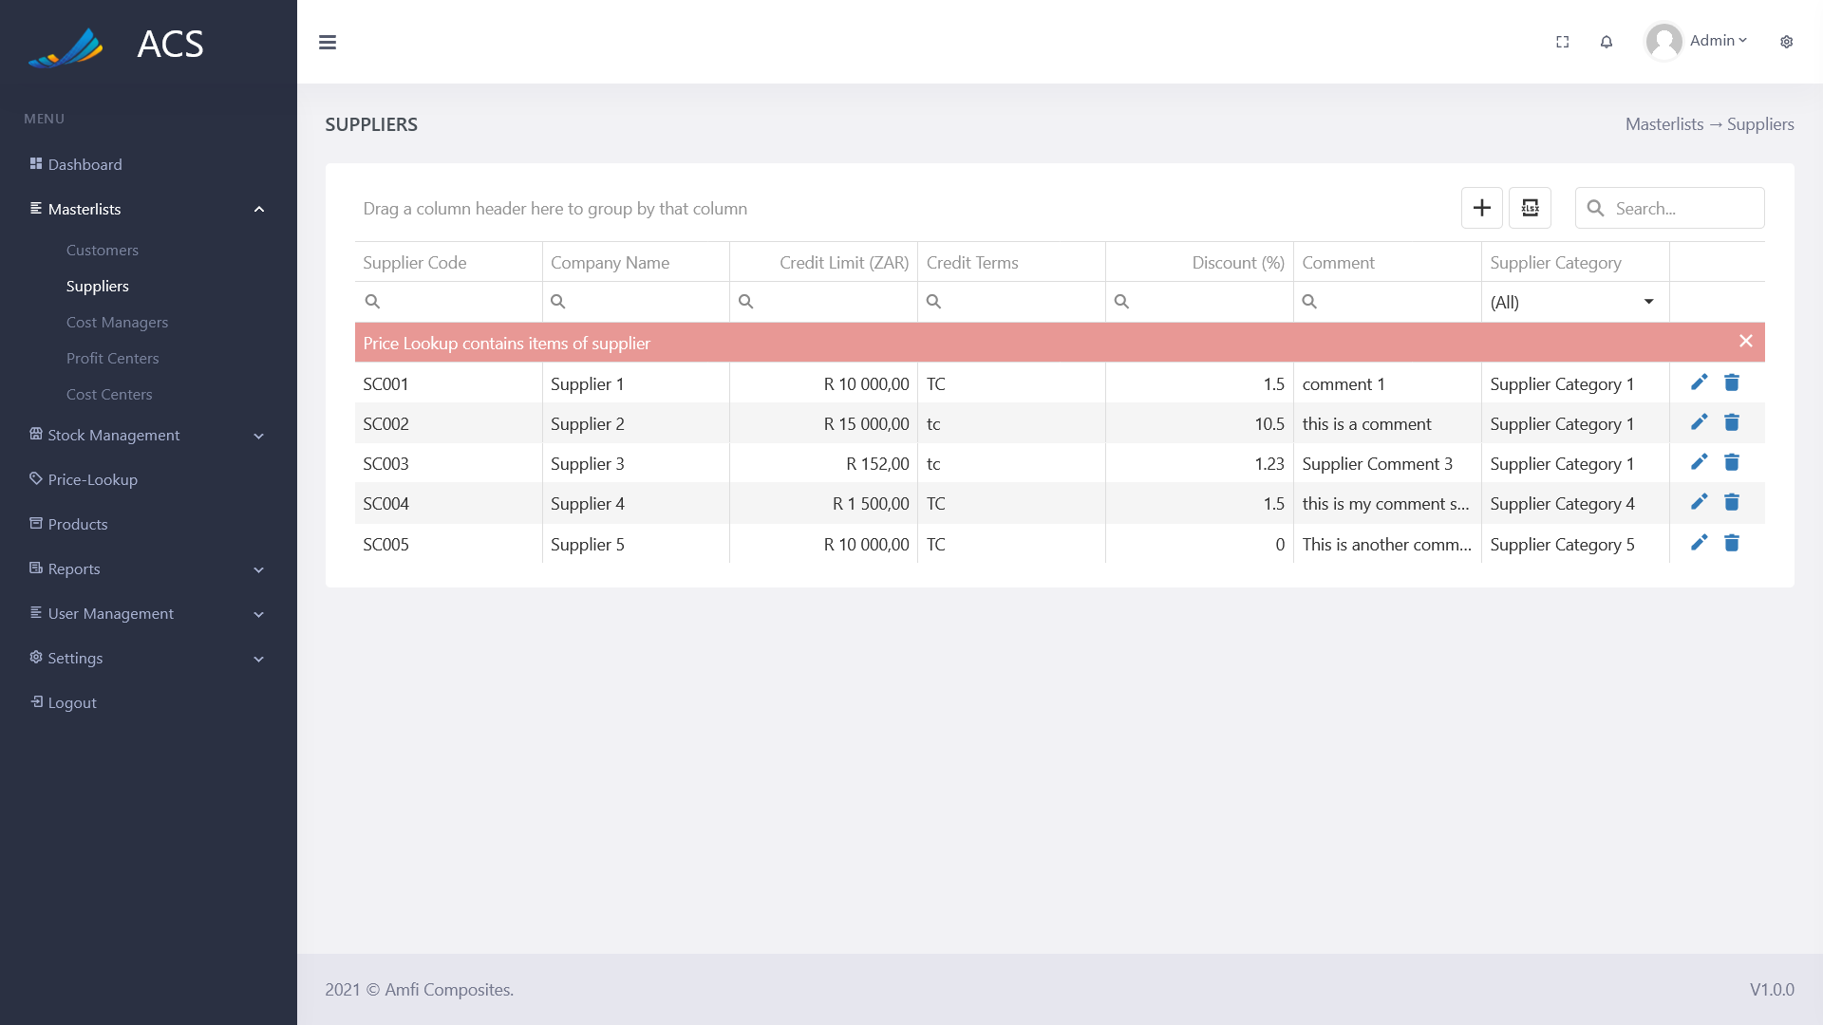

Figures 55: Error

**Image:**

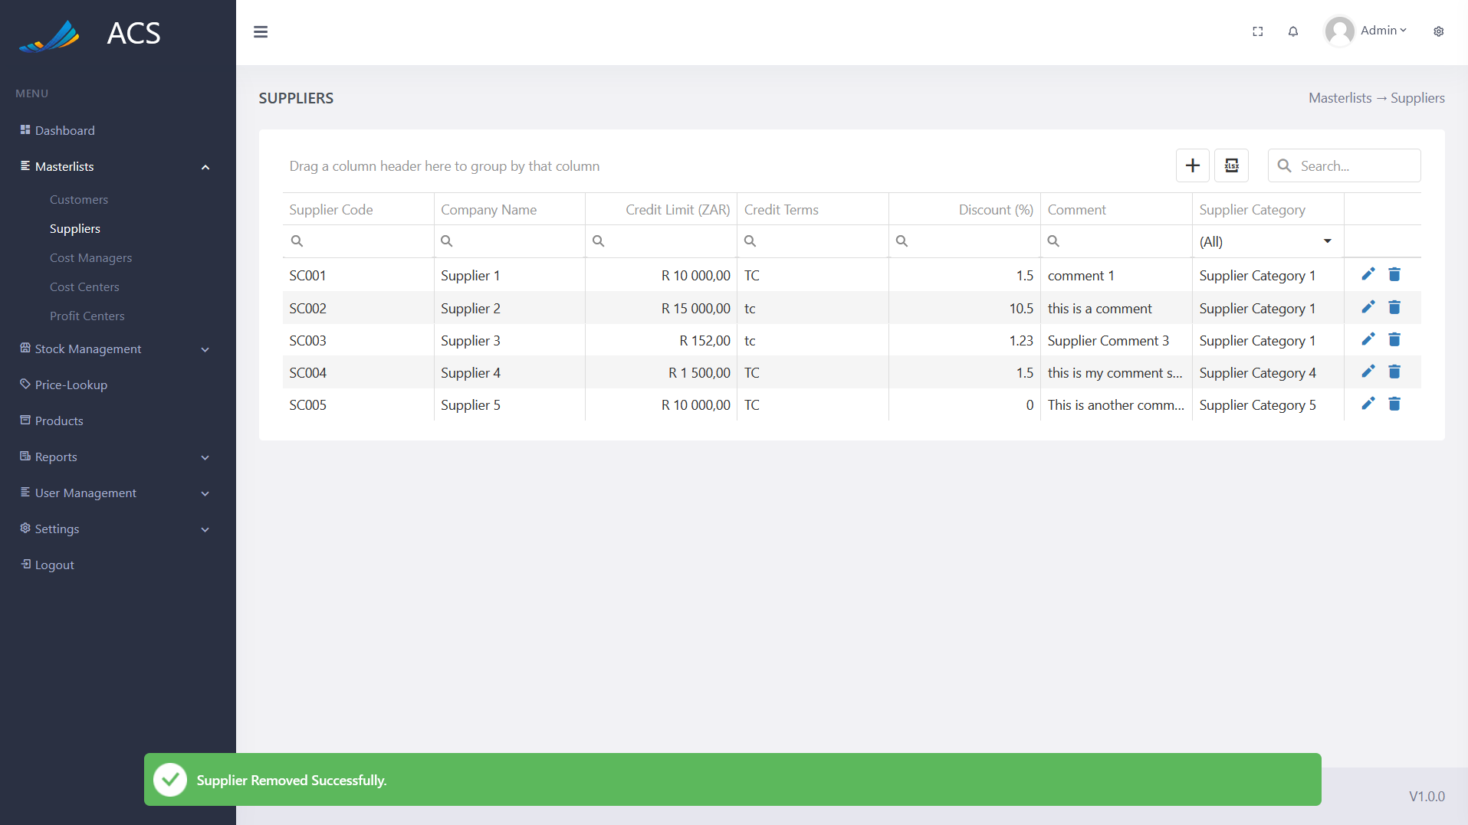

Figures 56: Supplier Removed Successfully

#### Cost Managers

The user will be able to view, add, edit and remove cost managers. The user can capture Employee Position and Employee. Employee Positions can be managed on the following page: *Settings -> System Config -> Employee Position Tab*

The user dropdown will automatically be populated with the active users entered on the following page:

*User Management -> Users*

**Image:**

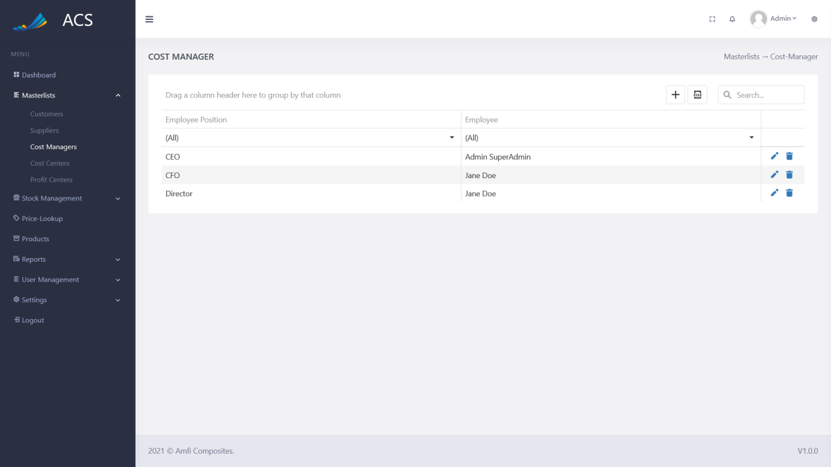

Figures 57: Cost Manager View

The user will be able to add a new cost manager by pressing the plus icon button below.

**Image:**

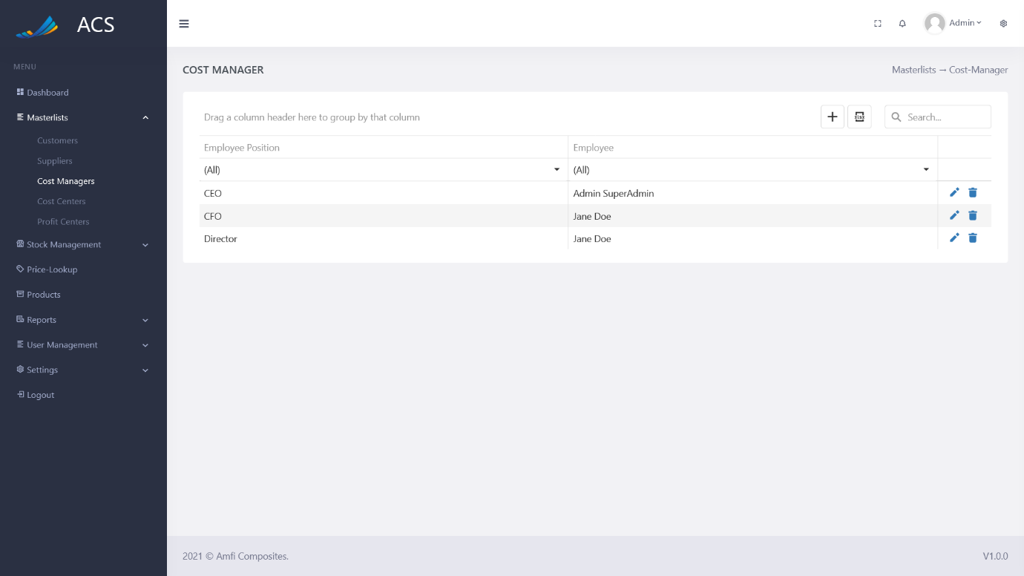

Figures 58: Cost Manager Add Button

A cost manager popup will appear, the user can fill in all the required fields (marked with a red *) and press the save button.

**Image:**

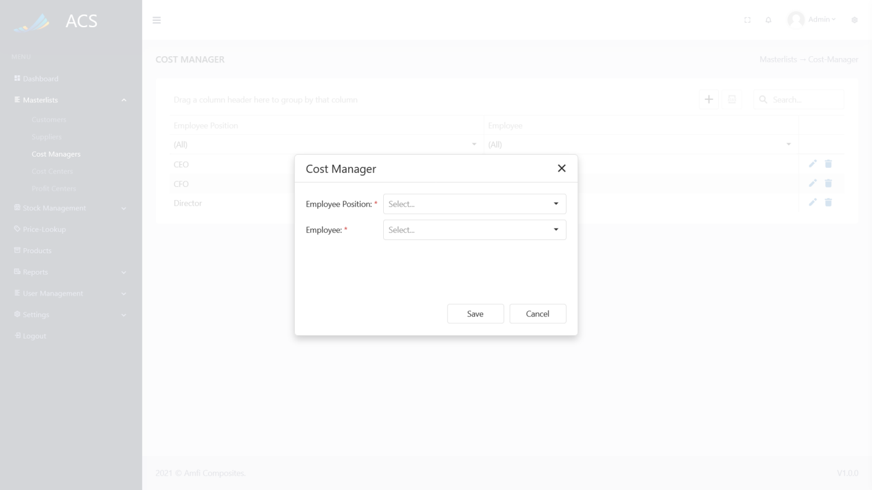

Figures 59: Cost Manager Add

A success message will appear at the bottom of the screen if a cost manager was added successfully.

**Image:**

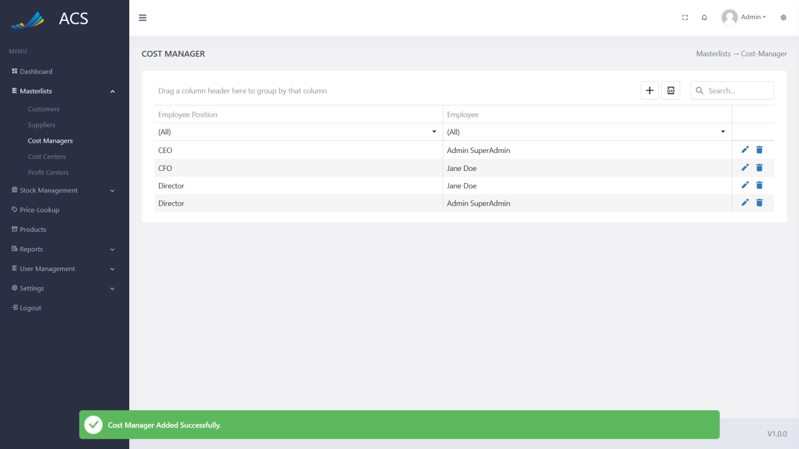

Figures 60: Cost Manager Added Successfully

If duplicate cost managers (Employee Position AND Employee) are added the system will block the request and send back an error message to the user to state the cost manager already exists.

**Image:**

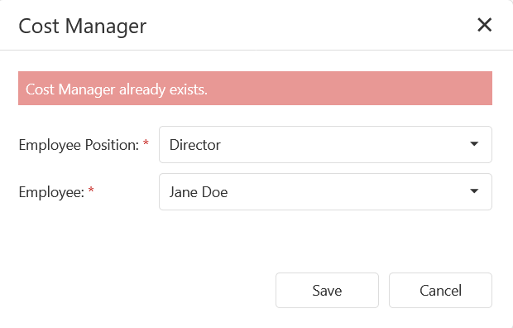

Figures 61: Adding duplicate Cost Manager

The user will be able to edit a cost manager by pressing the pencil icon button on the record they wish to edit, see below.

**Image:**



Figures 62: Cost Manager View

The cost manager popup will appear with pre-populated data of the cost manager, the user can fill in/change all the required fields (marked with a red *) and press the save button.

**Image:**

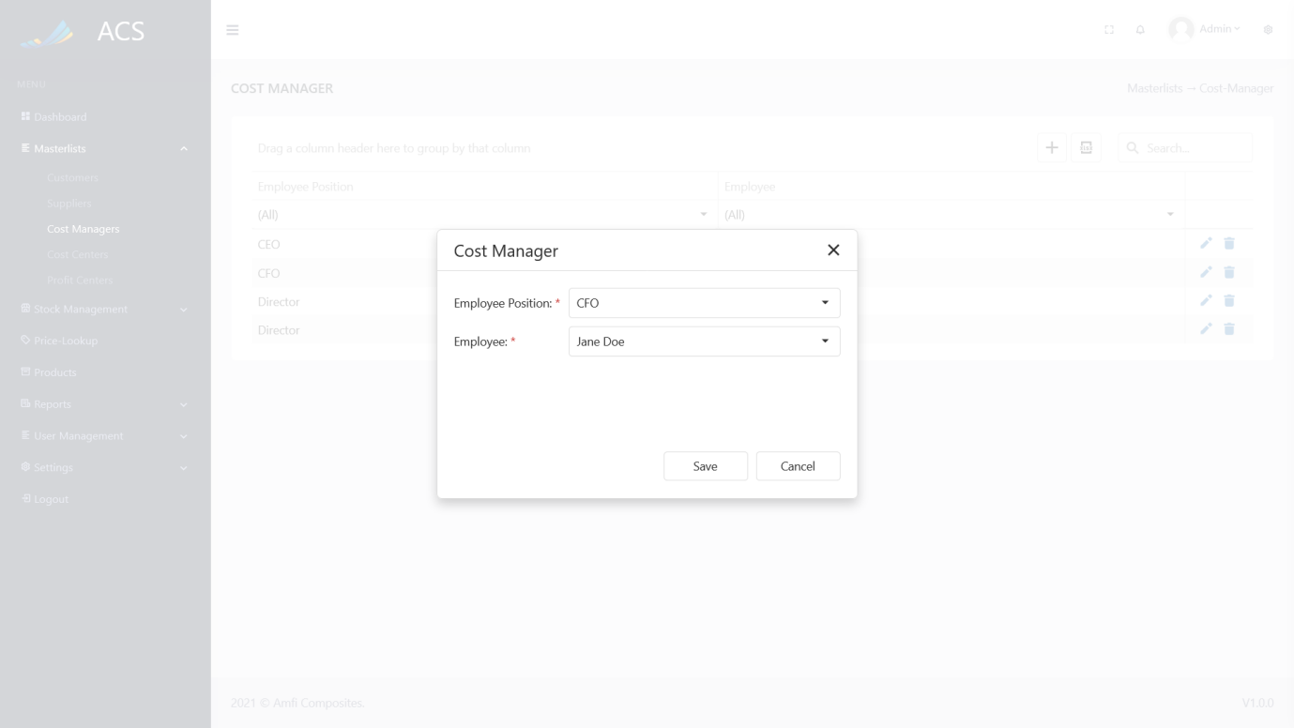

Figures 63: Cost Manager Edit

A success message will appear at the bottom of the screen if a cost manager was updated successfully.

**Image:**

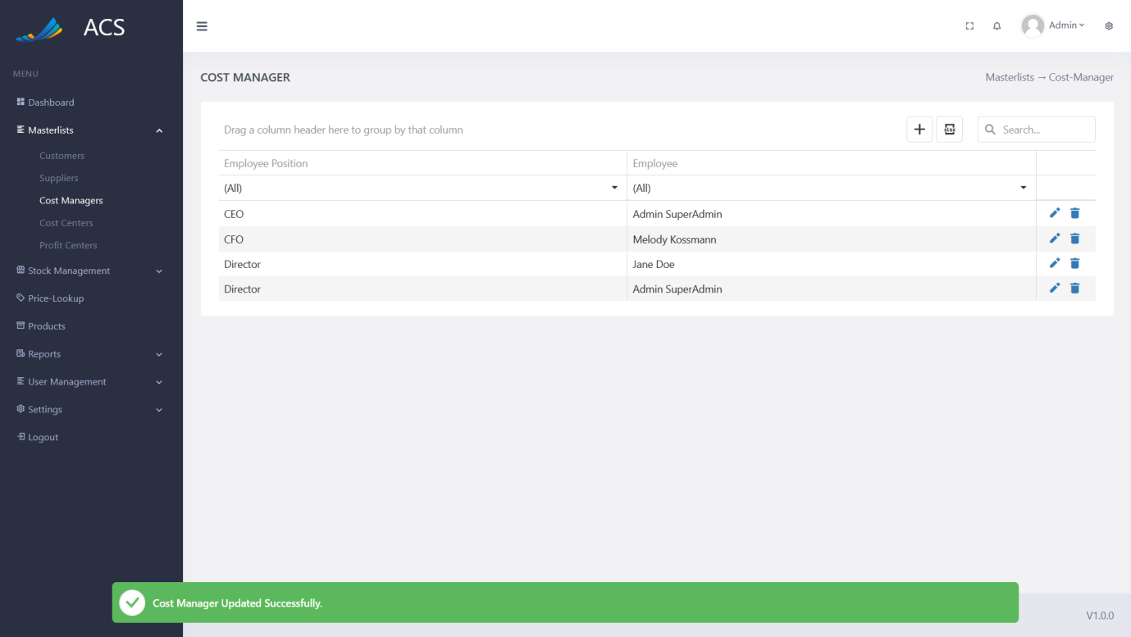

Figures 64: Cost Manager Edited Successfully

The user will be able to remove a cost manager by pressing the trash icon button on the record they wish to remove, see below.

**Image:**



Figures 65: Cost Manager View

A confirmation popup will appear, press yes to continue OR no to cancel.

**Image:**

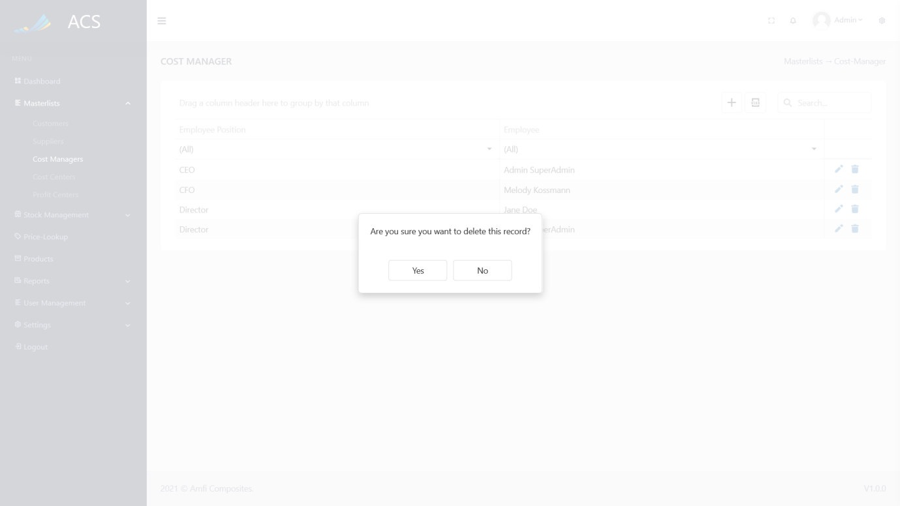

Figures 66: Cost Manager View

The system will display an error message if the user tries to delete a cost manager that is linked to a Cost Center.

**Image:**

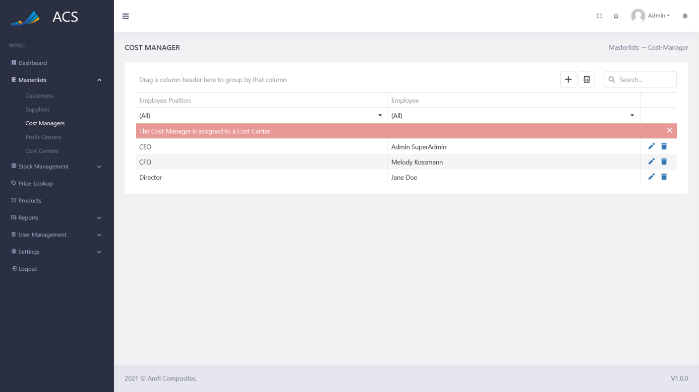

Figures 67: Error

**Image:**

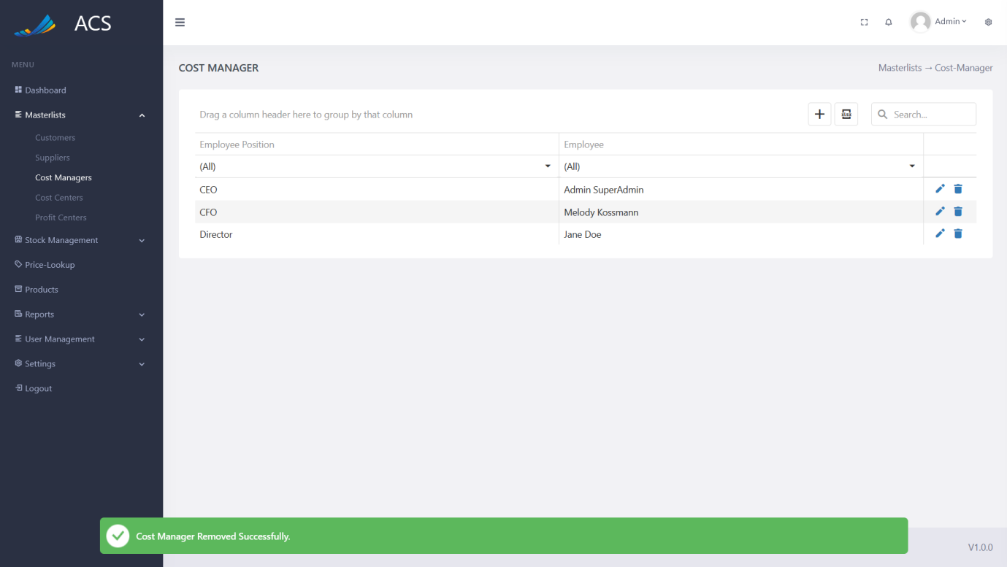

Figures 68: Cost Manager Removed Successfully

#### Cost Centers

The user will be able to view, add, edit and remove cost centers. The user can capture Name, Description, Cost Manager, and Profit Center. The Cost Manager and Profit Center fields are auto-generated dropdowns. Cost Managers can be managed on the following pages: *Masterlist -> Cost Managers*

Profit Centers can be managed on the following page: *Masterlist -> Profit Centers*

**Image:**

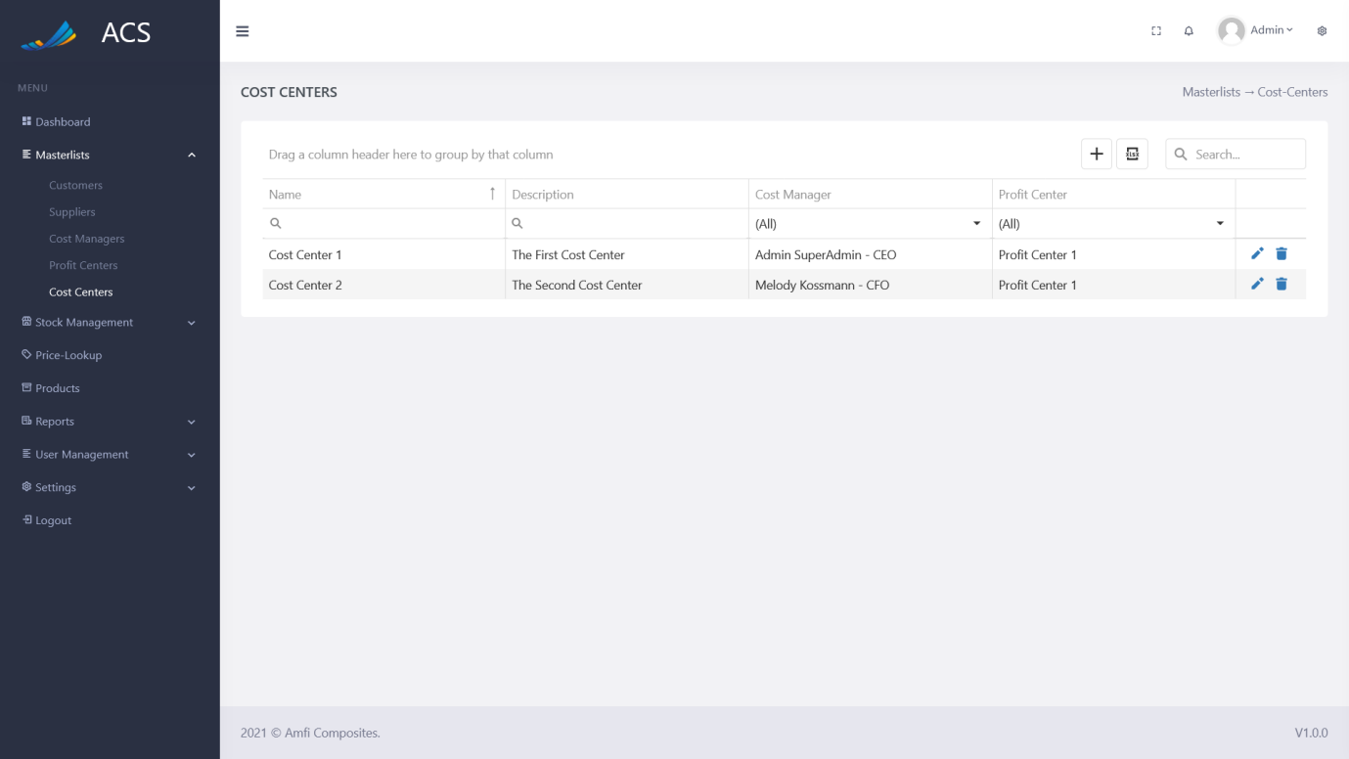

Figures 69: Cost Centers View

The user will be able to add a new Cost Centers by pressing the plus icon button below.

**Image:**

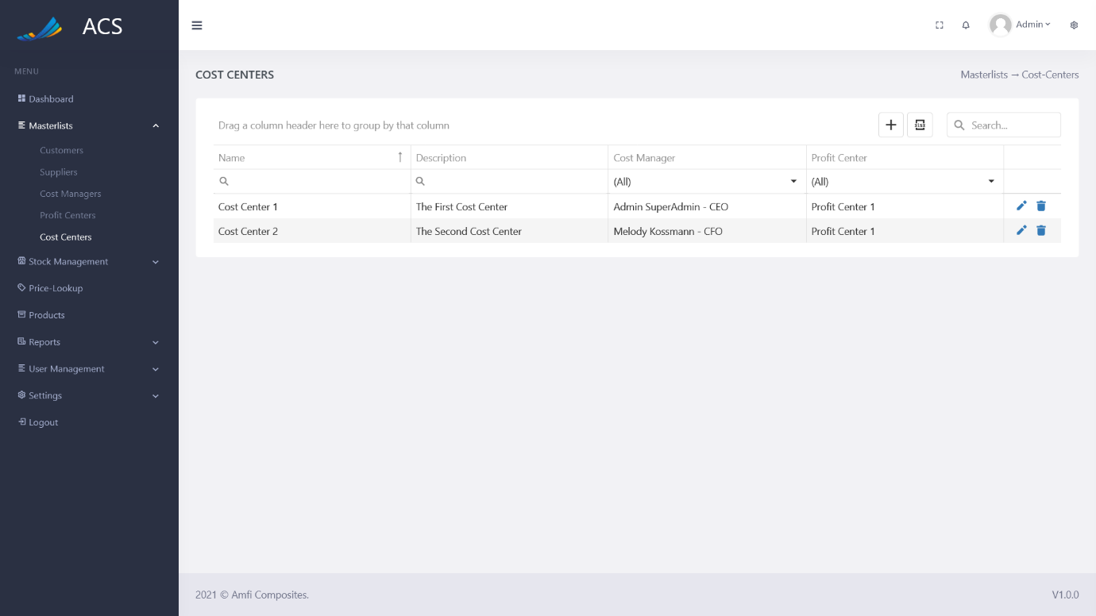

Figures 70: Cost Centers Add Button

A Cost Center popup will appear, the user can fill in all the required fields (marked with a red *) and press the save button.

**Image:**

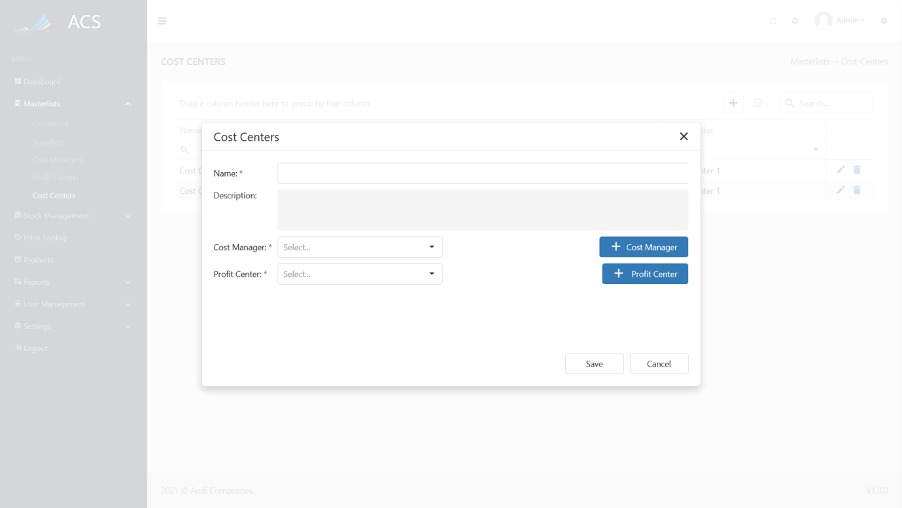

Figures 71: Cost Center Add

The user can enter a new name for the cost center or the user can select one of the already added cost center names.

**Image:**

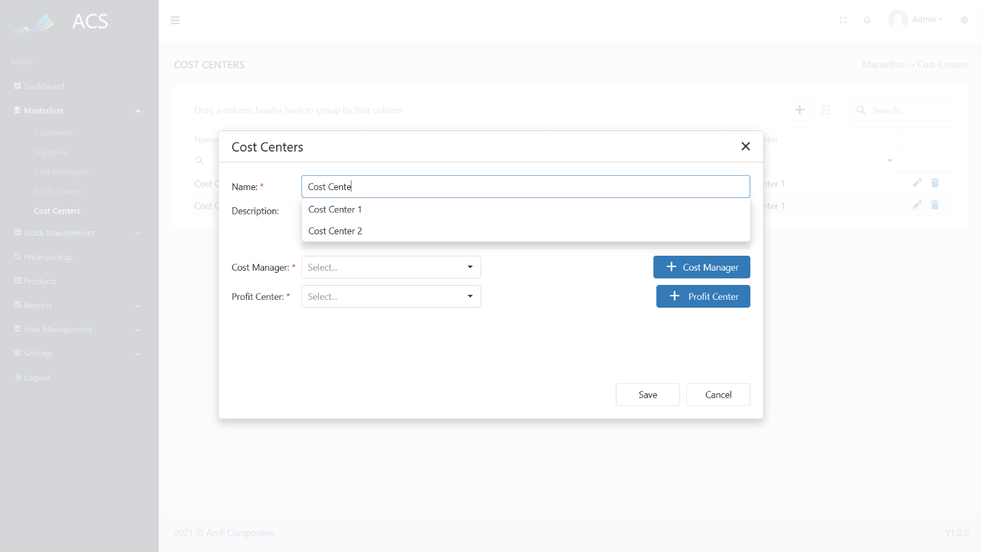

Figures 72: Adding Cost Center Names

A success message will appear at the bottom of the screen if a Cost Center was added successfully.

**Image:**

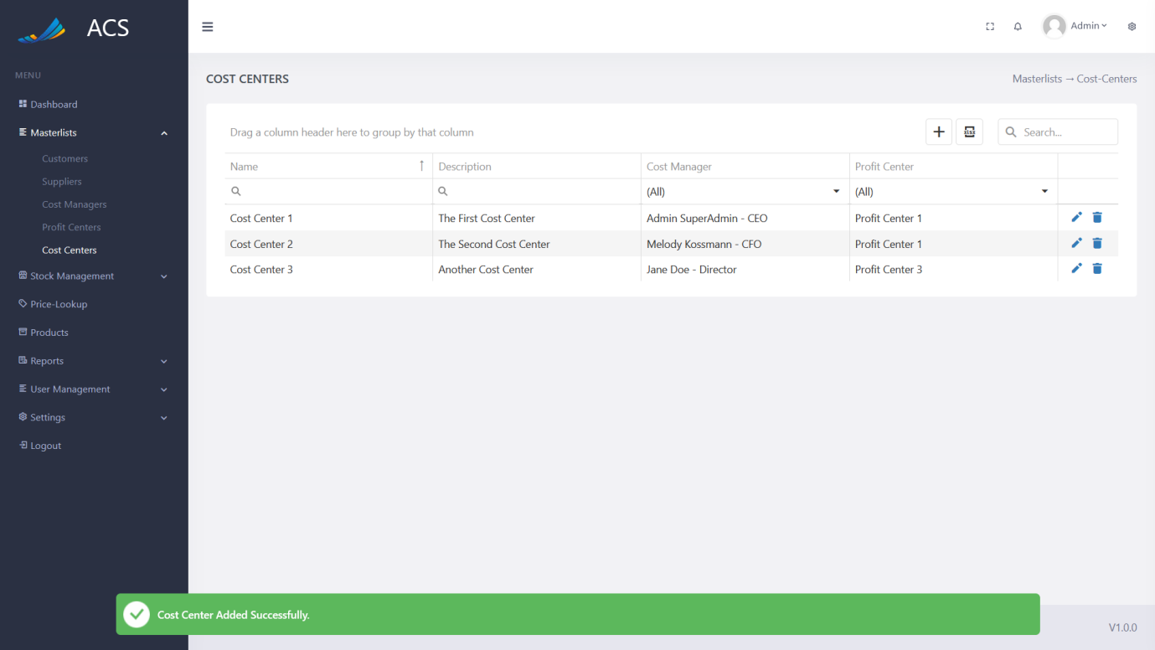

Figures 73: Cost Center Added Successfully

If duplicate cost centers (Name AND Cost Manager AND Profit Center) are added the system will block the request and send back an error message to the user to state the cost center already exists.

**Image:**

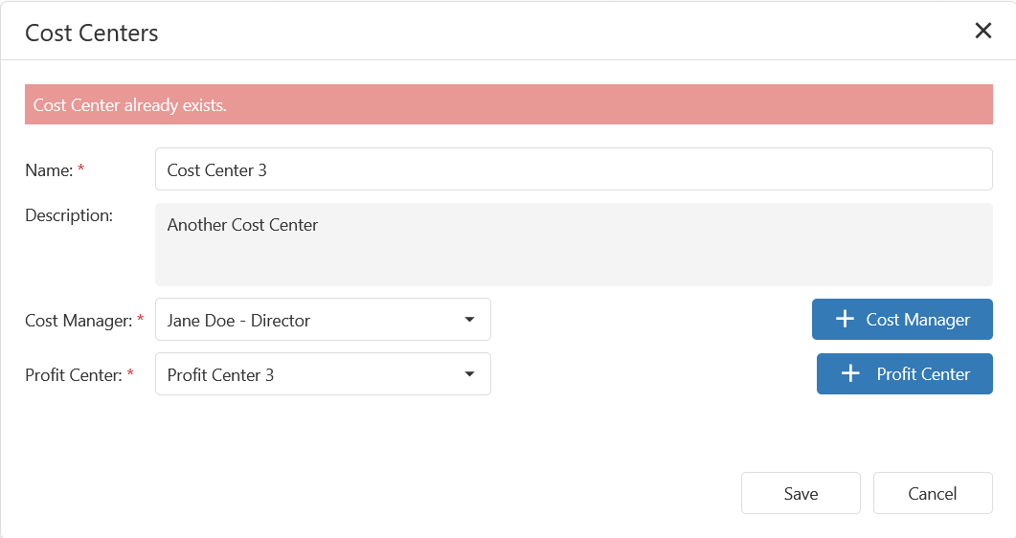

Figures 74: Adding duplicate cost centers

The user will be able to edit a cost center by pressing the pencil icon button on the record they wish to edit, see below.

**Image:**



Figures 75: Cost Center View

The Cost Center popup will appear with pre-populated data of the cost center, the user can fill in/change all the required fields (marked with a red *) and press the save button.

**Image:**

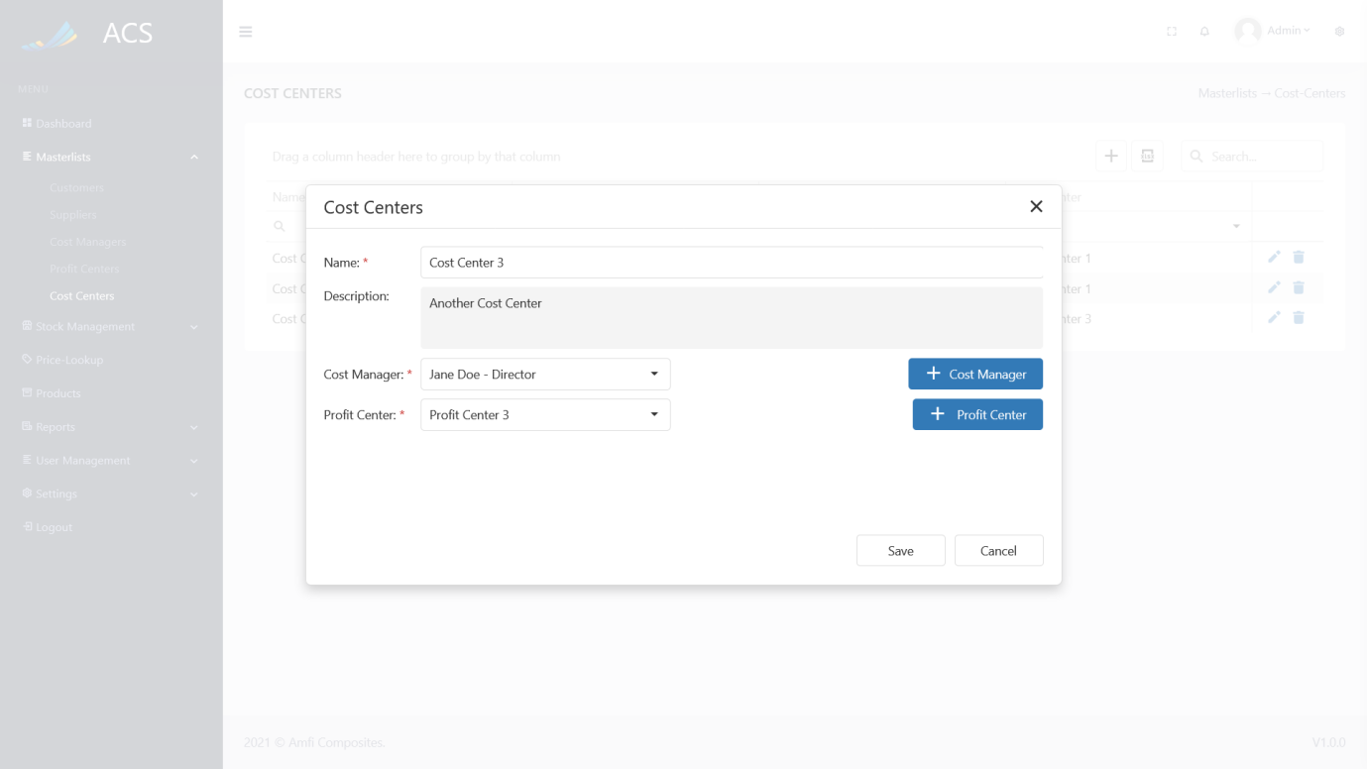

Figures 76: Cost Center Edit

A success message will appear at the bottom of the screen if a cost center was updated successfully.

**Image:**

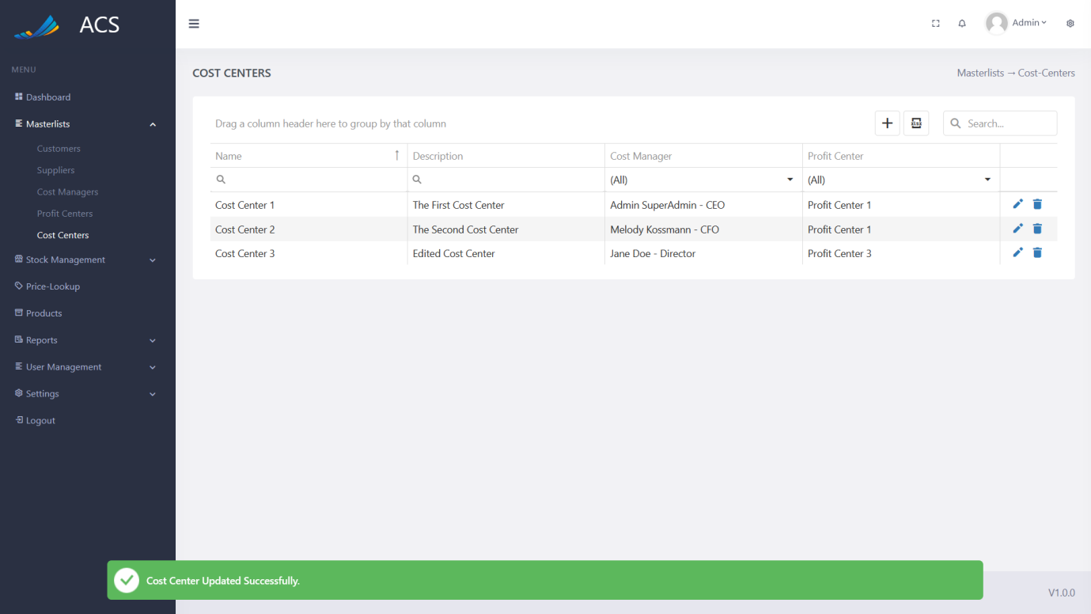

Figures 77: Cost Center Edited Successfully

The user will be able to remove a cost center by pressing the trash icon button on the record they wish to remove, see below.

**Image:**

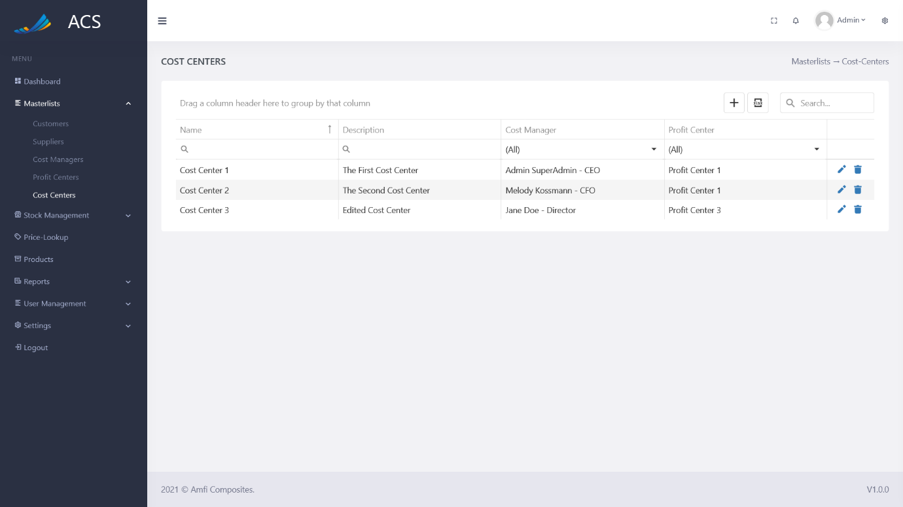

Figures 78: Cost Center View

A confirmation popup will appear, press yes to continue OR no to cancel.

**Image:**

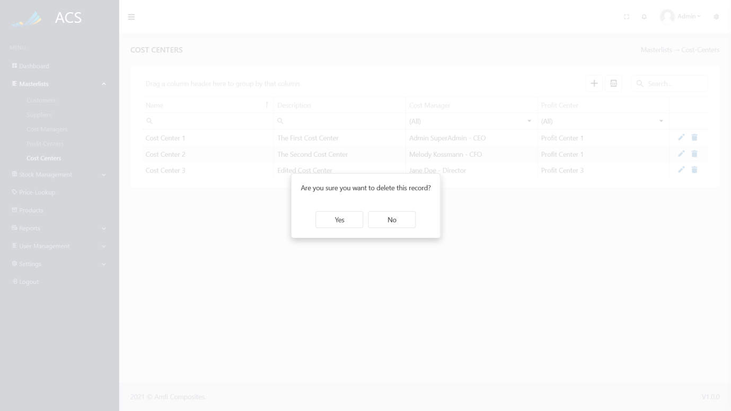

Figures 79: Cost Center View

The system will display an error message if the user tries to delete a cost center that is linked to a Product.

**Image:**

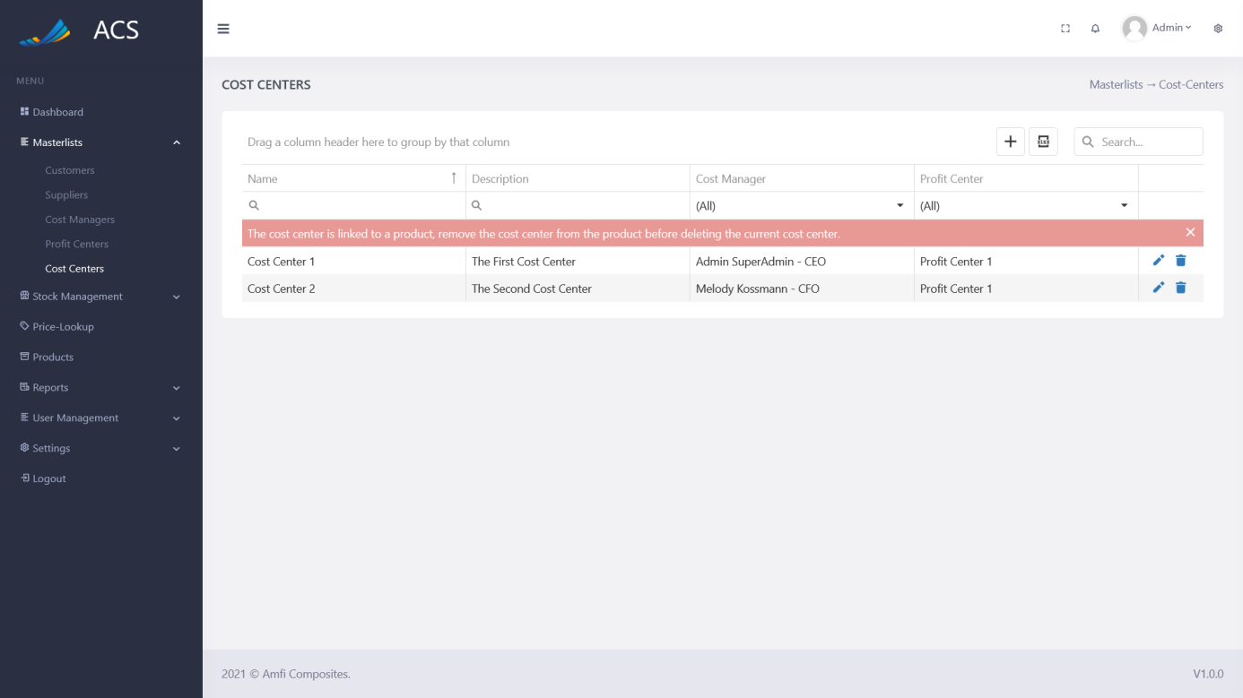

Figures 80: Error

**Image:**

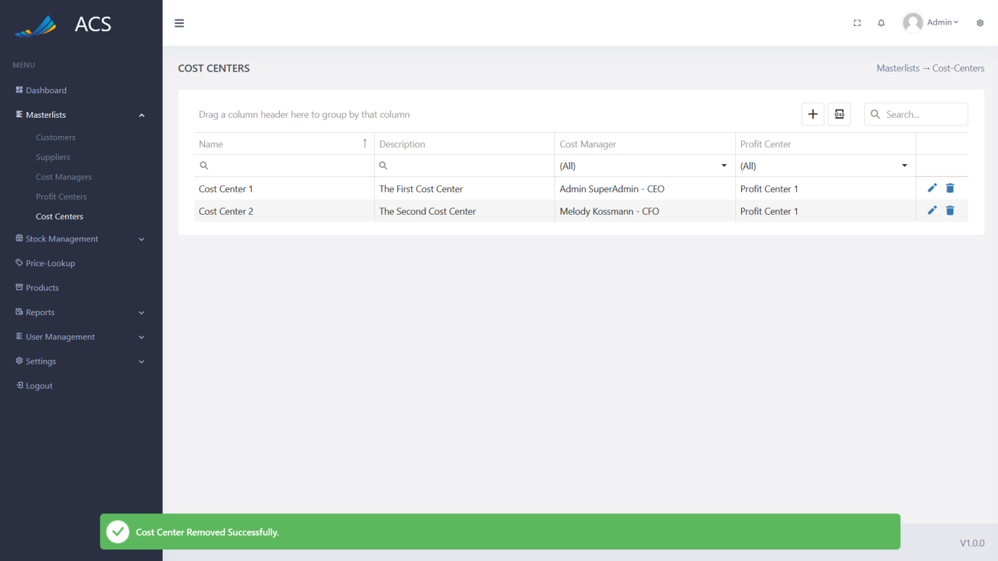

Figures 81: Cost Center Removed Successfully

#### Profit Centers

The user will be able to view, add, edit and remove profit centers. The user can capture Name, Description, Profit Center Color.

**Image:**

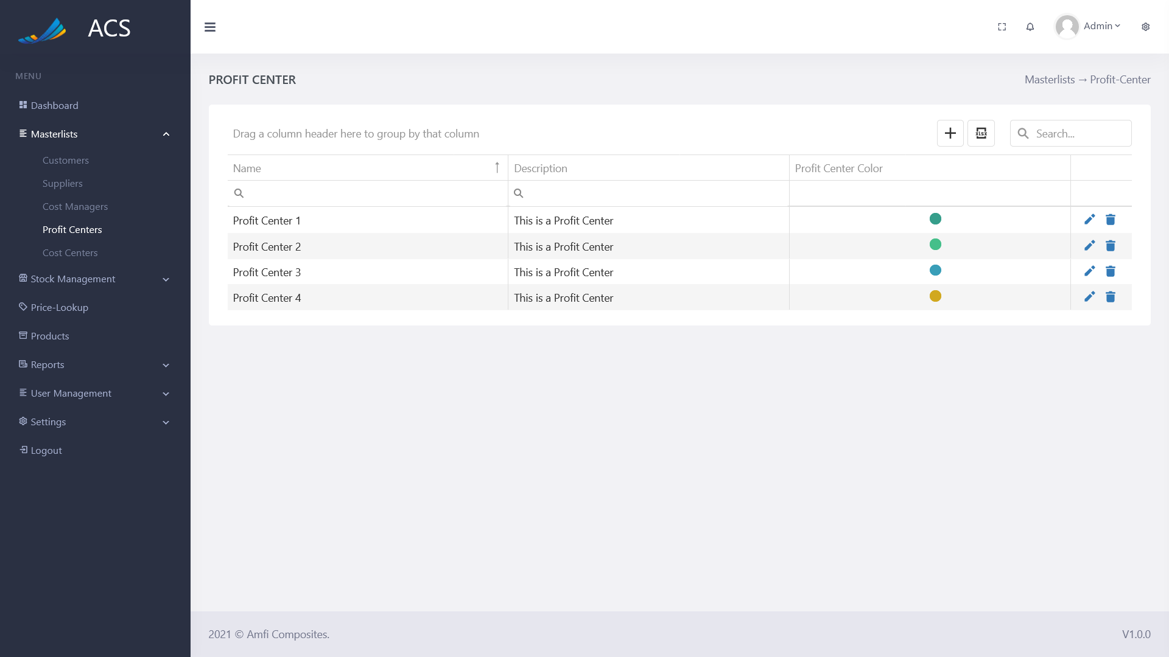

Figures 82: Profit Centers View

The user will be able to add a new Profit Center by pressing the plus icon button below.

**Image:**



Figures 83: Profit Centers Add Button

A Profit Center popup will appear, the user can fill in all the required fields (marked with a red *) and press the save button.

**Image:**

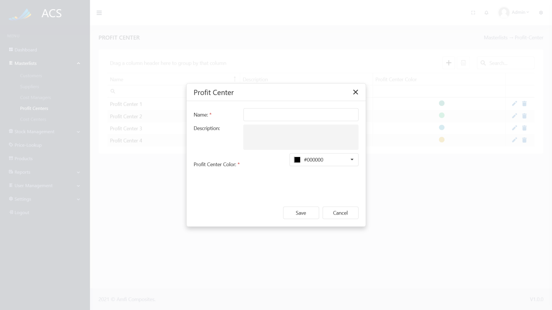

Figures 84: Profit Center Add

The user can choose a profit center color by dragging the mouse over the color pallet and pressing apply.

**Image:**

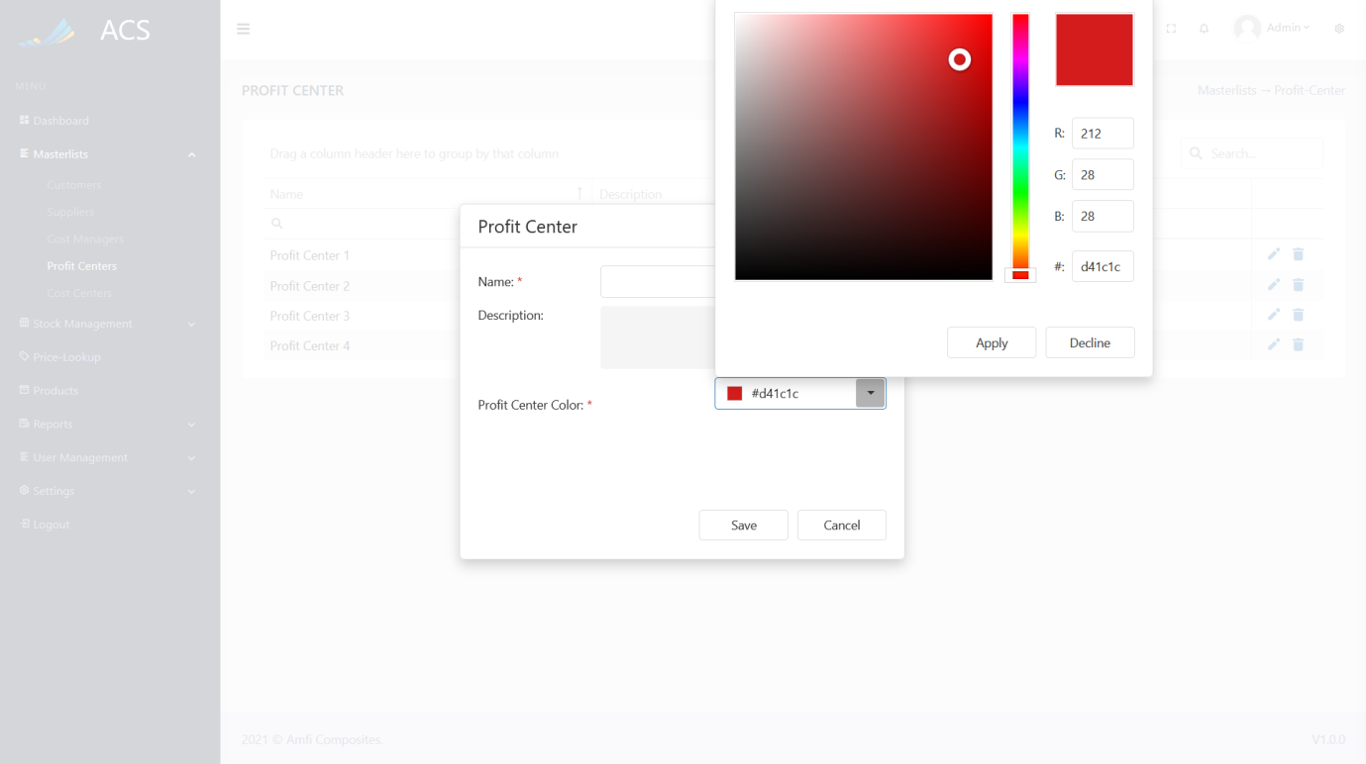

Figures 85: Profit Center Color Picking

A success message will appear at the bottom of the screen if a Profit Center was added successfully.

**Image:**

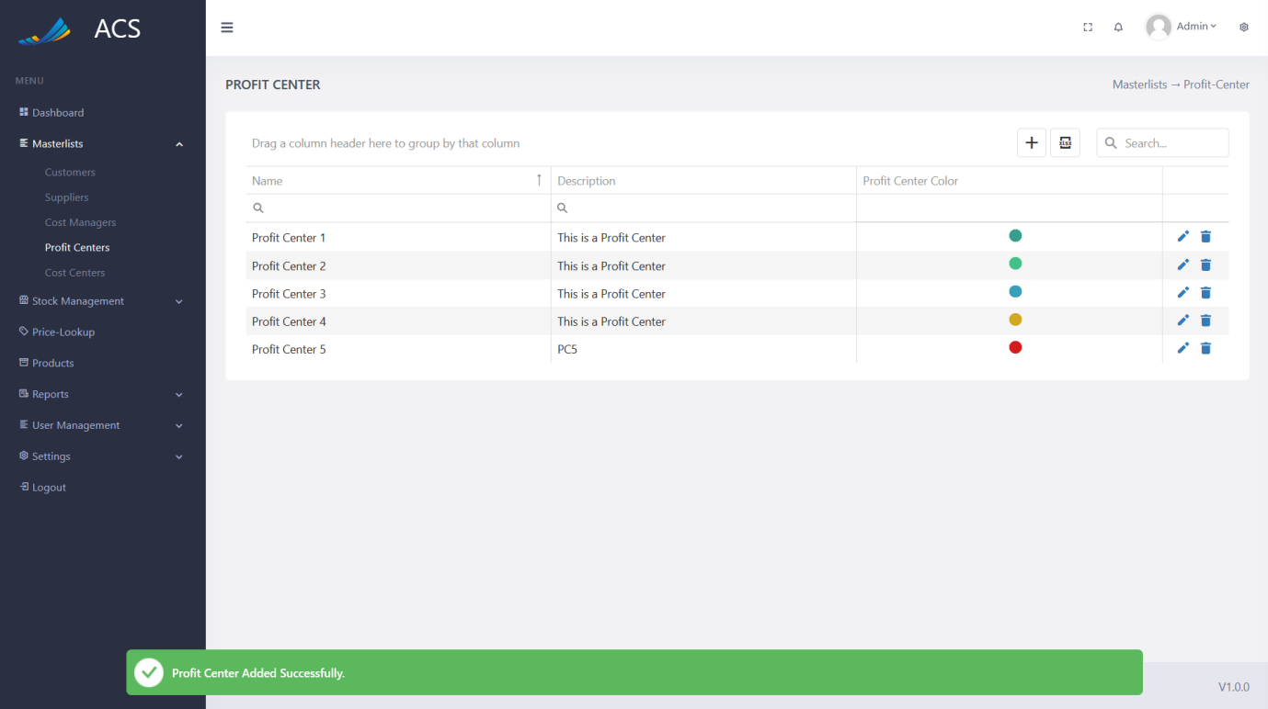

Figures 86: Profit Center Added Successfully

If duplicate profit centers (Name AND Profit Center Color) are added the system will block the request and send back an error message to the user to state the profit center already exists.

**Image:**

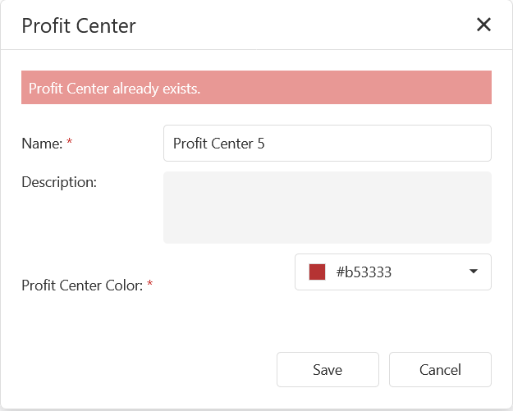

Figures 87: Adding duplicate profit centers

The user will be able to edit a profit center by pressing the pencil icon button on the record they wish to edit, see below.

**Image:**

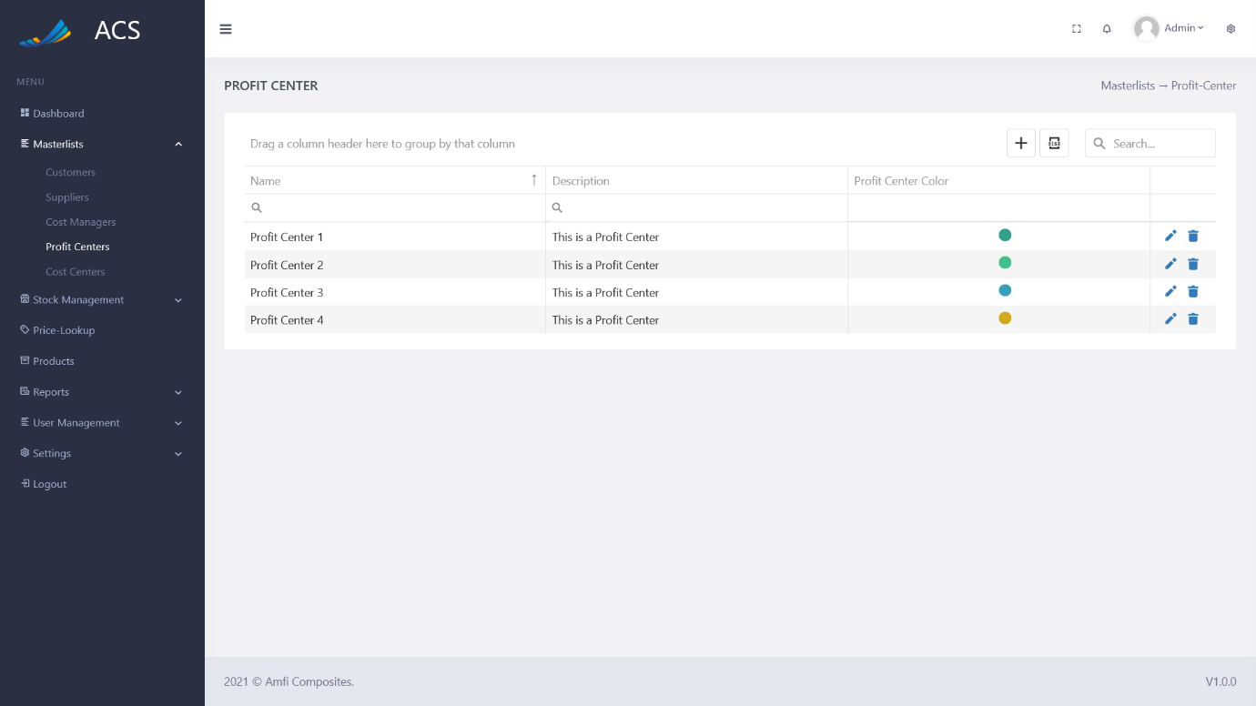

Figures 88: Profit Center View

The Profit Center popup will appear with pre-populated data of the Profit center, the user can fill in/change all the required fields (marked with a red *) and press the save button.

**Image:**

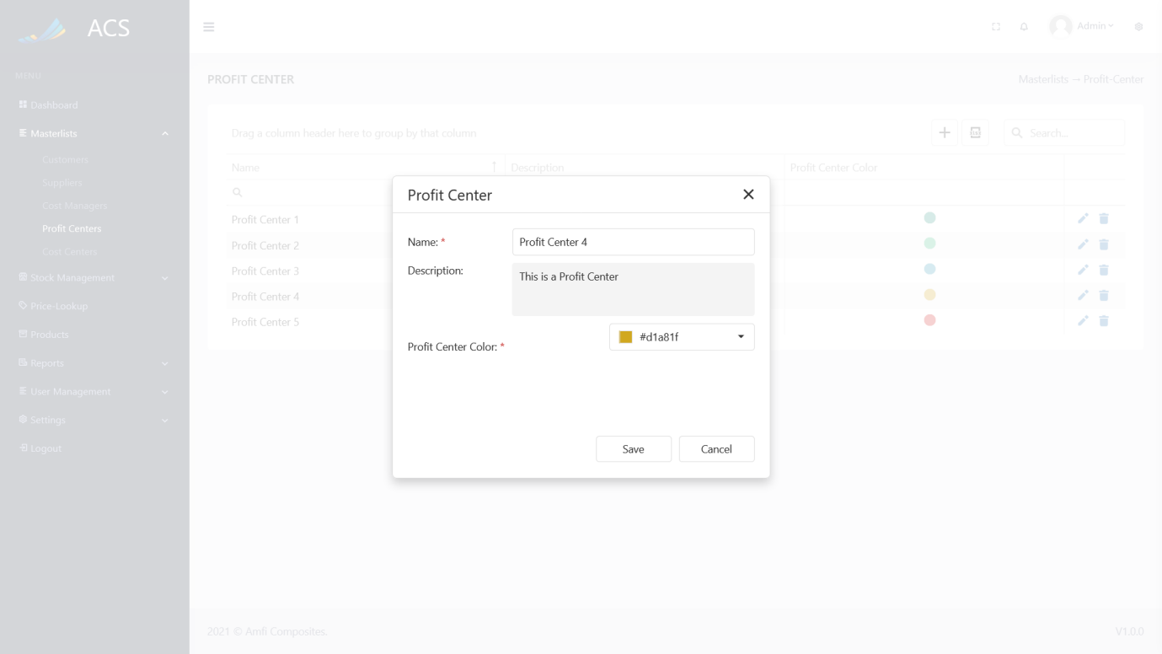

Figures 89: Profit Center Edit

A success message will appear at the bottom of the screen if a profit center was updated successfully.

**Image:**

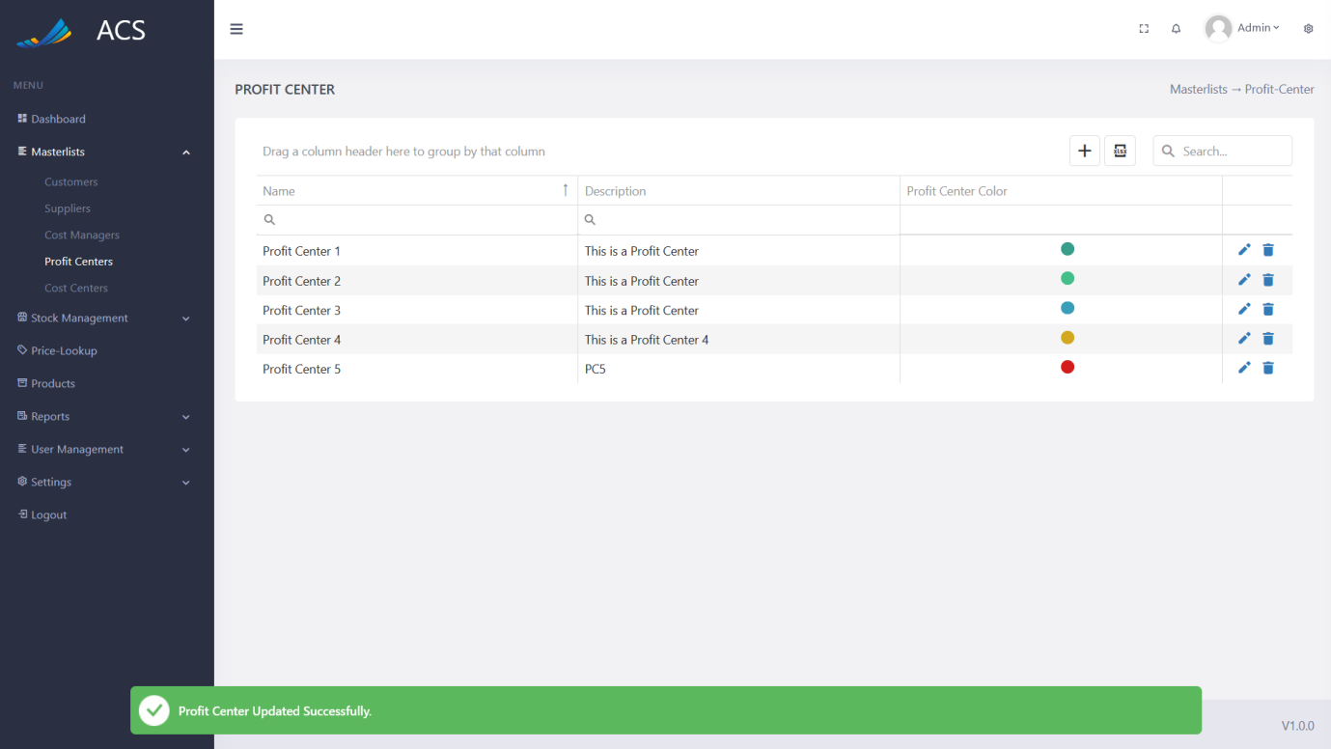

Figures 90: Profit Center Edited Successfully

The user will be able to remove a profit center by pressing the trash icon button on the record they wish to remove, see below.

**Image:**



Figures 91: Profit Center View

A confirmation popup will appear, press yes to continue OR no to cancel.

**Image:**

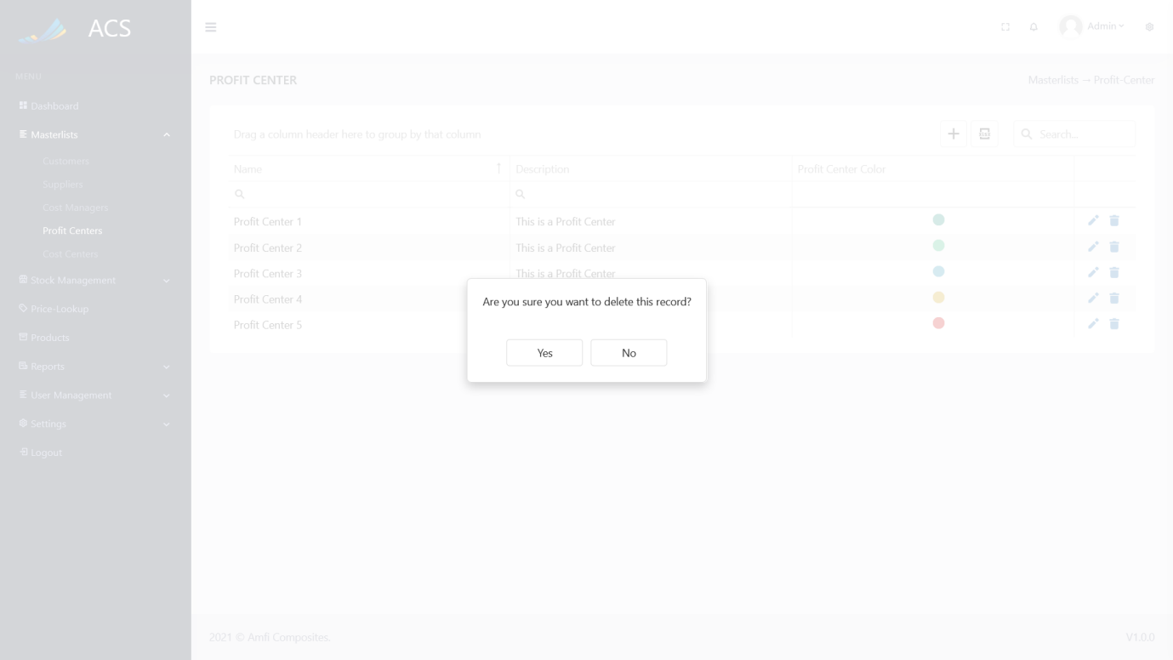

Figures 92: Profit Center View

The system will display an error message if the user tries to delete a profit center that is linked to a Cost Center.

**Image:**

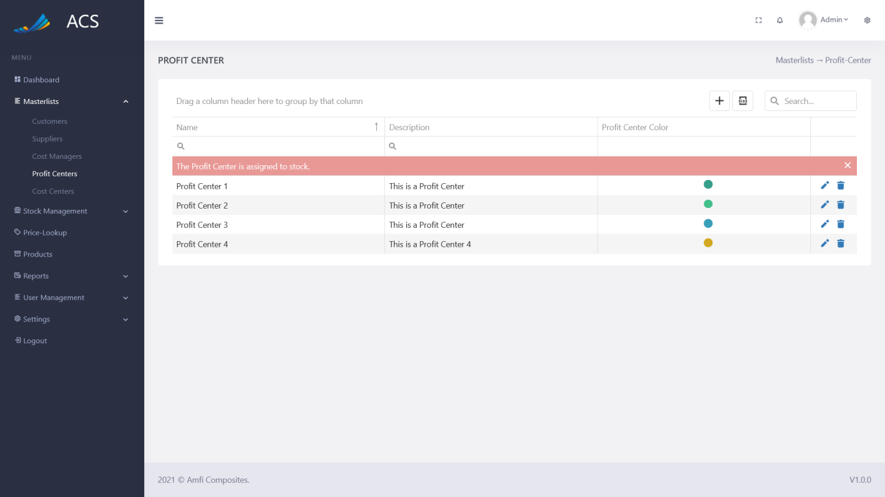

Figures 93: Error

**Image:**

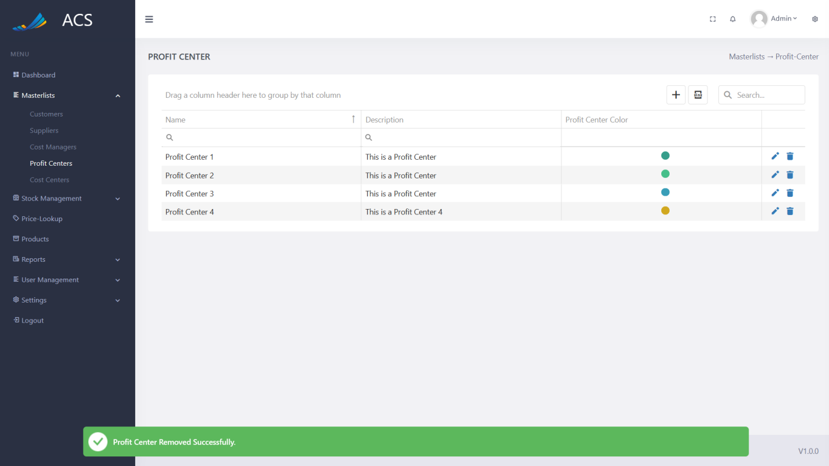

Figures 94: Profit Center Removed Successfully

### Stock Management

#### Stock

The user will be able to view, add, edit, remove and manage stock. The user can capture the Order Number, Product Code, Product Name, Stock Category, Quantity, Unit of Measurement, and Min Threshold (The minimum quantity the stock item can have before a notification is displayed on the dashboard). The total value column is an auto-calculated field.

**Image:**

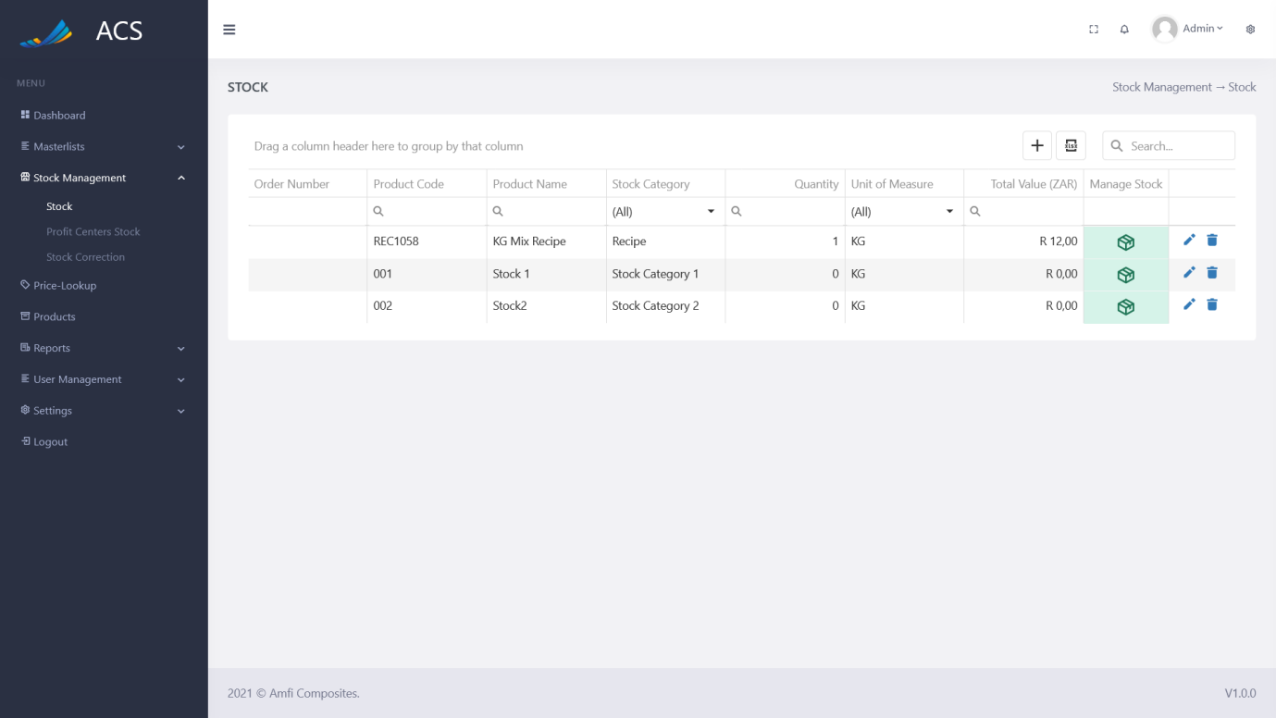

Figures 95: Stock View

##### Stock Categories Explained

* *Recipe*
  + A stock recipe stock category cannot be deleted from the system, the system uses that category to know when a stock item will be a recipe or not. A recipe is a stock item that contains a mixture of two or more stock items.
* *Others*
  + *A stock category (not a recipe) can be anything descriptive to the stock items you will be assigning it to.*

The user will be able to add a new stock item by pressing the plus icon button below.

**Image:**

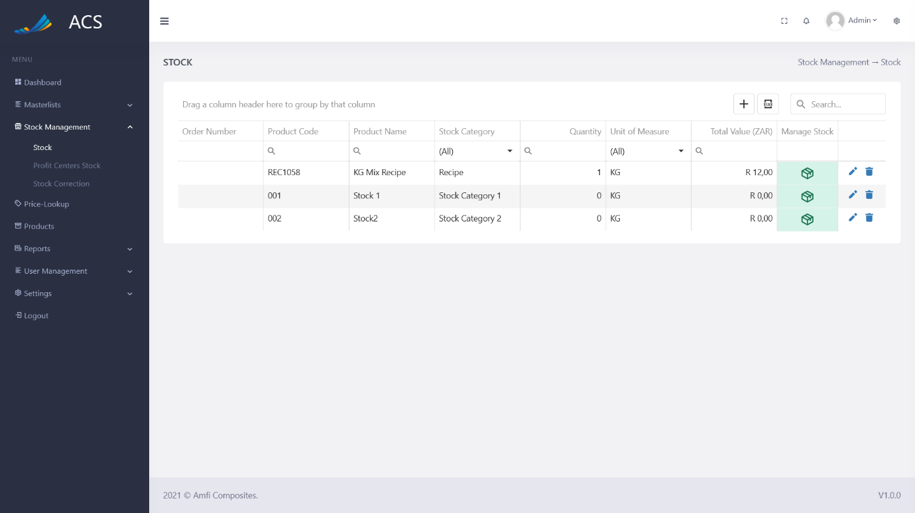

Figures 96: Stock View

A Stock popup will appear, the user can fill in all the required fields (marked with a red *) and press the save button.

**Image:**

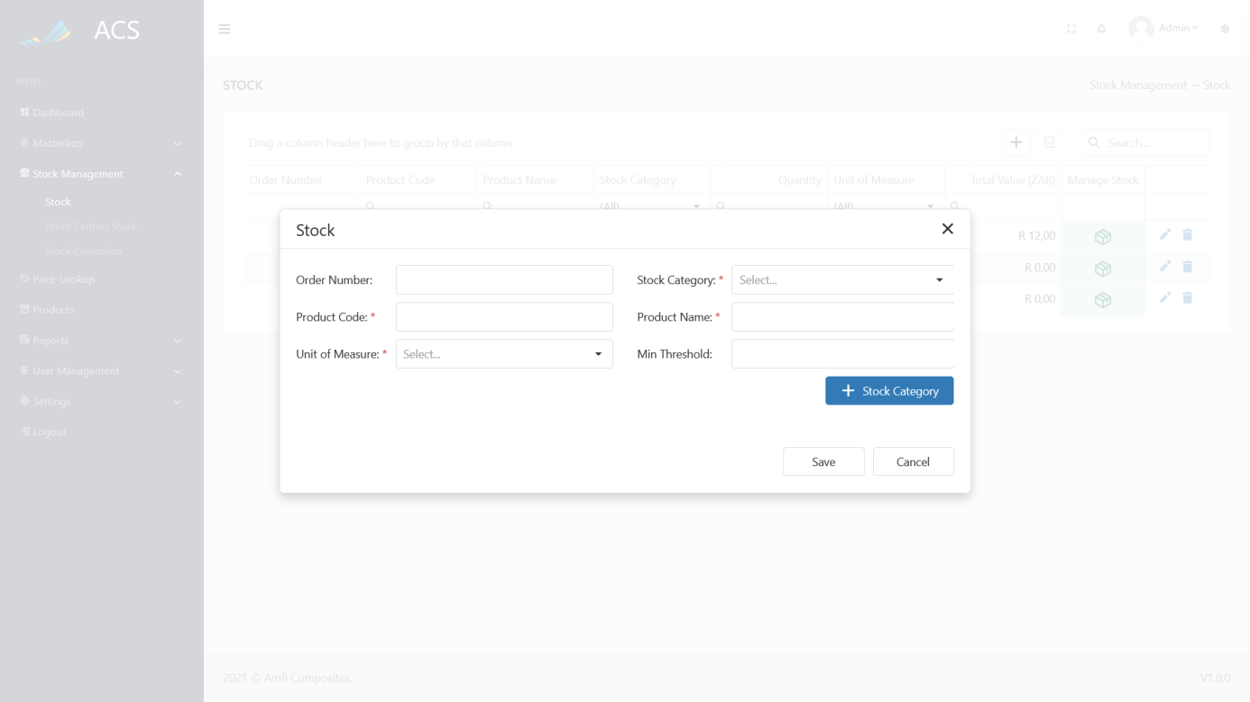

Figures 97: Stock Add

A success message will appear at the bottom of the screen if a Stock item was added successfully.

**Image:**

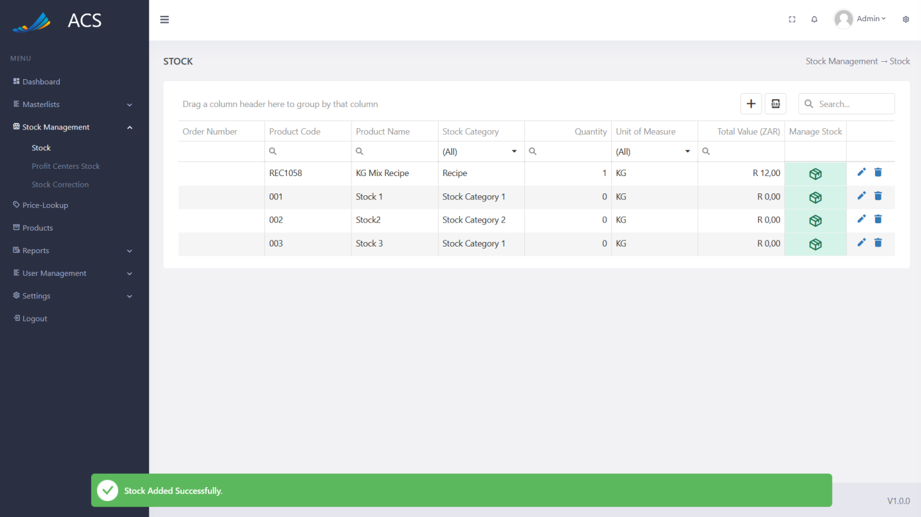

Figures 98: Stock Added Successfully

If duplicate Stock items (Product Name) are added the system will block the request and send back an error message to the user to state the Role already exists.

**Image:**

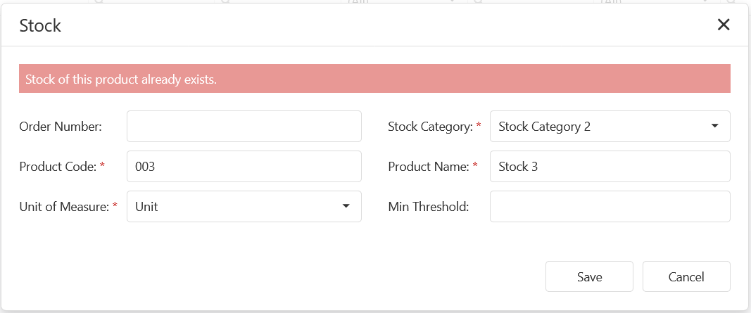

Figures 99: Adding duplicate Stock Items

The user will be able to edit a stock item by pressing the pencil icon button on the record they wish to edit, see below.

**Image:**

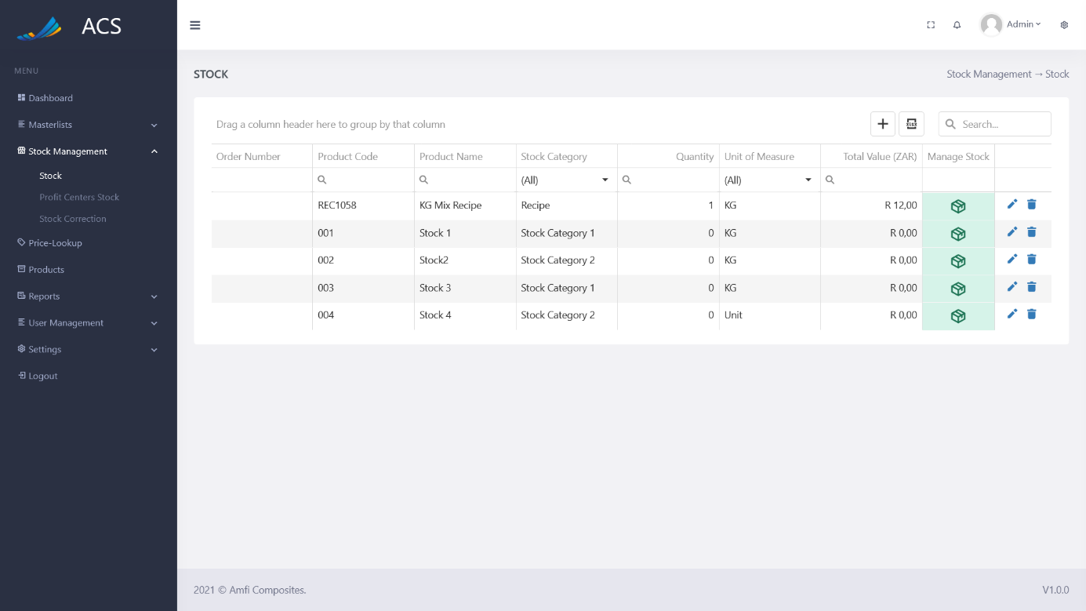

Figures 100: Stock View

The Stock popup will appear with pre-populated data of the stock the user can fill in/change all the required fields (marked with a red *) and press the save button.

**Image:**

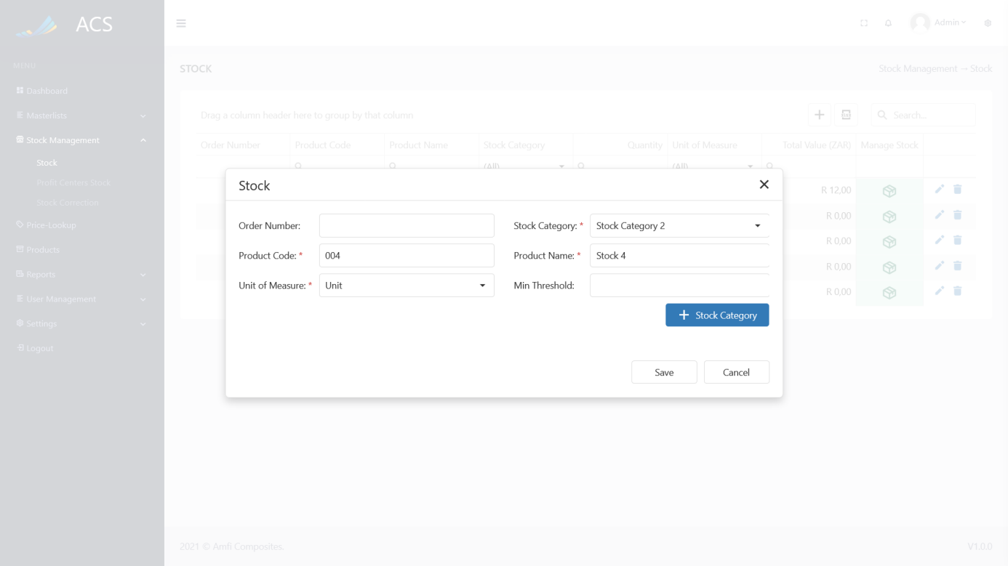

Figures 101: Stock Edit

A success message will appear at the bottom of the screen if a stock item was updated successfully.

**Image:**

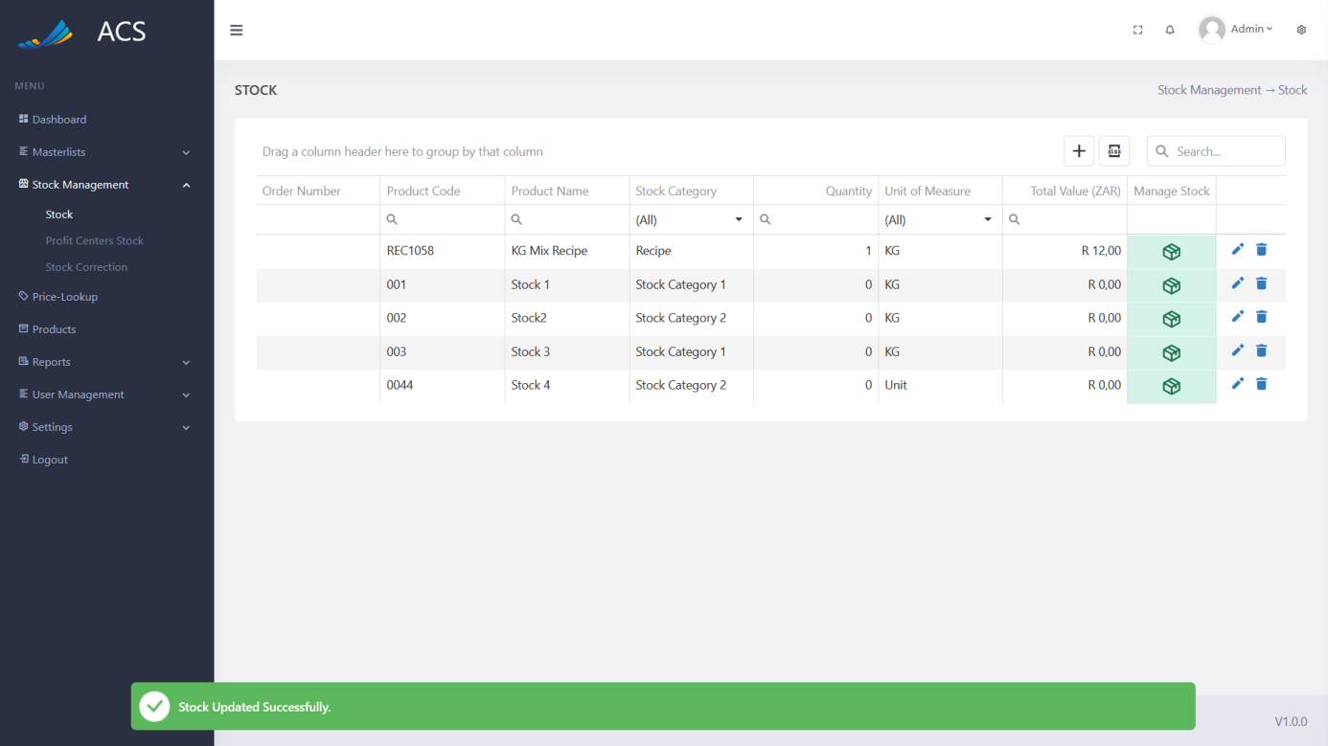

Figures 102: Stock Edited Successfully

The user will be able to remove stock by pressing the trash icon button on the record they wish to remove, see below.

**Image:**

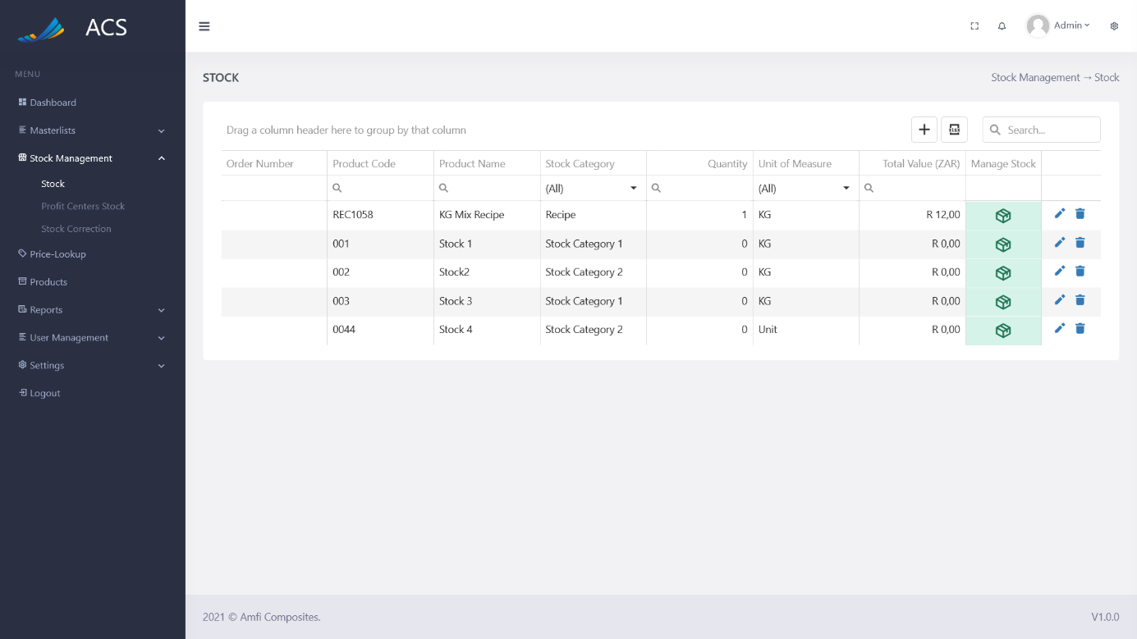

Figures 103: Stock View

A confirmation popup will appear, press yes to continue OR no to cancel.

**Image:**

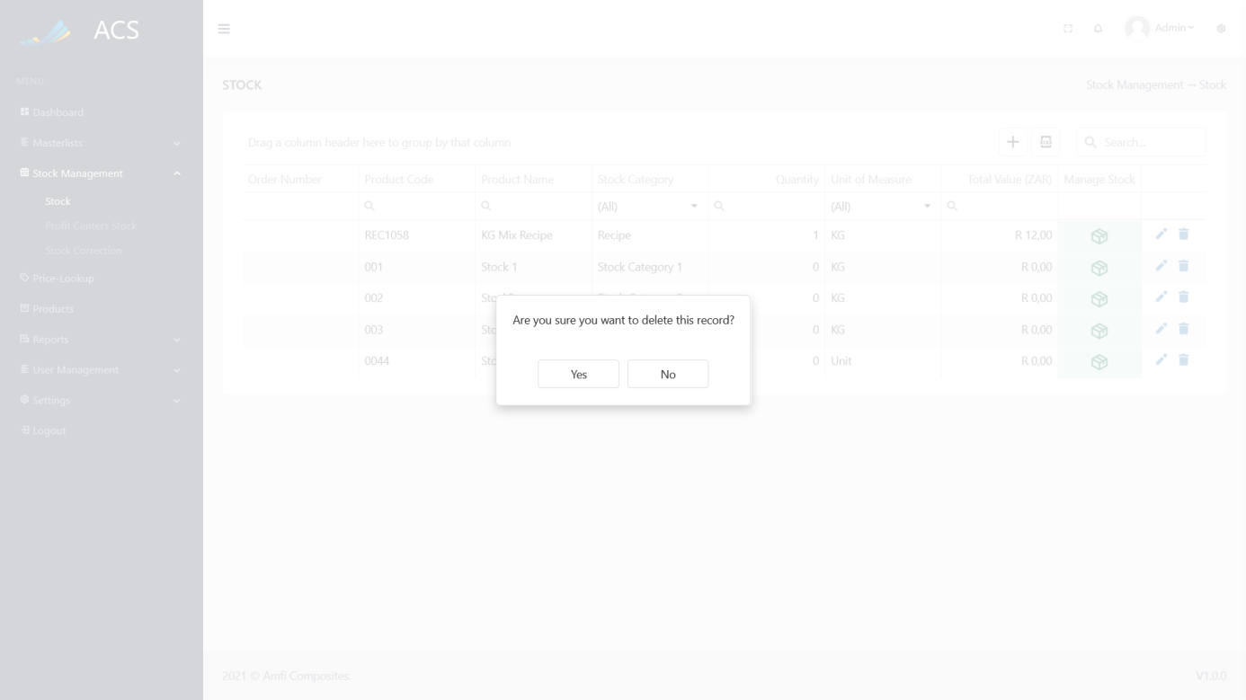

Figures 104: Remove Confirmation

**Image:**

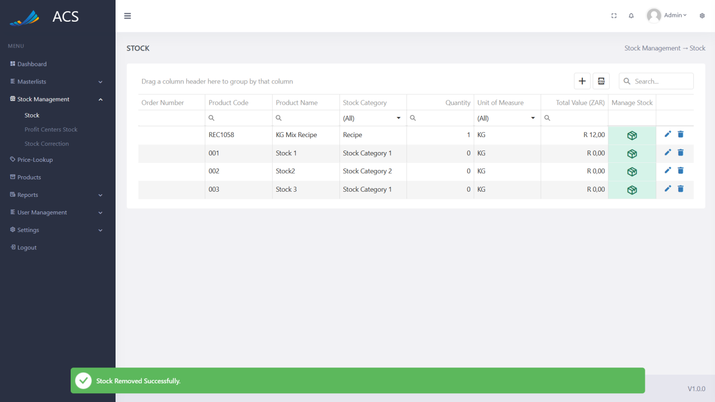

Figures 105: Stock Removed Successfully

##### Manage Stock

The Manage Stock section is where the user will be able to do the following:

* Add Stock
* Remove Stock
* Set Stock
* Stock Recipe *(only if the stock category is Recipe)*

The user can access the Manage section by pressing the green Manage Stock button on the stock item record they would want to manage stock for.

**Image:**

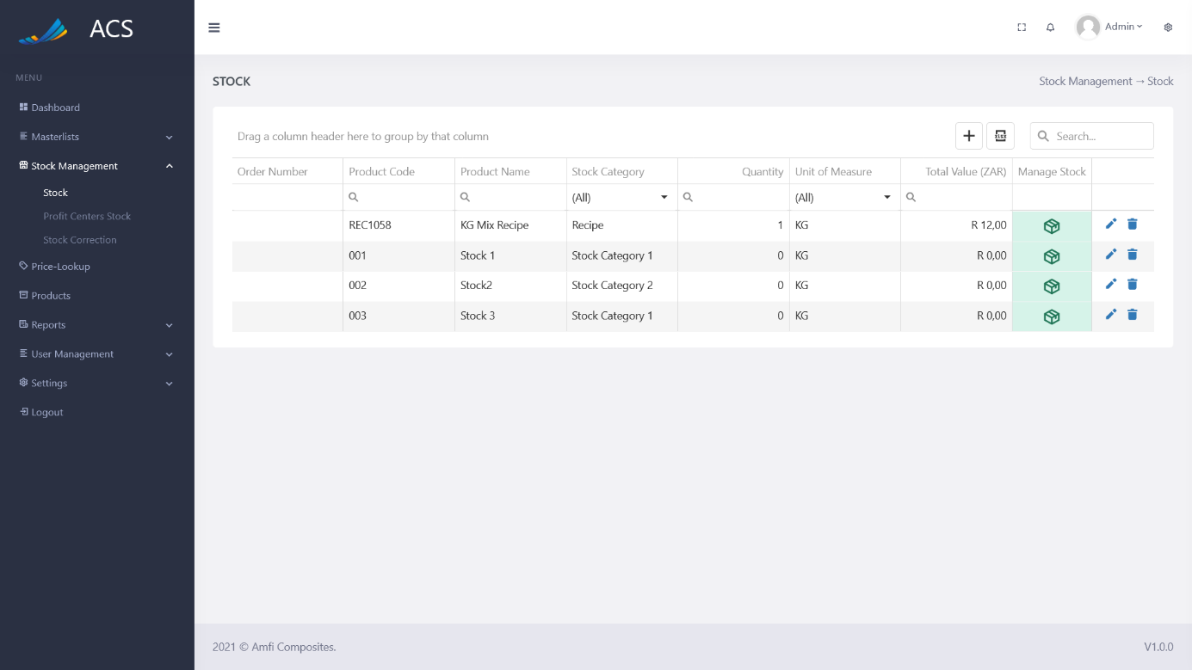

Figures 106: Manage Stock

A Manage Stock popup will appear with tabs (Other Stock Categories):

* Add Stock
* Remove Stock
* Reset Stock

**Image:**

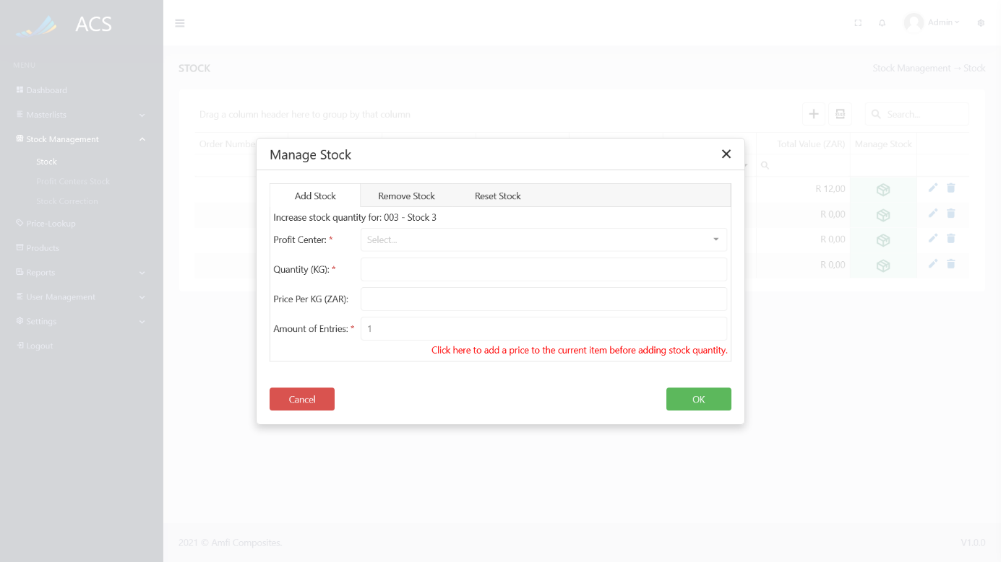

Figures 107: Other Stock Categories

Before the user can add, remove or set quantities to stock items, they should add a price for the item. The user can do it by clicking the red *“Click here to add a price to the current item before adding stock quantity“* link.

**Image:**

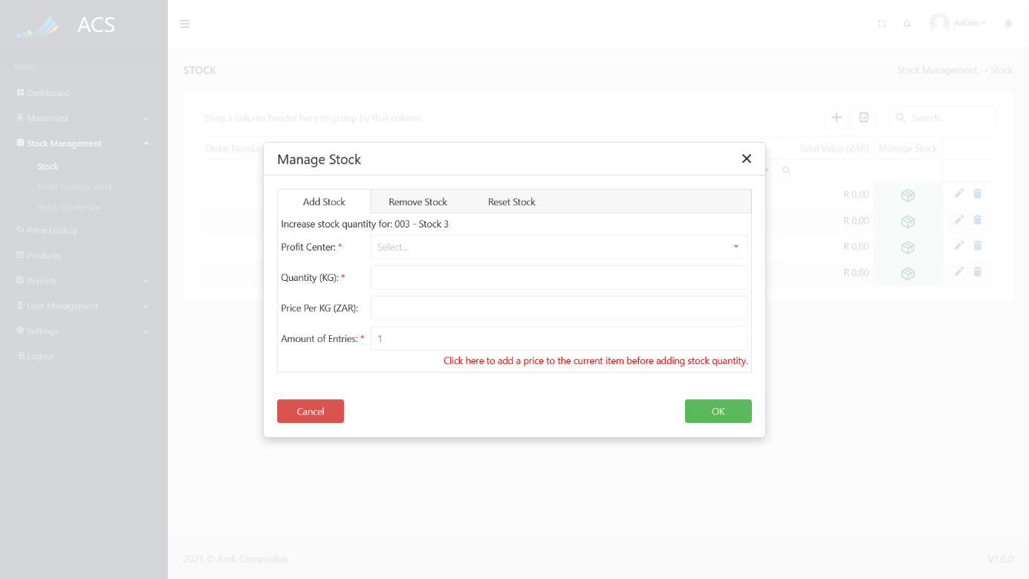

Figures 108: Price Lookup link

The system will navigate the user to the price lookup page and open the new Current Price popup with the stock item auto-selected in the dropdown.

**Image:**

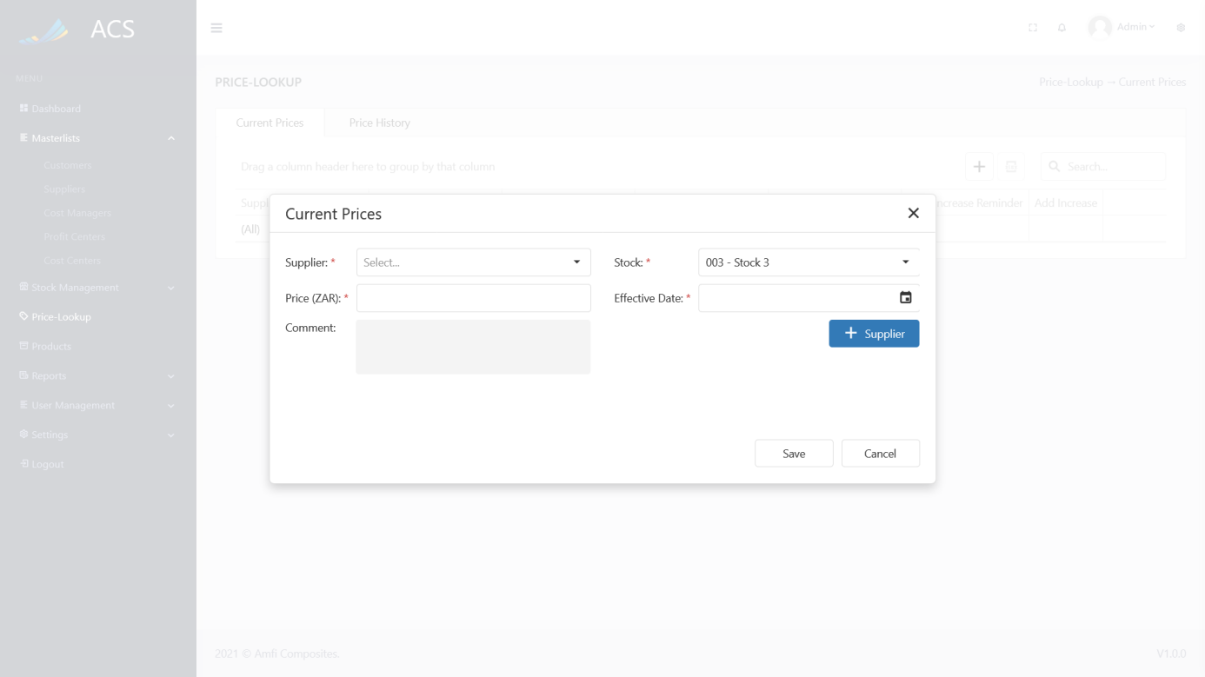

Figures 109: Current Price

The user will enter the details and click save. The user will then navigate back to the stock page and open the manage stock section to make modifications. The stock item's price will now be visible in the Price Per UOM field. (The Price Lookup page and related activities will be discussed in the ***Price Lookup*** section of this document.

**Image:**

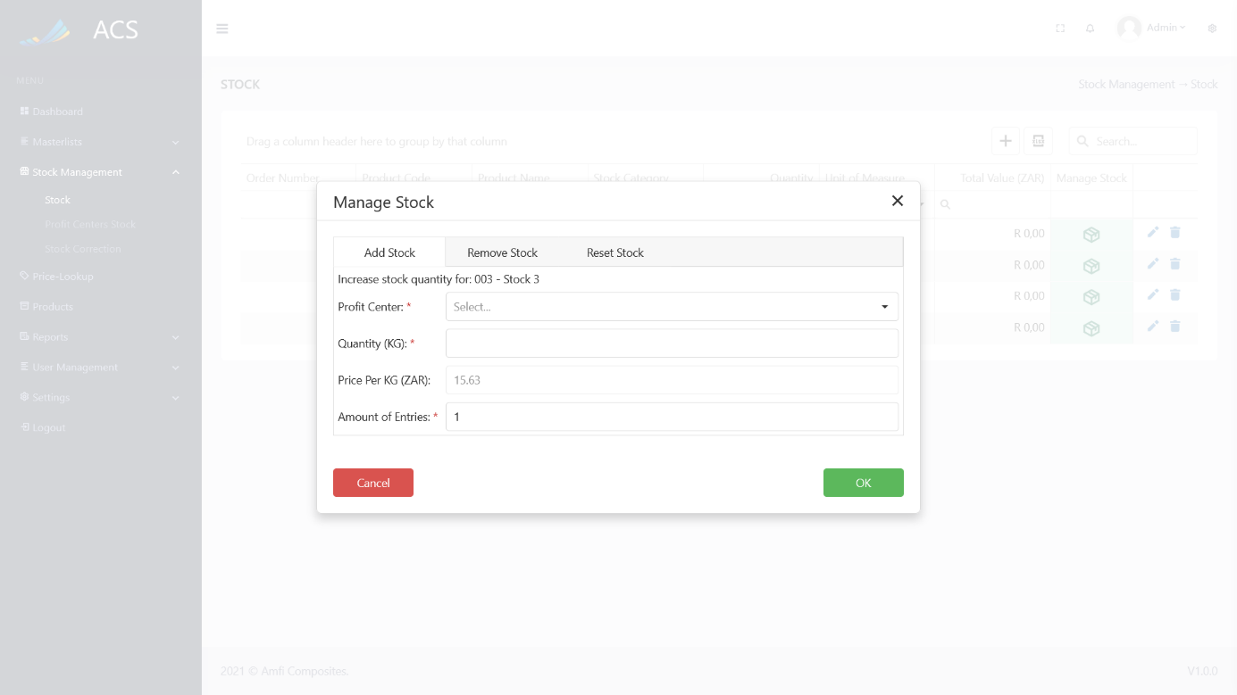

Figures 110: Manage Stock

The user can add stock quantities and click the OK button. Understanding the fields on the form:

*Profit Center: Select the Profit Center the stock quantity will be assigned to.*

*Quantity (UOM): The UOM of the single stock item. (Paint Can equal 25L)*

*Amount of Entries: The number of single stock items entered. (5 Paint Cans)*

**Image:**

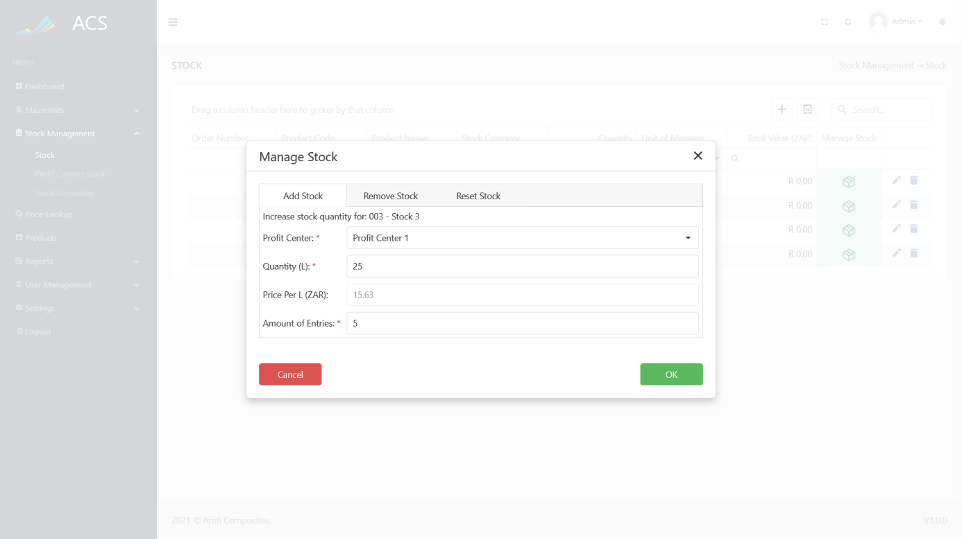

Figures 111: Adding Items

The system will auto calculate the quantity and the total value for the stock item.

*Quantity(UOM): The capacity/weight/units of the item (25L) * The amount of entries (5 cans)*

*Total Value: The total value of the calculation above * The price assigned to the stock item. (R15.63)***Image:**

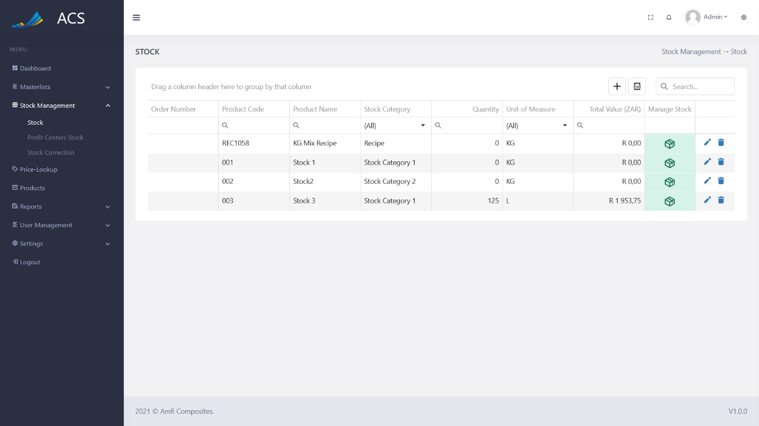

Figures 112: Adding Items Successfully

The user can remove stock for the stock item by opening the Manage Stock section and navigating to the remove stock tab. The system uses FIFO (*First in First Out*) to remove stock from the system, we assume the shopfloor workers will follow FIFO when they use products with best before dates.

**Image:**

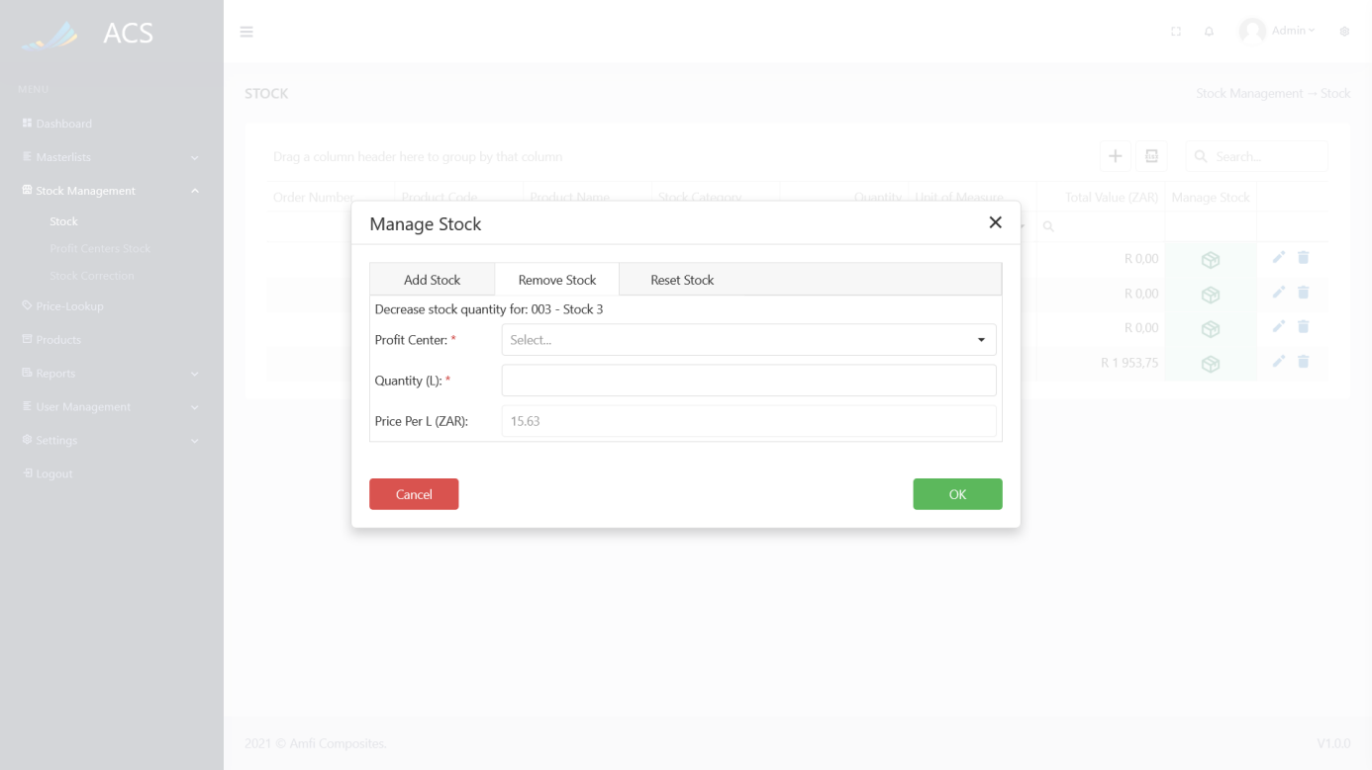

Figures 113: Remove quantity

The user can remove stock quantities and click the OK button. Understanding the fields on the form:

*Profit Center: Select the Profit Center the stock quantity will be removed for, the dropdown is filtered to only show the profit center that has the stock item assigned to it.*

*Quantity (UOM): The UOM the user would like to remove (25L)*

**Image:**

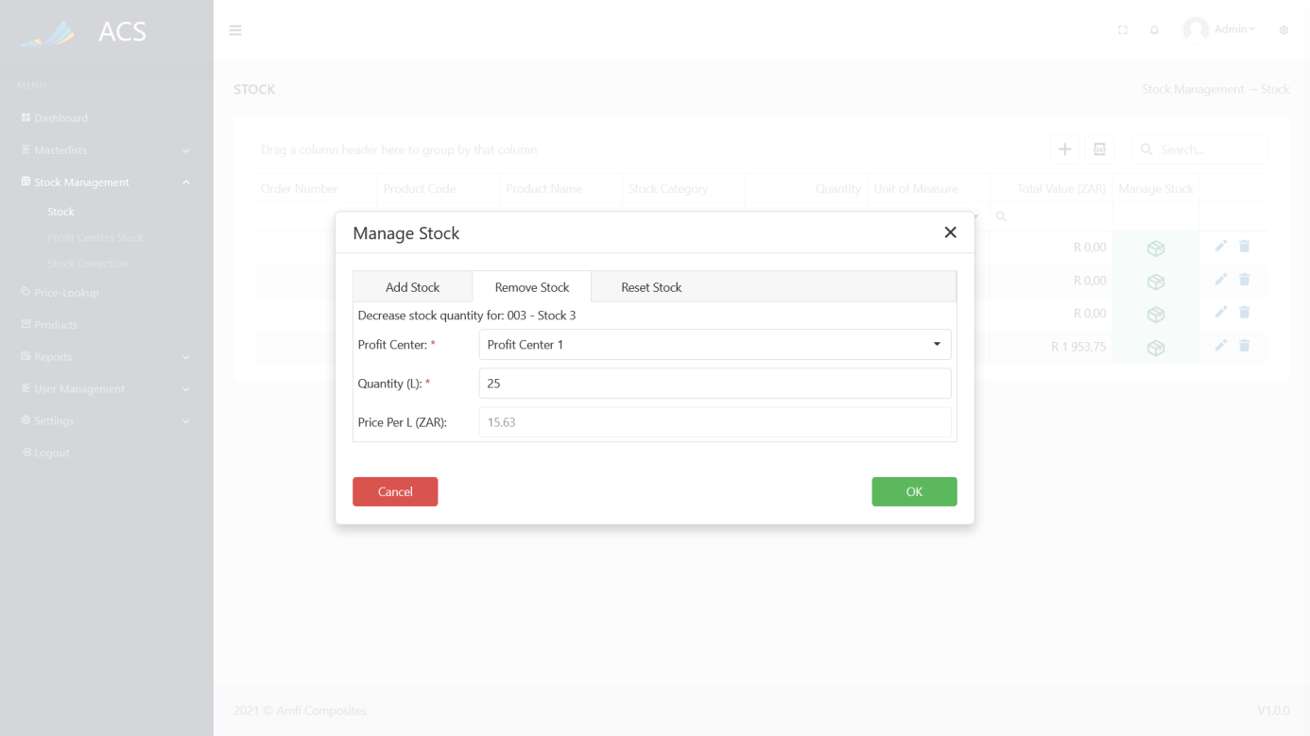

Figures 114: Remove quantity filled in

The system will auto calculate the quantity and total value fields.

**Image:**

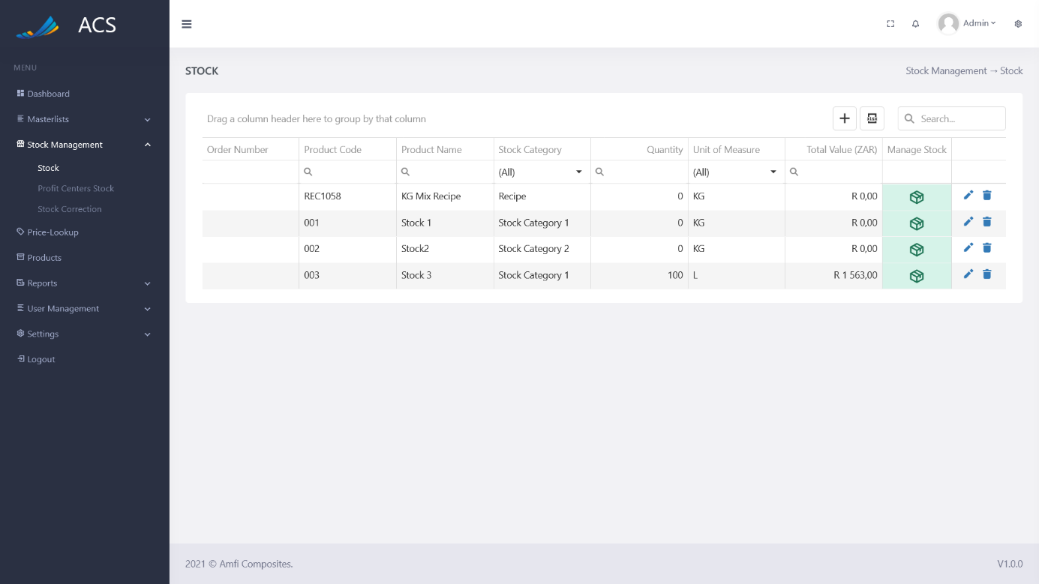

Figures 115: Remove quantity successfully

The user can reset stock for the stock item by opening the Manage Stock section and navigating to the reset stock tab.

**Image:**

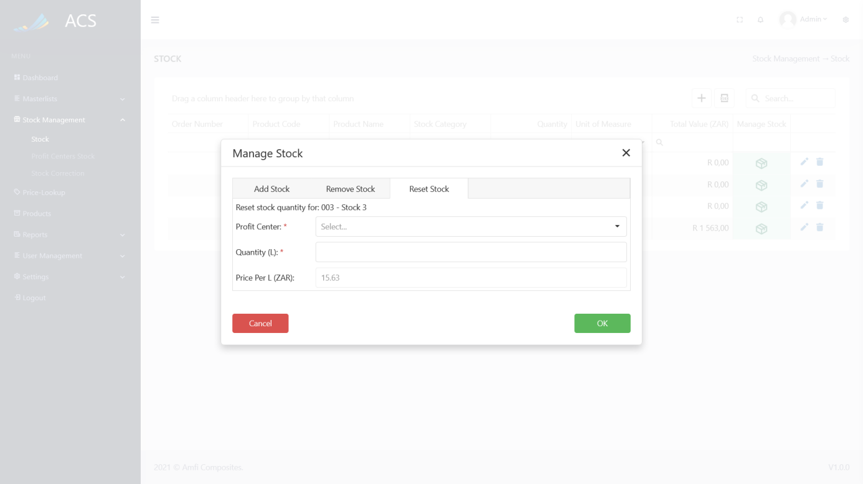

Figures 116: Reset Stock

The user can reset stock quantities and click the OK button. Understanding the fields on the form:

*Profit Center: Select the Profit Center the stock quantity will be reset for, the dropdown is filtered to only show the profit center that has the stock item assigned to it.*

*Quantity (UOM): The UOM the user would like to reset (80L)*

The FIFO (*First in First out*) rule applies when a user resets the stock as well.

**Image:**

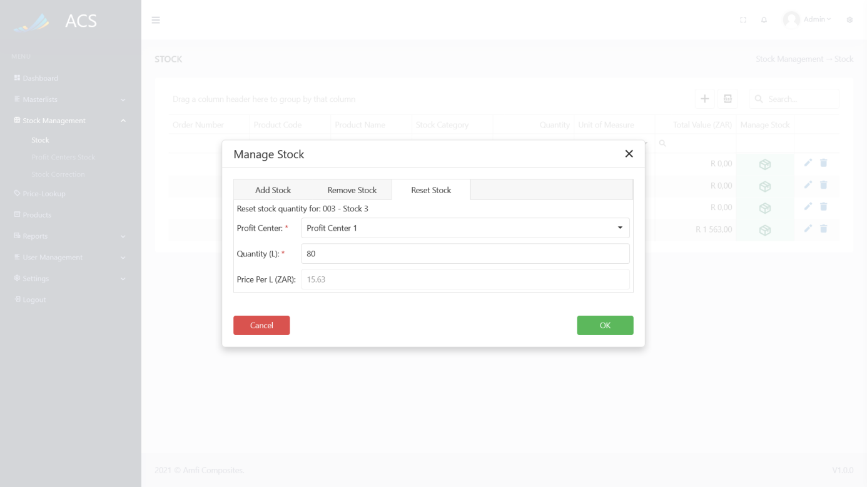

Figures 117: Reset Stock

The system will auto calculate the total value.

**Image:**

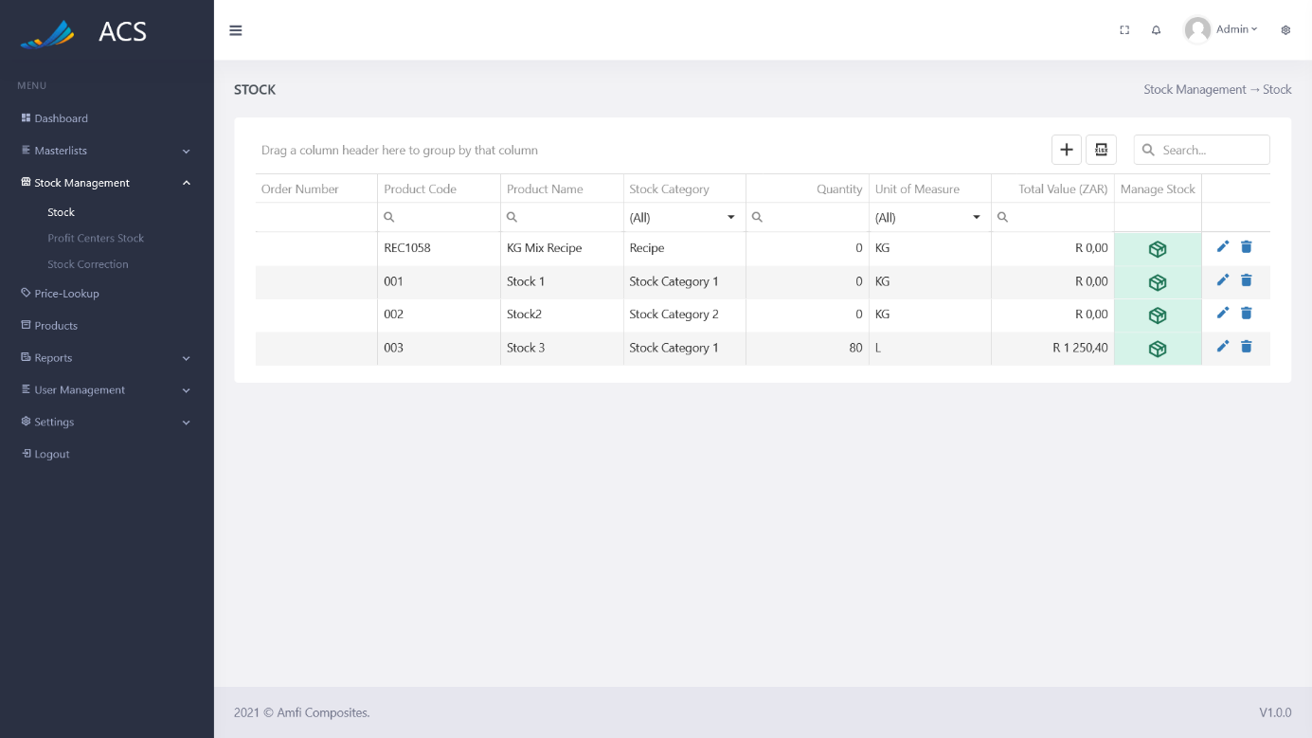

Figures 118: Reset Stock Successfully

A Manage Stock popup will appear with tabs (Recipe Stock Categories):

* Add Stock
* Remove Stock
* Reset Stock
* Stock Recipe

**Image:**

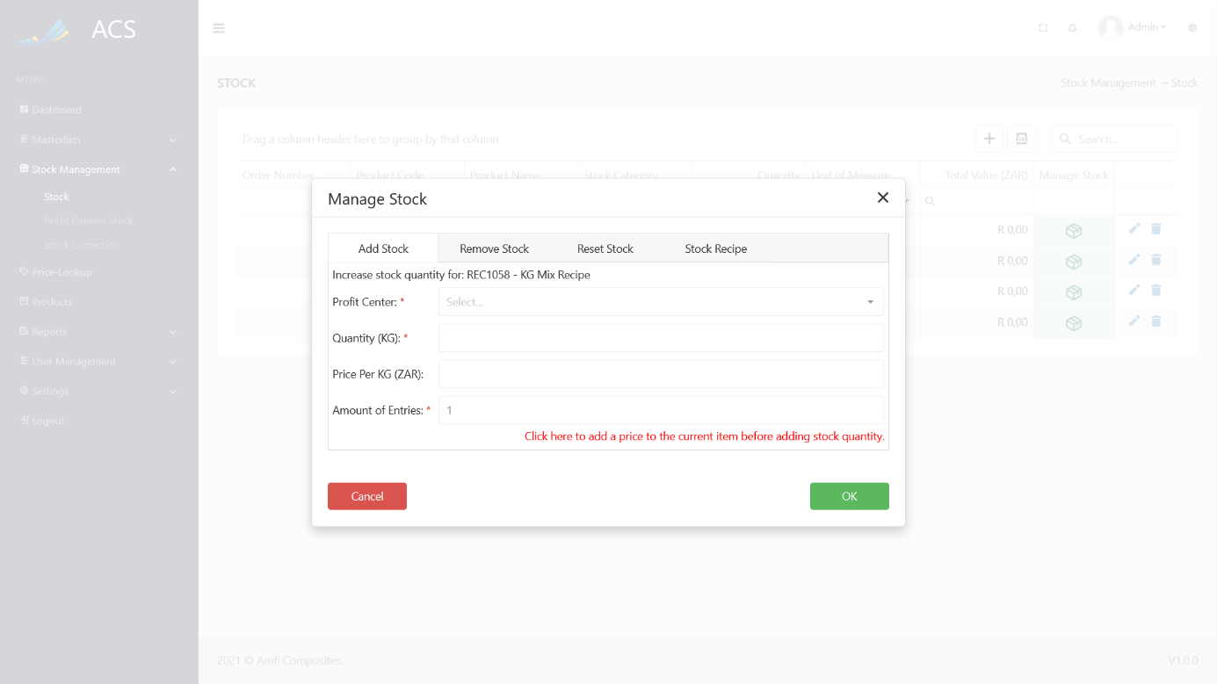

Figures 119: Recipe Stock Categories

The user can follow the Add, Remove and Reset steps for the Recipe Stock Category.

The user can open the manage stock section and navigate to the Stock Recipe tab.

**Image:**

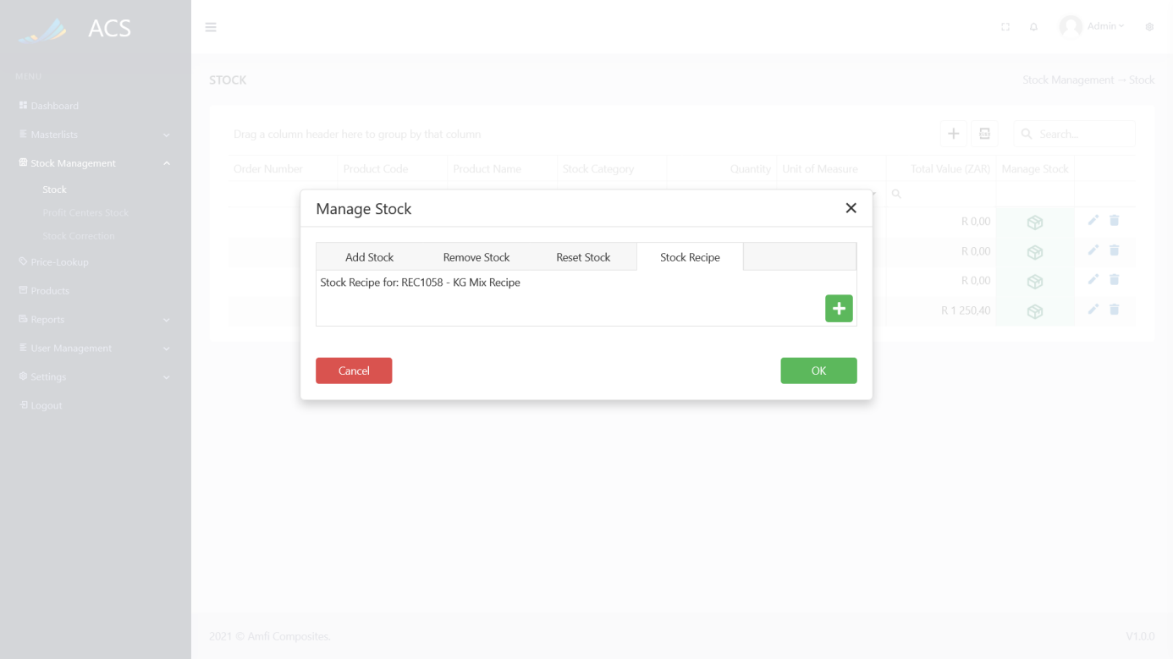

Figures 120: Stock Recipe

The user can press the green plus icon button to add a stock item to the recipe. A recipe requires a minimum of two items.  
**Image:**

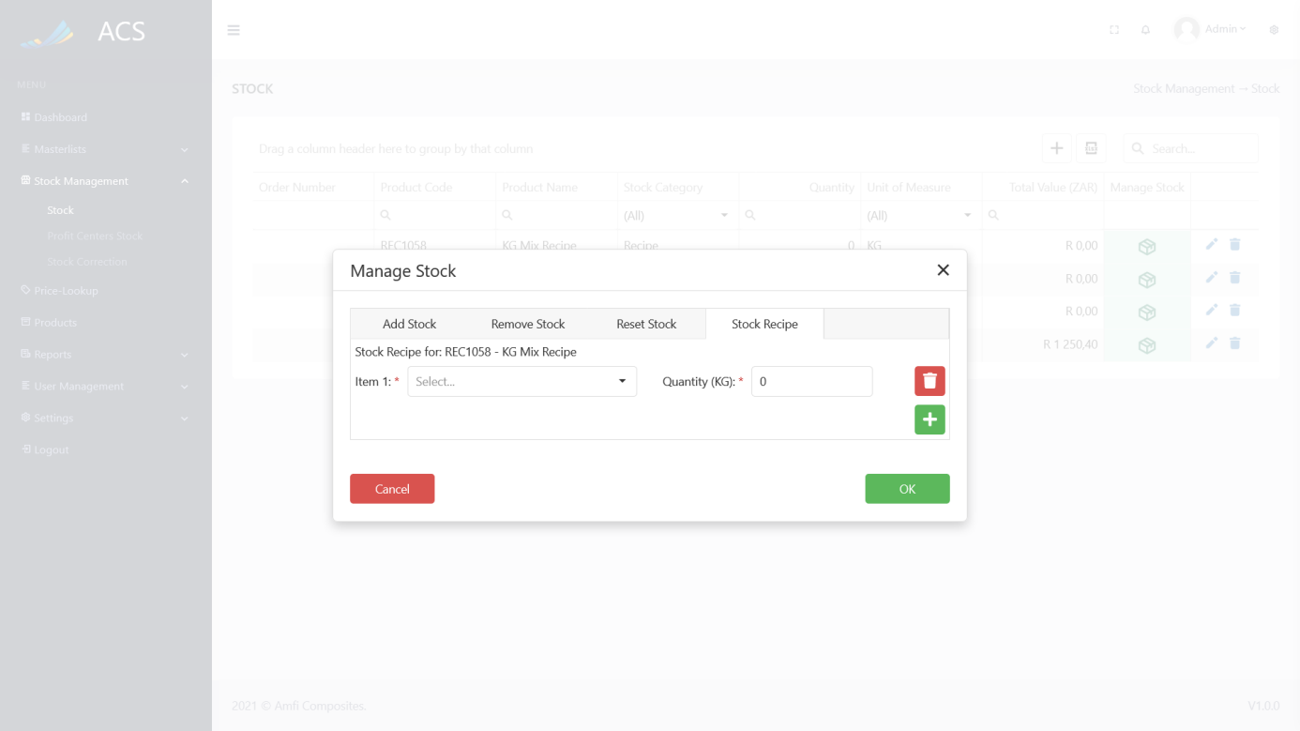

Figures 121: Stock Recipe Items

The user can select stock items from the dropdown and the quantity of each item required for the recipe and press the OK button.

**Image:**

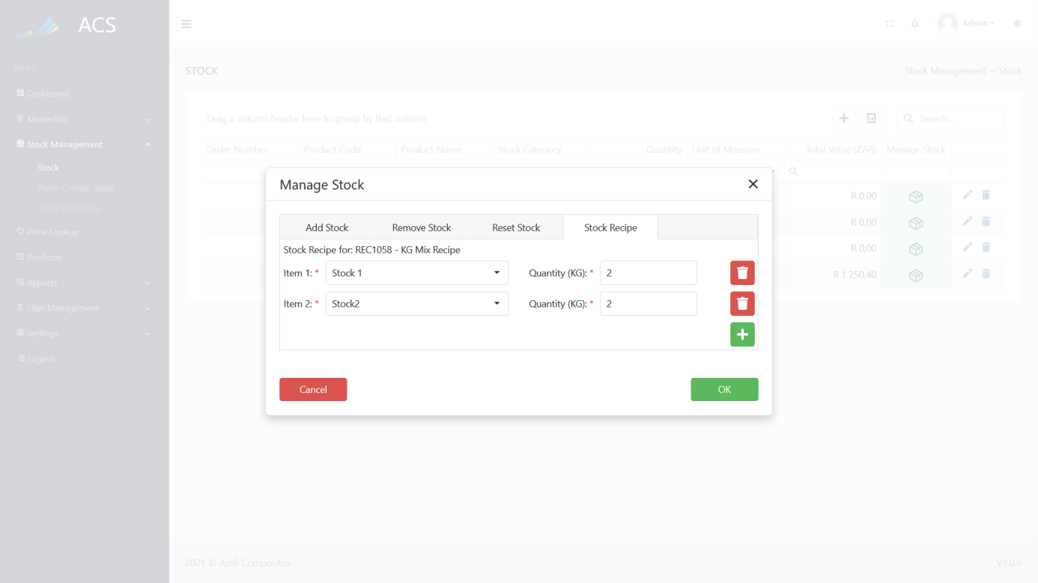

Figures 122: Recipe Created

#### Profit Centers Stock

The user will be able to view stock allocated to each profit center, the number of items assigned to the profit center, and the total stock amount of each profit center.

**Image:**

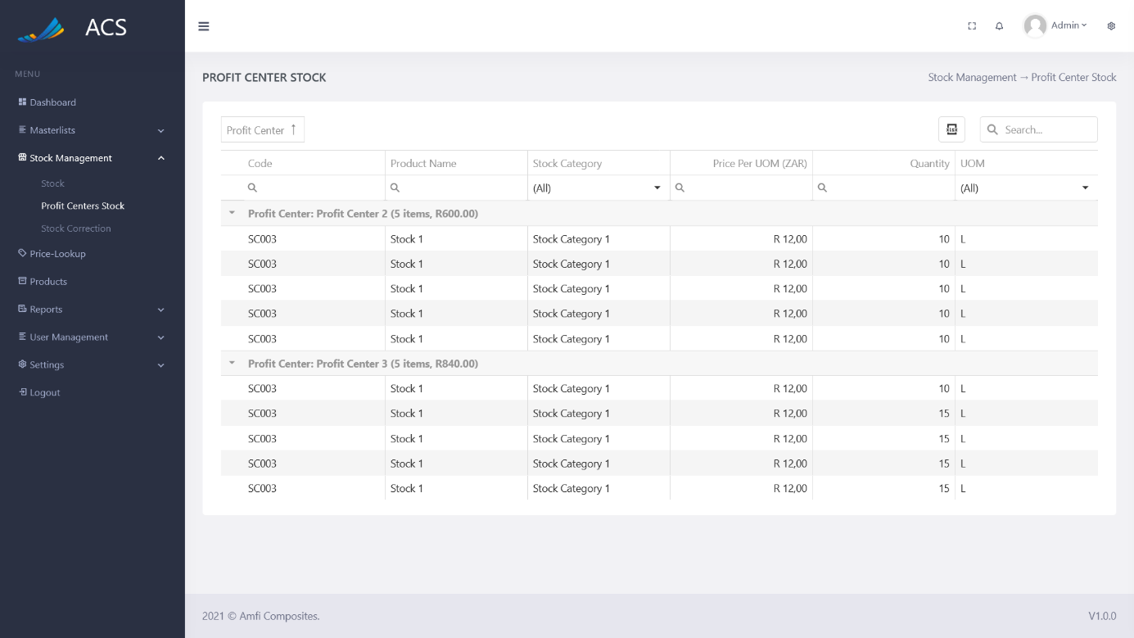

Figures 123: Profit Center Stock

#### Stock Corrections

The stock correction page is only for the highest admin user to edit. The user will only be able to edit stock items. The user will only be able to edit the following fields:

* Quantity
* Price
* Profit Center

**Image:**

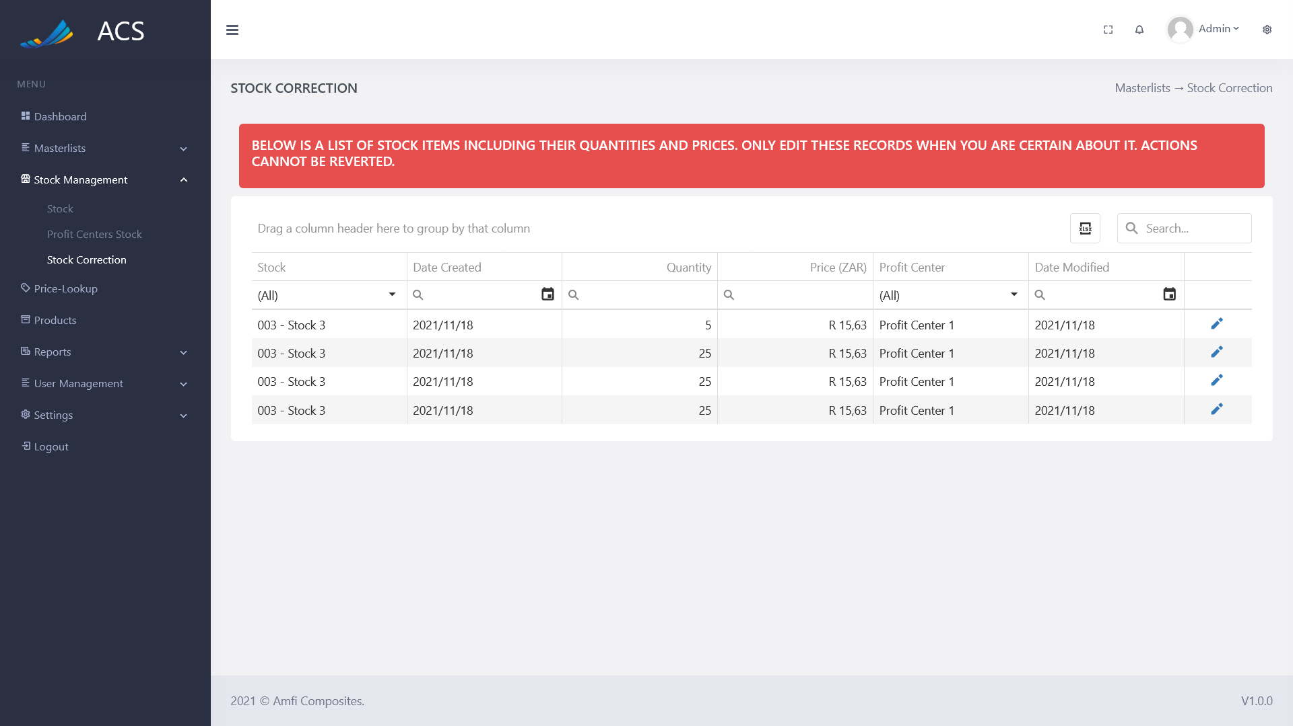

Figures 124: Stock Correction

**Image:**

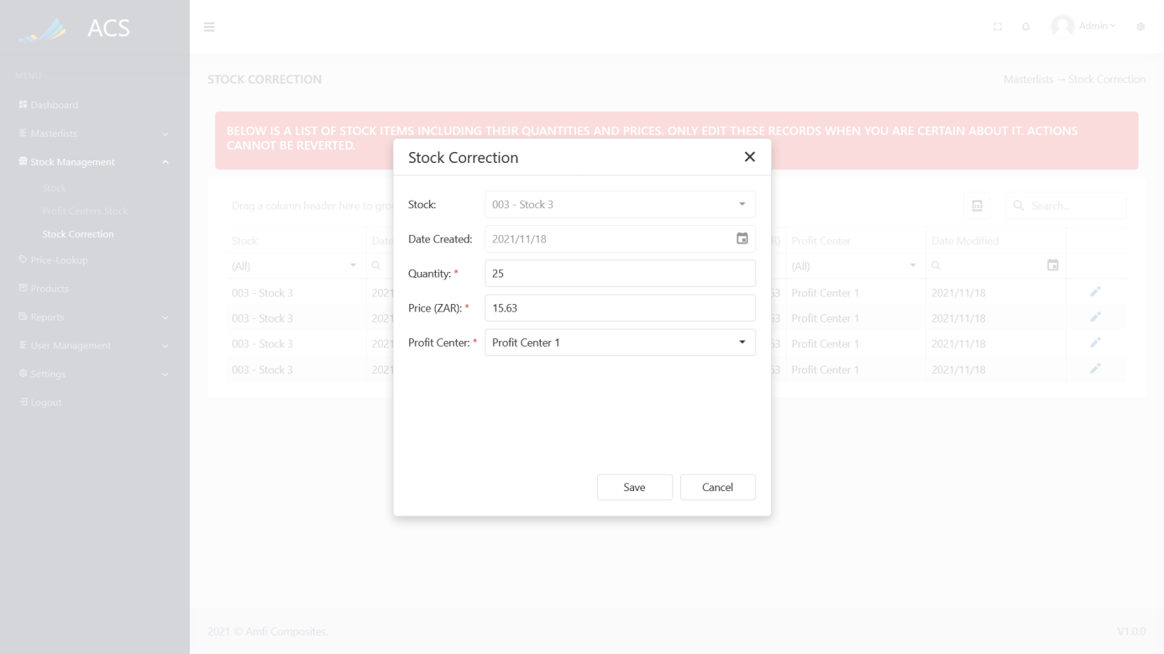

Figures 125: Stock Correction Edit

### Price Lookup

The user will be able to navigate between current prices and price history by clicking on the tabs.

**Image:**

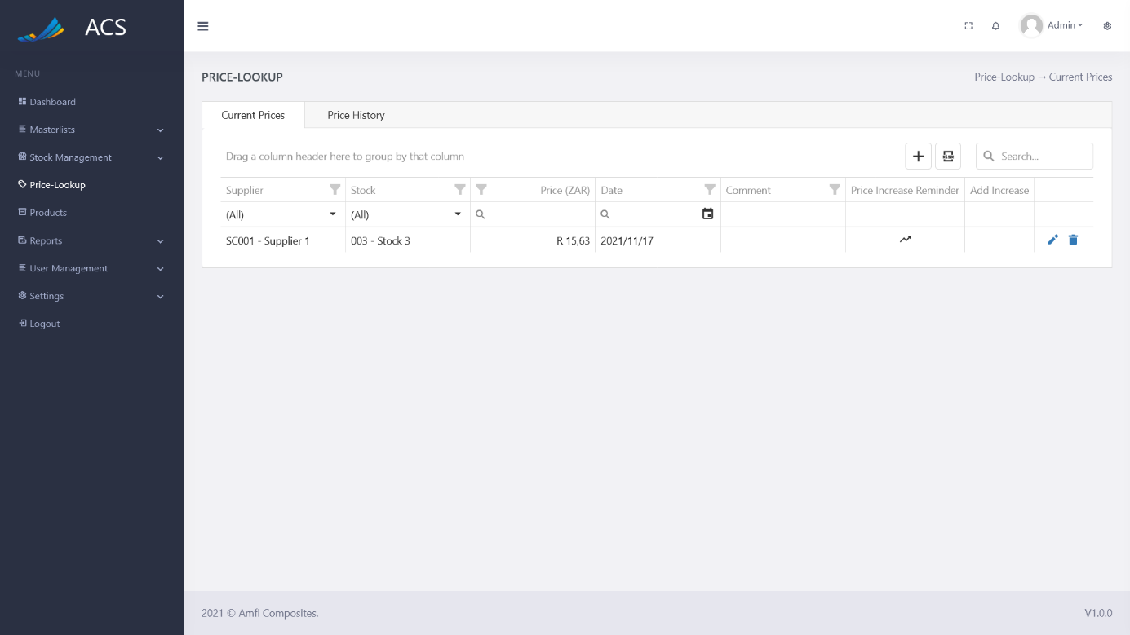

Figures 126: Price Lookup

#### Current Prices

The user will be able to view, add, edit and remove prices. The user can capture the Supplier, Stock, Price, Effective Date, and Comment.

**Image:**

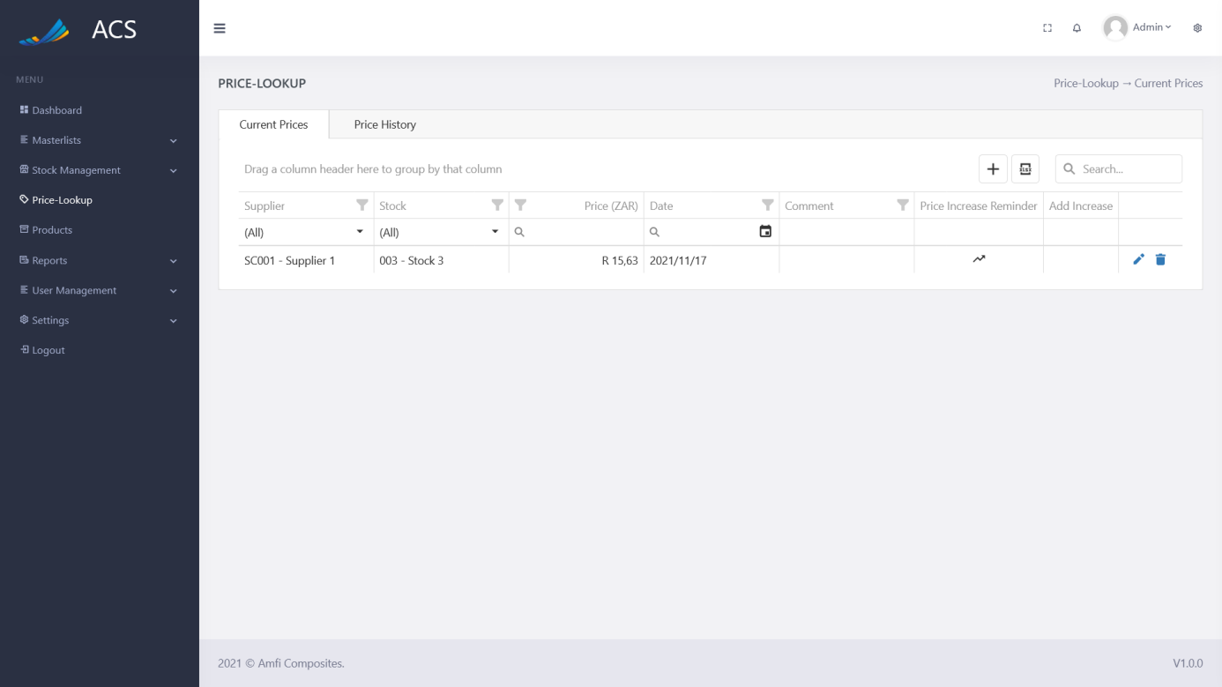

Figures 127: Current Prices

The user will be able to add a new Price by pressing the plus icon button below.

**Image:**



Figures 128: Price Add Button

A Current Prices popup will appear, the user can fill in the required fields (marked with a red *) and press the save button.

**Image:**

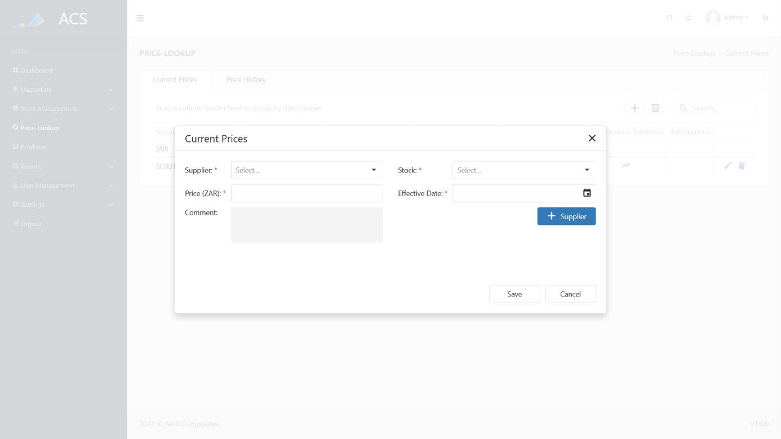

Figures 129: Price Add

*The Stock dropdown will only display stock items with now prices allocated to them.*

A success message will appear at the bottom of the screen if a price was added successfully.

**Image:**

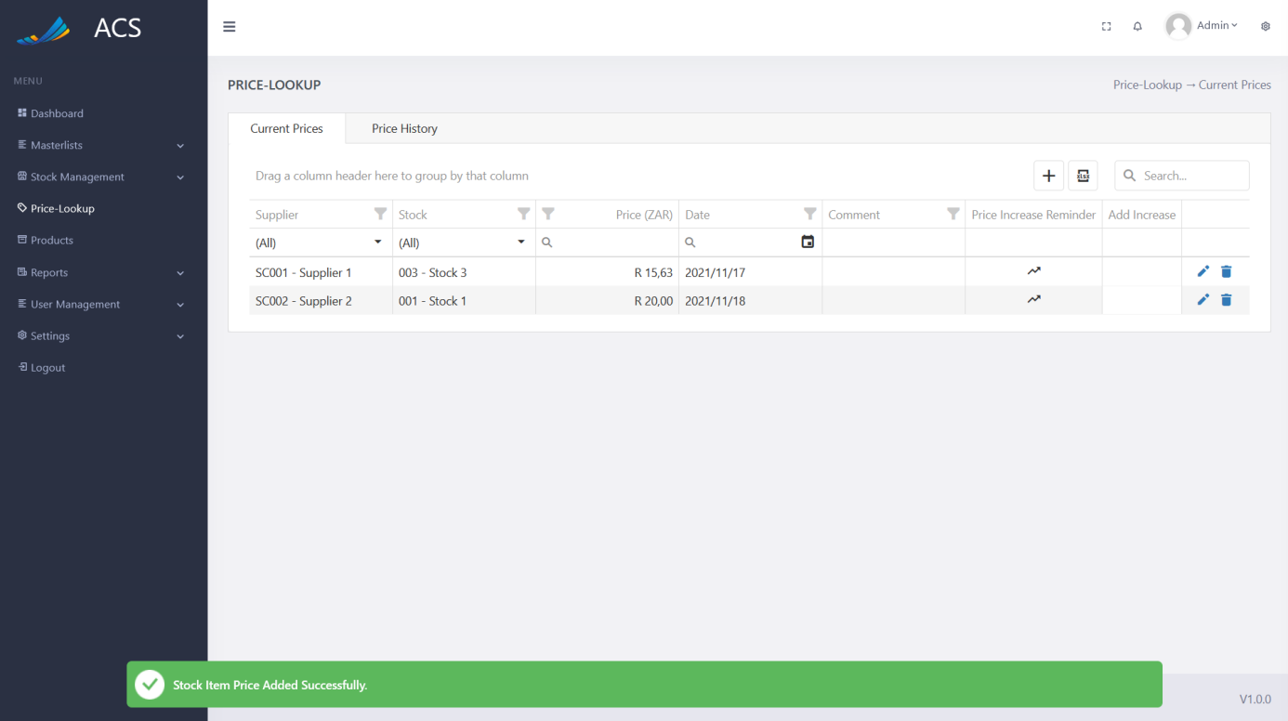

Figures 130: Price Added Successfully

The user will be able to edit a price by pressing the pencil icon button on the record they wish to edit, see below.

**Image:**

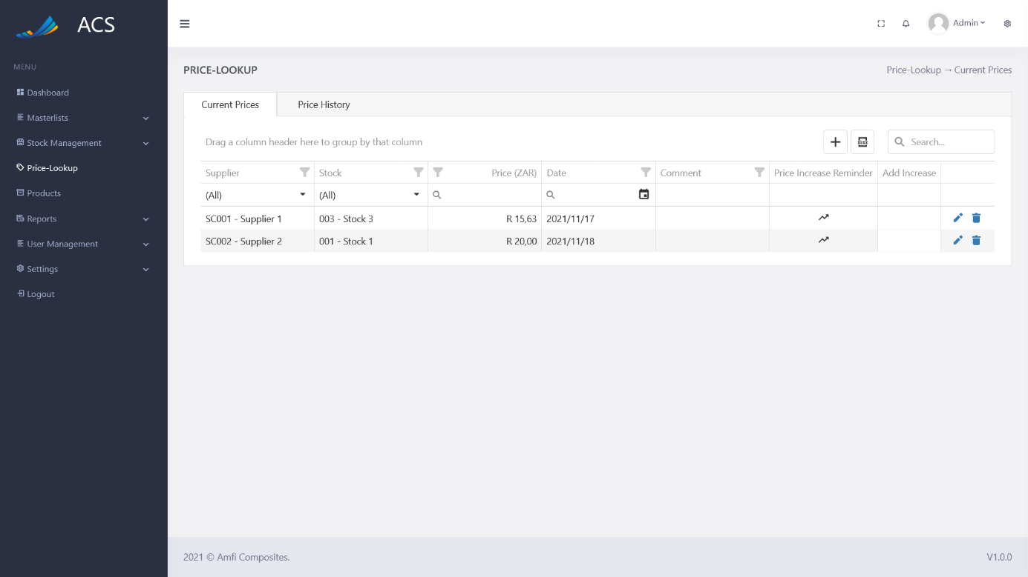

Figures 131: Current Price View

The Current Price popup will appear with pre-populated data of the stock item price the user can fill in/change all the required fields (marked with a red *) and press the save button.

**Image:**

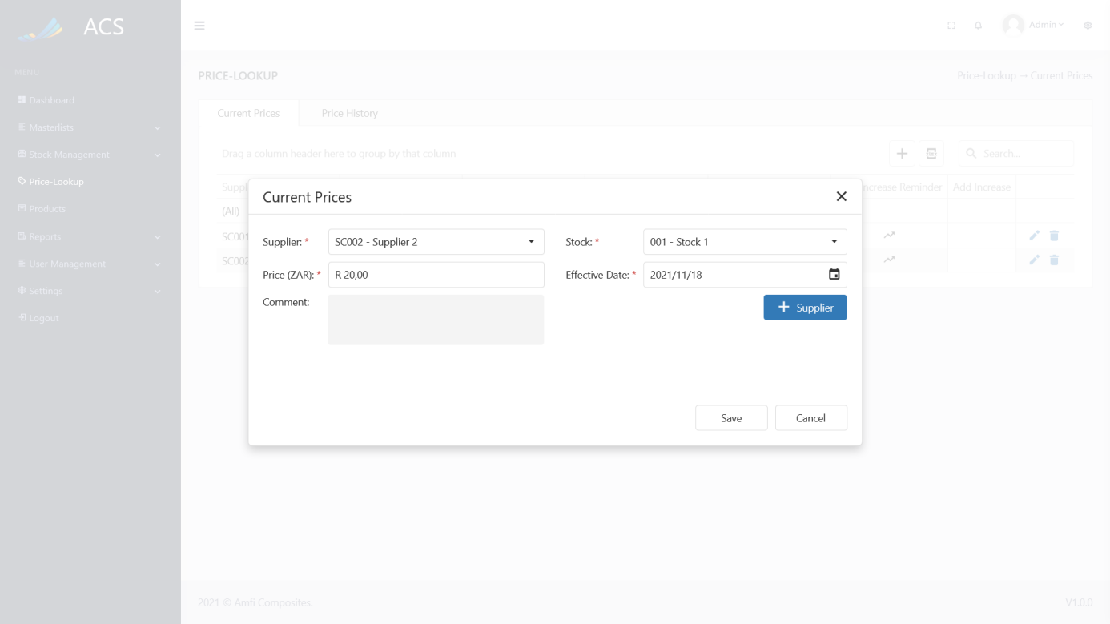

Figures 132: Price Edit

A success message will appear at the bottom of the screen if a Price was updated successfully.

**Image:**

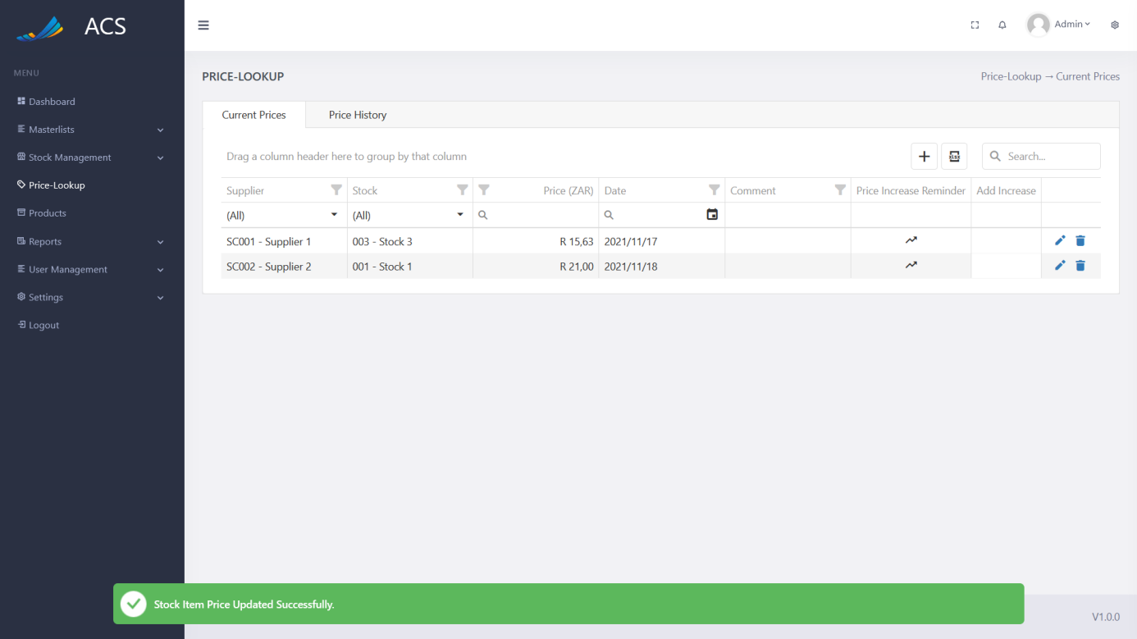

Figures 133: Price Edited Successfully

The user will be able to remove a Price by pressing the trash icon button on the record they wish to remove, see below.

**Image:**

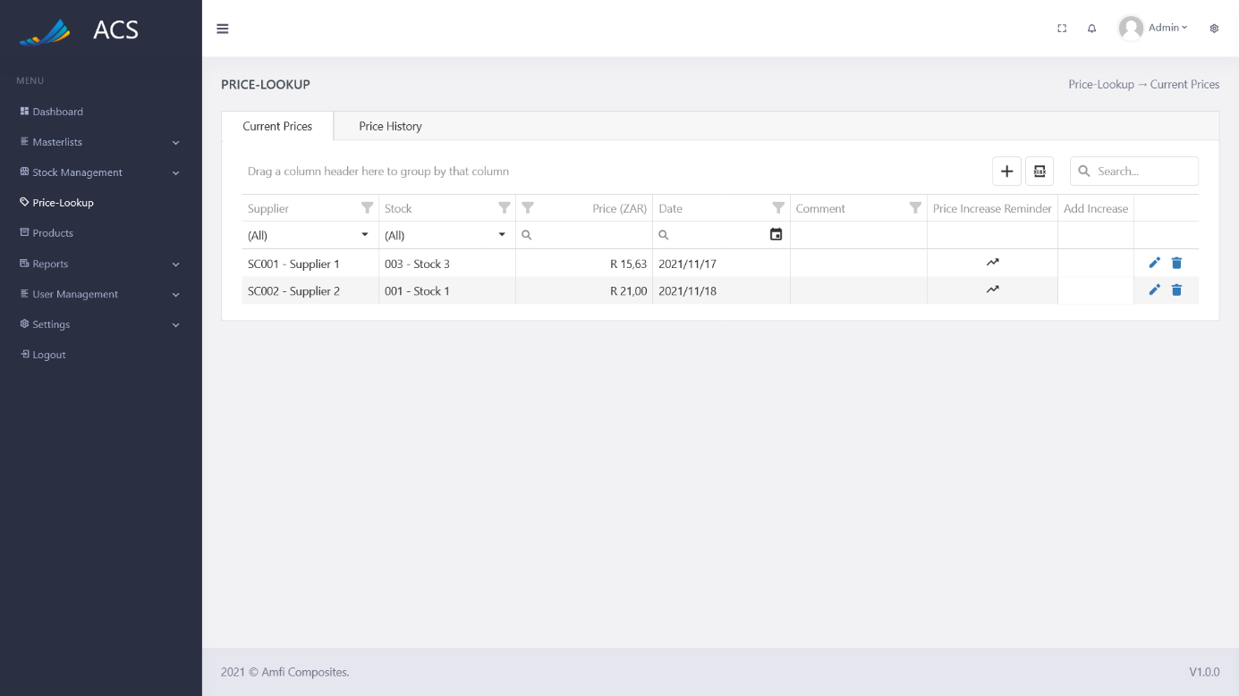

Figures 134: Current Price View

A confirmation popup will appear, press yes to continue OR no to cancel.

**Image:**

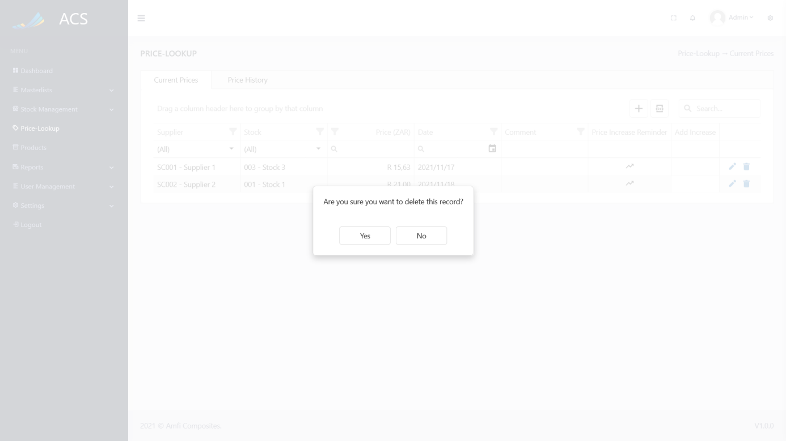

Figures 135: Current Price View

**Image:**

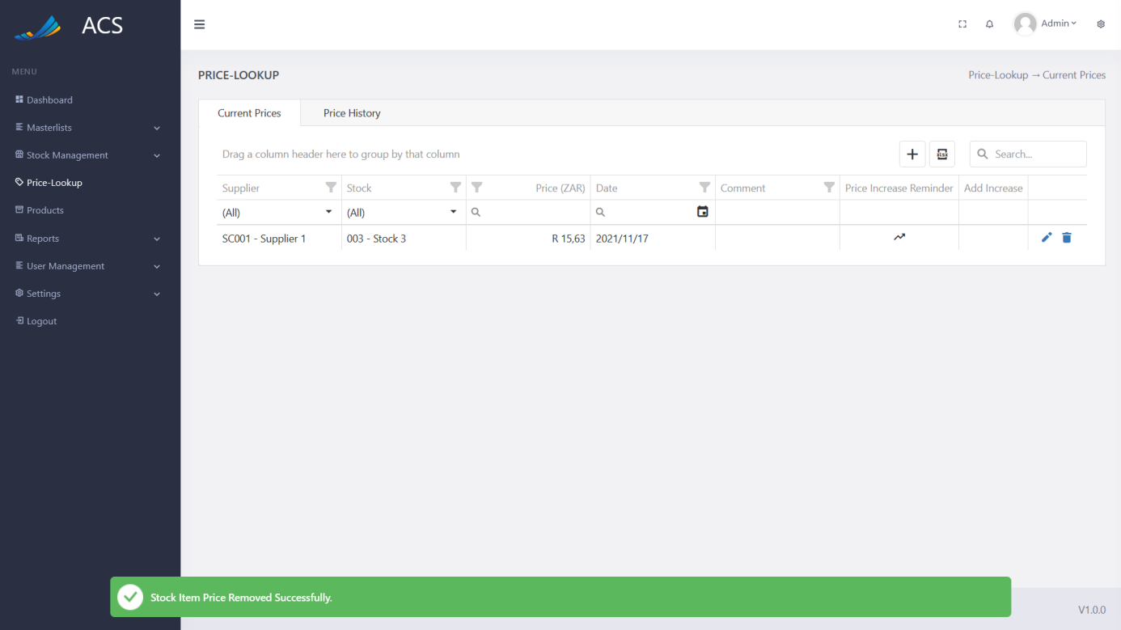

Figures 136: Price Removed Successfully

##### Price Increase Reminder

The user can add a price increase reminder by clicking on the increase icon button.

**Image:**



Figures 137: Increase View

The Price Increase Reminder will appear, the user can fill in all the required fields (marked with a red *) and press the Add Reminder button.

Understanding the fields:

*Increase Type: ZAR or %*

*ZAR: The amount the price will go up with (R15 the previous price + R15)*

*Percentage: The percentage the price will go up with (R10 the previous price + 1%)*

*Increase: The value (ZAR or %)*

*Date: The date of the increase*

**Image:**

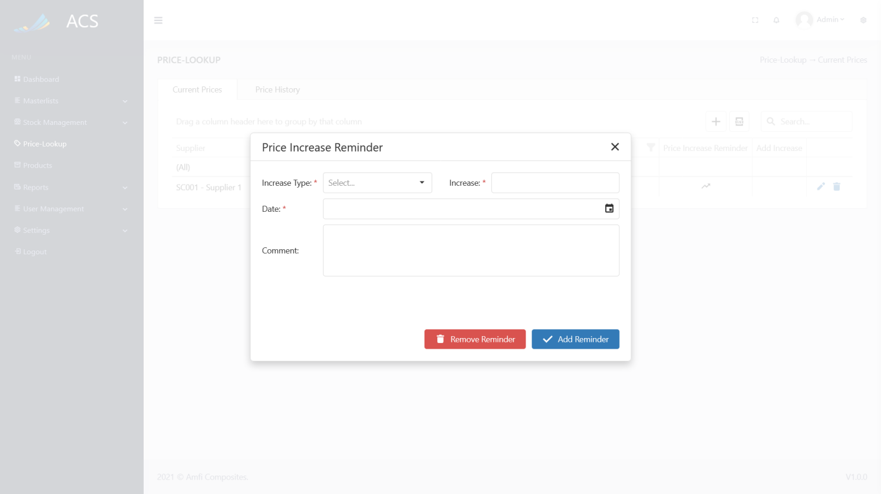

Figures 138: Add Increase

**Image:**

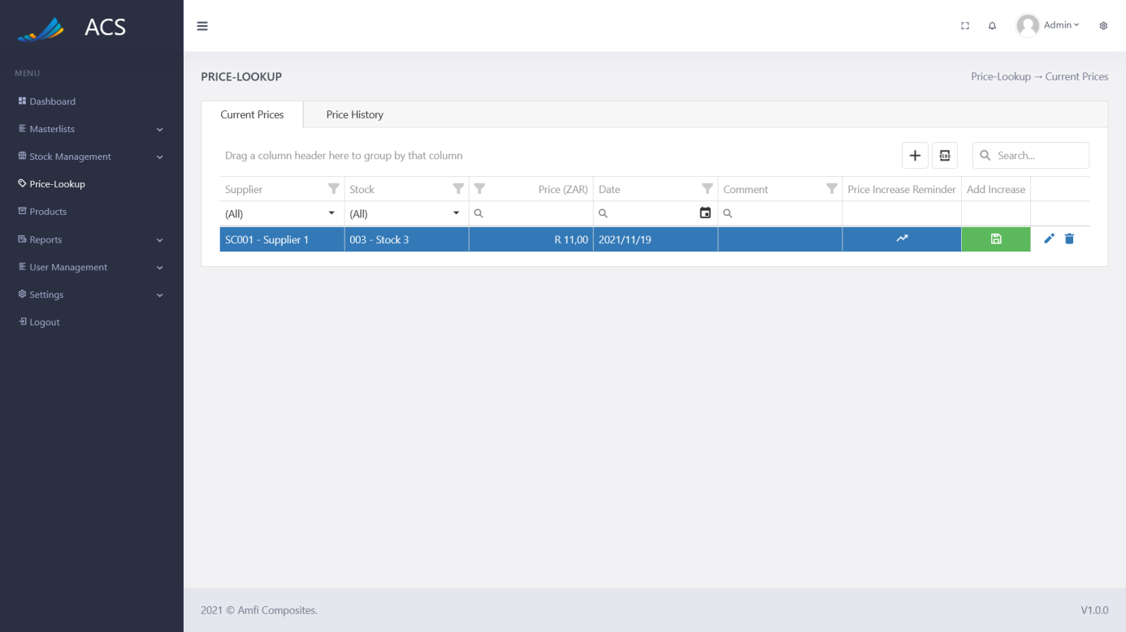

Figures 139: Increase added successfully

The user can edit the price increase reminder by clicking the increase button, the price increase popup will appear with pre-populated data of the price increase the user can make changes and press Update Reminder.

**Image:**

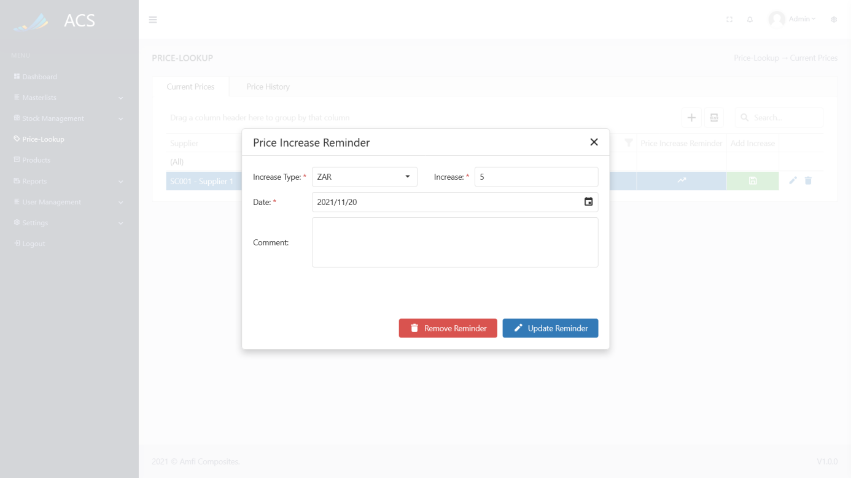

Figures 140: Price Increase Reminder Update

The system will turn the stock price row blue when a reminder is set and the row will turn red when the price increase reminder date has passed.

**Image:**

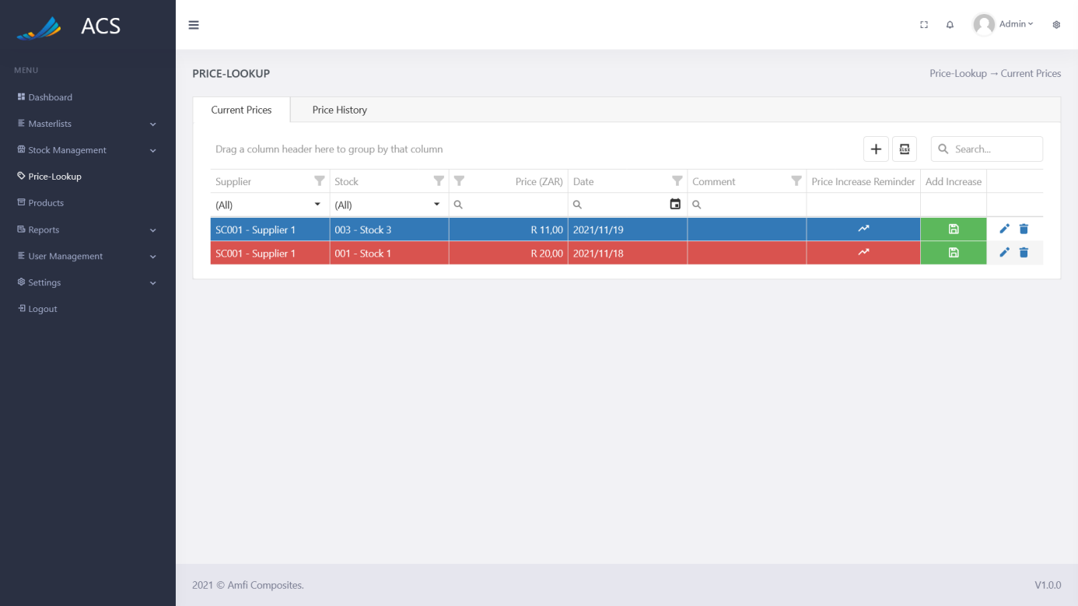

Figures 141: Reminder Colors

##### Add Increase

The user can add an increase to the price. By adding the price increase reminder the system is changing the item price and adding the amount or percentage to the stock item price. The user can add the price increase by pressing the green save icon button.

**Image:**

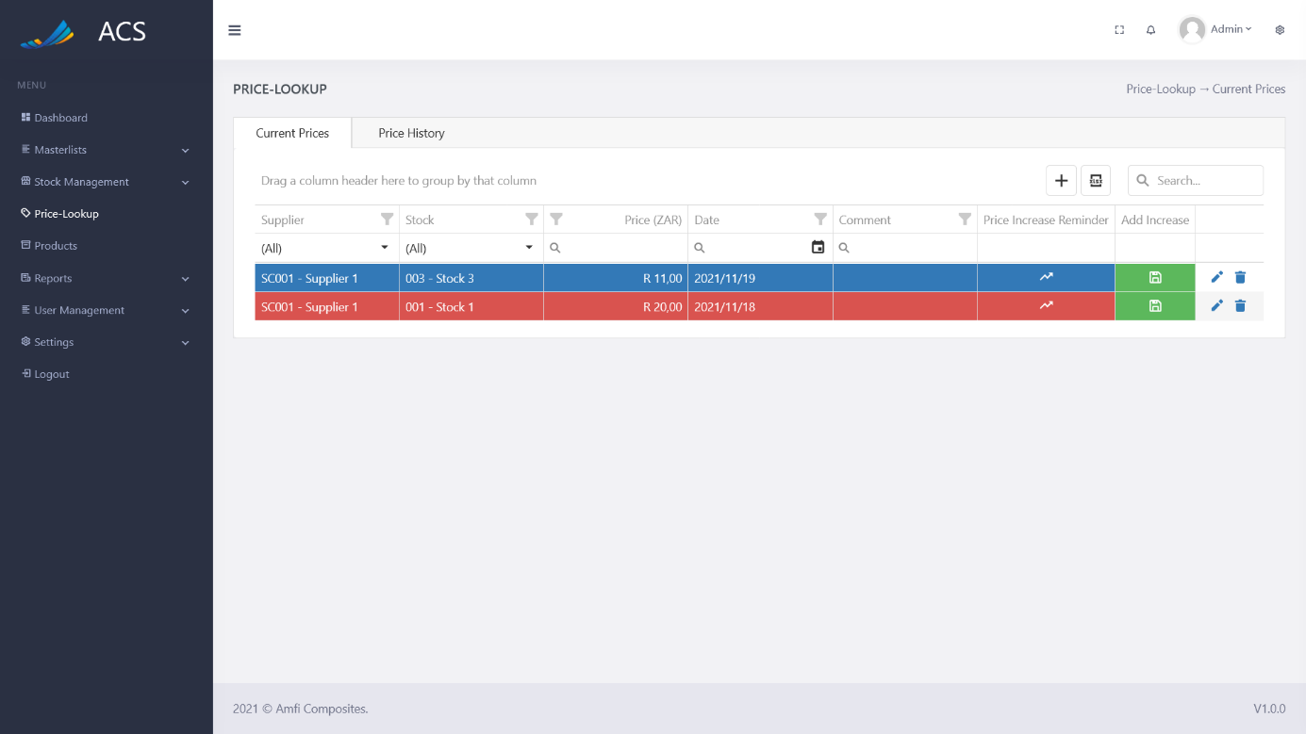

Figures 142: Add Increase

A confirmation popup will appear, press yes to continue OR no to cancel.

**Image:**

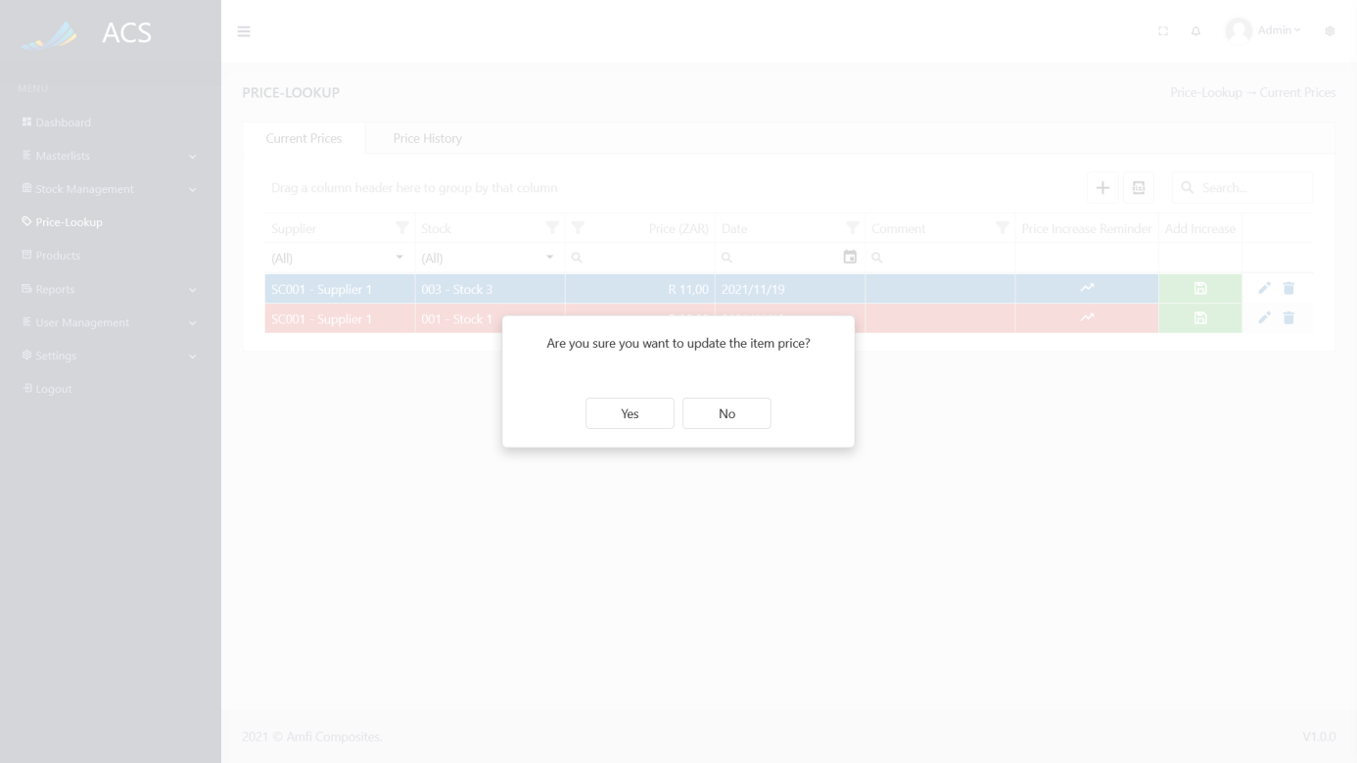

Figures 143: Confirmation

The price of the stock item will update after the price increase was added.

**Image:**

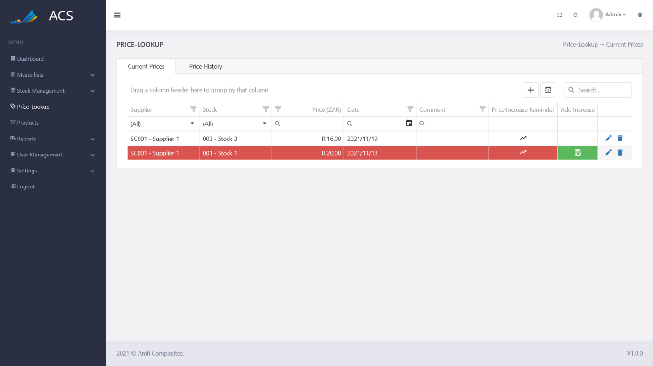

Figures 145: Price Lookup View

#### Price History

The user will be able to view the prices of items that changed over 5 years.

**Image:**

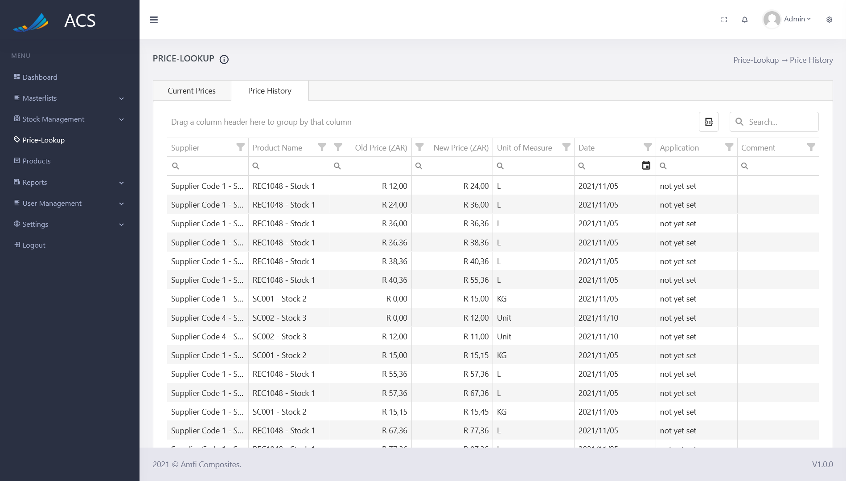

Figures 146: Price History

### Products

The user will be able to view, add, edit and remove products. The user can capture the Product Code, Product Name, Profit Center and Cost Center. The Cost Center dropdown is filtered depending on the Profit Center the user selects. (Profit Centers are linked to Cost Centers)

**Image:**

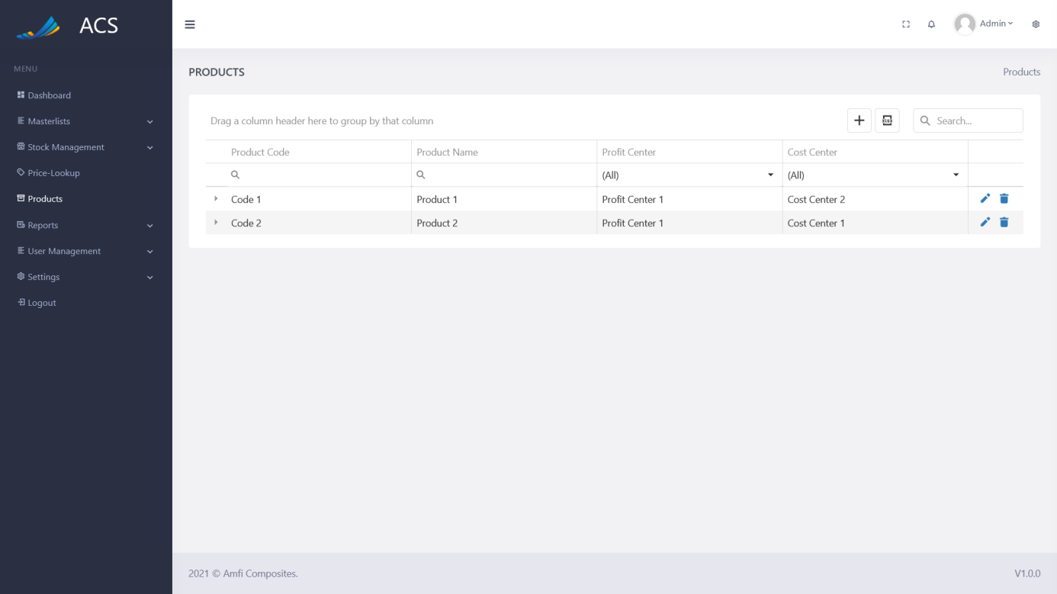

Figures 147: Products View

The user will be able to add a new Product by pressing the plus icon button below.

**Image:**

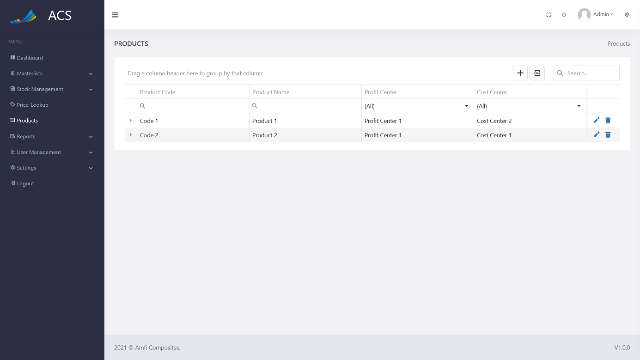

Figures 148: Products View

A Product Information popup will appear, the user can fill in all the required fields (marked with a red *) and press the save button.

**Image:**

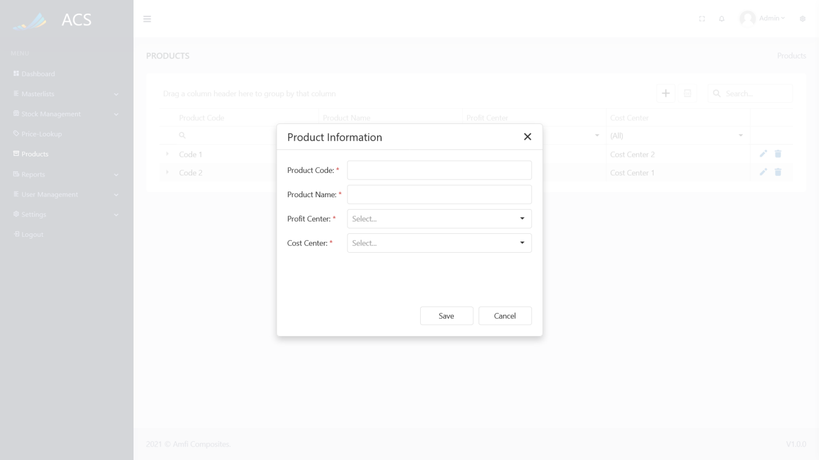

Figures 149: Products View

A success message will appear at the bottom of the screen if a Product was added successfully.

**Image:**

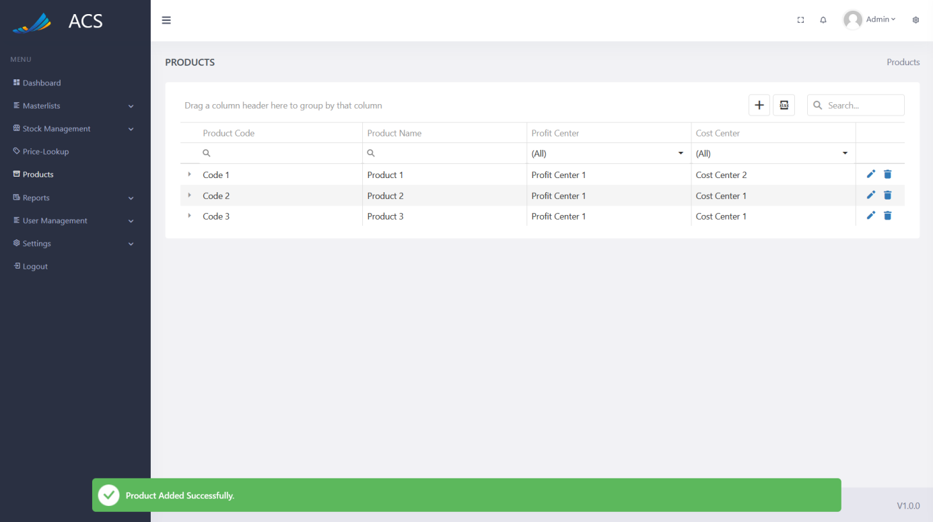

Figures 150: Product Added Successfully

The user will be able to edit a Product by pressing the pencil icon button on the record they wish to edit, see below.

**Image:**



Figures 151: Products View

The Product Information popup will appear with pre-populated data of the Product Information the user can fill in/change all the required fields (marked with a red *) and press the save button.

**Image:**

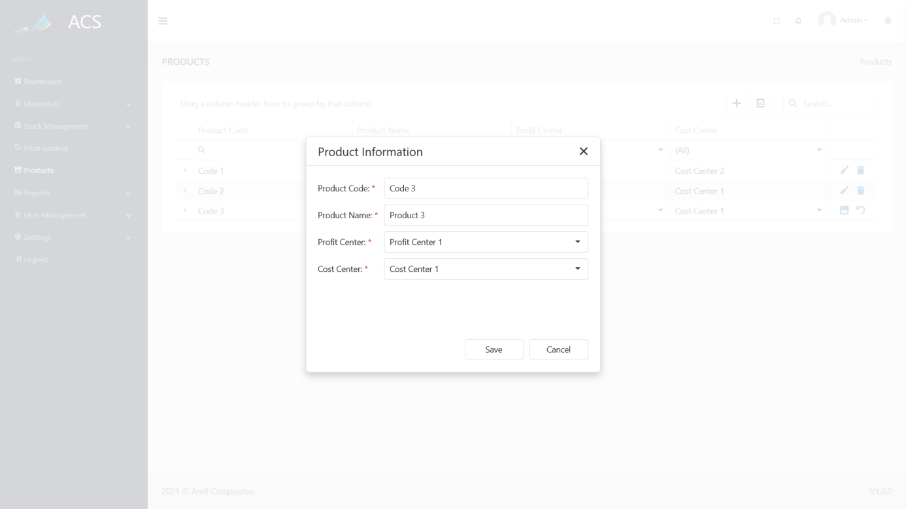

Figures 152: Product Edit

A success message will appear at the bottom of the screen if a Product was updated successfully.

**Image:**

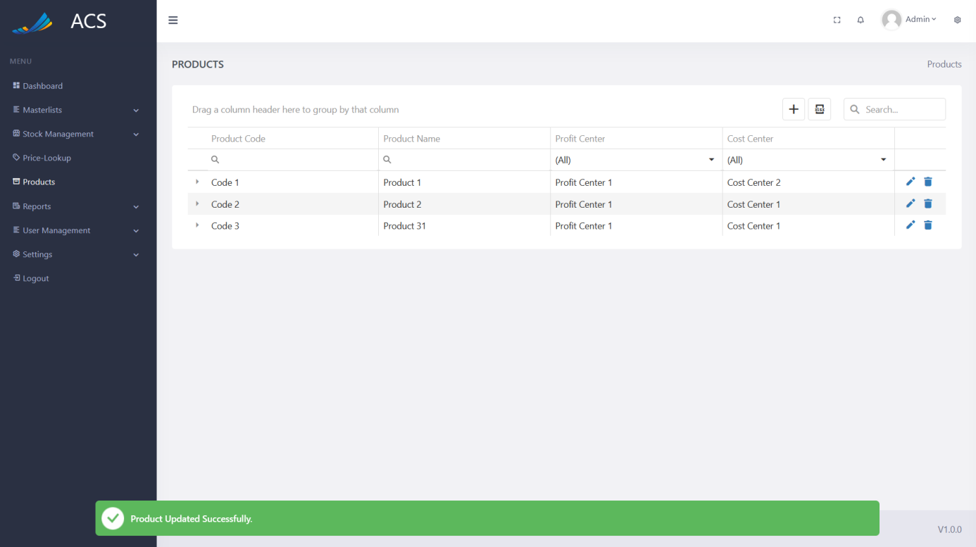

Figures 153: Role Edited Successfully

The user will be able to remove a Product by pressing the trash icon button on the record they wish to remove, see below.

**Image:**

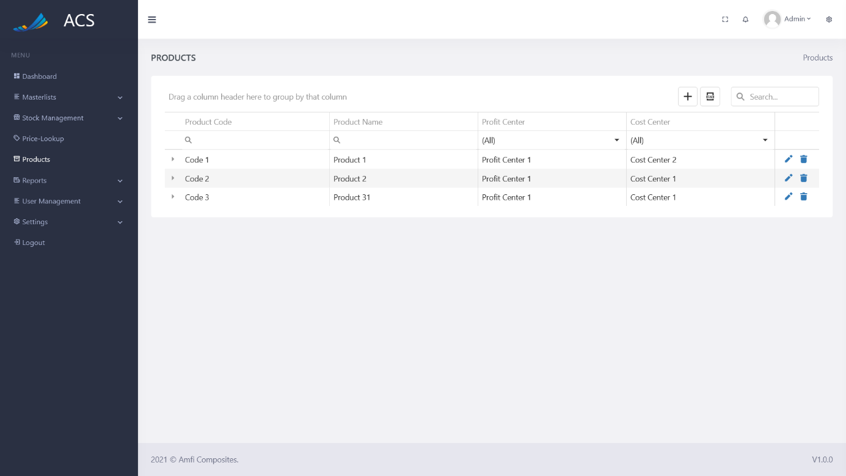

Figures 154: Product View

A confirmation popup will appear, press yes to continue OR no to cancel.

**Image:**

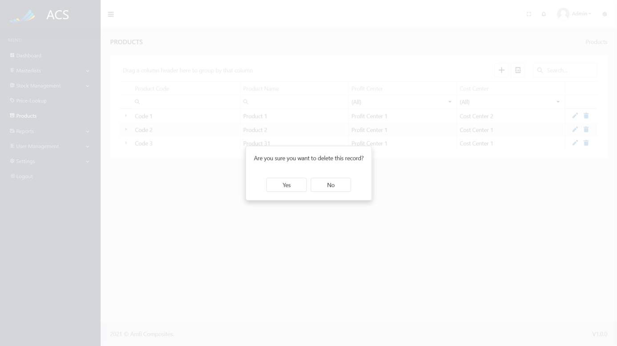

Figures 155: Product View

**Image:**

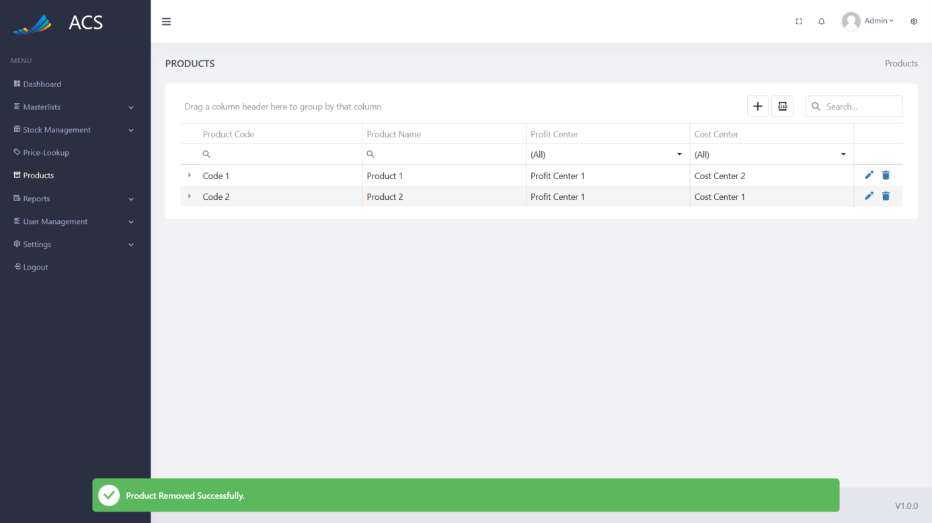

Figures 156: Product Removed Successfully

The user can add stock items to each product. These will be the items needed to create this product. The Product Configuration allows for items to be added, edited, and removed.

**Image:**

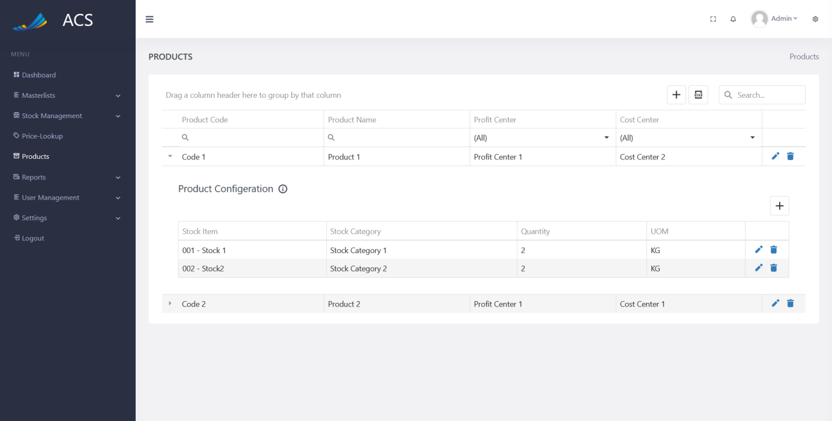

Figures 157: Sub Product Added

### Reports

#### Stock Report

The user will be able to view stock quantity added and stock quantity removed.

**Image:**

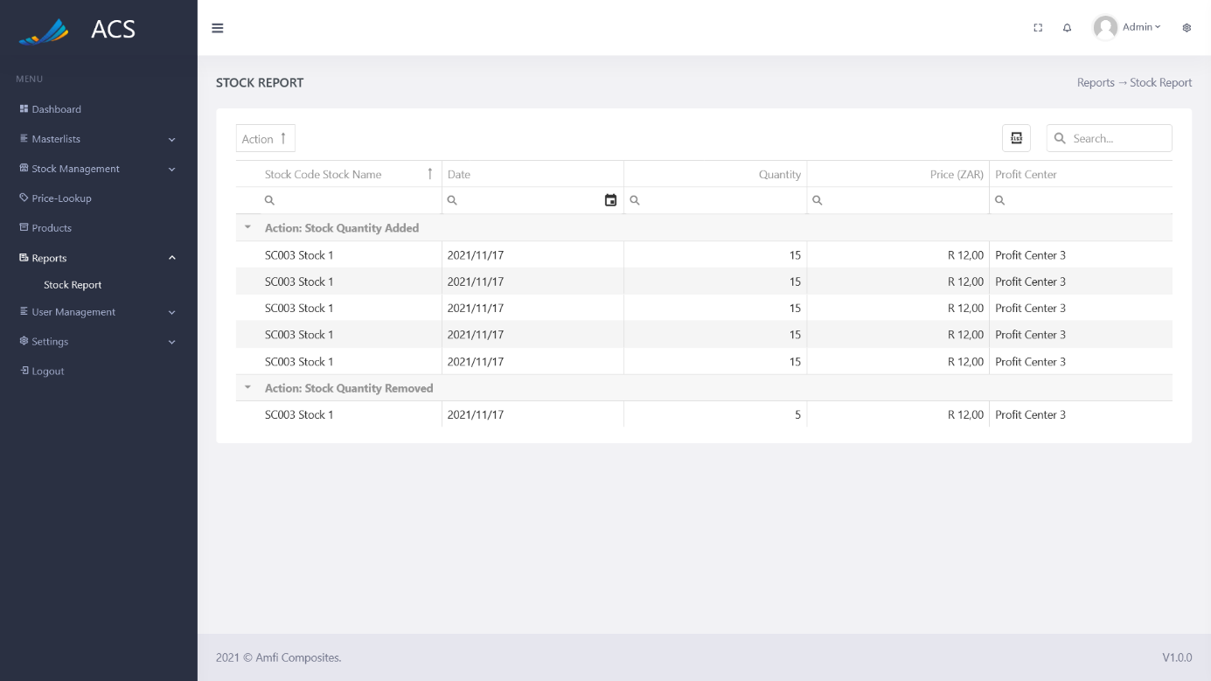

Figures 158: Stock Report

### User Management

#### Users

The user will be able to view, add, edit, deactivate User and Manage Password. The user can capture the Name, Surname, User Name, ID Number, Employee Number, Contact Number, Birthday, Income Tax Number, Race, Gender, Marital Status, Next of Kin Name, Next of Kin Contact Number, Hourly Rate, Base Salary Per Month, Highest Qualification, Number of Dependants, Type of Employment, Email, Start Date, Employee Position, Payment Intervals, Law, Physical Address, Banking Details.

**Image:**

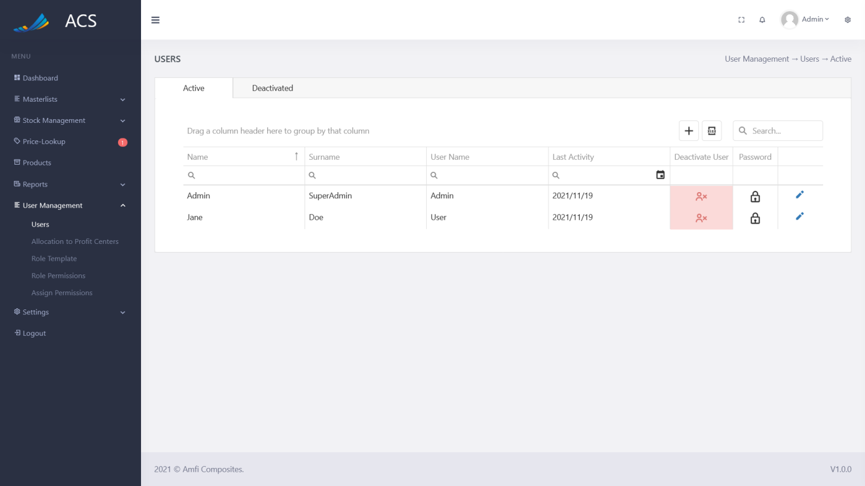

Figures 159: Users View

The user will be able to add a new user by pressing the plus icon button below.

**Image:**

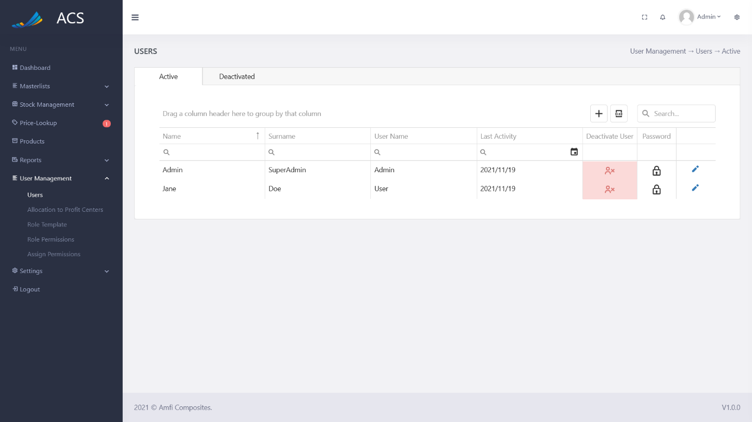

Figures 160: Users View

A User Information popup will appear, the user can fill in all the required fields (marked with a red *) and press the save button.

**Image:**

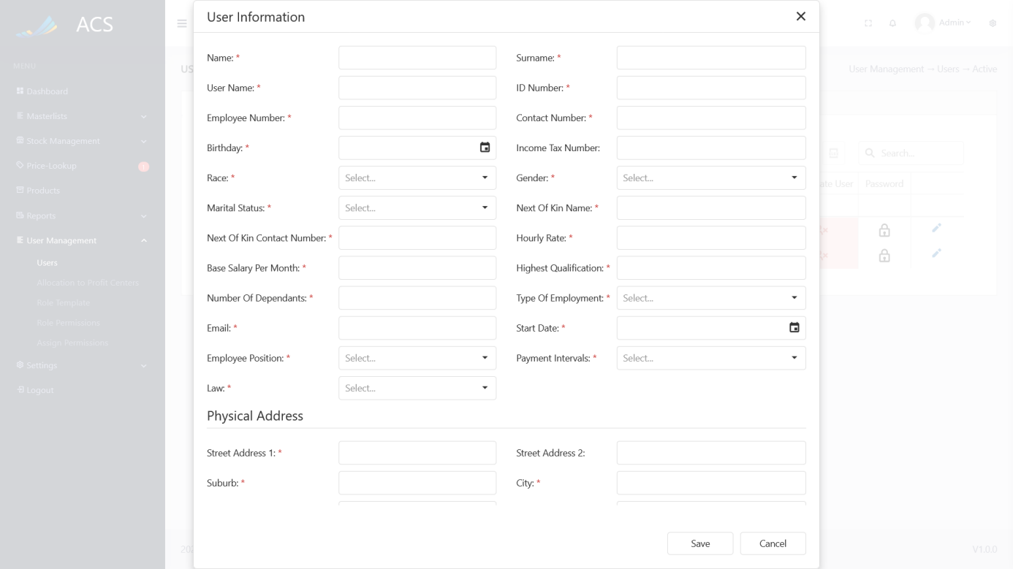

Figures 161: User View

A success message will appear at the bottom of the screen if a User was added

**Image:**

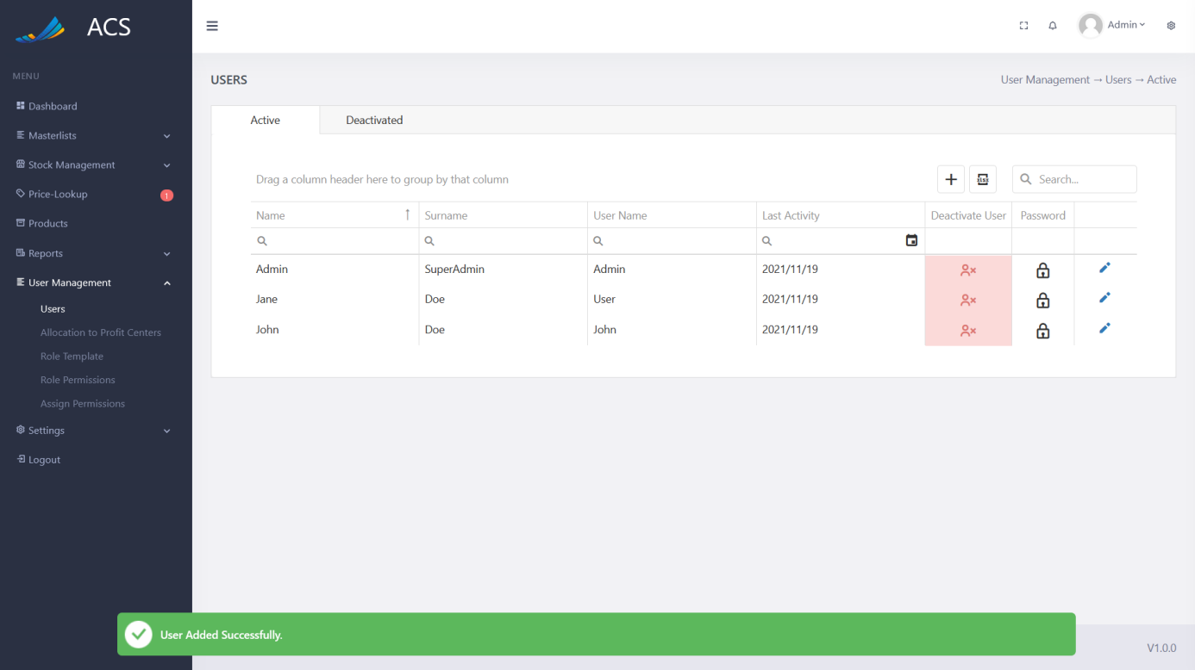

Figures 162: User Added Successfully

The user will be able to edit a User by pressing the pencil icon button on the record they wish to edit, see below.

**Image:**

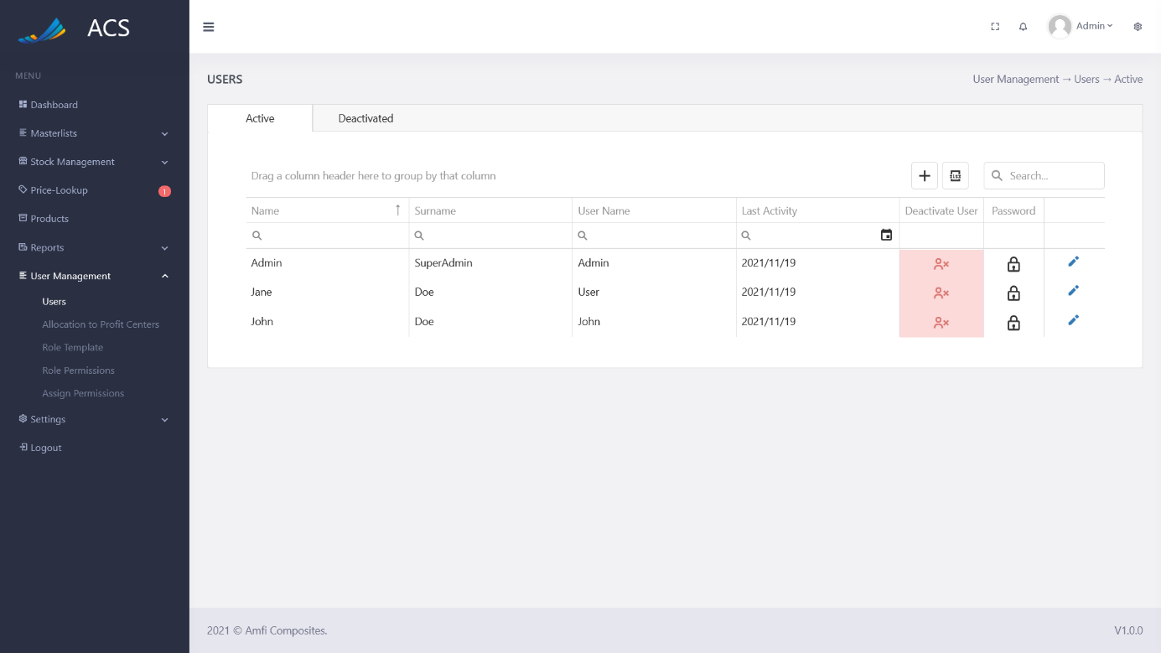

Figures 167: User View

The User Information popup will appear with pre-populated data of the User Information the user can fill/change all the required fields (marked with a red *) and press the save button.

**Image:**

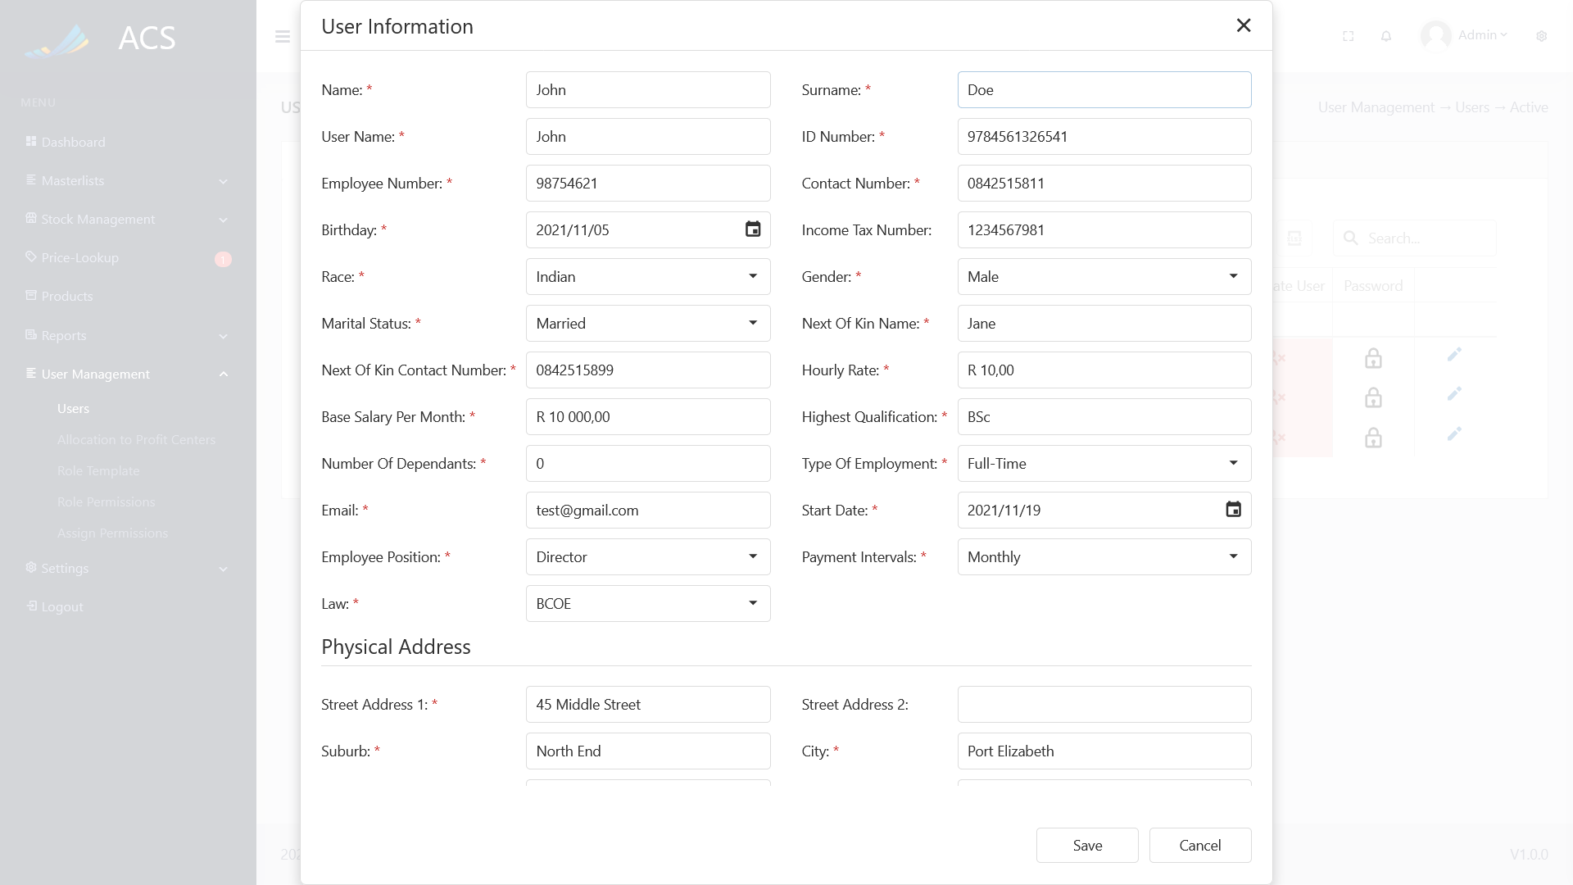

Figures 168: User Edit

A success message will appear at the bottom of the screen if a User was updated successfully.

**Image:**

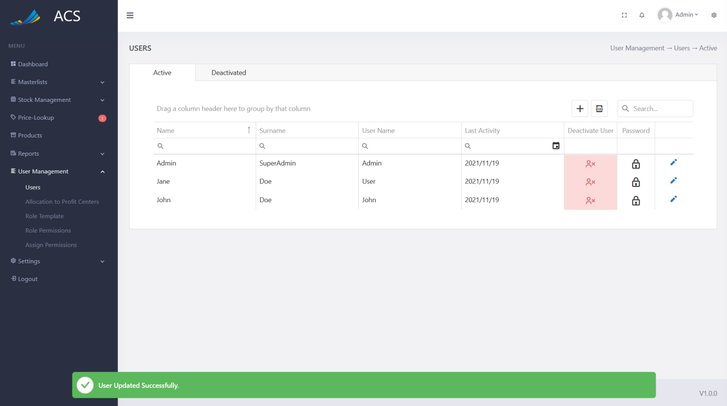

Figures 169: User Edited Successfully

##### Deactivated

The user will be able to Deactivate a user. A user can be deactivated by pressing the red deactivate user button.

**Image:**



Figures 170: Deactivate User

A Disable User popup will appear, the user can type “DISABLE“ into the input field and press the green disable button.

**Image:**

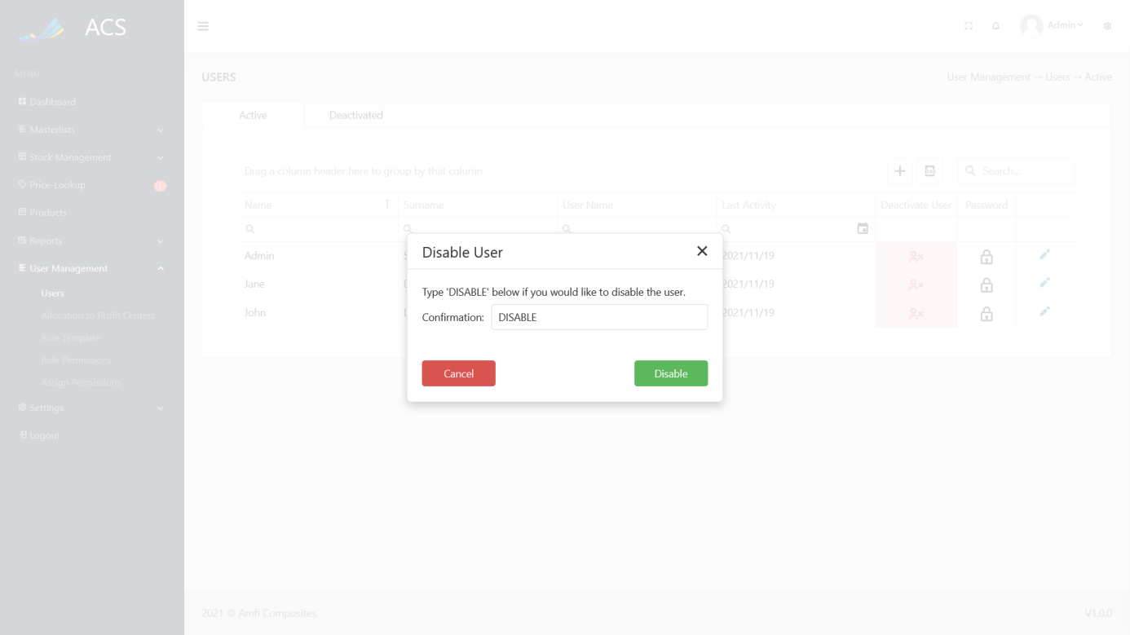

Figures 171: confirmation box

A success message will appear at the bottom of the screen if a User was successfully deactivated. The active user table will update.

**Image:**

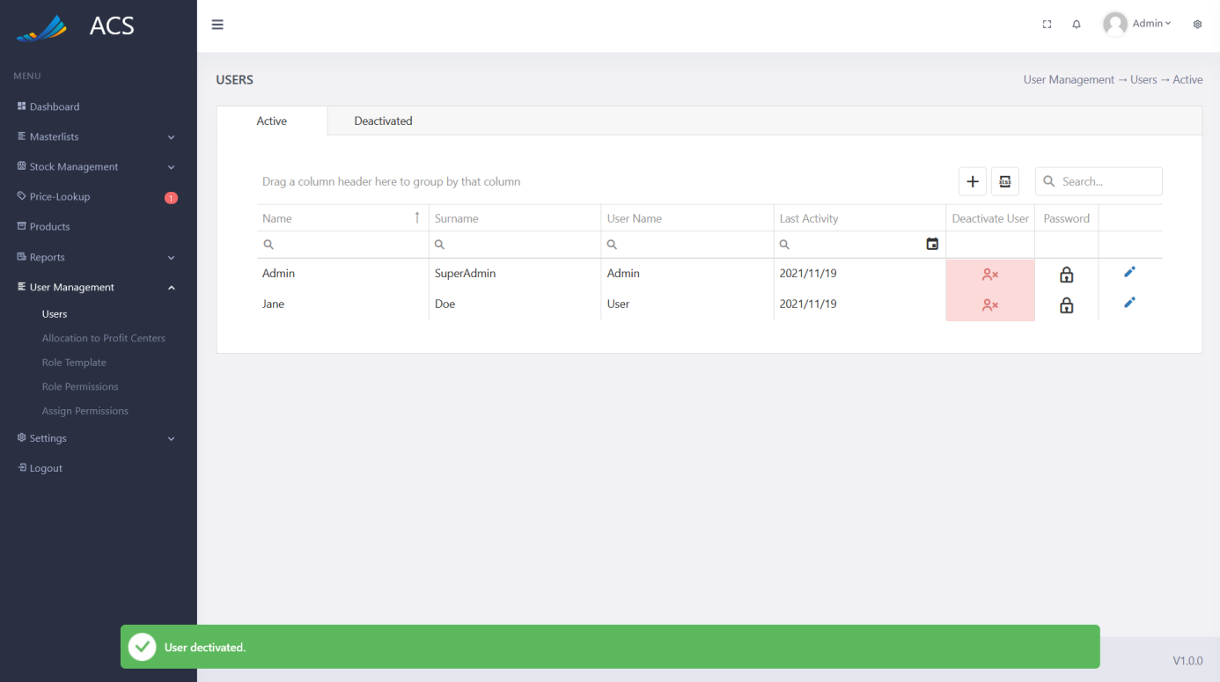

Figures 172: Successfully Deactivate a user

##### Manage Password

The user will be able to manage the password. A user's password can be changed by pressing the lock icon button.

**Image:**



Figures 173: Manage Password

A Manage Password popup will appear, the user can select one of these methods:

* *Reset Password (Send Email Link)*
* *Admin set a new password*

The user can select a method, enter the new password and press the green manage button.

**Image:**

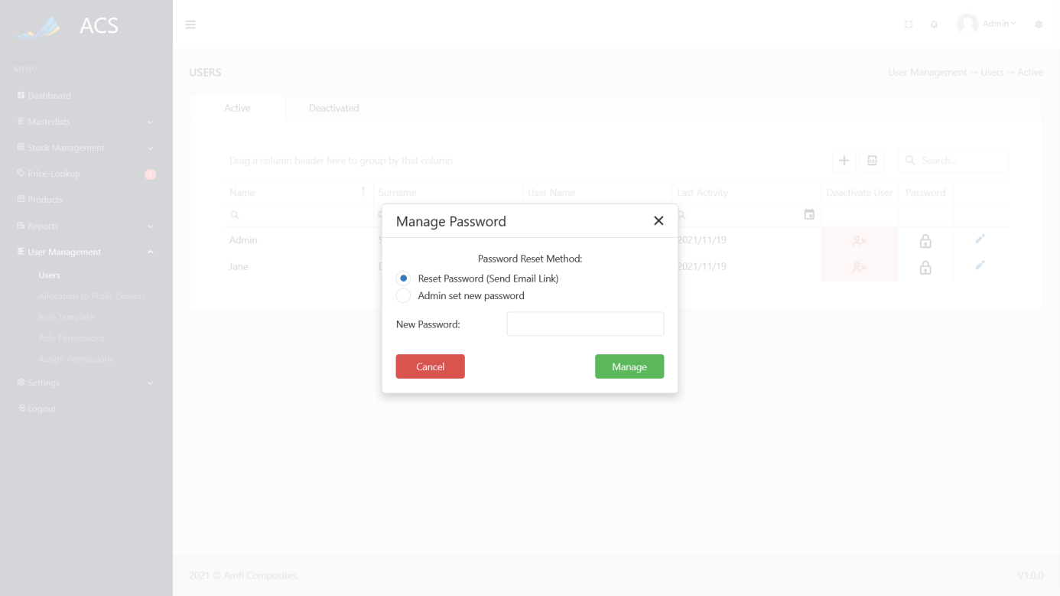

Figures 178: Manage Password Popup

##### Active

The user will be able to activate a user again by pressing the green activate user button. The deactivated user table will update.

**Image:**

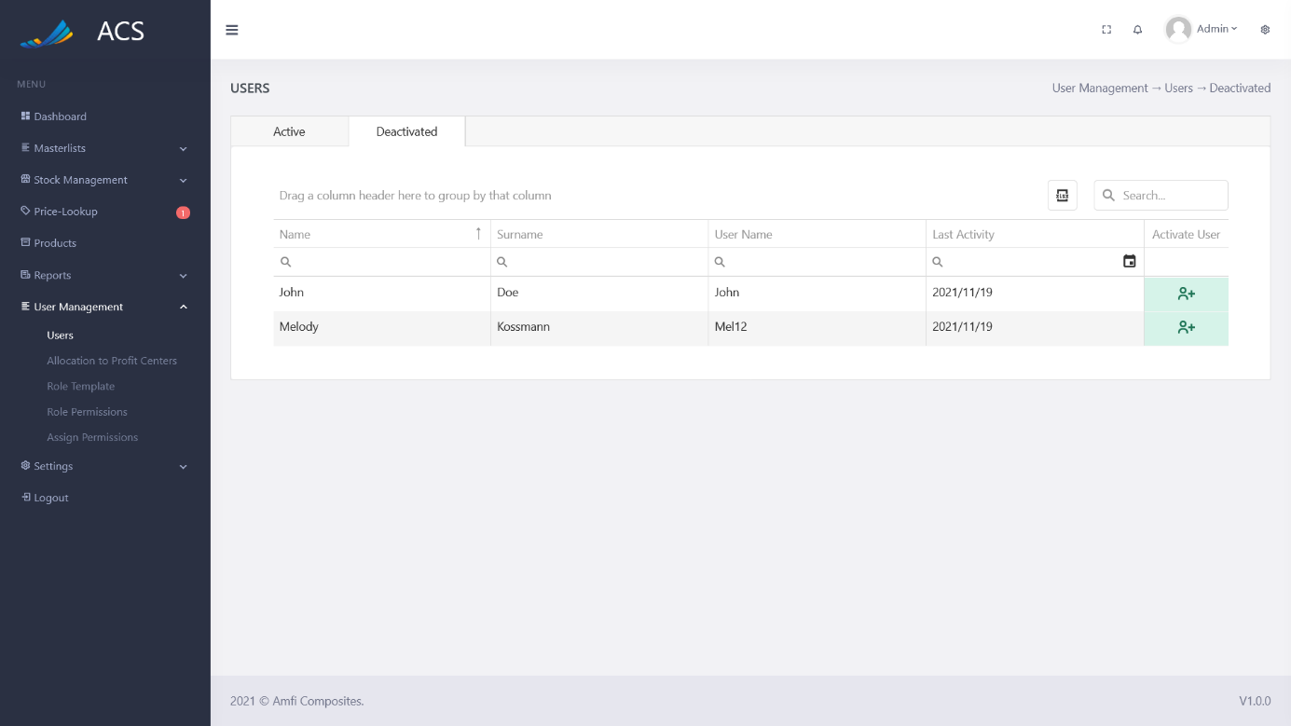

Figures 179: Activate User

#### Allocation to Profit Centers

The user will be able to allocate a user to multiple profit centers. A user can be divided into multiple profit centers. A user should have a total percentage of 100% between the profit centers. All the active users in the system will be listed in the table.

**Image:**

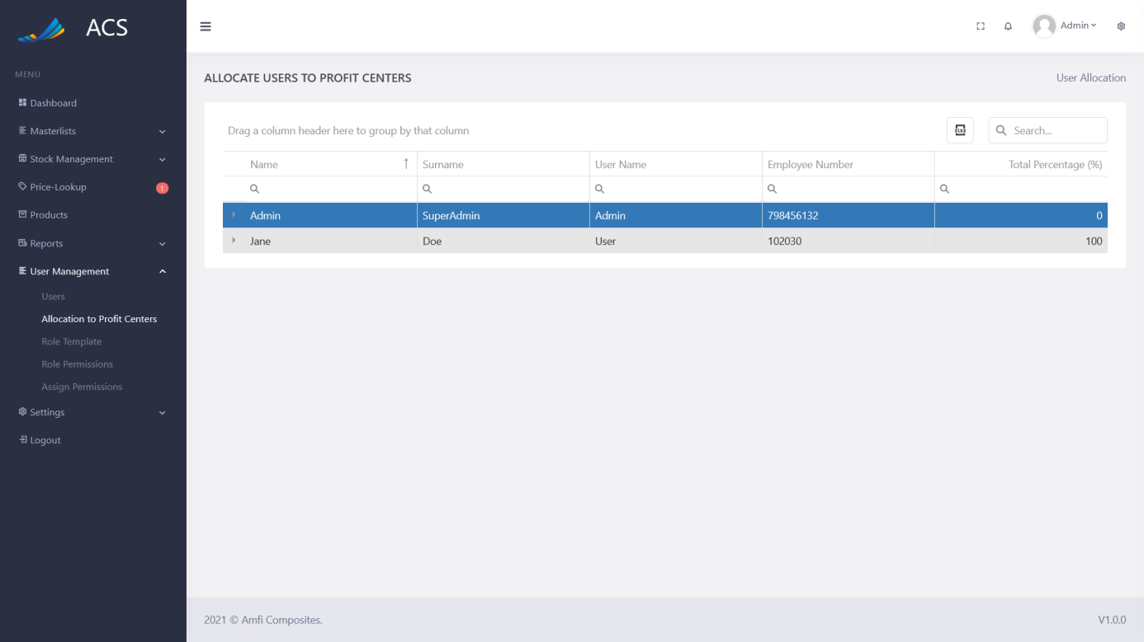

Figures 180: Allocation to Profit Center

The user can add profit centers to users by clicking the plus icon at the top and selecting the profit center and entering a percentage.

**Image:**

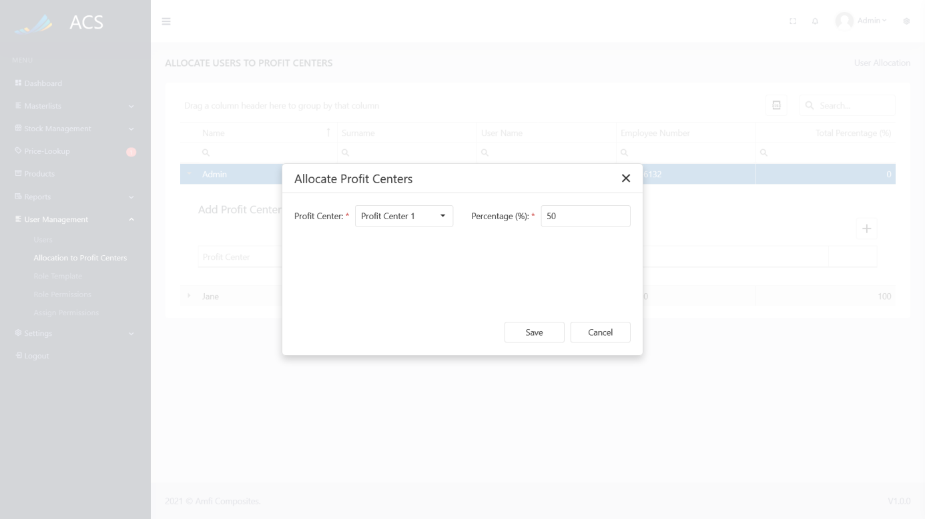

Figures 181: Allocation to Profit Center

The user row will turn blue if a user's profit center allocation is less than 100%. The row will turn white if the user's profit center allocation is 100%.

**Image:**

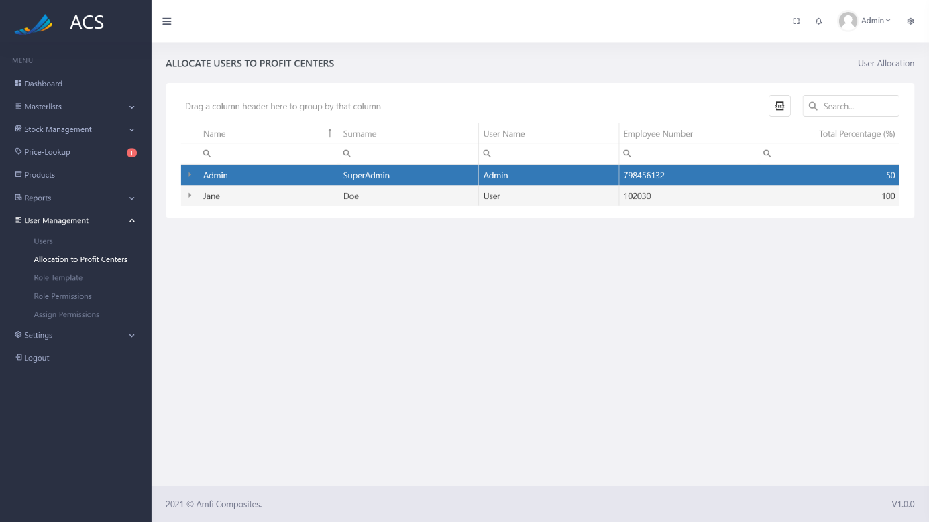

Figures 182: Allocation to Profit Center

#### Role Template

The user will be able to view, add, edit and remove Role Templates. The user can capture the Name. Role Templates can be used to assign permission to, for example:

* *Admin Role will have the following permissions:*
  + *View All Pages*
  + *Modify All Pages*
* *User Role, Will have the following permissions:*
  + *View All Pages*

**Image:**

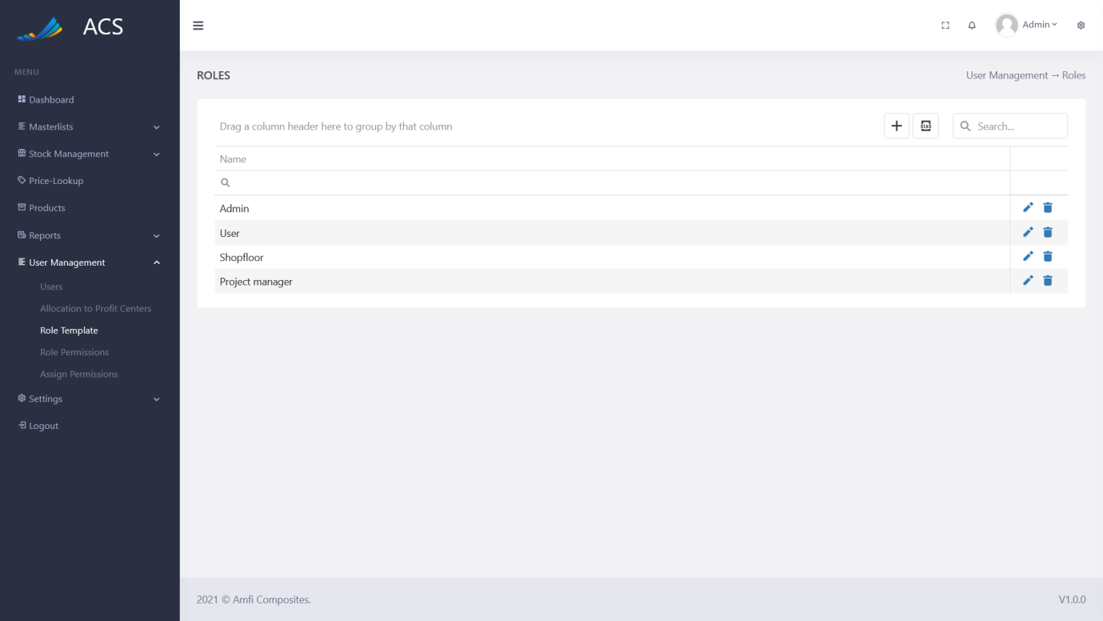

Figures 183: Roles Template View

The user will be able to add a new Role by pressing the plus icon button below.

**Image:**

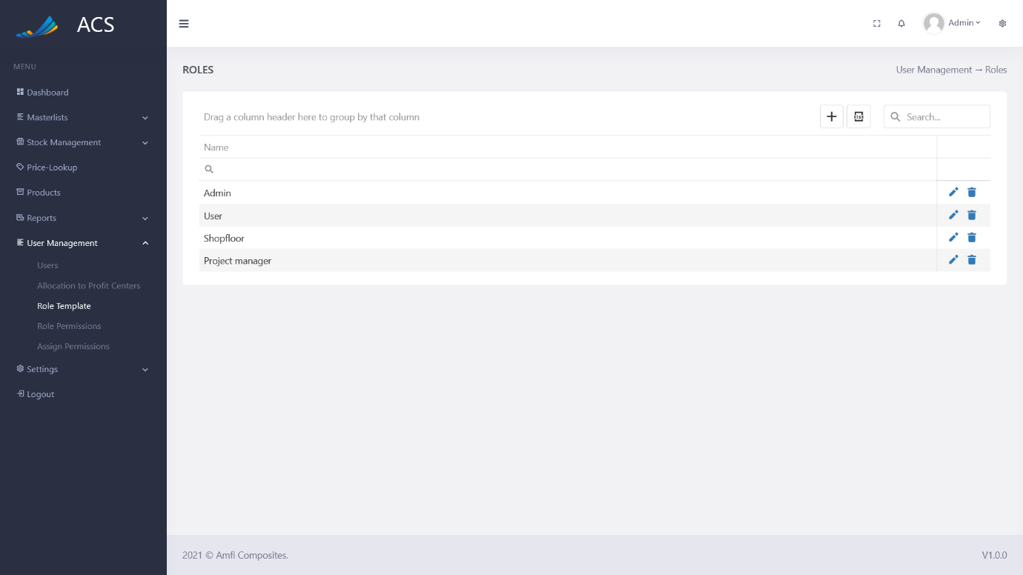

Figures 184: Roles Add Button

A Roles Template popup will appear, the user can fill in all the required fields (marked with a red *) and press the save button.

**Image:**

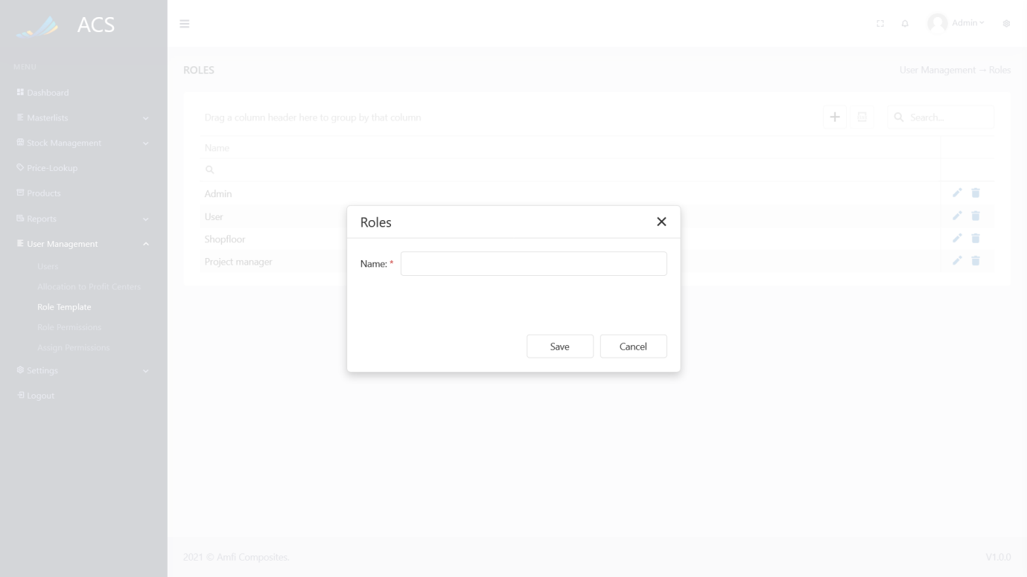

Figures 185: Roles Add

A success message will appear at the bottom of the screen if a Role was added successfully.

**Image:**

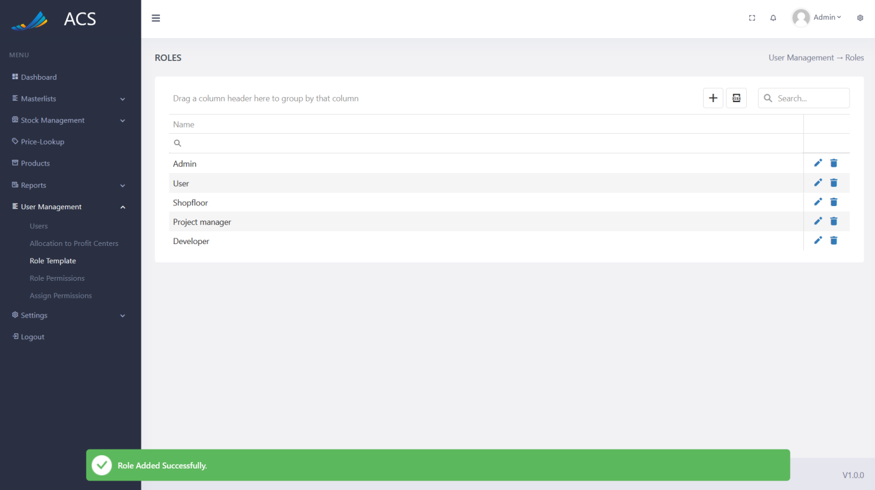

Figures 186: Role Added Successfully

If duplicate Roles (Name) are added the system will block the request and send back an error message to the user to state the Role already exists.

**Image:**

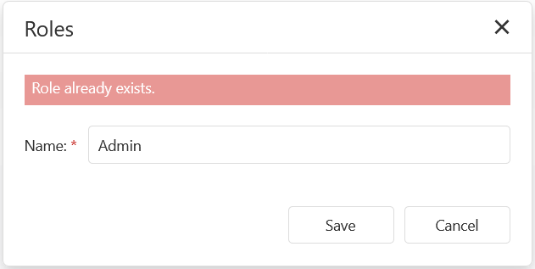

Figures 187: Adding duplicate Roles

The user will be able to edit a Role Template by pressing the pencil icon button on the record they wish to edit, see below.

**Image:**

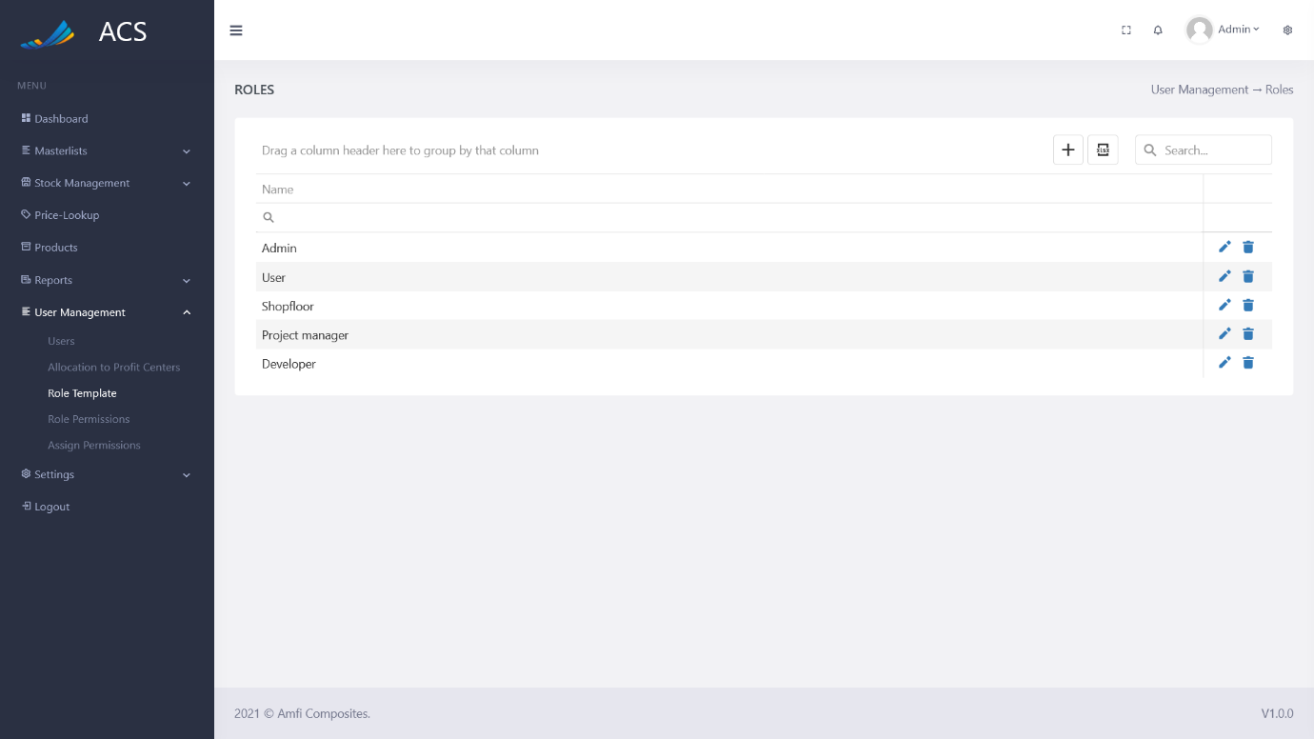

Figures 188: Roles View

The Role Template popup will appear with pre-populated data of the Role Template the user can fill in/change all the required fields (marked with a red *) and press the save button.

**Image:**

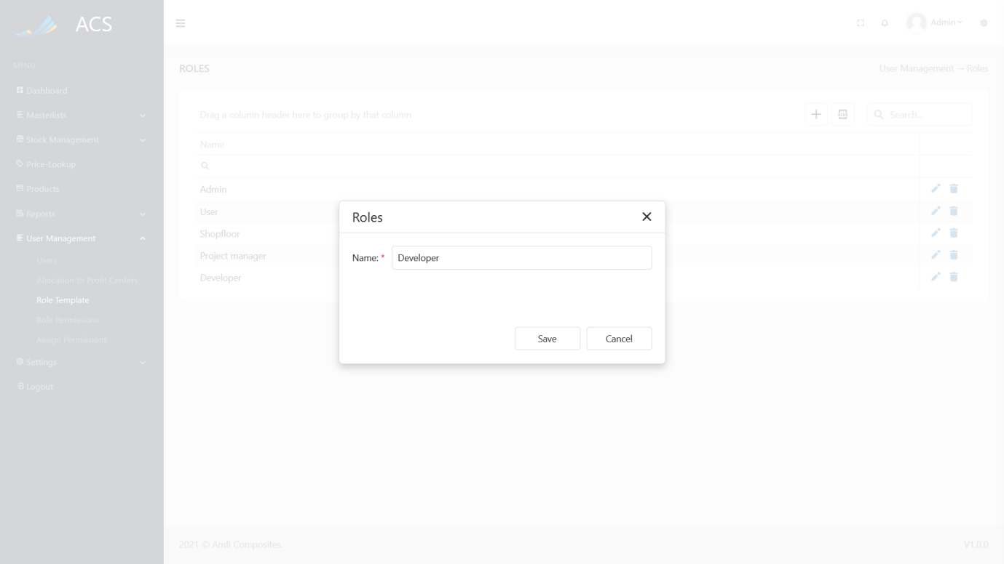

Figures 189: Roles Edit

A success message will appear at the bottom of the screen if a Role Template was updated successfully.

**Image:**

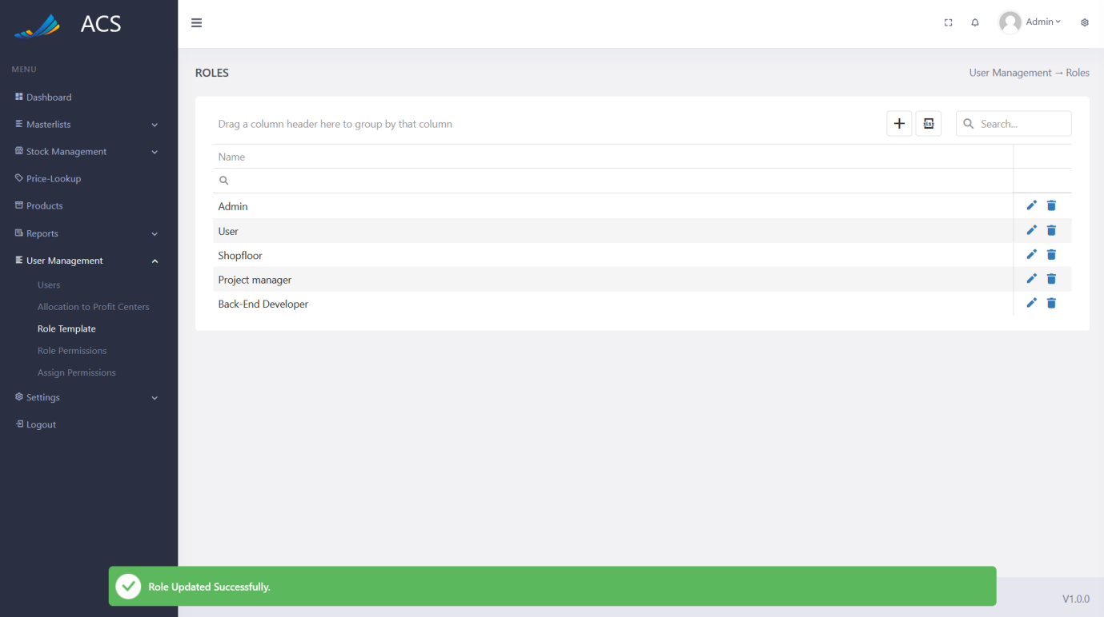

Figures 190: Roles Edited Successfully

The user will be able to remove a Role by pressing the trash icon button on the record they wish to remove, see below.

**Image:**

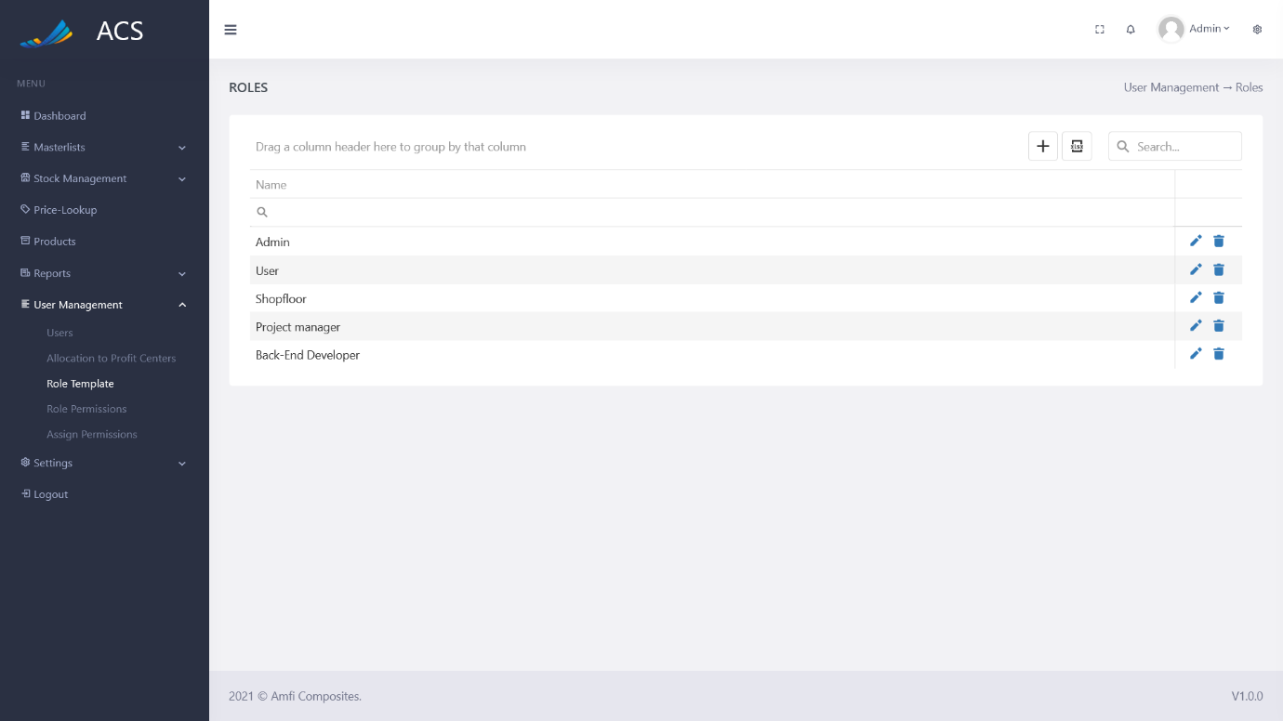

Figures 191: Role Template View

A confirmation popup will appear, press yes to continue OR no to cancel.

**Image:**

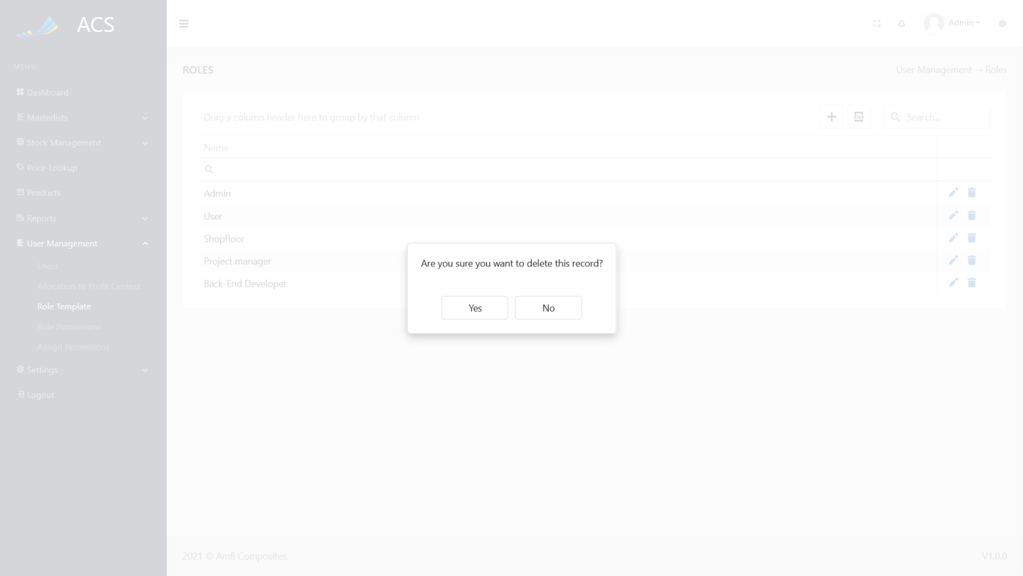

Figures 192: Role Template View

**Image:**

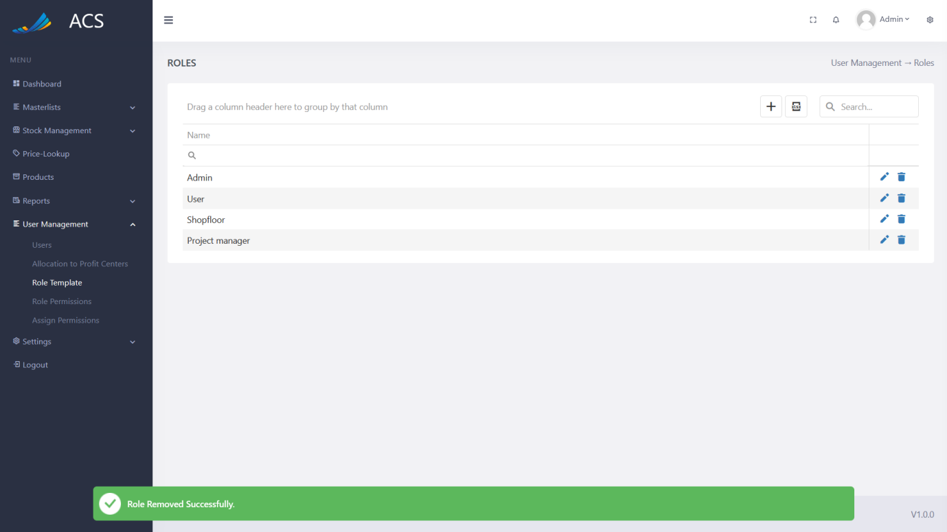

Figures 193: Role Template Removed Successfully

#### Role Permissions

The user will be able to assign permission to a role by selecting a role blueprint and ticking all the permission the user wishes to assign to the role. The user will then press the green Update Role Permission button to assign the permission to the role blueprint.

**Image:**

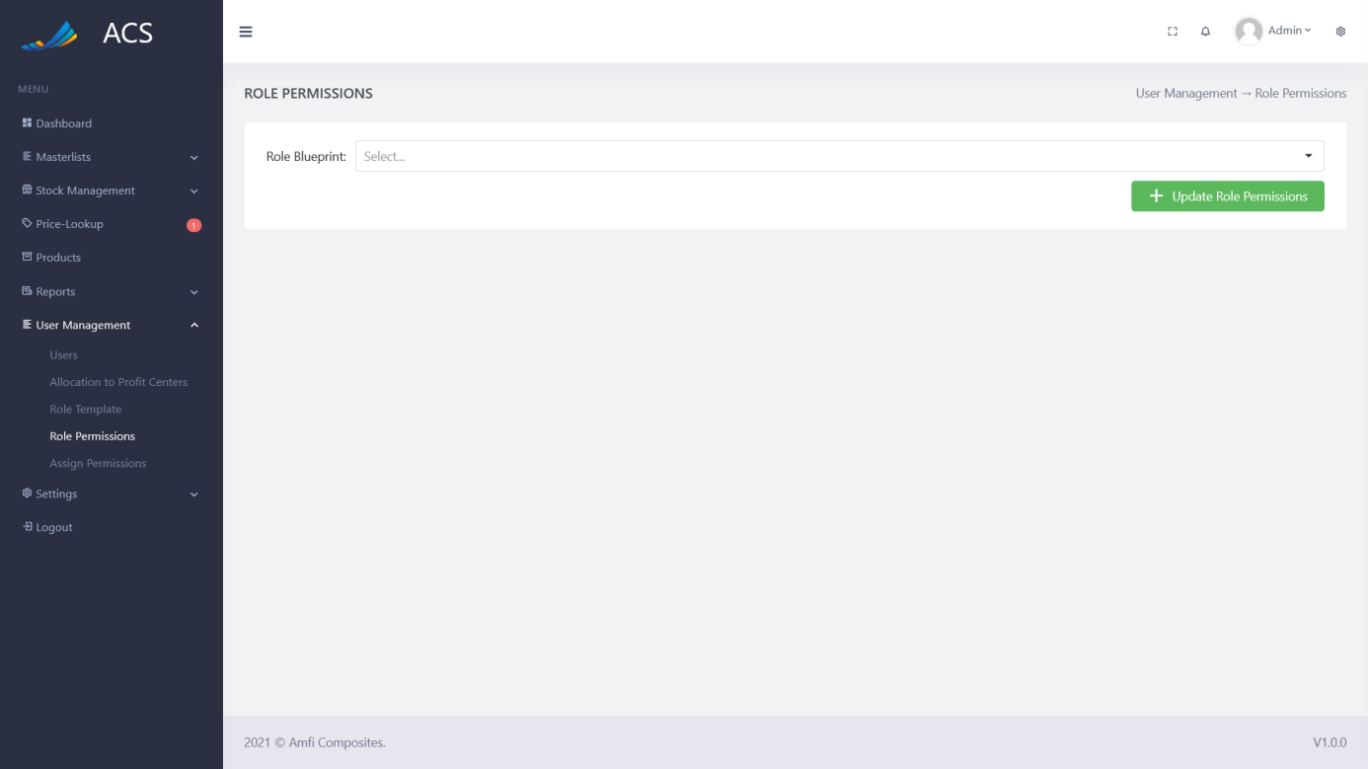

Figures 194: Role Permissions

**Image:**

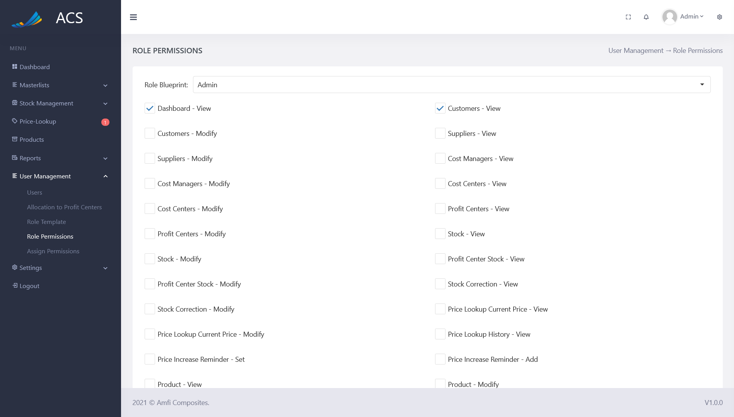

Figures 195: Update Role Permissions

#### Assign Permissions

The user will be able to assign a Role Blueprint to a user. The Role Blueprint can be assigned to a user by selecting a user from the dropdown and the role blueprint and clicking the green Update User Permissions button.

**Image:**

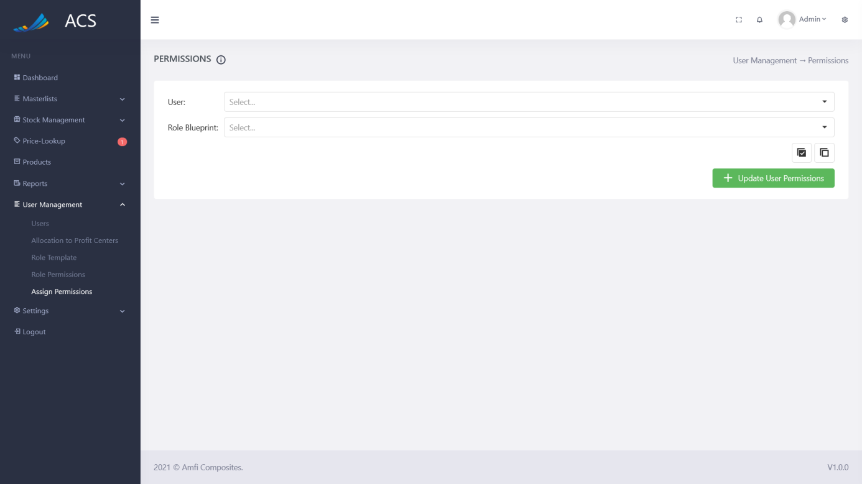

Figures 196: Assign Permissions

**Image:**

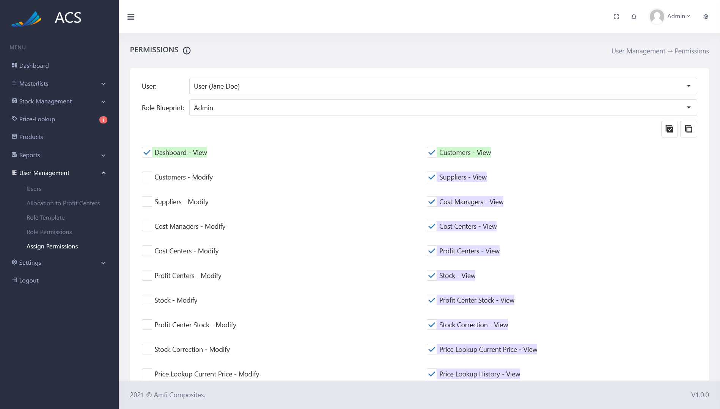

Figures 197: Assign Permissions

Permission Rule Colors to understand before assigning permissions to users

**Image:**

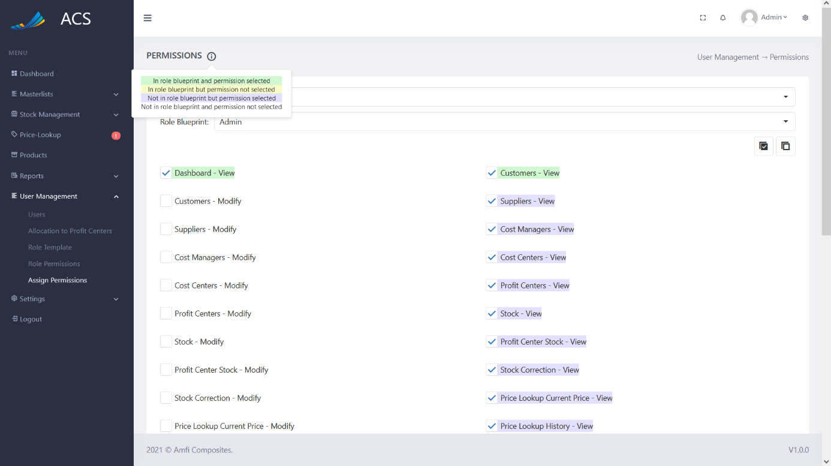

Figures 198: Rules

### Settings

#### System Config

The user will be able to add data to use within the system, this data will auto-populate some dropdowns used within the system. The user will be able to add data for the following pages:

* Supplier Category
* Stock Category
* Unit of Measurement
* Payment Methods
* Employee Position

The user can navigate to each section by clicking on the tab they wish to navigate to.

**Image:**

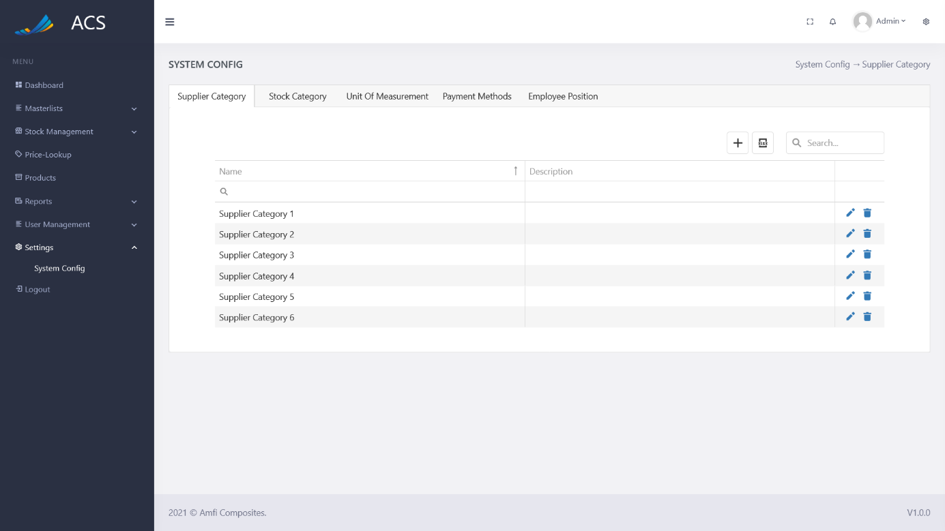

Figures 199: System Config

##### Supplier Category

The user will be able to view, add, edit and remove supplier categories. The user can capture the Name and Description.

**Image:**

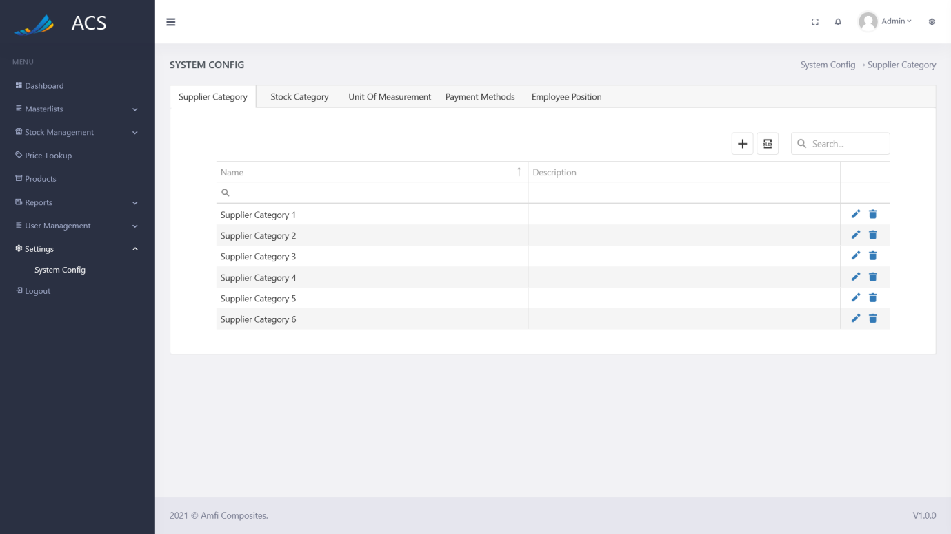

Figures 200: Supplier Category View

The user will be able to add a new Supplier Category by pressing the plus icon button below.

**Image:**

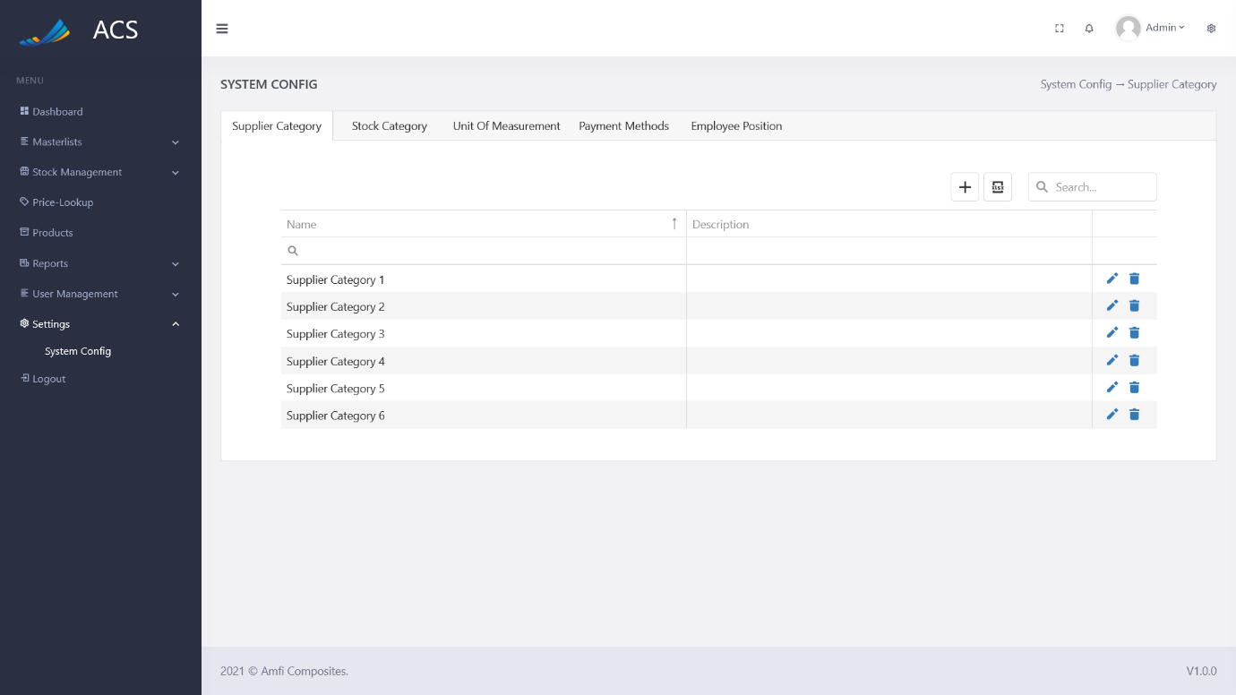

Figures 201: Supplier Category Add Button

A Supplier Category popup will appear, the user can fill in all the required fields (marked with a red *) and press the save button.

**Image:**

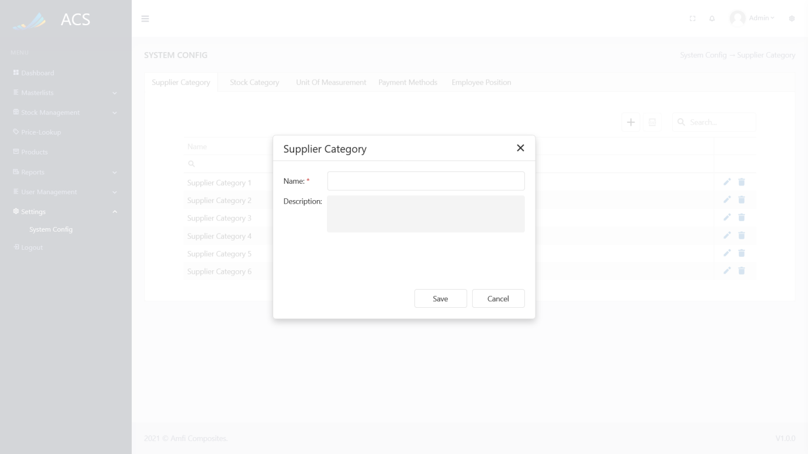

Figures 202: Supplier Category Add

A success message will appear at the bottom of the screen if a Supplier Category was added successfully.

**Image:**

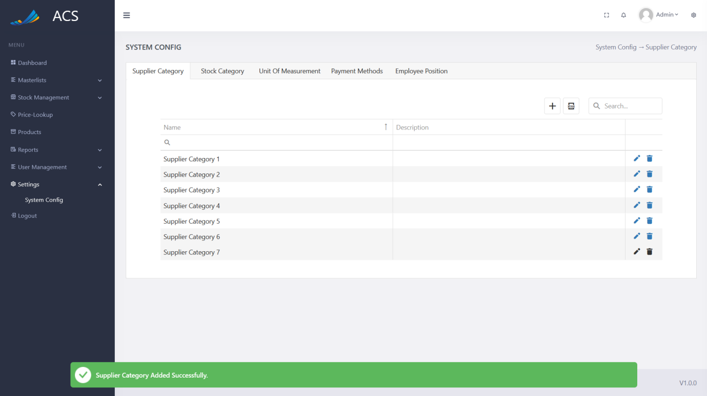

Figures 203: Supplier Category Added Successfully

If duplicate supplier categories (Name) are added the system will block the request and send back an error message to the user to state the supplier category already exists.

**Image:**

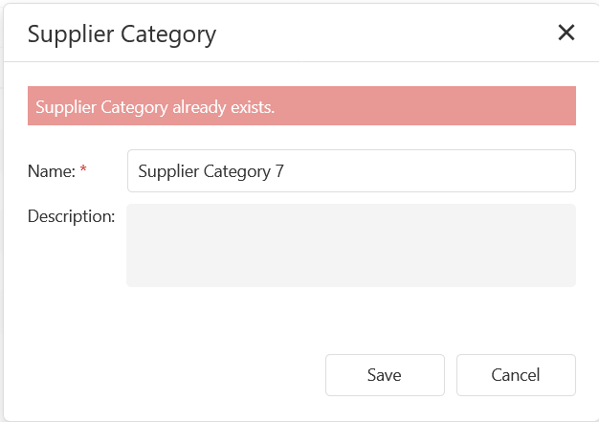

Figures 204: Adding duplicate Supplier Categories

The user will be able to edit a supplier category by pressing the pencil icon button on the record they wish to edit, see below.

**Image:**

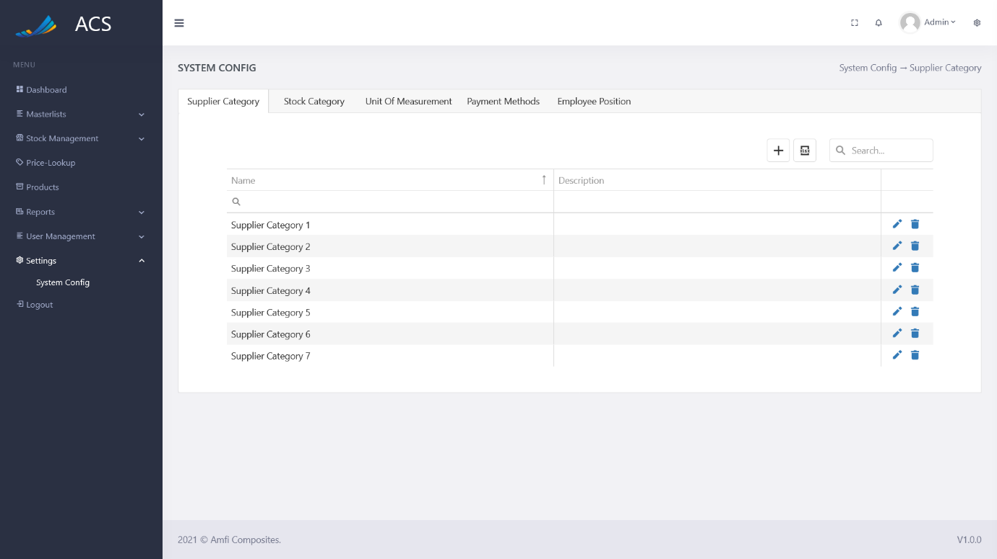

Figures 205: Supplier Category View

The Supplier Category popup will appear with pre-populated data of the Supplier Category, the user can fill in/change all the required fields (marked with a red *) and press the save button.

**Image:**

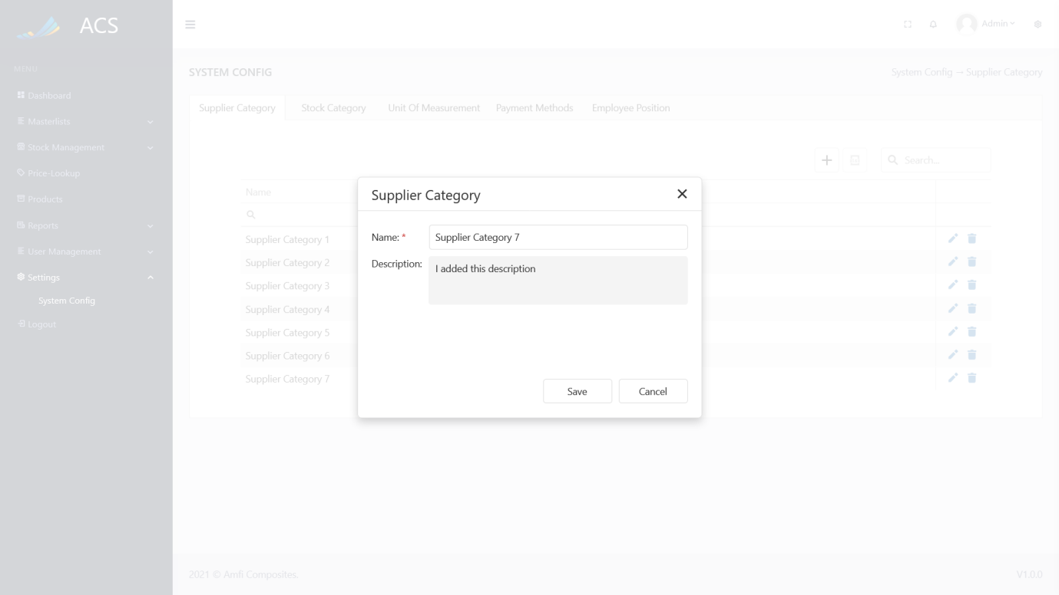

Figures 206: Supplier Category Edit

A success message will appear at the bottom of the screen if a supplier category was updated successfully.

**Image:**

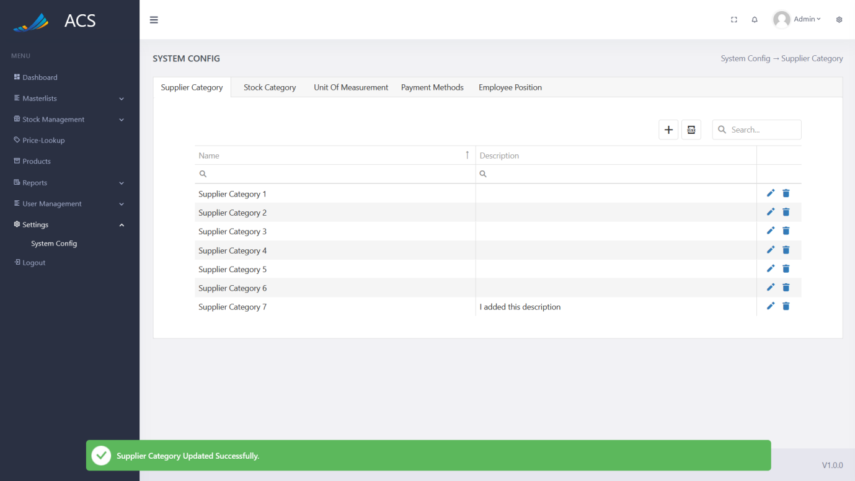

Figures 207: Supplier Category Edited Successfully

The user will be able to remove a supplier category by pressing the trash icon button on the record they wish to remove, see below.

**Image:**

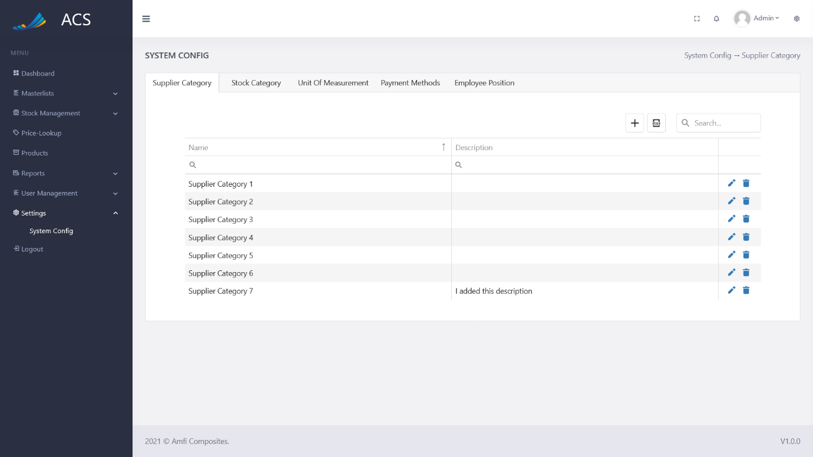

Figures 208: Supplier Category View

A confirmation popup will appear, press yes to continue OR no to cancel.

**Image:**

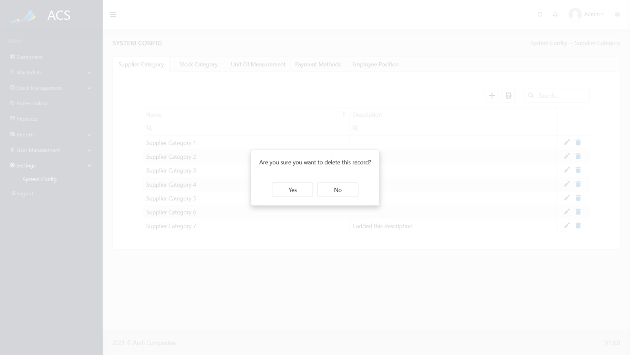

Figures 209: Supplier Category View

**Image:**

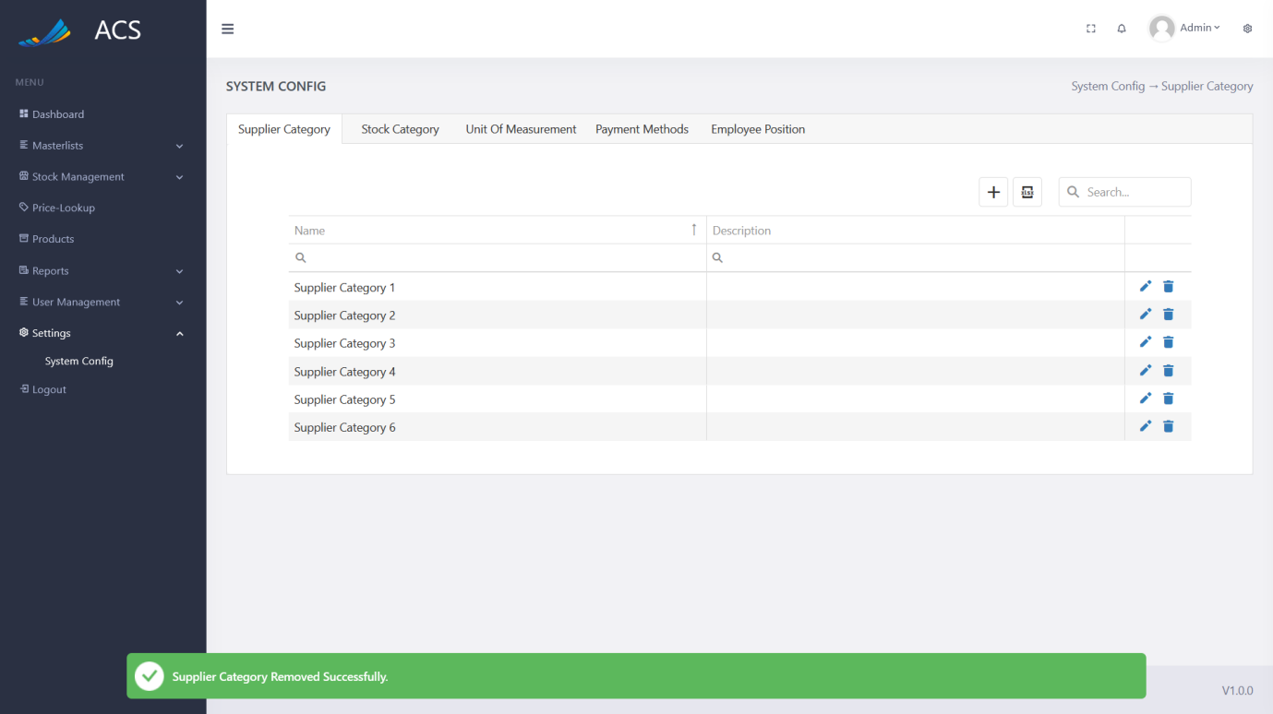

Figures 210: Supplier Category Removed Successfully

##### Stock Category

The user will be able to view, add, edit and remove stock categories. The user can capture the Name and Description.

**Image:**

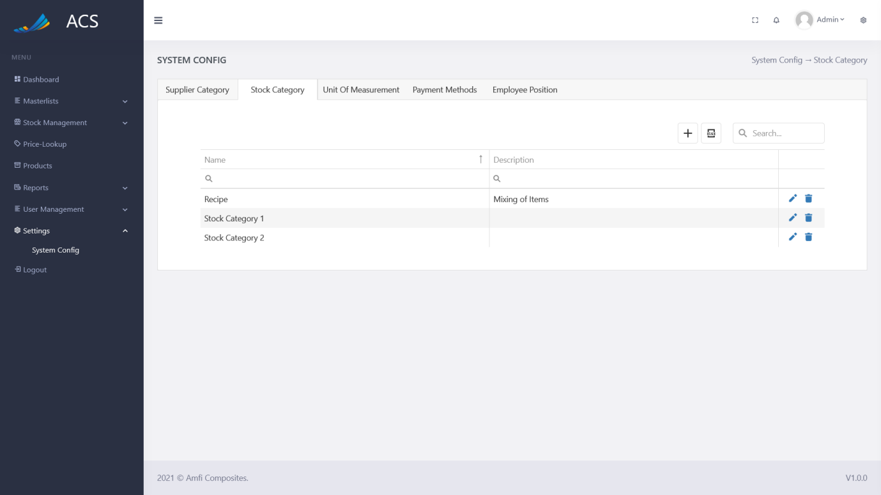

Figures 211: Stock Category View

The user will be able to add a new Stock Category by pressing the plus icon button below.

**Image:**

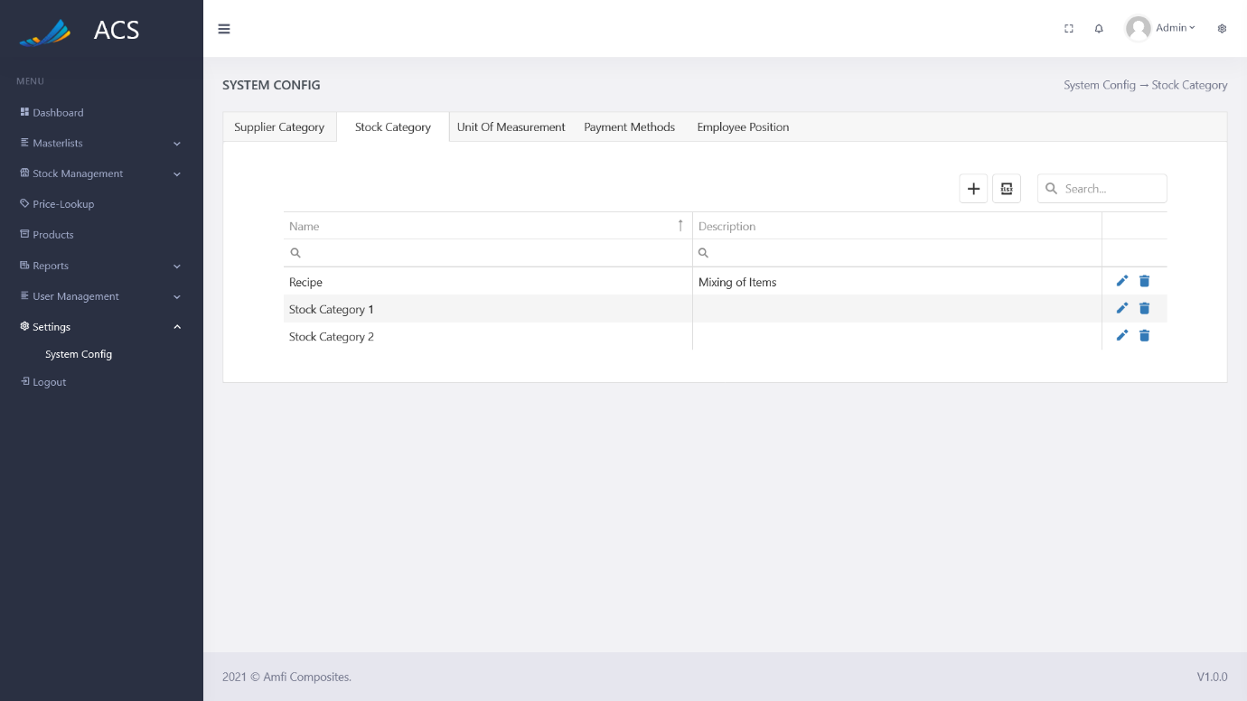

Figures 212: Stock Category Add Button

A Stock Category popup will appear, the user can fill in all the required fields (marked with a red *) and press the save button.

**Image:**

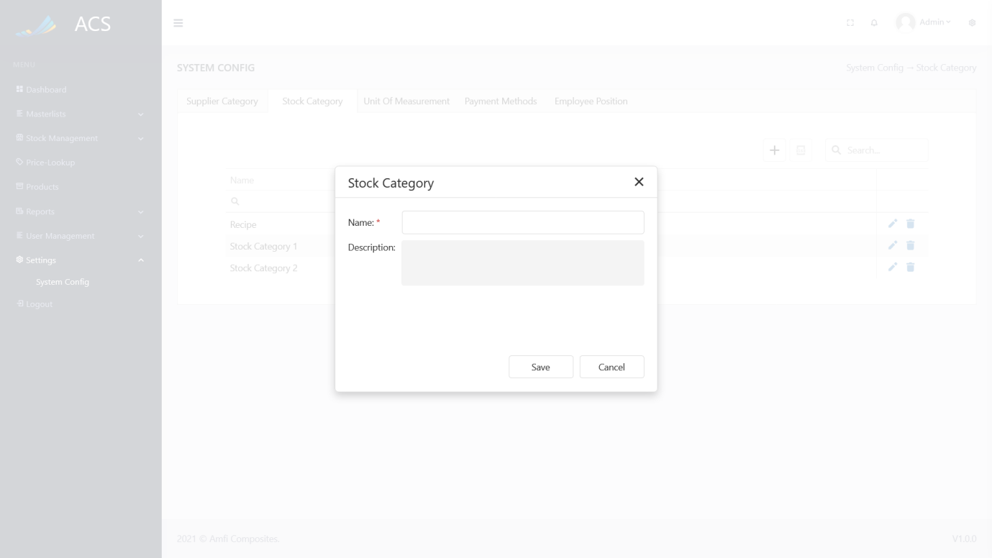

Figures 213: Stock Category Add

A success message will appear at the bottom of the screen if a Stock Category was added successfully.

**Image:**

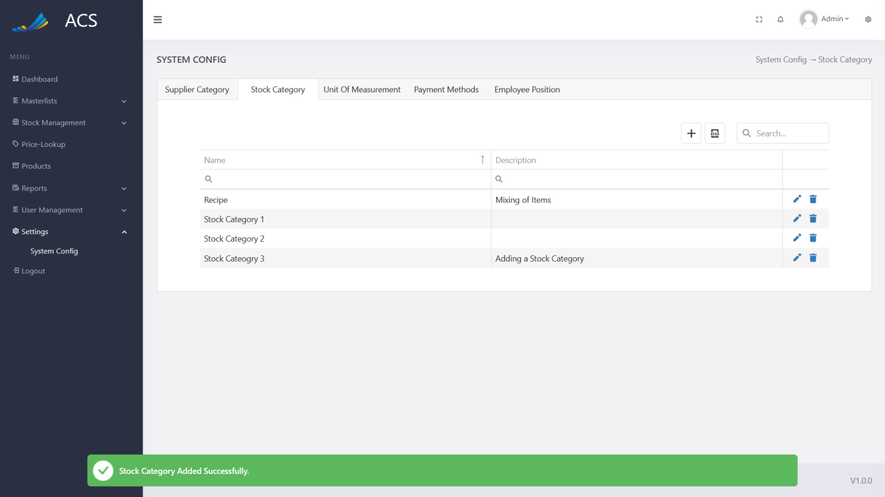

Figures 214: Stock Category Added Successfully

If duplicate stock categories (Name) are added the system will block the request and send back an error message to the user to state the stock category already exists.

**Image:**

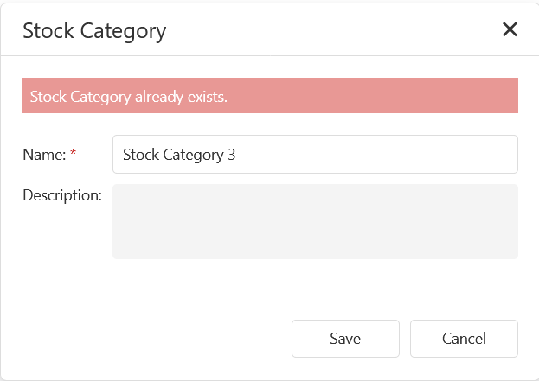

Figures 215: Adding duplicate Stock Categories

The user will be able to edit a stock category by pressing the pencil icon button on the record they wish to edit, see below.

**Image:**

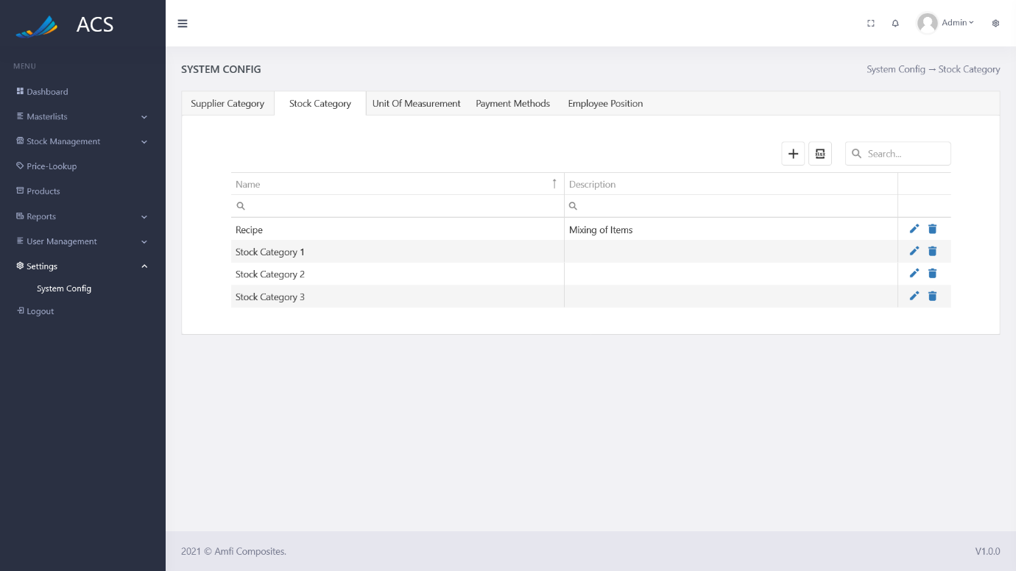

Figures 216: Stock Category View

The Stock Category popup will appear with pre-populated data of the Stock Category, the user can fill in/change all the required fields (marked with a red *) and press the save button.

**Image:**

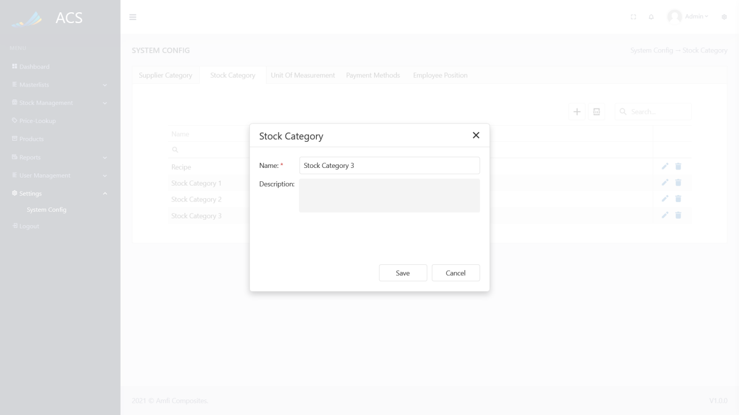

Figures 217: Stock Category Edit

A success message will appear at the bottom of the screen if a stock category was updated successfully.

**Image:**

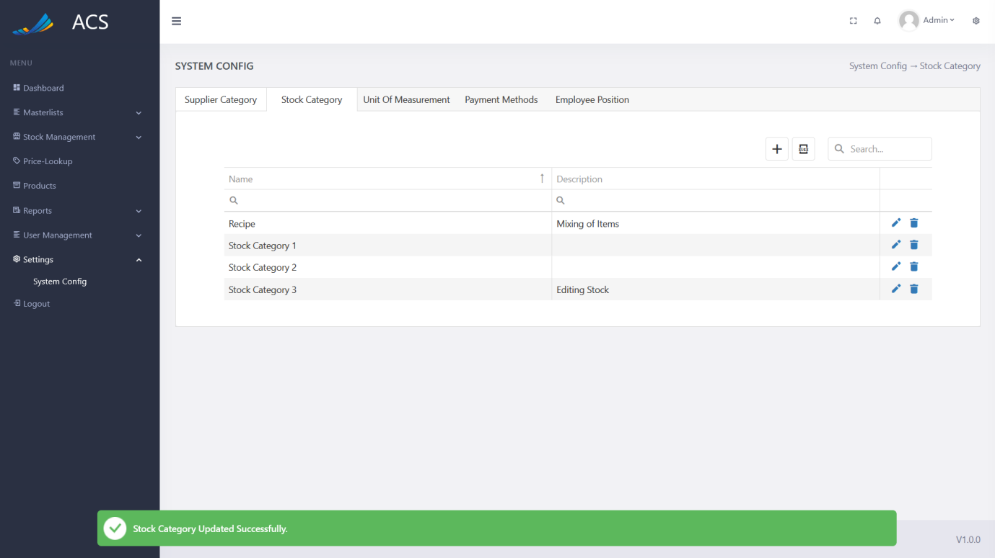

Figures 218: Stock Category Edited Successfully

The user will be able to remove a stock category by pressing the trash icon button on the record they wish to remove, see below.

**Image:**

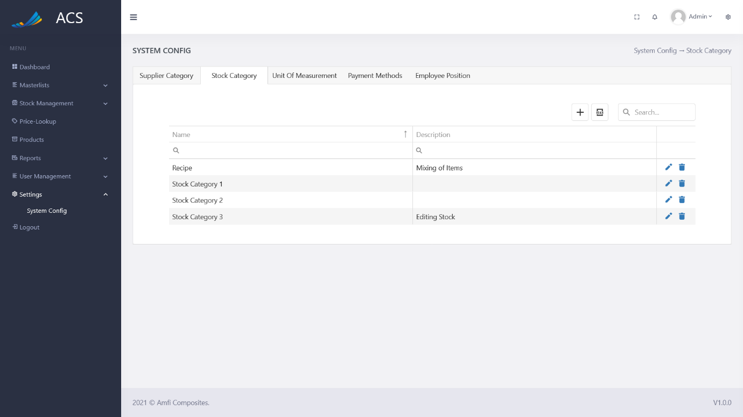

Figures 219: Stock Category View

A confirmation popup will appear, press yes to continue OR no to cancel.

**Image:**

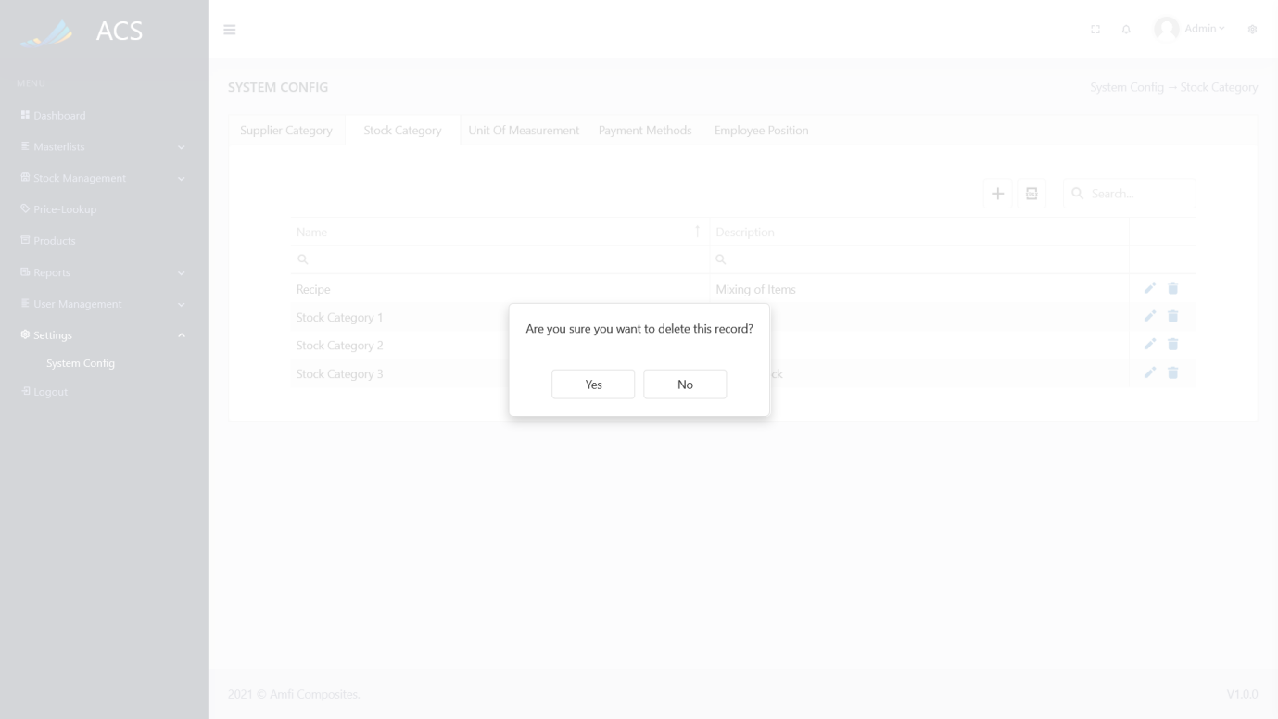

Figures 220: Stock Category View

**Image:**

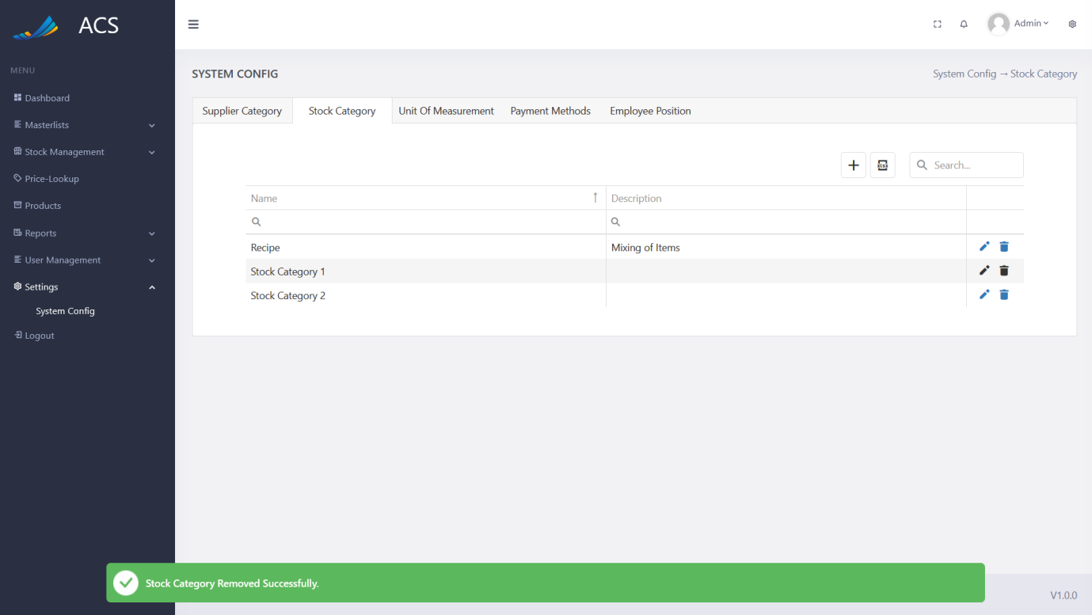

Figures 221: Stock Category Removed Successfully

##### Unit of Measurement

The user will be able to view, add, edit and remove a unit of measurement (UOM). The user can capture the Name.

**Image:**

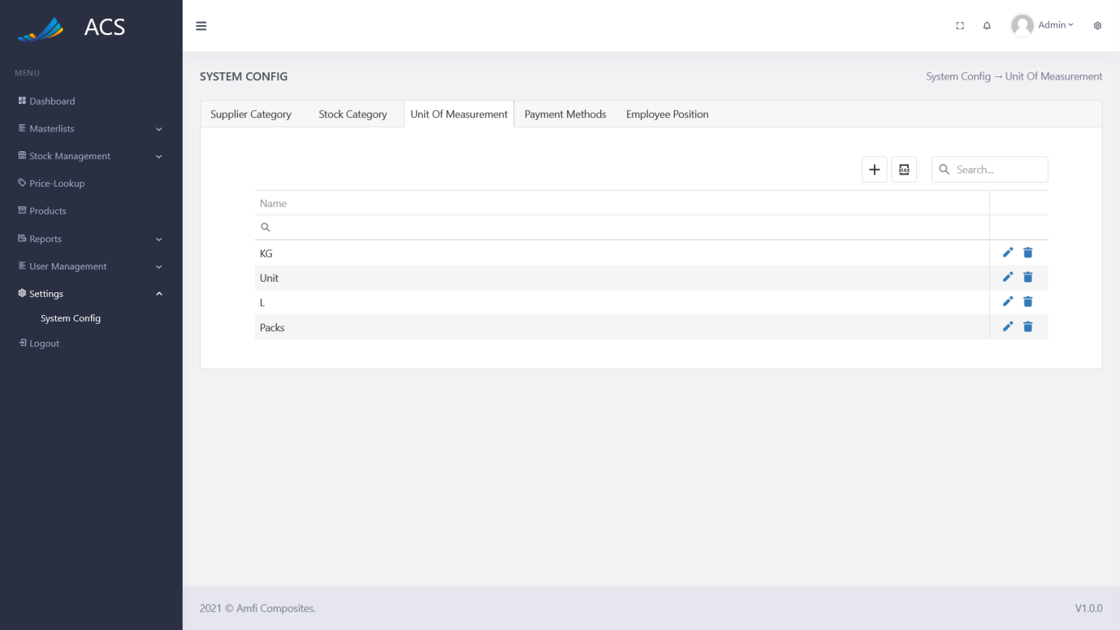

Figures 222: UOM View

The user will be able to add a new unit of measurement (UOM) by pressing the plus icon button below.

**Image:**

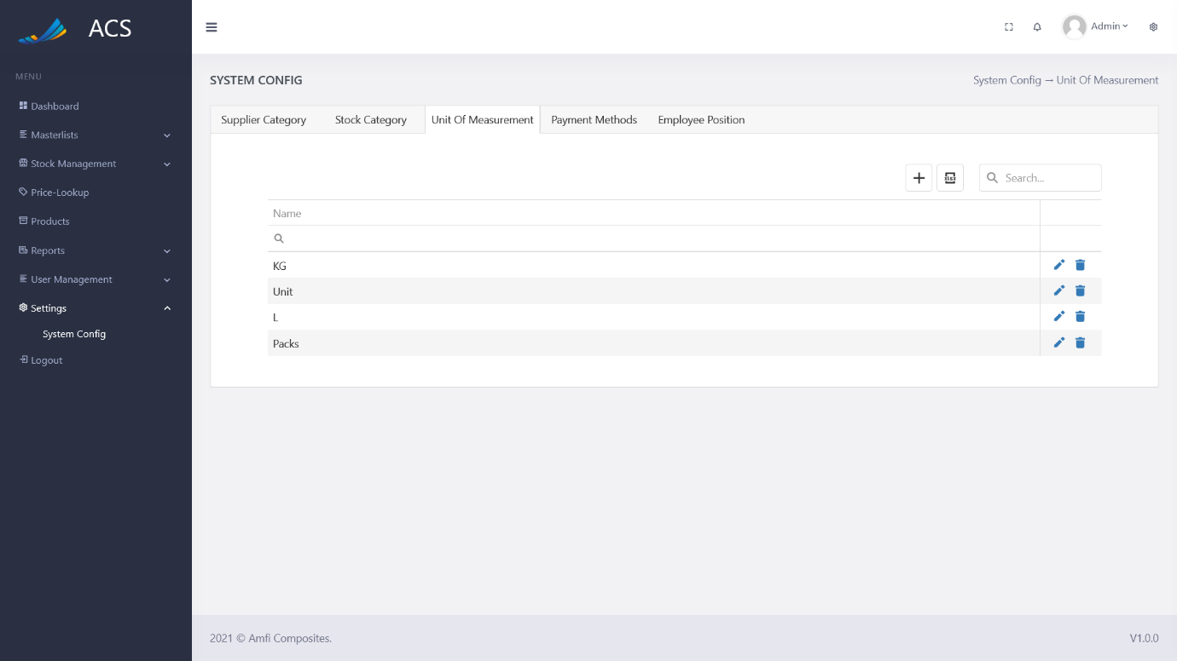

Figures 223: UOM Add Button

A unit of measurement popup will appear, the user can fill in all the required fields (marked with a red *) and press the save button.

**Image:**

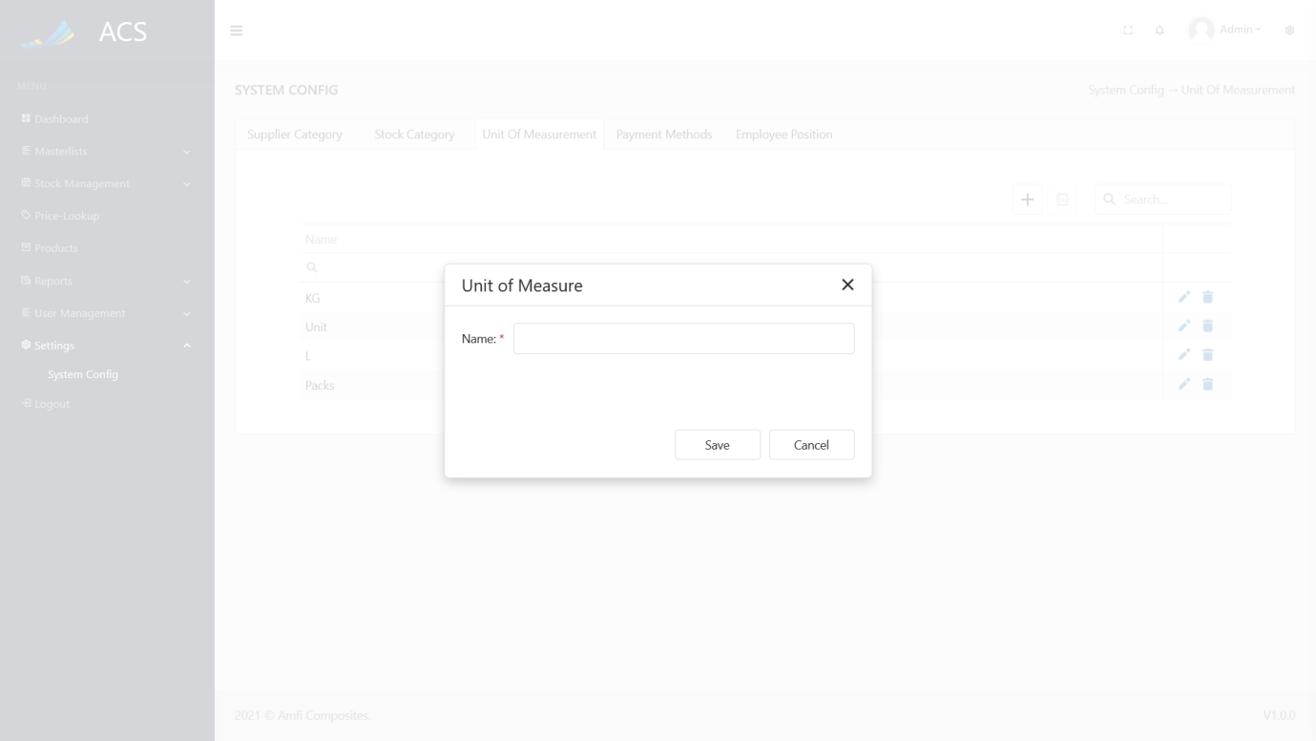

Figures 224: UOM Add

A success message will appear at the bottom of the screen if a unit of measurement (UOM) was added successfully.

**Image:**

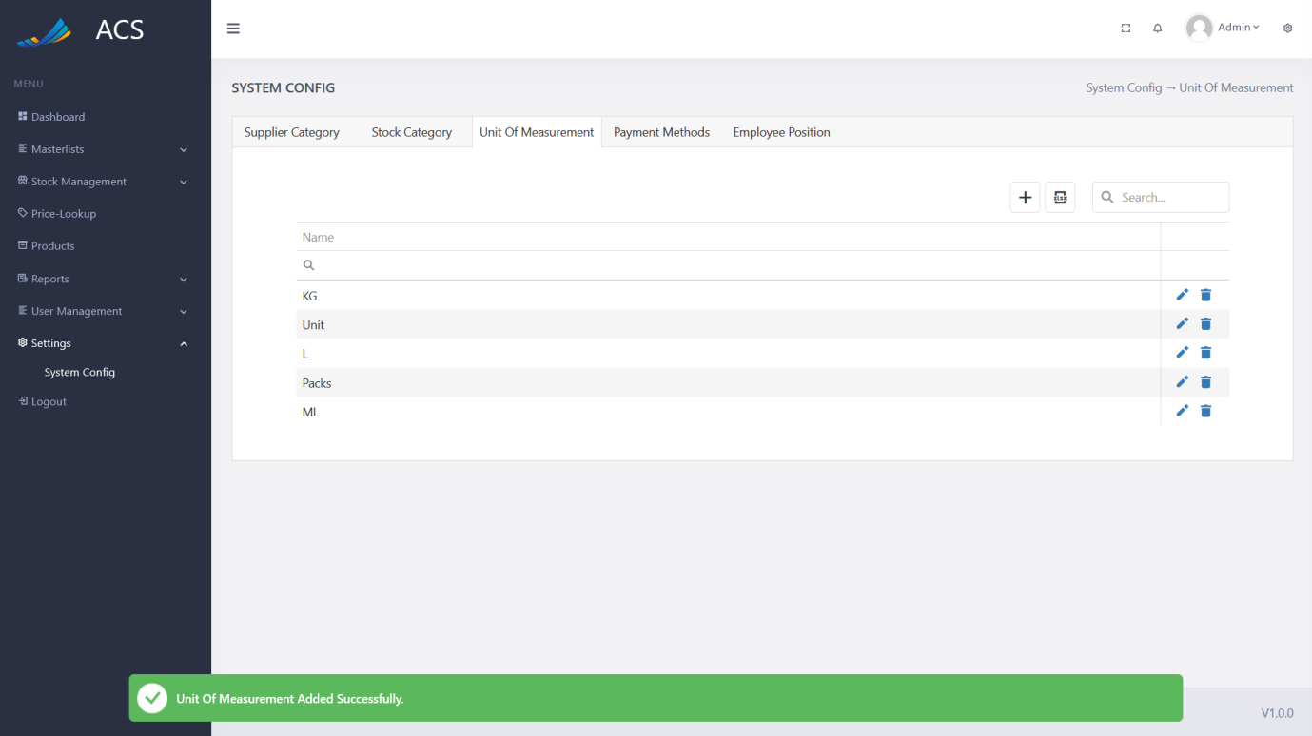

Figures 225: UOM Added Successfully

If a duplicate unit of measurement (Name) is added the system will block the request and send back an error message to the user to state the unit of measurement already exists.

**Image:**

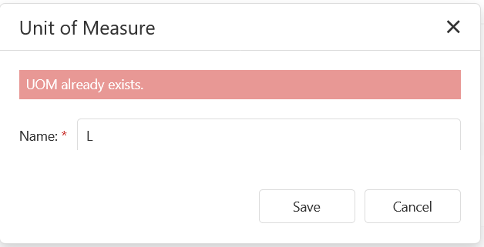

Figures 226: Adding duplicate UOM

The user will be able to edit a unit of measurement (UOM) by pressing the pencil icon button on the record they wish to edit, see below.

**Image:**

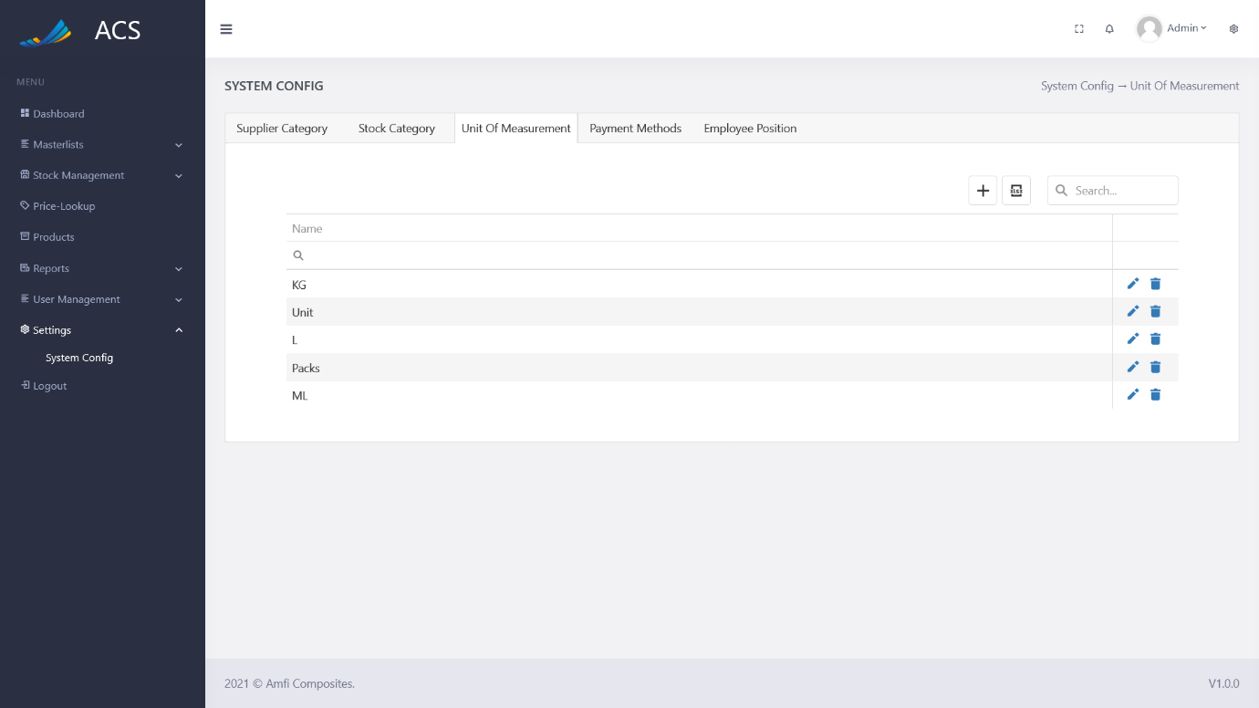

Figures 227 UOM View

The unit of measurement (UOM) popup will appear with pre-populated data of the UOM the user can fill in/change all the required fields (marked with a red *) and press the save button.

**Image:**

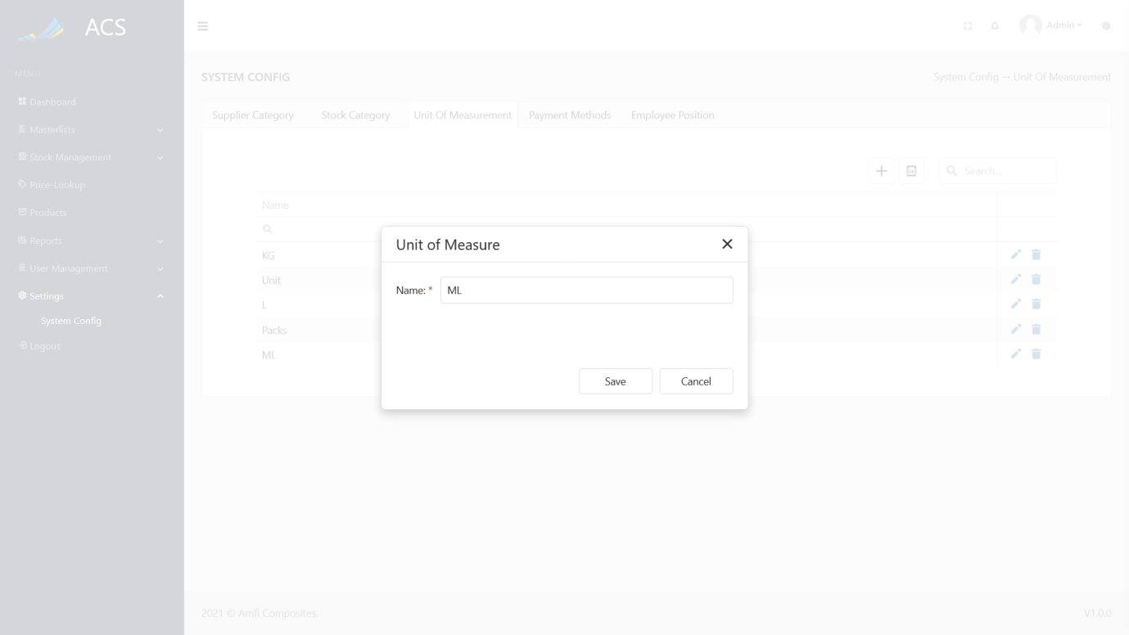

Figures 228: UOM Edit

A success message will appear at the bottom of the screen if a unit of measurement (UOM) was updated successfully.

**Image:**

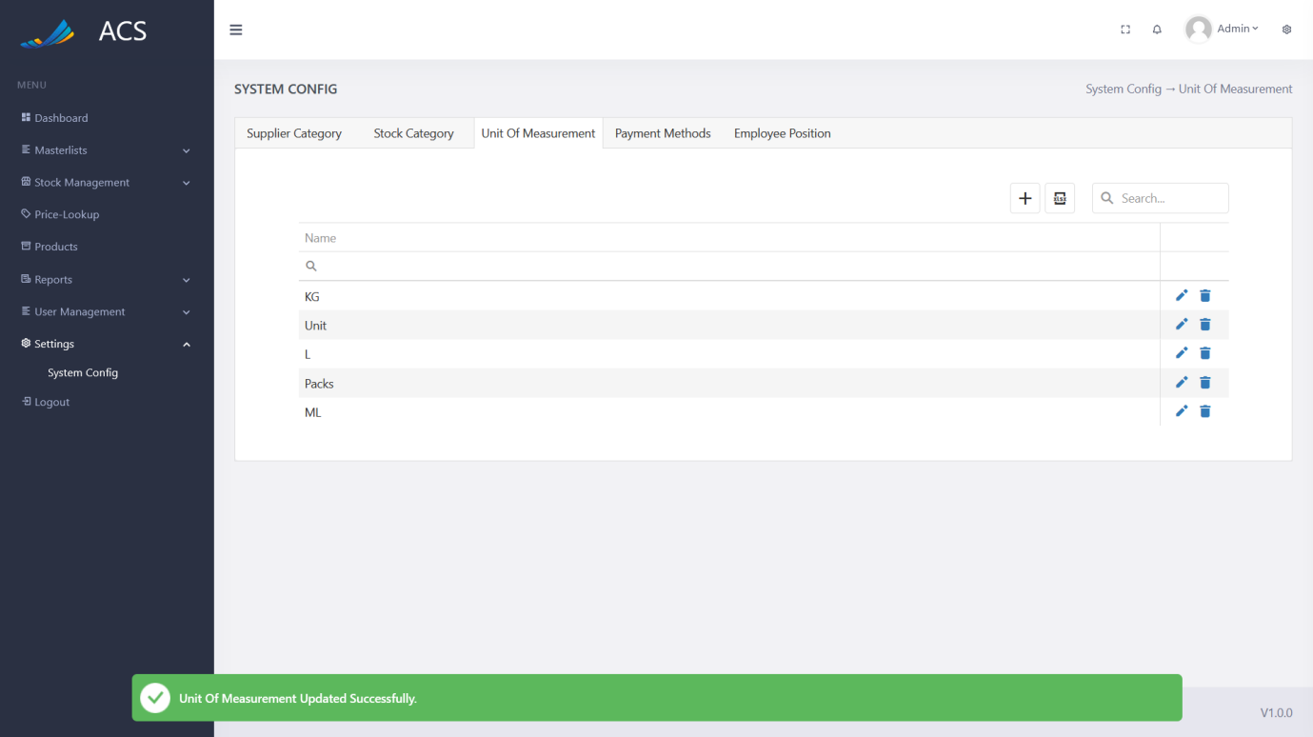

Figures 229: UOM Edited Successfully

The user will be able to remove a unit of measurement (UOM) by pressing the trash icon button on the record they wish to remove, see below.

**Image:**



Figures 230: UOM View

A confirmation popup will appear, press yes to continue OR no to cancel.

**Image:**

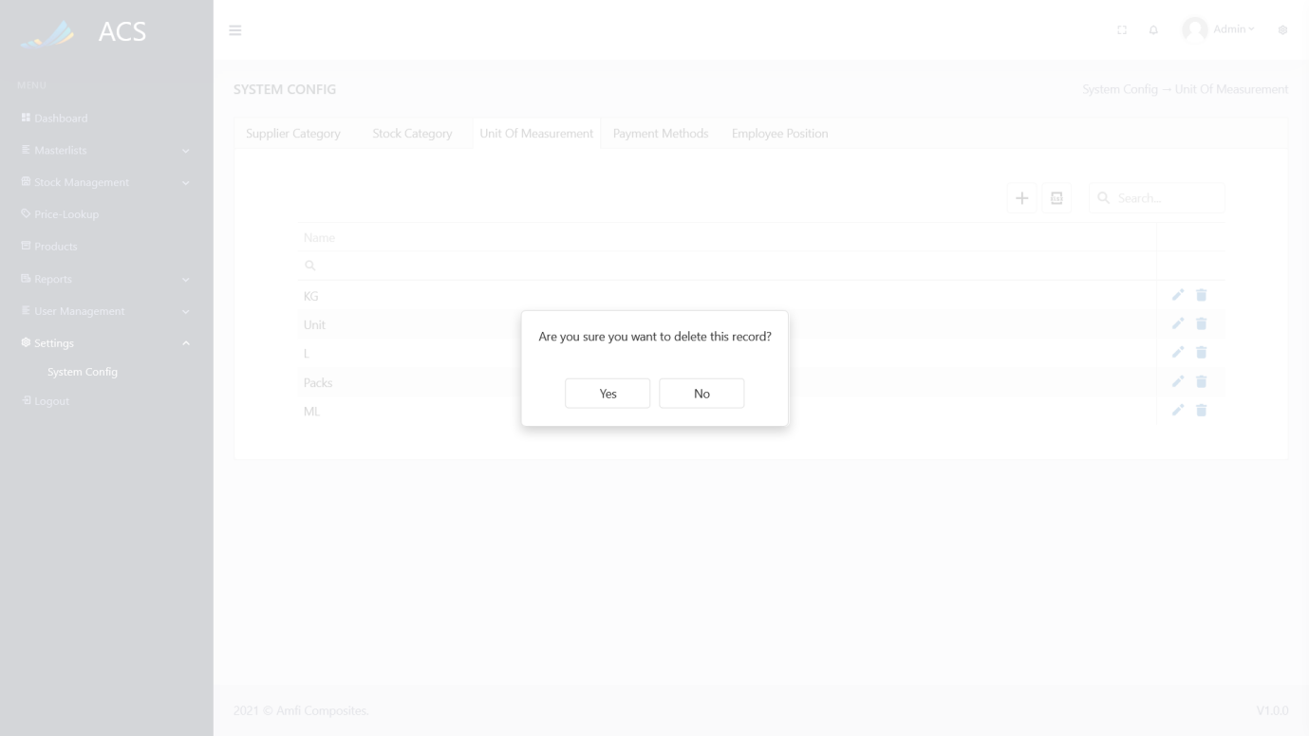

Figures 231: UOM View

**Image:**

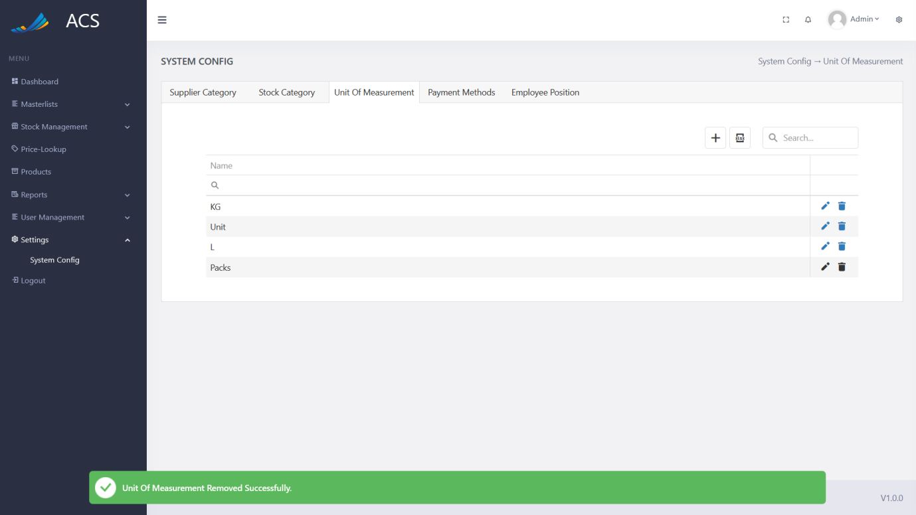

Figures 232: UOM Removed Successfully

##### Payment Methods

The user will be able to view, add, edit and remove Payment Methods. The user can capture the Type and Description.

**Image:**

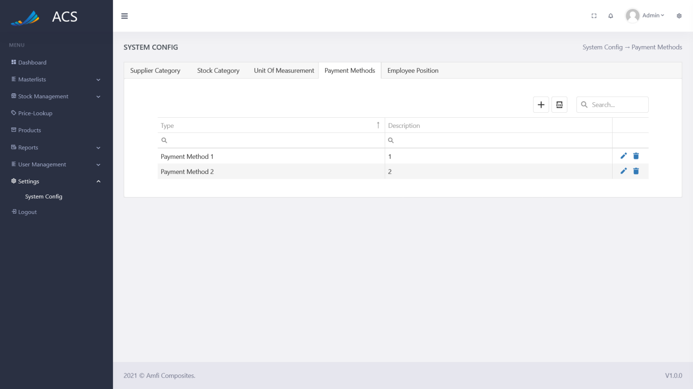

Figures 233: Payment Method View

The user will be able to add a new Payment Method by pressing the plus icon button below.

**Image:**

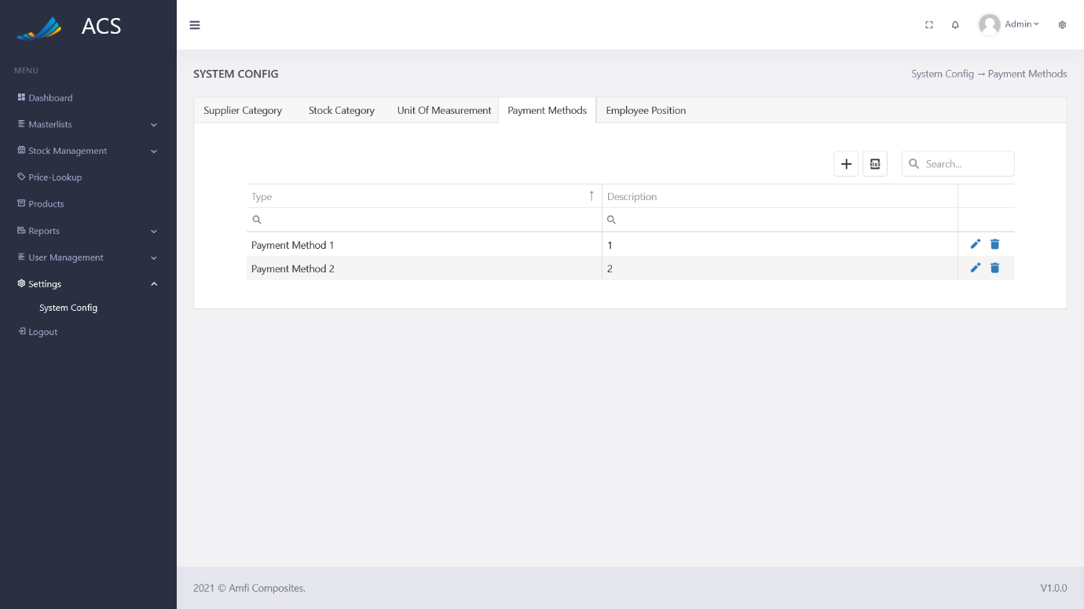

Figures 234: Payment Method Add Button

A Payment Method popup will appear, the user can fill in all the required fields (marked with a red *) and press the save button.

**Image:**

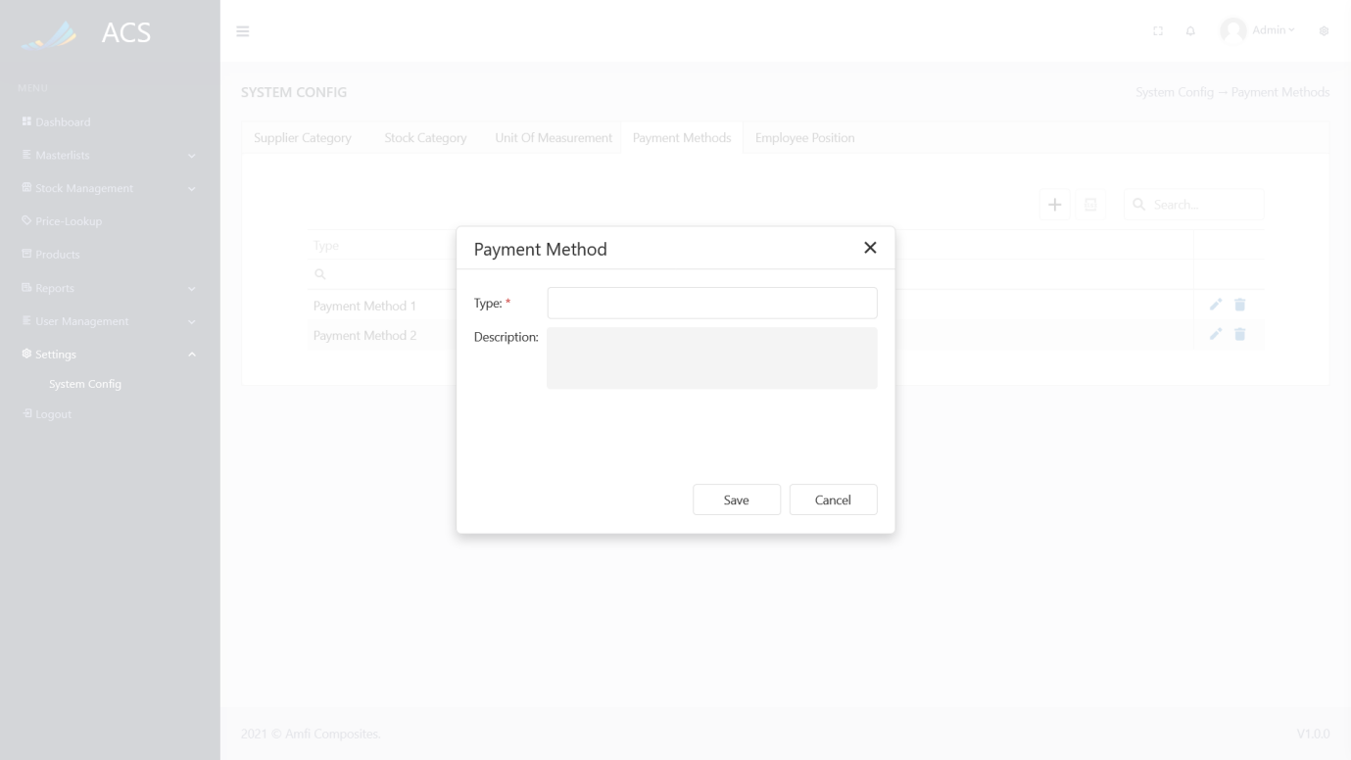

Figures 235: Payment Method Add

A success message will appear at the bottom of the screen if a Payment Method was added successfully.

**Image:**

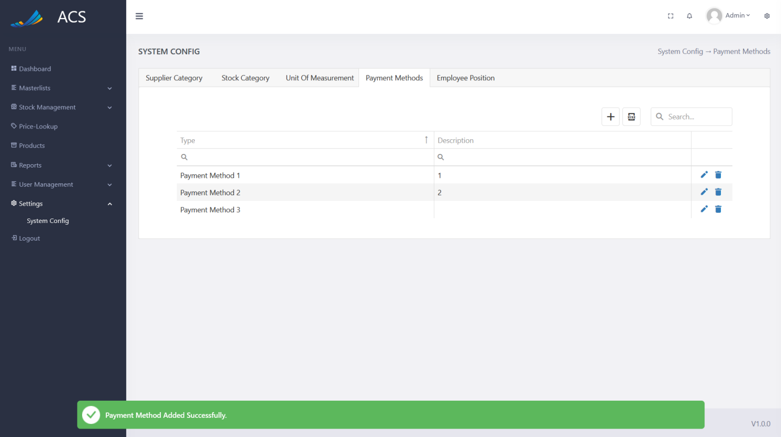

Figures 236: Payment Method Added Successfully

If duplicate Payment Methods (Type) are added the system will block the request and send back an error message to the user to state the Payment Method already exists.

**Image:**

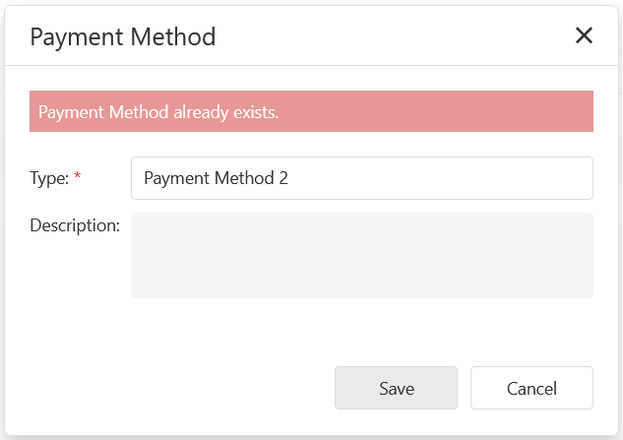

Figures 237: Adding duplicate Payment Method

The user will be able to edit a Payment Method by pressing the pencil icon button on the record they wish to edit, see below.

**Image:**

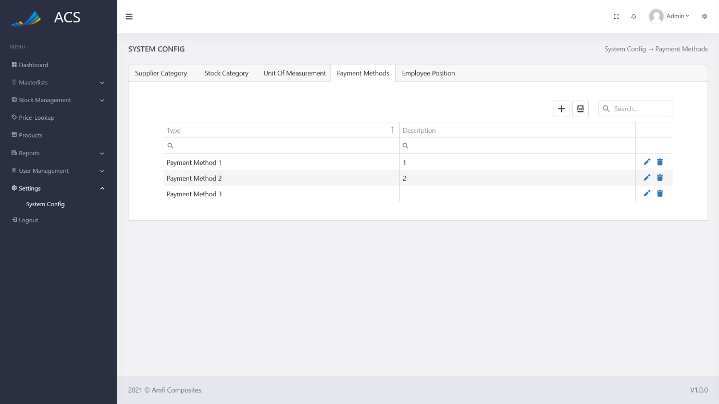

Figures 238: Payment Method View

The Payment Method popup will appear with pre-populated data of the Payment Method the user can fill in/change all the required fields (marked with a red *) and press the save button.

**Image:**

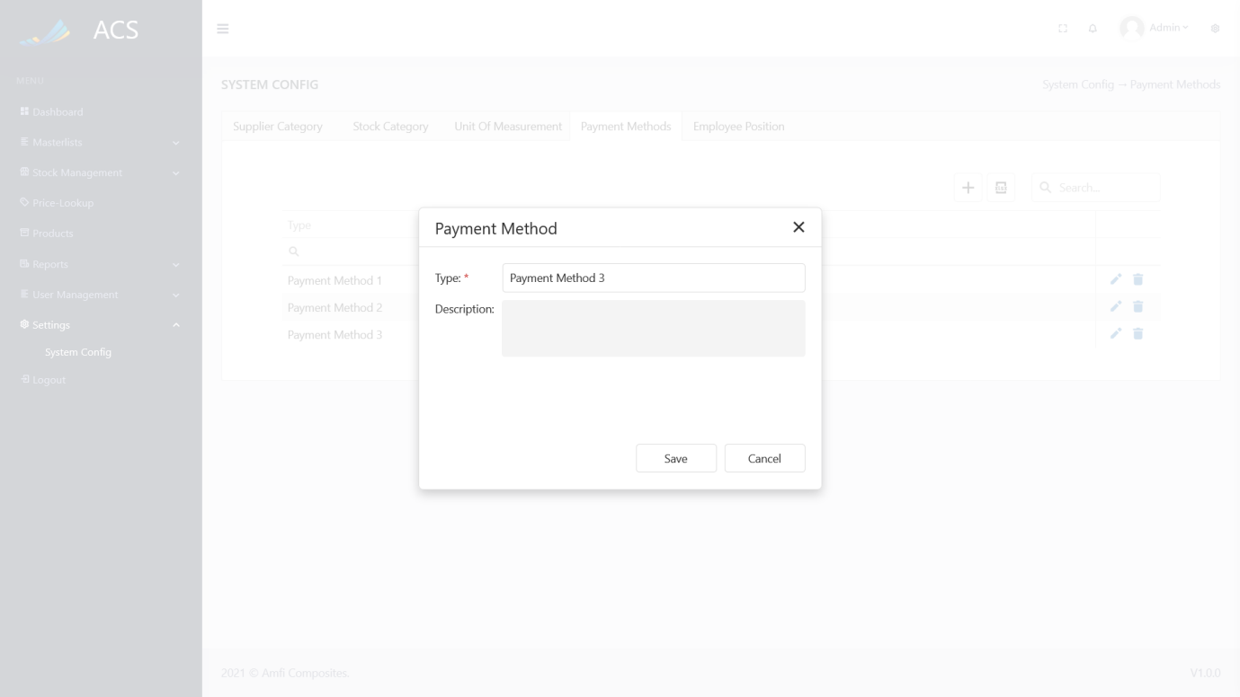

Figures 239: Payment Method Edit

A success message will appear at the bottom of the screen if a Payment Method was updated successfully.

**Image:**

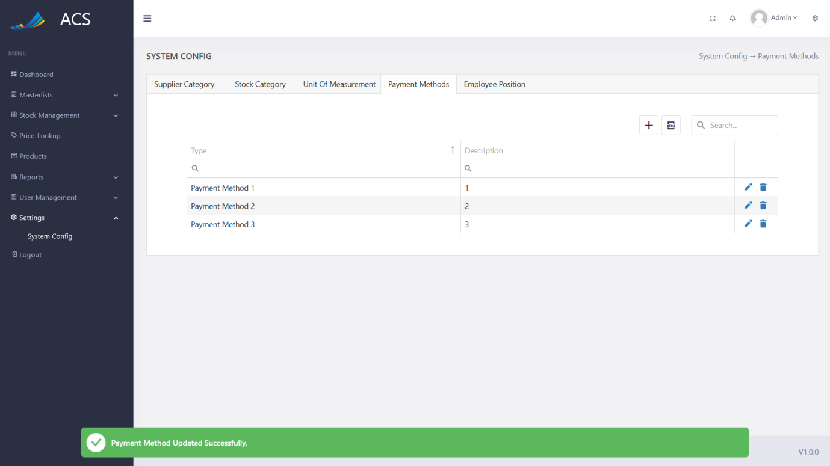

Figures 240: Payment Method Edited Successfully

The user will be able to remove a Payment Method by pressing the trash icon button on the record they wish to remove, see below.

**Image:**

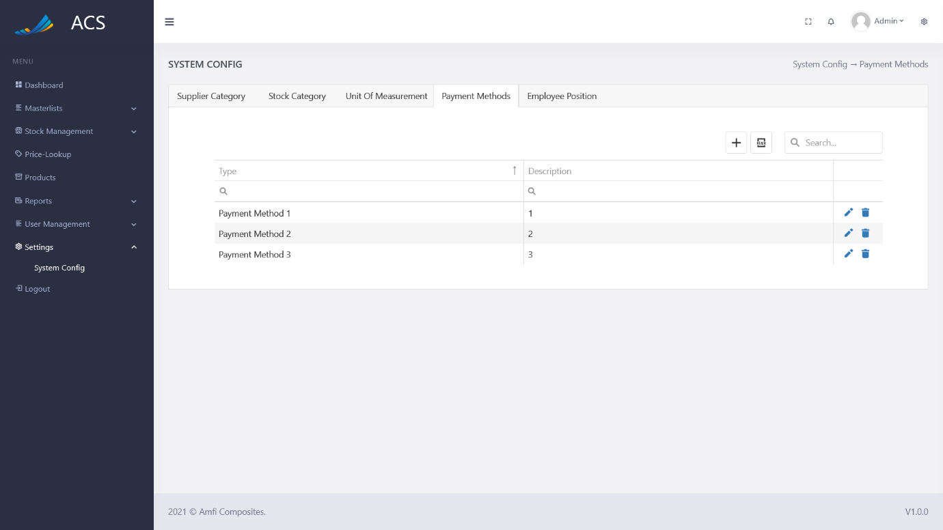

Figures 241: Payment Method View

A confirmation popup will appear, press yes to continue OR no to cancel.

**Image:**

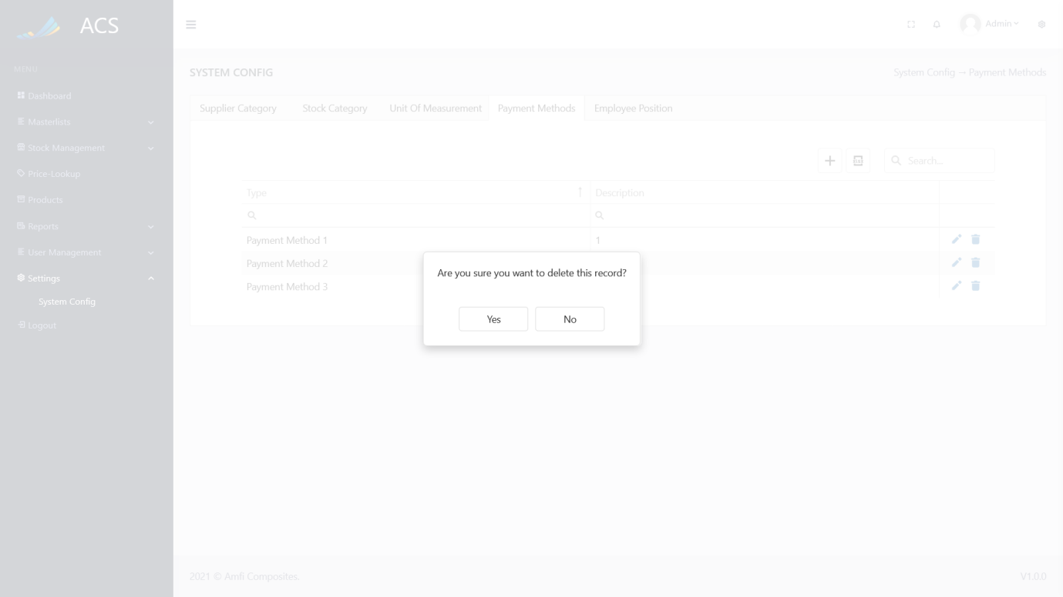

Figures 242: Payment Method View

**Image:**

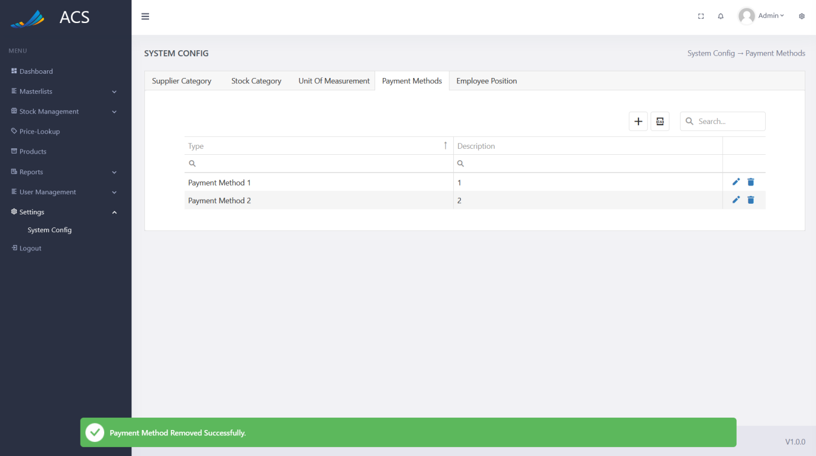

Figures 243: Payment Method Removed Successfully

##### Employee Position

The user will be able to view, add, edit and remove Employee Positions. The user can capture the Position and Description.

**Image:**

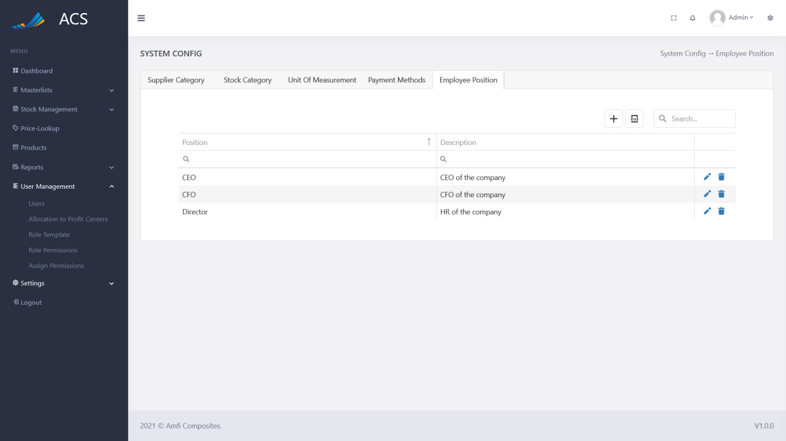

Figures 244: Employee Position View

The user will be able to add a new Employee Position by pressing the plus icon button below.

**Image:**

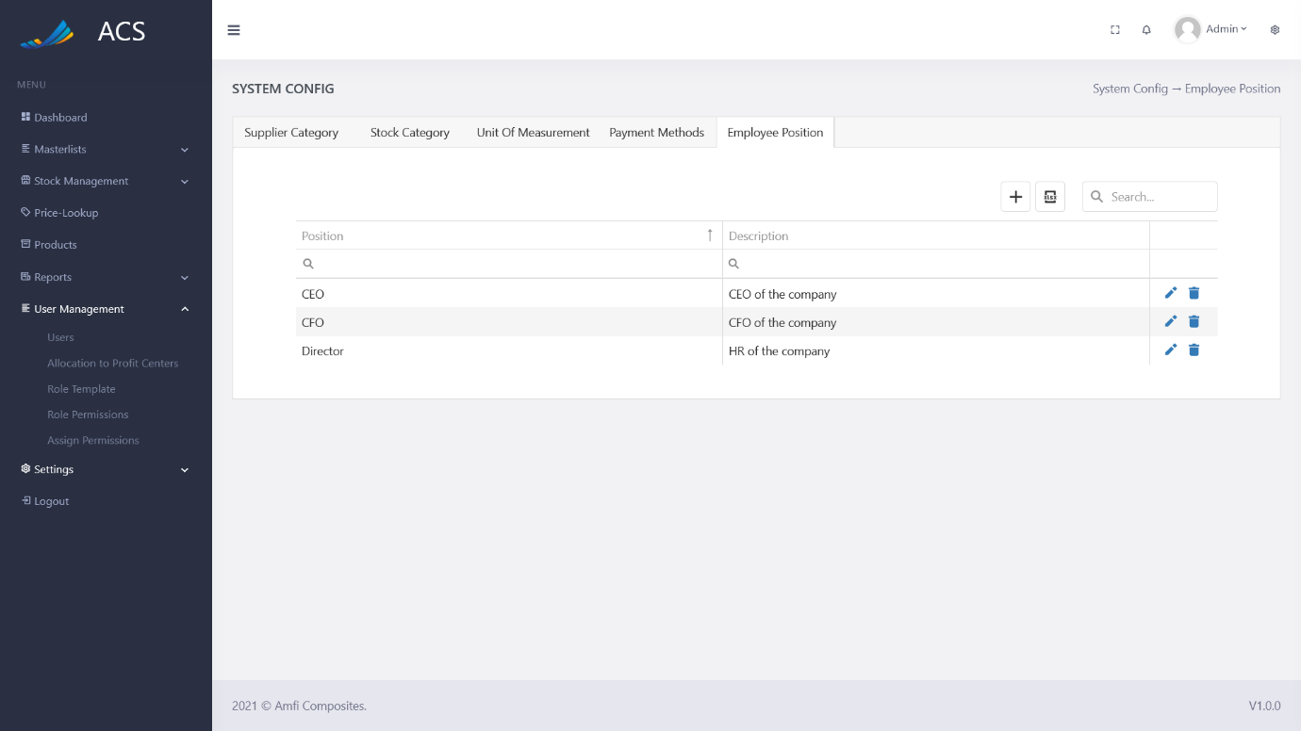

Figures 245: Employee Position Add Button

An Employee Position popup will appear, the user can fill in all the required fields (marked with a red *) and press the save button.

**Image:**

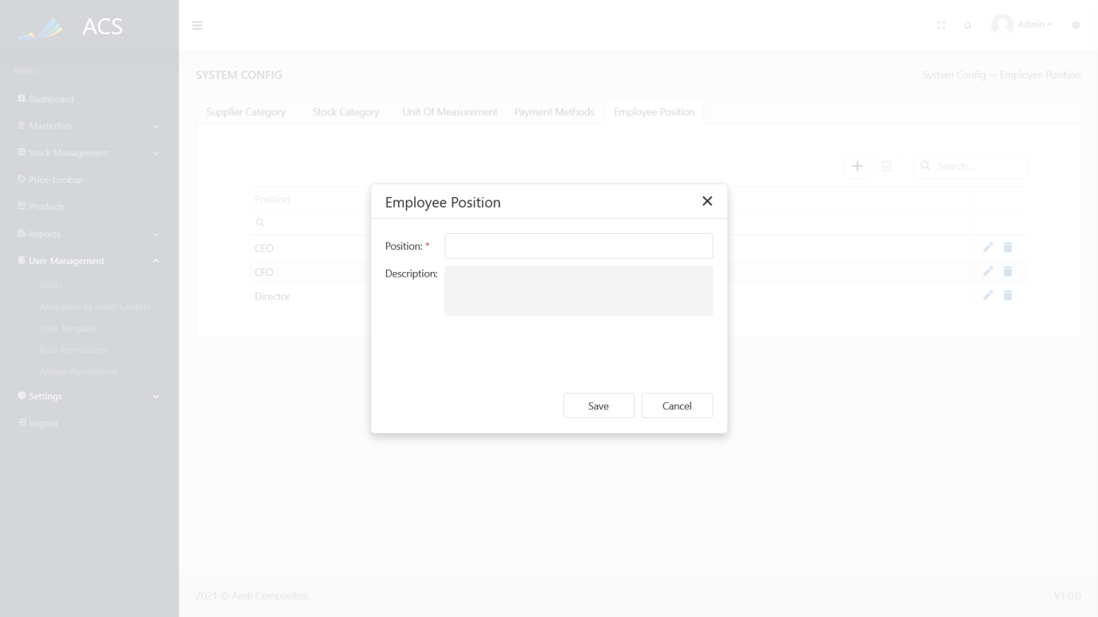

Figures 246: Employee Position Add

A success message will appear at the bottom of the screen if an Employee Position was added successfully.

**Image:**

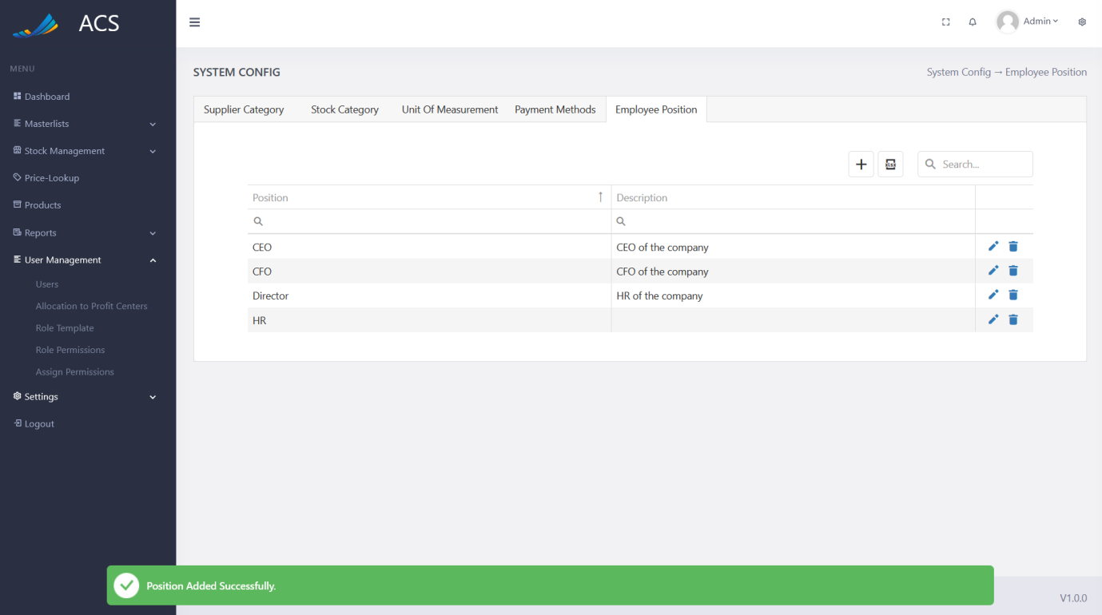

Figures 247: Employee Position Added Successfully

If duplicate Employee Positions (Position) are added the system will block the request and send back an error message to the user to state the Employee Position already exists.

**Image:**

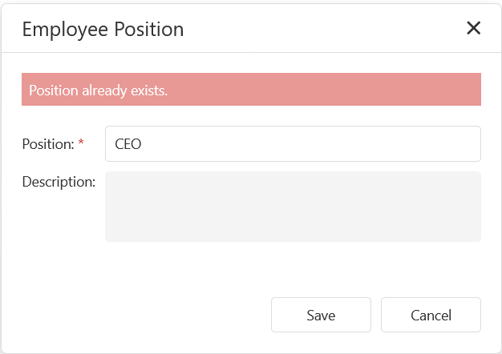

Figures 248: Adding duplicate Employee Position

The user will be able to edit an Employee Position by pressing the pencil icon button on the record they wish to edit, see below.

**Image:**

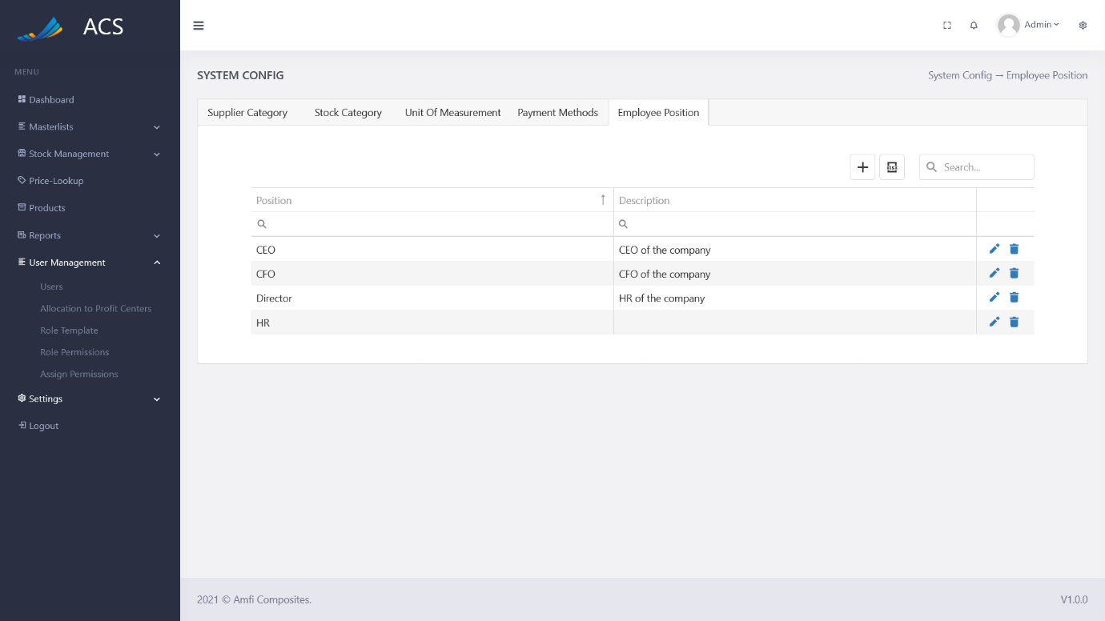

Figures 249: Employee Position View

The Employee Position popup will appear with pre-populated data of the Employee Position the user can fill in/change all the required fields (marked with a red *) and press the save button.

**Image:**

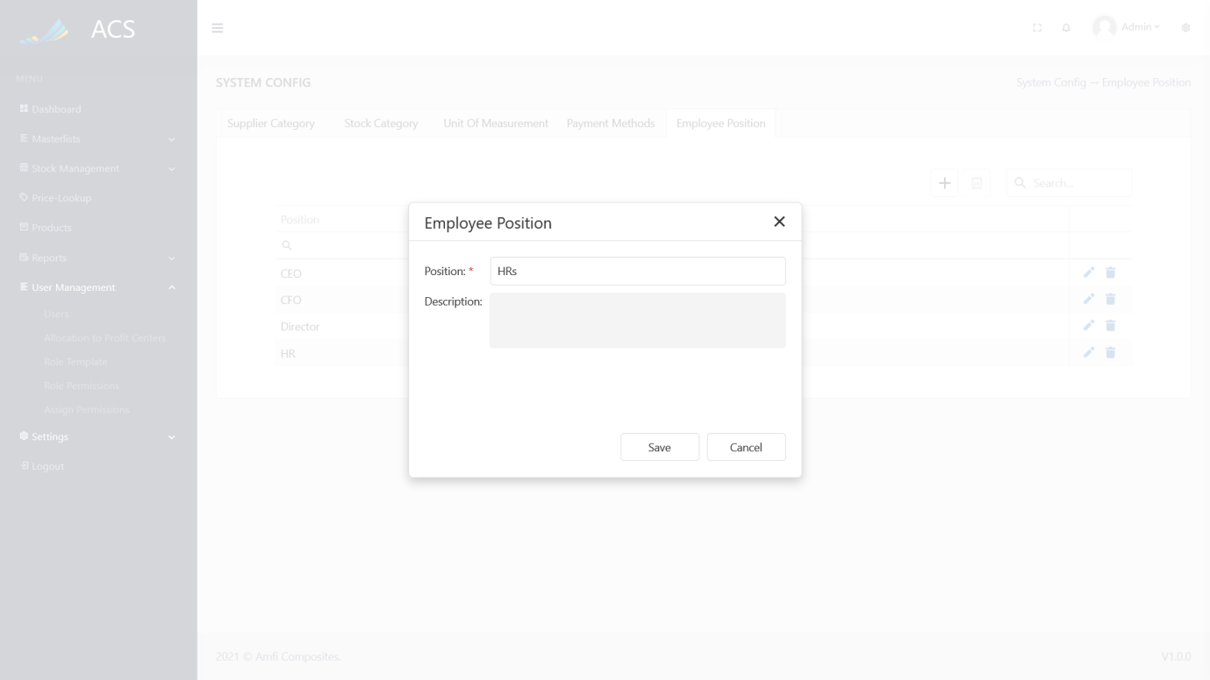

Figures 250: Employee Position Edit

A success message will appear at the bottom of the screen if an Employee Position was updated successfully.

**Image:**

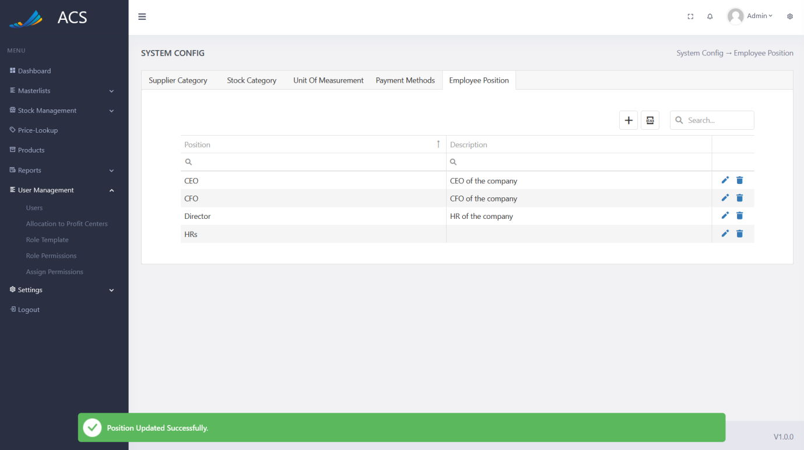

Figures 251: Employee Position Edited Successfully

The user will be able to remove an Employee Position by pressing the trash icon button on the record they wish to remove, see below.

**Image:**

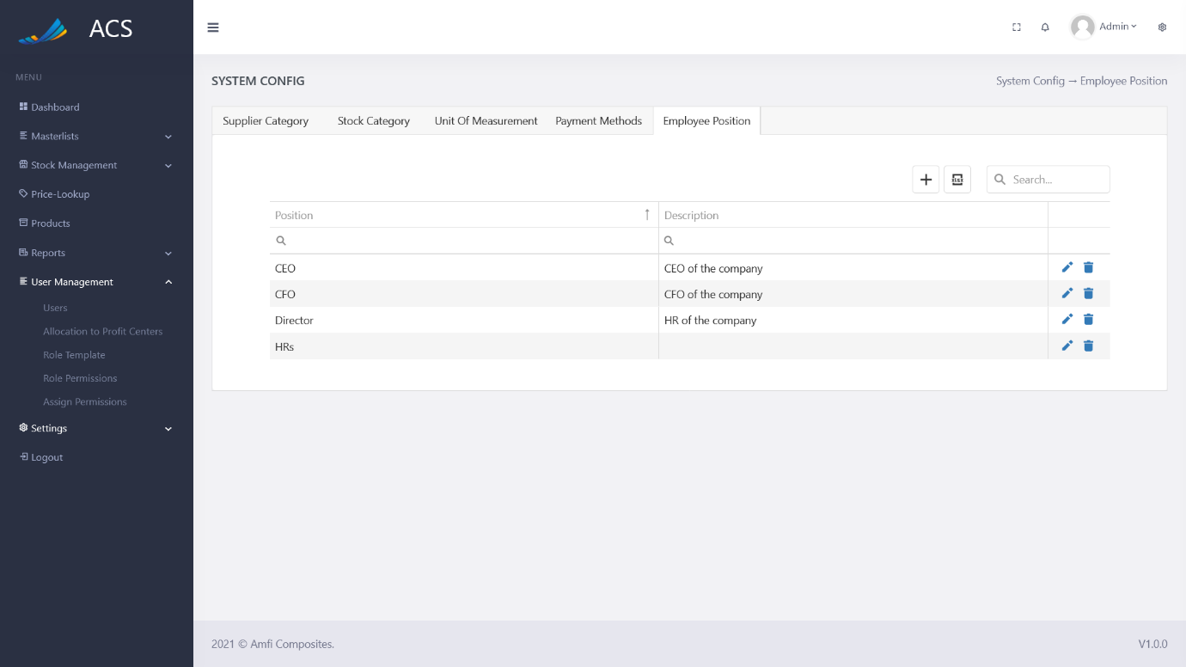

Figures 252: Employee Position View

A confirmation popup will appear, press yes to continue OR no to cancel.

**Image:**

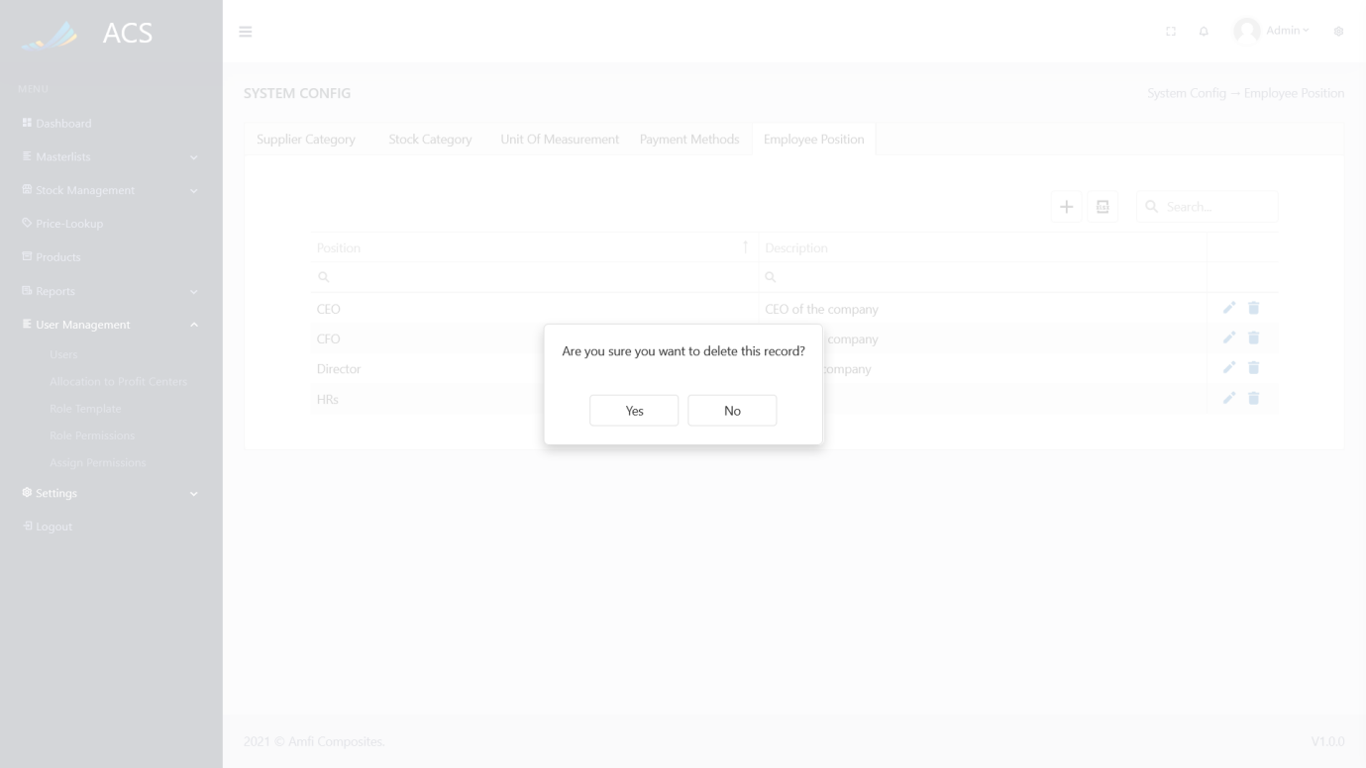

Figures 253: Employee Position View

**Image:**

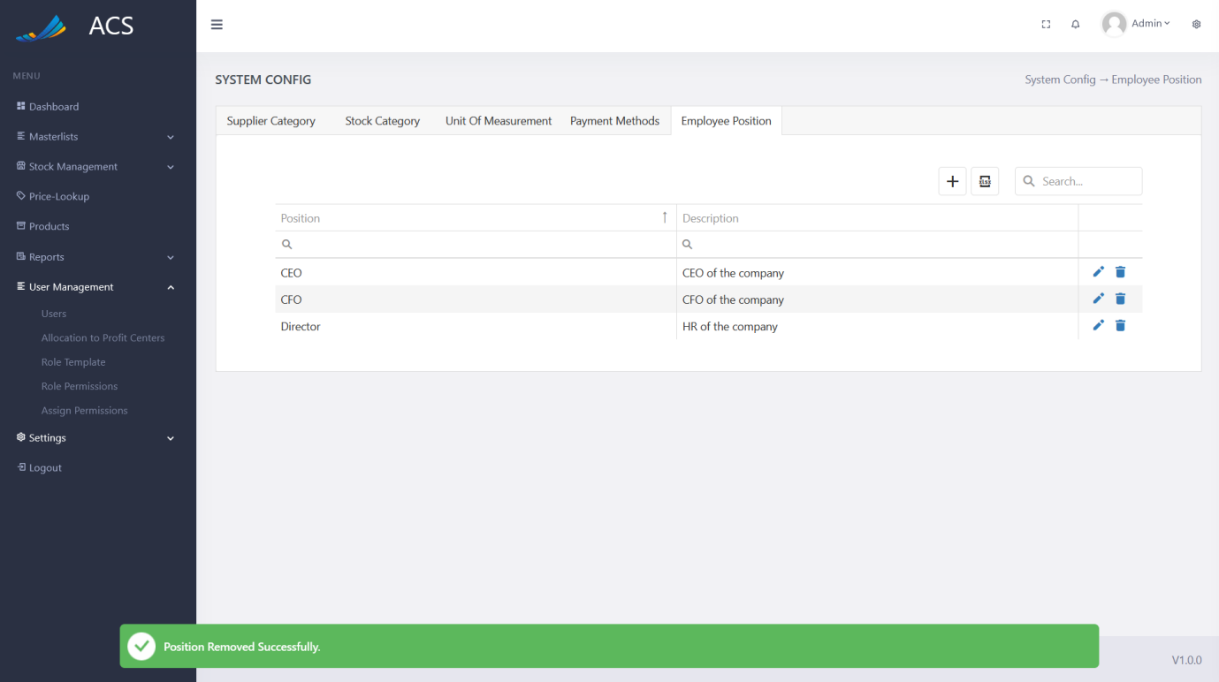

Figures 254: Employee Position Removed Successfully

### Logout

The user will be able to log out of the system by pressing the logout button in the side menu or top bar. See images below:

**Image:**

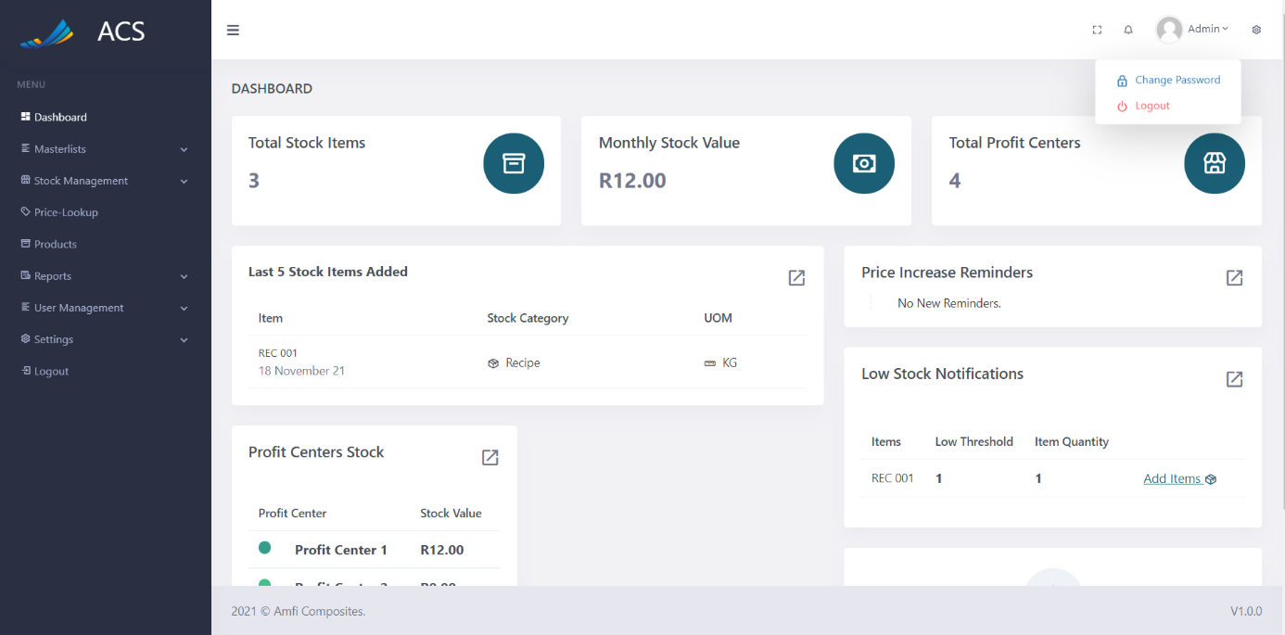

Figures 255: Logout

The system will also log the user out after 30 minutes of inactivity. The user can enter their login details again to continue using the system.